Table of Contents

Introduction 1

1.1 Purpose of this document 1

1.2 Scope 1

1.3 Key Stakeholders 1

2 Design Overview 2

2.1 User interface Design 2

2.2 User interface Design description 2

3 System Design 2

3.1 function Design 2

3.2 Class Design 3

3.3 Class Diagram 3

3.4 Sequence setup 4

3.5 Sequence Diagram 4

4 Maintenance Scenario 5

# Introduction

## Purpose of this document

This document is used to describe the Design of the Venn System, Including the System Design, the Class Design and the Sequence Design, and Maintenance Design.

## Scope

The scope of the document focus on Class Design the System Design, making the audience understand how the Venn System design

## Key Stakeholders

The Programmers will continue working the project, the Tester with this project, the Technical writer who will explain to the users with this project.

# Design Overview

## User interface Design

## User interface Design description

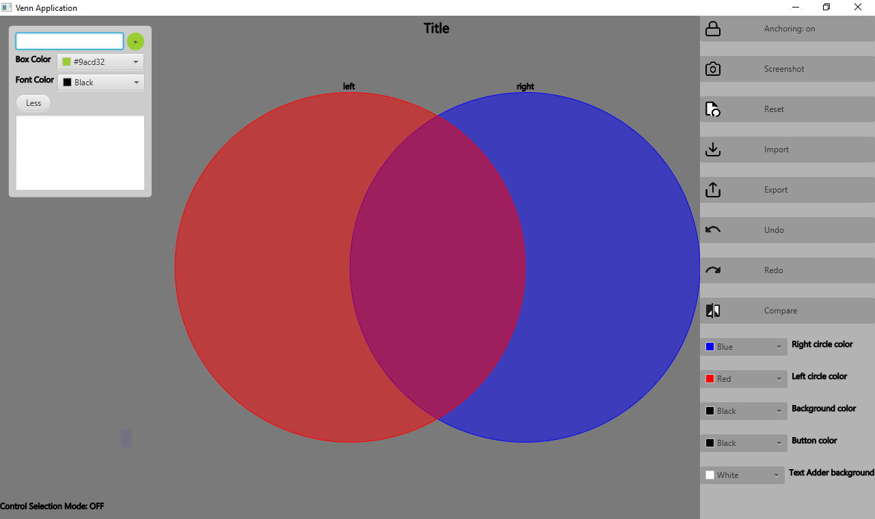

The user interface design including two circles, add textbox box, and 7 buttons at the right which is Anchoring on, screenshot, Reset, import, Export, Undo, Redo, Compare. And 5 colors pickers for circles, background, Button color, and text background.

# System Design

## function Design

Base on the UI, we design the function: The add New text Box is used to create a textbox to drag into the left, right circles, Anchoring on button is used to maintain the textbox in the left circle, right circle or between them. Import is used to import the text file and keep the textbox for previous setup, Export is used to export the text file for right now setup, Undo is used to undo the right now setup, redo is used to redo the action just do. Screenshot is used to save the app screen shot for photo file, compare is used to compared the right now setup with previous setup.

## Class Design

Base on the function design, we use Java & JavaFX to implementation of the Venn system. Because JavaFX has the graph class to implementation the graph function, we create the main class called implementation of the UI first we create two circles object, 4 buttons objects which are used to the click event, two colors picker objects which are used to setOnAction event which are used to fill the two circles colors according to what the users pick.

We create Anchor to keep point location of left, right circles and intersect area.

After that, we create the points class which are the composite of point class which contain x, y attribute, the point class is use to set the x, y location of the textbox when they are dragged into the two circles, so we create 11 point objects in right circle anchor, 11 point object in left circle anchor, 6 point objects in intersect anchor. When the Anchoring button is On, the Textboxes inside the circles will stay in the related location.

The record class is used to detect the textboxes is inside the circles or not, when the textboxes inside the location, it has remove/add textboxes function, and detect the textboxes if this the right location, ask the user to check it

The textbox is use change the text in the texbox and use can remove/multiple change the textbox and drag into the circles and outside.

## Class Diagram

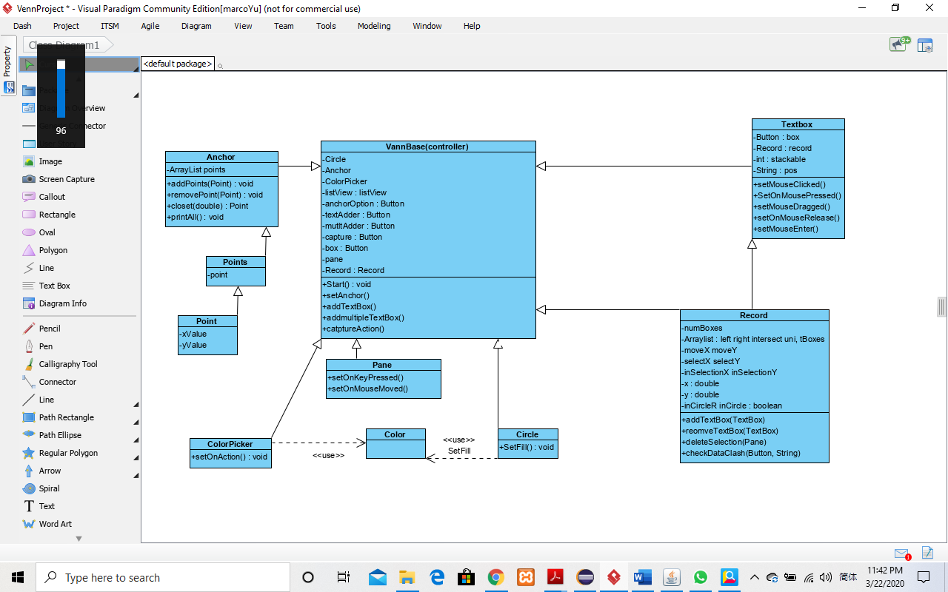

## Sequence setup

When the user want to add textbox, just click the textbox Creator, select the colors they want, and type the text, and then click the + button, then create the textbox and drop textbox into circles, when the textbox move, the popup dialog will ask you to move, delete or cancel, with each textbox will have delete, text color, background color, and font family of text option. If you want to add multiple texbox, you can just select multiple textbox, and move them together. In the process, you can use undo/redo button, to undo/redo the action, you just done. And you can use the arching on button, to the textbox in fixed location, such as left circle, right circle and intersection. When you finish the setup with the textbox, you can export the setup right now with txt file, and all the setup will be saved to the text file, and you want to find the previous setups, you just click the import button, find the previous save text file, and recover the previous setup. If you want to compare the right now setup with previous setup, you just click the compare button, the find the previous saved text file, and save the compare result to a text file. After that you can screenshot the right now setup with a picture.

## Sequence Diagram

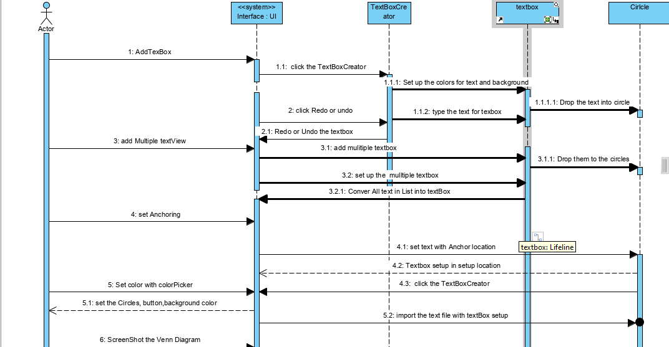

# Maintenance Scenario

In future, if the System is not only used to analyst the text file, we can setup to connect a database to save the every time setup, with database analyst ability, we can easily the analyst the data we saved and optimize our selection. And more option is once we use database, we can create a users/administer login system which make the more security for our system. Or embed our system to another System which will use Big data or more useful function.