Version

F

York university

Lassonde School of Engineering

Venn Diagram Visual Tool User Manual

EECS2311 - Group #17

Venn Diagram Visual Tool User Manual

Table of Contents

Running the application on different Operating Systems 1

Linux 1

Windows 1

Mac OS 1

Customizing Titles 3

How to Customize the Title of the Venn Diagram 3

User Case Scenario: Changing the title to “My Venn Diagram” 3

How to Customize the Circle Titles of the Venn Diagram 5

User Case Scenario: Changing the right circle’s title to “Things I’m Good At” 5

Customizing Venn Diagram Circles 7

How to Customize the Circles’ Color 7

User Case Scenario: Making the left circle’s colour yellow 7

Customizing Text Boxes 9

Adding a Text Box to the Universal List 9

Changing the text of a Text Box 10

User Case Scenario: Making the text of a Text Box “Hello World” 10

Changing the text color of a Text Box 12

User Case Scenario: Making the text color of a Text Box red 12

Changing the color of a Text Box 13

User Case Scenario: Making the color of a Text Box purple 13

Deleting a Text Box 14

User Case Scenario: Deleting a Text Box 15

Undo/Redo options 16

User Case Scenario: Undoing the deletion of a Text Box 16

Dragging a Text Box into a Venn Diagram Section 17

User Case Scenario: Dragging a Text Box into the intersection section of the Venn Diagram 17

Anchoring toggled off 19

Anchoring toggled on 19

User Case Scenario: Dragging 3 Text Boxes into the each of the 3 sections of the Venn Diagram with anchoring toggled on 19

User Case Scenario: Taking a screenshot 22

Using the Multi-Selection options………………………………..24

# Running the application on different Operating Systems

Java must be installed on any OS to run this application.

# Linux

To run the VennApplication.jar on a Linux Operating System:

1. Open the terminal with CTRL + ALT + T.
2. Change directory to where the .**jar** file is located.
3. Type the following command on the terminal: java -jar VennApplication.jar & in order to run the **jar** application in the background.

# Windows

Running the VennApplication.jar is relatively simple:

1. Open the directory where the VennApplication.jar is located.
2. Double-Click on the **VennApplication.jar**, and a new window with the application will pop-up.

# Mac OS

1. Open the directory where the VennApplication.jar is located.
2. Right-click the VennApplication.jar, choose open with/jar Launcher, the application will pop-up.

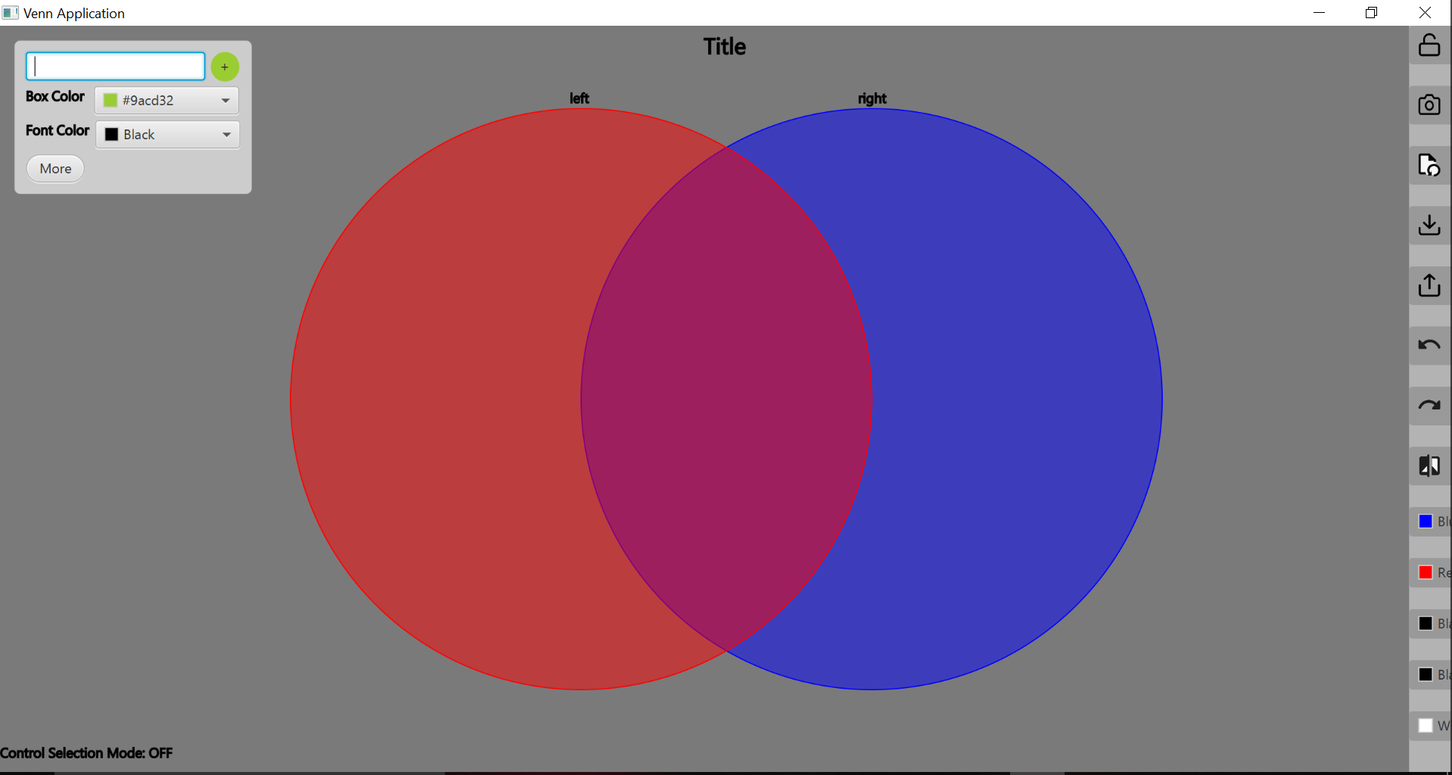

Fig: Default state of the Venn Application after being executed for the first time

# Customizing Titles

# How to Customize the Title of the Venn Diagram

1. Move the mouse cursor above the default Title located at the top of the user interface.

2. Right Click on the title with the mouse cursor.

3. A Text Editor Interface will open where you can change the text to your preferred title.

4. Click ‘OK’.

# User Case Scenario: Changing the title to “My Venn Diagram”

1. Move the mouse cursor above the title located at the top of the user interface.

2. Right Click on the title with the mouse cursor.

3. A Text Editor Interface will open, change the text box to “Venn Diagram Demo”.

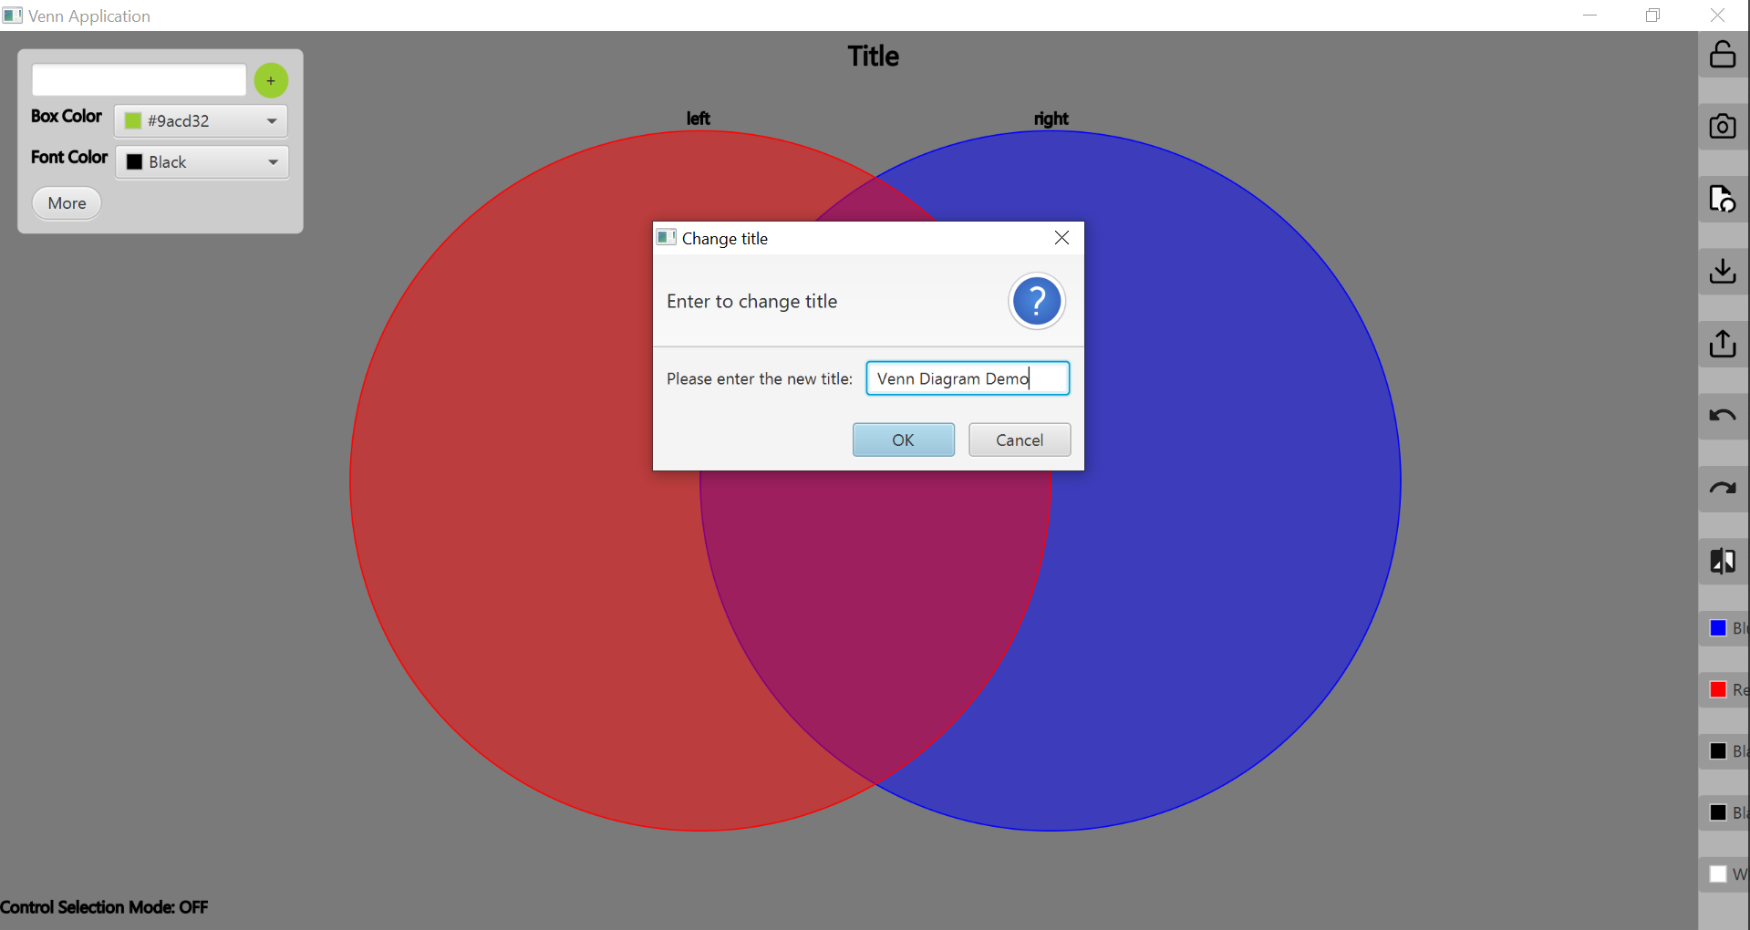

Fig: After right-clicking on the default “Title”

4. Click ‘OK’.

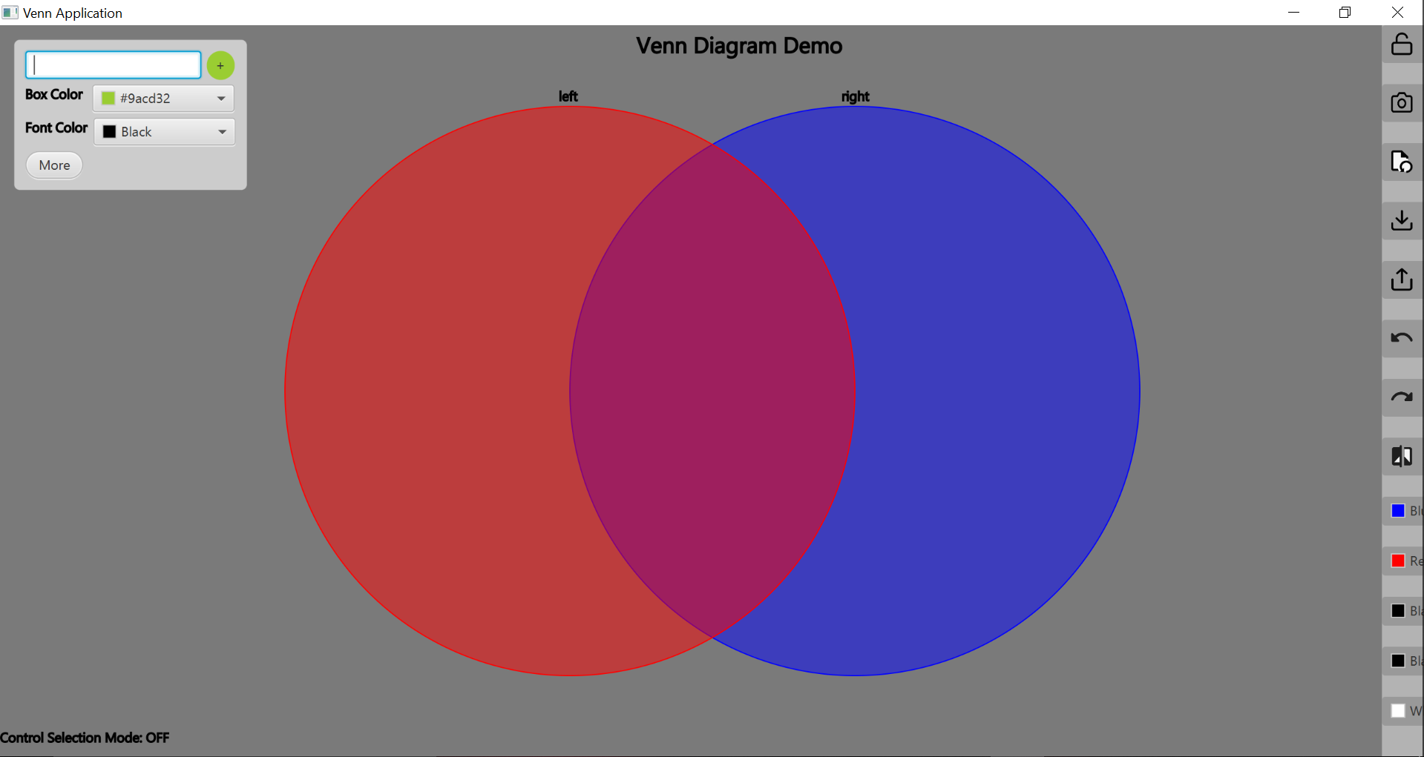

Fig: New title name taking effect after clicking “OK”

# How to Customize the Circle Titles of the Venn Diagram

1. Move the mouse cursor above one of the circle titles located above the Venn diagram circles.

2. Right Click on the text with the mouse cursor.

3. A Text Editor Interface will open where you can change the text to your preferred title of that circle.

4. Click ‘OK’.

# 

# User Case Scenario: Changing the right circle’s title to “Things I’m Good At”

1. Move the mouse cursor above the right circle’s title located above the Venn diagram’s right circle.

2. Right Click on the text with the mouse cursor.

3. A Text Editor Interface will open, change the text of the circle title to “Left Circle Demo”.

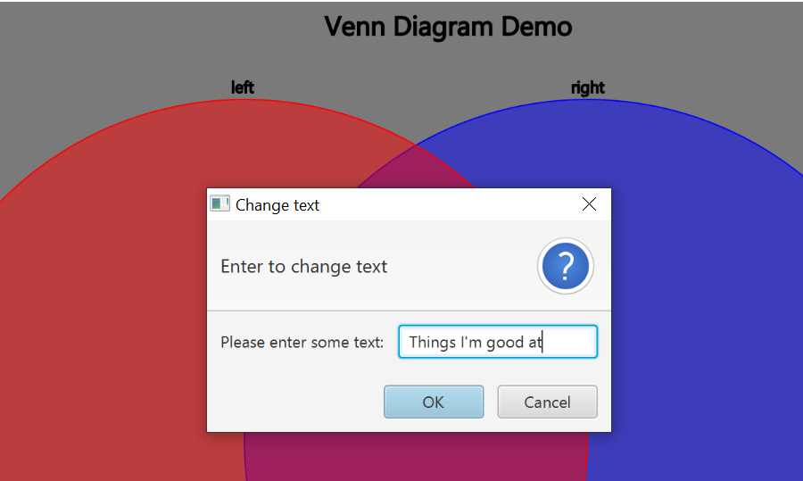

Fig: After right-clicking on the right circle’s title ‘right’

4. Click ‘OK’.



Fig: New title for the right circle taking effect after clicking “OK”

The same procedure could be repeated in order to change the title name for the left circle as well.

Customizing Venn Diagram Circles

# How to Customize the Circles’ Color

# 1. Select the left or right circle Color Pallet buttons located in the menu options on the right side of the screen.

# 2. A selection of colors will open, click your preferred color for the circle.

# User Case Scenario: Making the left circle’s colour yellow

# Click the ‘Left circle color’ button located in the menu options on the right side of the screen.

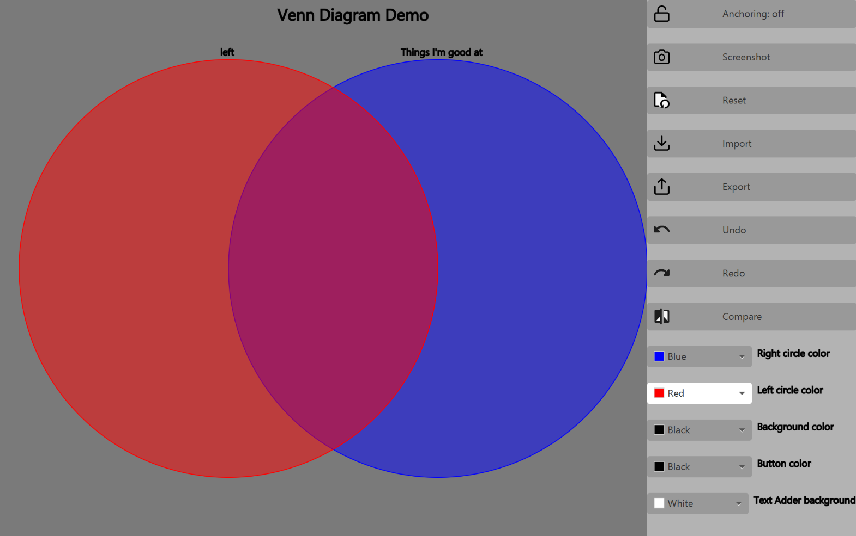

Fig: Color boxes located in the menu options on the right side of the screen

# 2. A selection of colours will open.

3. Click on ‘Custom Color…’ and pick a yellow color

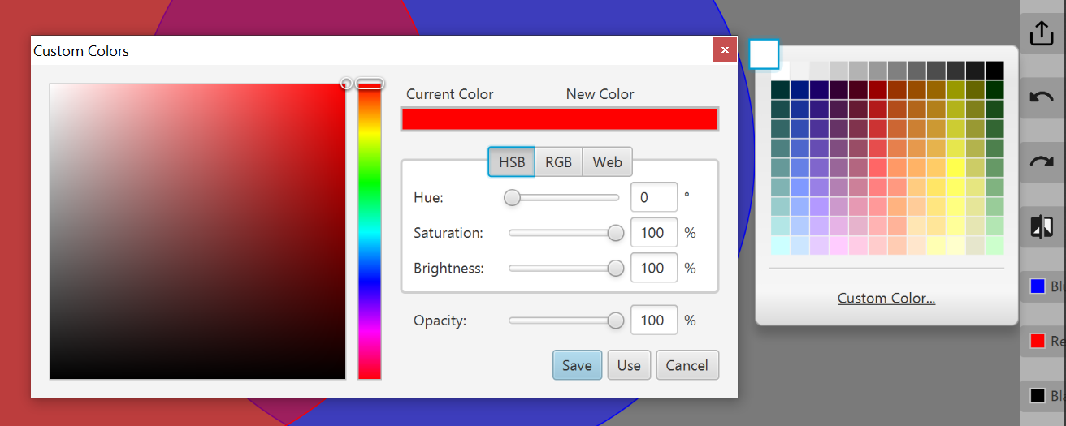

Fig: Selection of colors to choose from, after clicking on each of the boxes and then Custom Color option

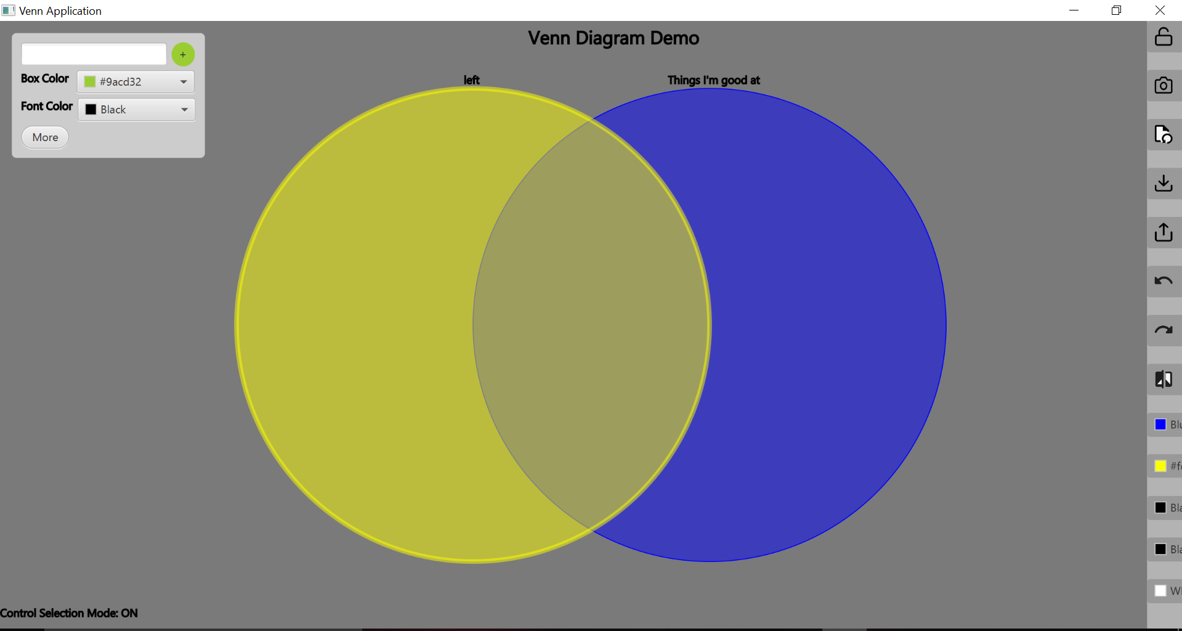

Fig: New color applied to the left circle after selection.

The same procedure could be repeated in order to change the color for the right circle as well.

Customizing Text Boxes

# Adding a Text Box to the Universal List

1. Enter relevant information for the text box to hold and press the “+” when done

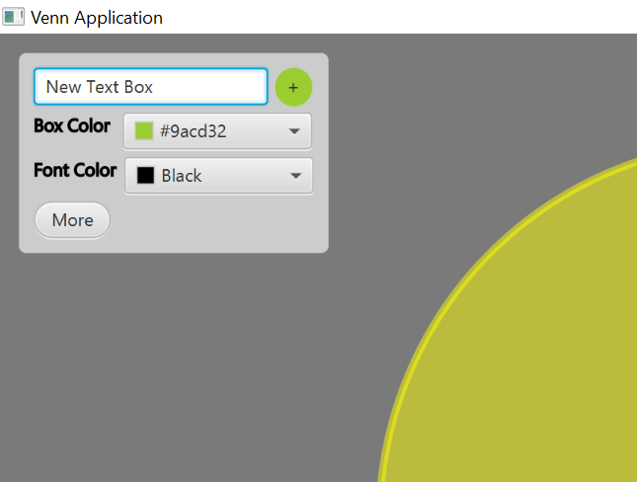

2. Text Box is added to Universal List, located at the left side of the window.

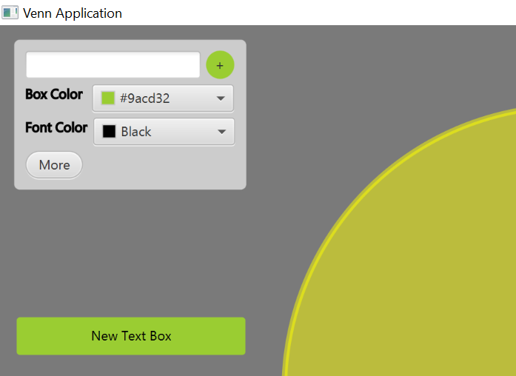

# Changing the text of a Text Box

1. Hover on a Text Box (if hover options don’t show up, press “c” to ensure hover options weren’t locked).

2. Click on the “T” option.

3. Modify Text to user preference in the text editor window that pops up.

4. Click ‘OK’

# User Case Scenario: Making the text of a Text Box “Hello World”

1. Hover on a Text Box (if hover options don’t show up, press “c” to ensure hover options weren’t locked).

2. Modify Text to “Hello World” in the text editor window that pops up.

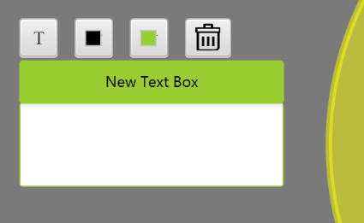

Fig: After hovering on the Text Box

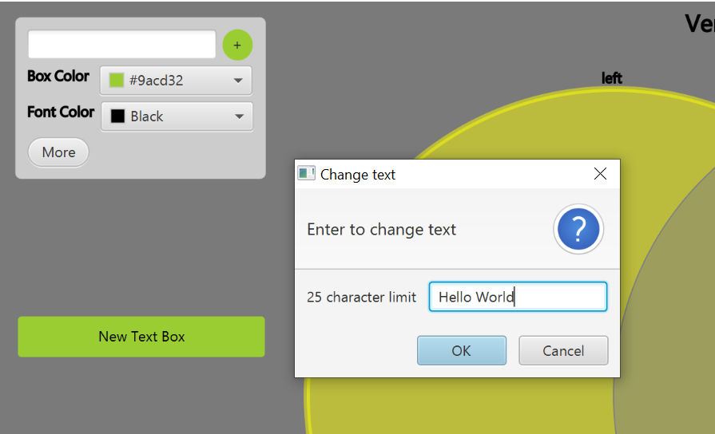

Fig: After clicking on the “T” option

3. Click ‘OK’

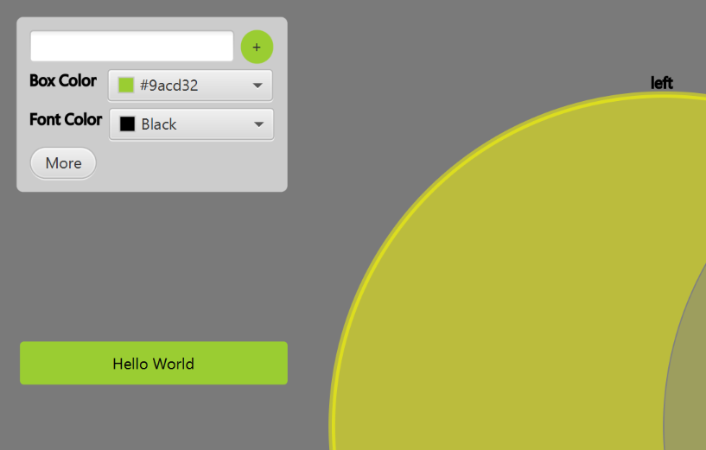

Fig: After clicking “OK”, the text of the text box has changed to ‘Hello World’

# Changing the text color of a Text Box

1. Hover on a Text Box (if hover options don’t show up, press “c” to ensure hover options weren’t locked).

2. Click on the left color block option.

3. Pick and click a color in the color pallet window that pops up.

# User Case Scenario: Making the text color of a Text Box red

1. Hover on a Text Box (if hover options don’t show up, press “c” to ensure hover options weren’t locked).



Fig: After hovering on the Text Box

2. Click on the left color block option.

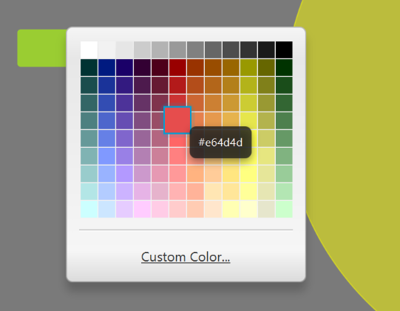

Fig: After clicking on the left color block option

3. Pick and Click on red



Fig: After clicking red, the text color of the text box has changed to red

# Changing the color of a Text Box

1. Hover on a Text Box (if hover options don’t show up, press “c” to ensure hover options weren’t locked).

2. Click on the right color block option.

3. Pick and click a color in the color pallet window that pops up.

# User Case Scenario: Making the color of a Text Box purple

1. Hover on a Text Box (if hover options don’t show up, press “c” to ensure hover options weren’t locked).

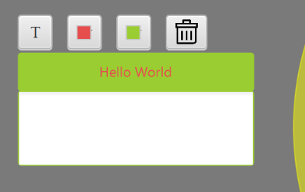

Fig: After hovering on the Text Box

2. Modify Text to “Hello World” in the text editor window that pops up.

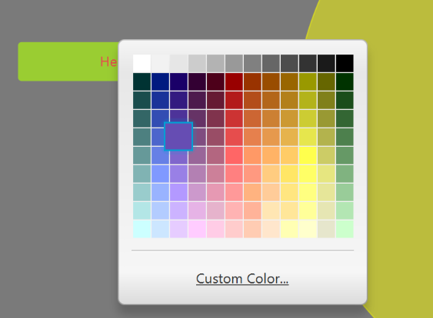

Fig: After clicking on the right color block option

3. Pick and Click on purple



Fig: After clicking purple, the color of the text box has changed to purple

# Deleting a Text Box

1. Hover on a Text Box (if hover options don’t show up, press “c” to ensure hover options weren’t locked).

2. Click on the trash can.

# User Case Scenario: Deleting a Text Box

1. Hover on a Text Box (if hover options don’t show up, press “c” to ensure hover options weren’t locked).

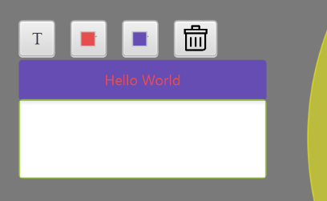

Fig: After hovering on the Text Box

2. Click on the trash can

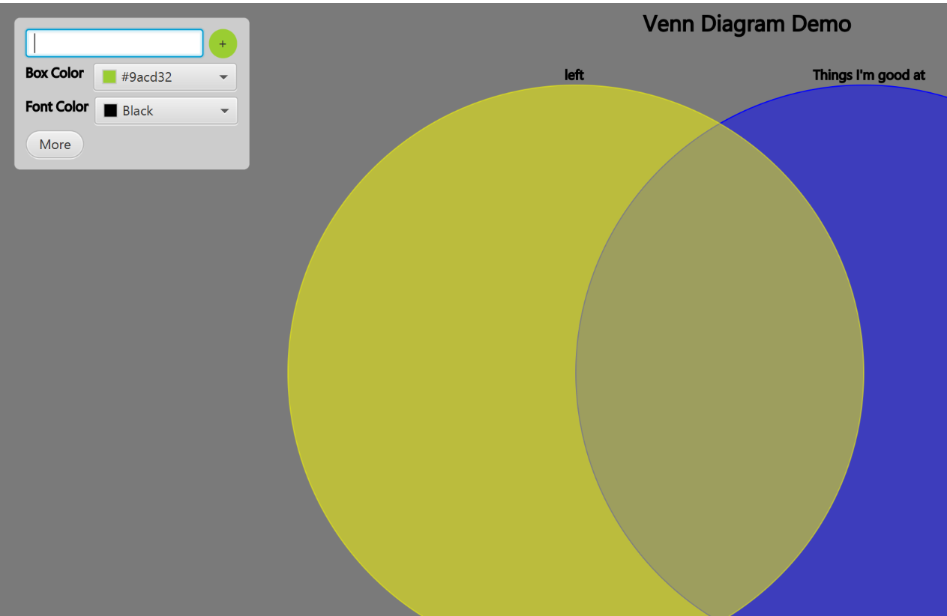

Fig: After clicking the trash can, the text box has been deleted

# Undo/Redo options

1. Click the undo/redo buttons located in the menu options on the right side of the screen.

2. Undo/Redo supports most operations such as textbox deletion, circle color change, title change, etc... but isn’t perfect.

# User Case Scenario: Undoing the deletion of a Text Box

1. Click the undo/redo buttons located in the menu options on the right side of the screen. (A text Box was deleted from a previous use case scenario)

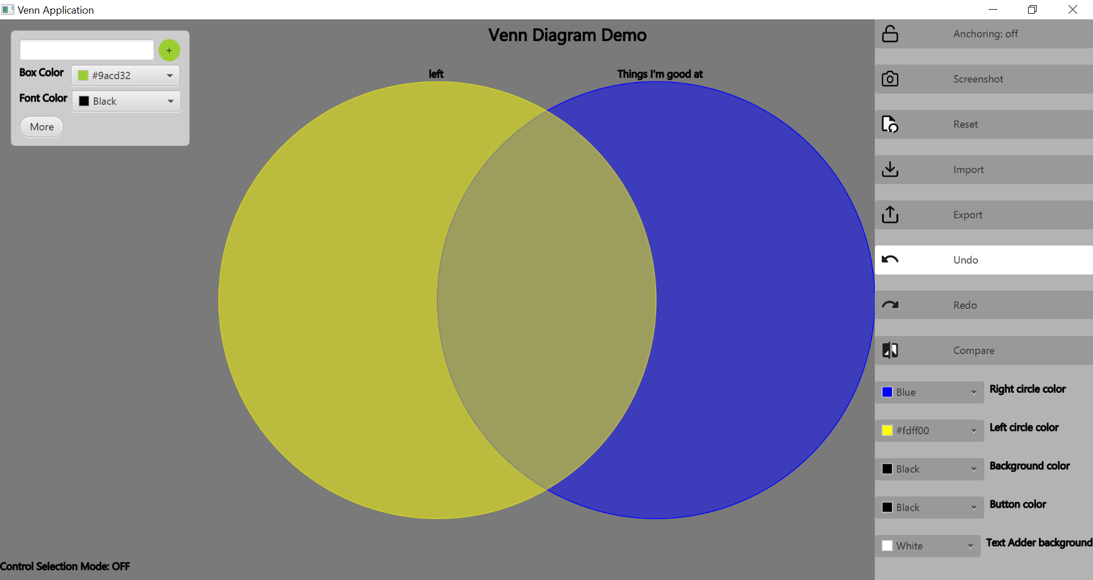

Fig: Hovering over the Undo option in the menu options on the right side of the screen

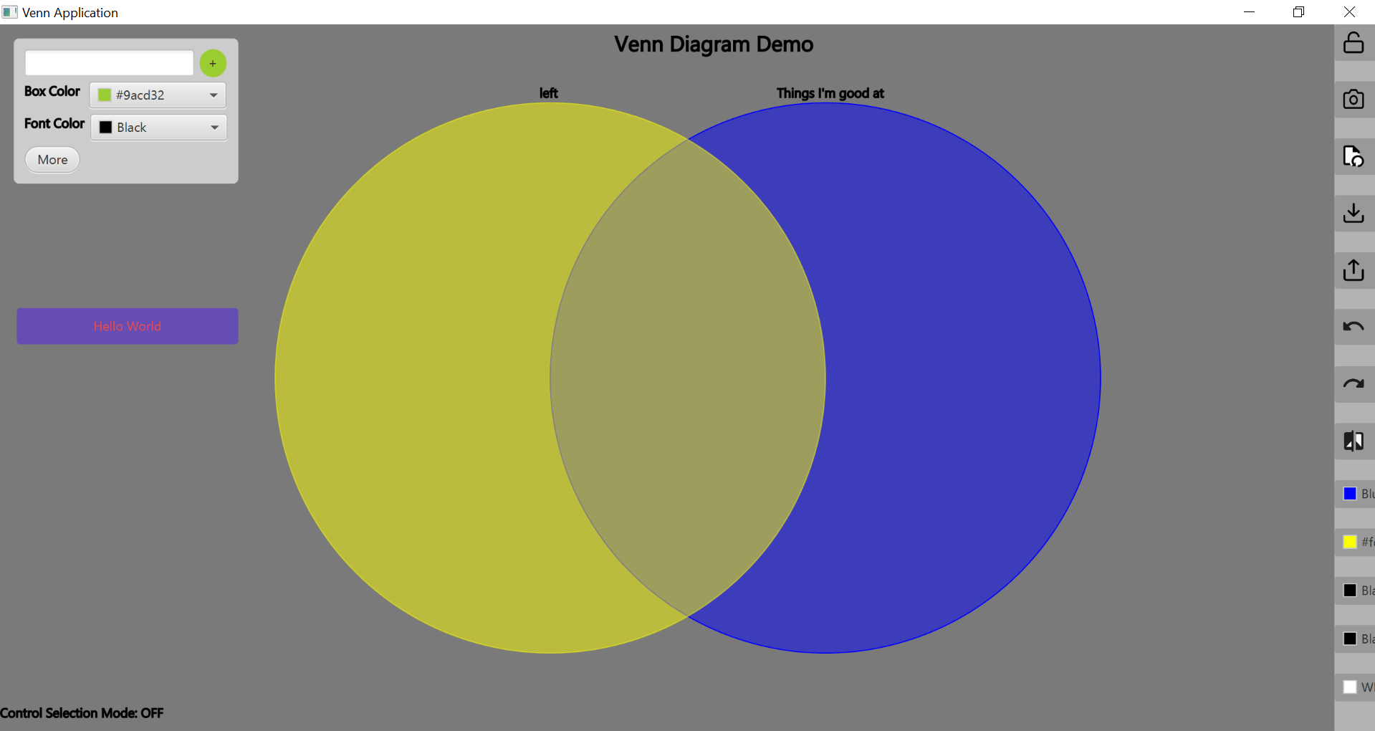

Fig: After clicking the undo button; the Text Box deletion has been undone

# Dragging a Text Box into a Venn Diagram Section

1. Select a Text Box with the cursor.

2. Keep selecting the Text Box while dragging it over to one of the three Venn Diagram Sections.

3. Drop the Text Box.

# User Case Scenario: Dragging a Text Box into the intersection section of the Venn Diagram

1. Select a Text Box you want to drag over with the cursor.

2. Keep selecting the Text Box while dragging it over to the middle section, located between the two Venn Diagram circles, of the Venn Diagram.

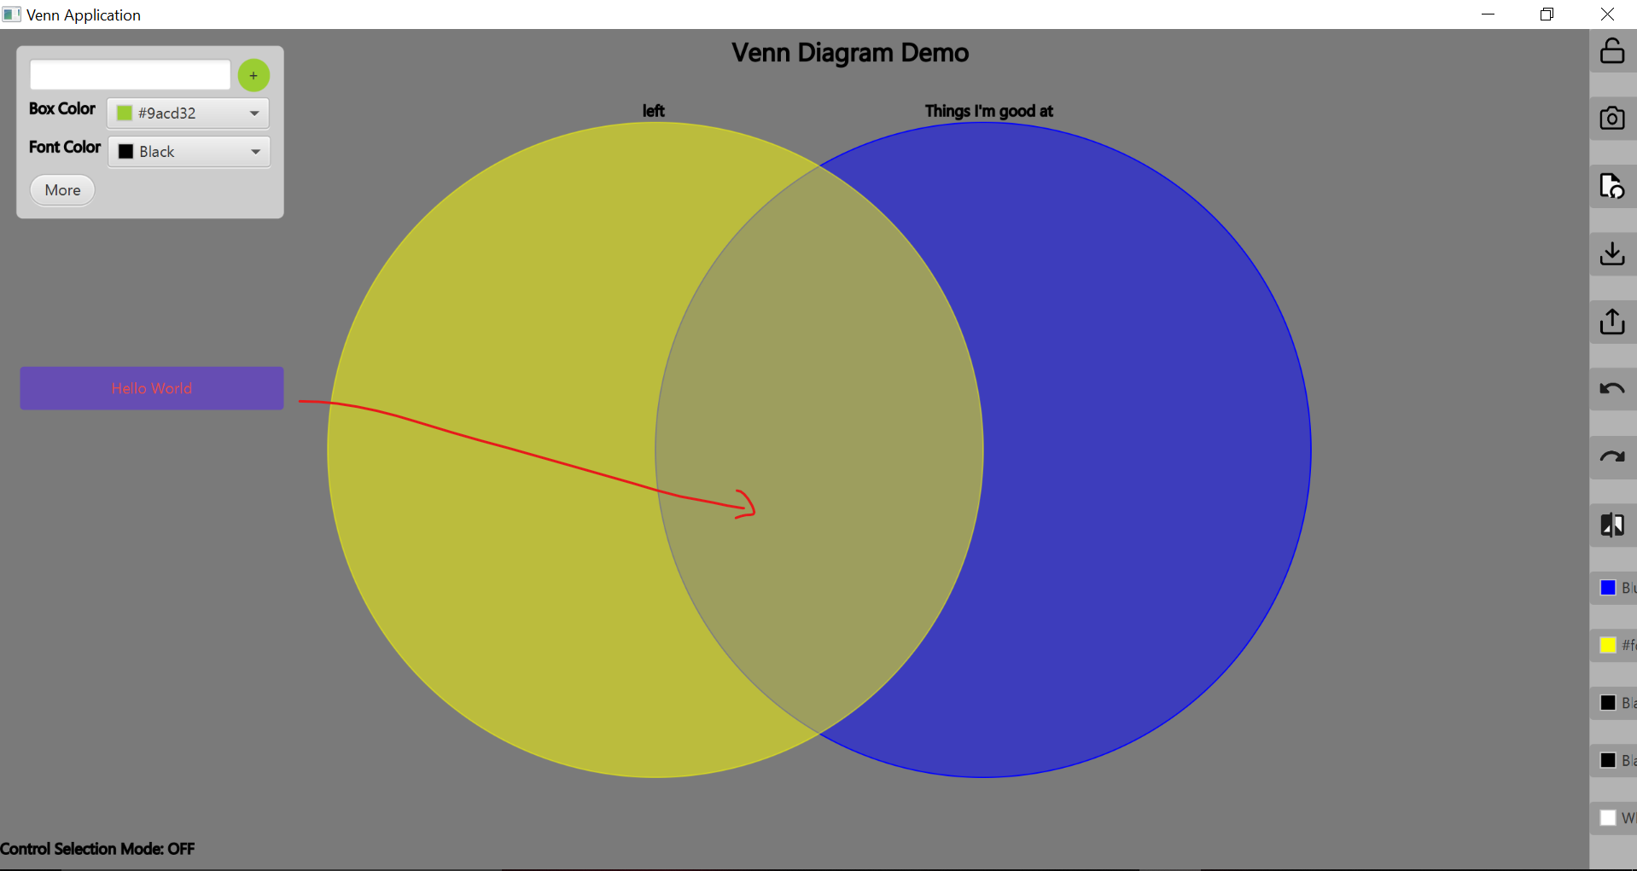

Fig: Keep dragging the box to the desired location.

3. Drop the Text Box.

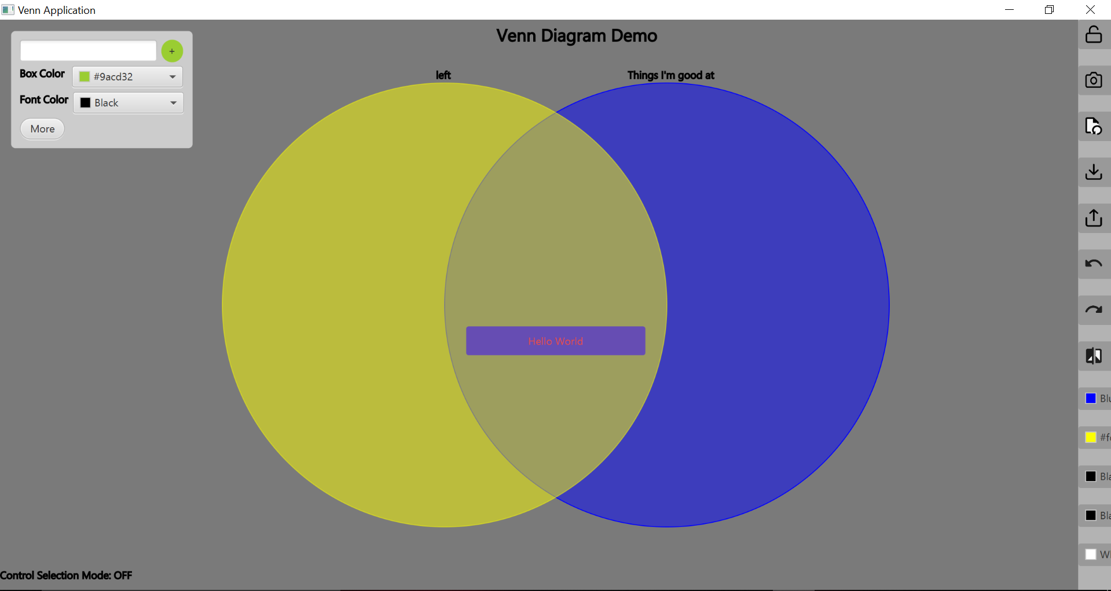

Fig: After dragging and dropping text box to desired location

Using the ‘Anchoring’ Button

The anchoring button is used to snap the text boxes into preprogrammed positions when dragged within the circles.

Anchoring will be off by default and can be toggled on or off depending on the user’s need.

# Anchoring toggled off

When anchoring is toggled off, the following features are implemented:

1. Text boxes will remain wherever the user dragged them.
2. No limitations will be present when dragging text boxes, even in potentially unfavourable positions.
3. Window can be resized and the Venn diagram will do its best to accommodate the resizing process. The diagram will not look good in a medium to small size so the user is advised to keep the resizing relatively big and with consistent dimensions.

# Anchoring toggled on

When anchoring is toggled on, the following features are implemented:

1. Text boxes snap to the closest preprogrammed positions when dragged within the circles.
2. Only a certain number of text boxes can be shown at any given time (11 in either circles and 6 in the intersection). Text boxes will start overlapping if the user attempts to drag a text box close to another text box.
3. Application window will remain maximized.

# User Case Scenario: Dragging 3 Text Boxes into the each of the 3 sections of the Venn Diagram with anchoring toggled on

1. Click on the ‘Anchoring’ button located in the menu options on the right side of the screen.

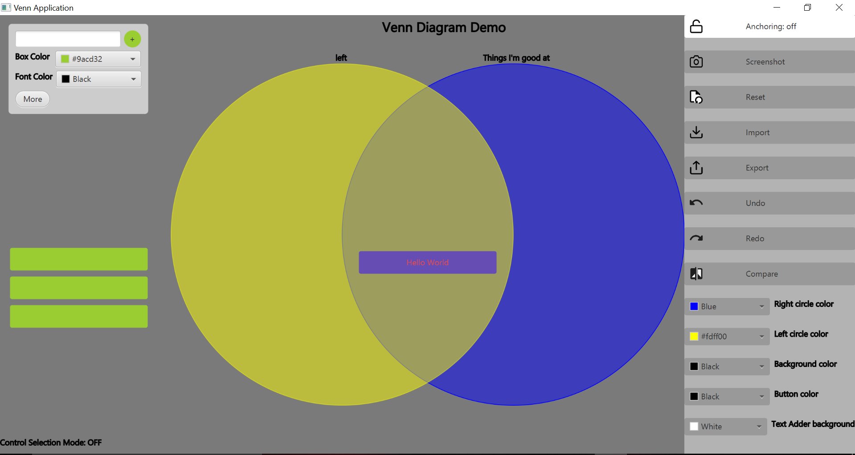

Fig: After creating 3 Text Boxes without a title and hovering over the anchoring button

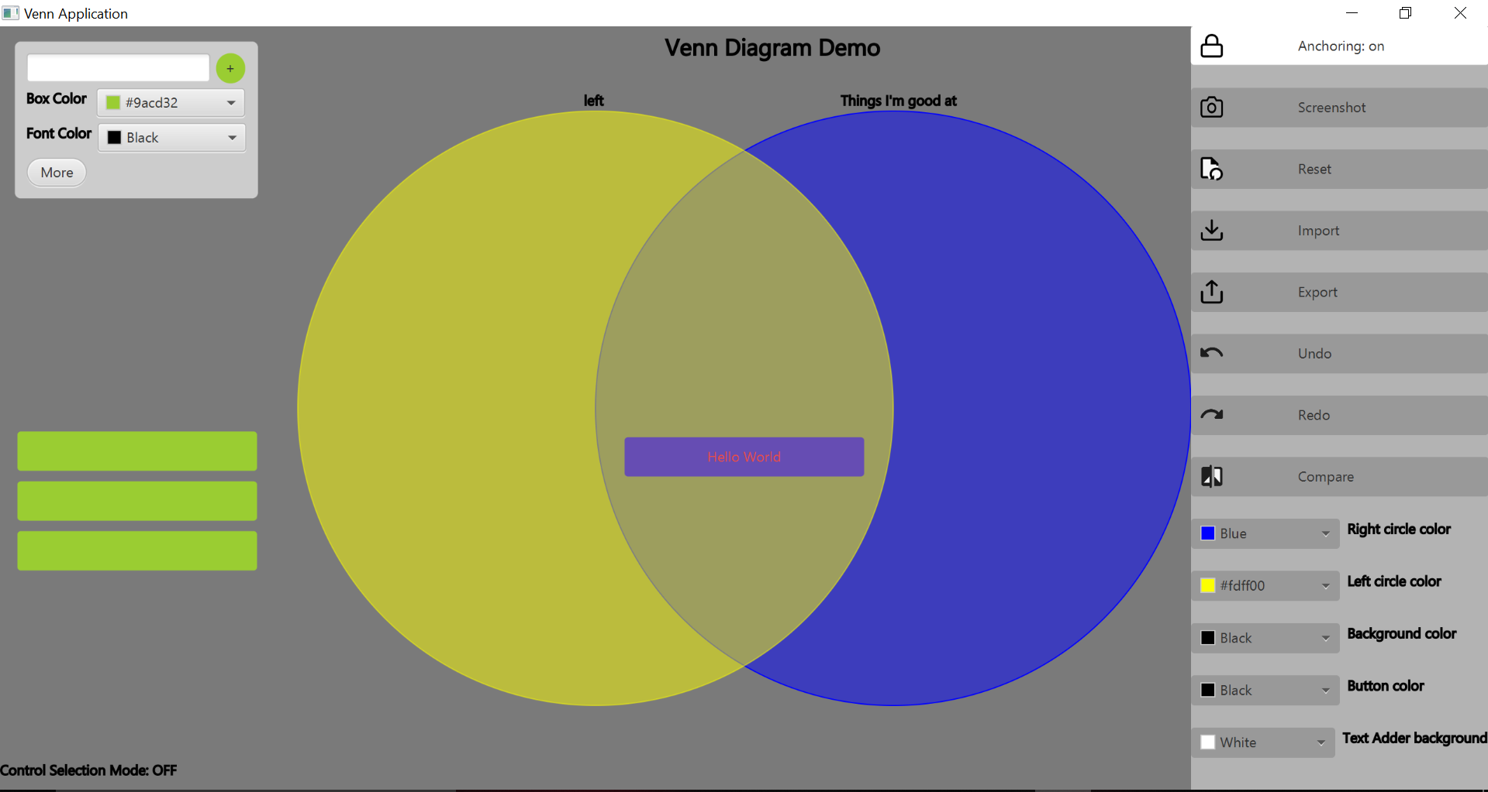

Fig: Clicking the Anchoring button to toggle Anchoring on

1. Drag the three boxes on the left into the left, intersection and the right circles. The text boxes will snap into place.

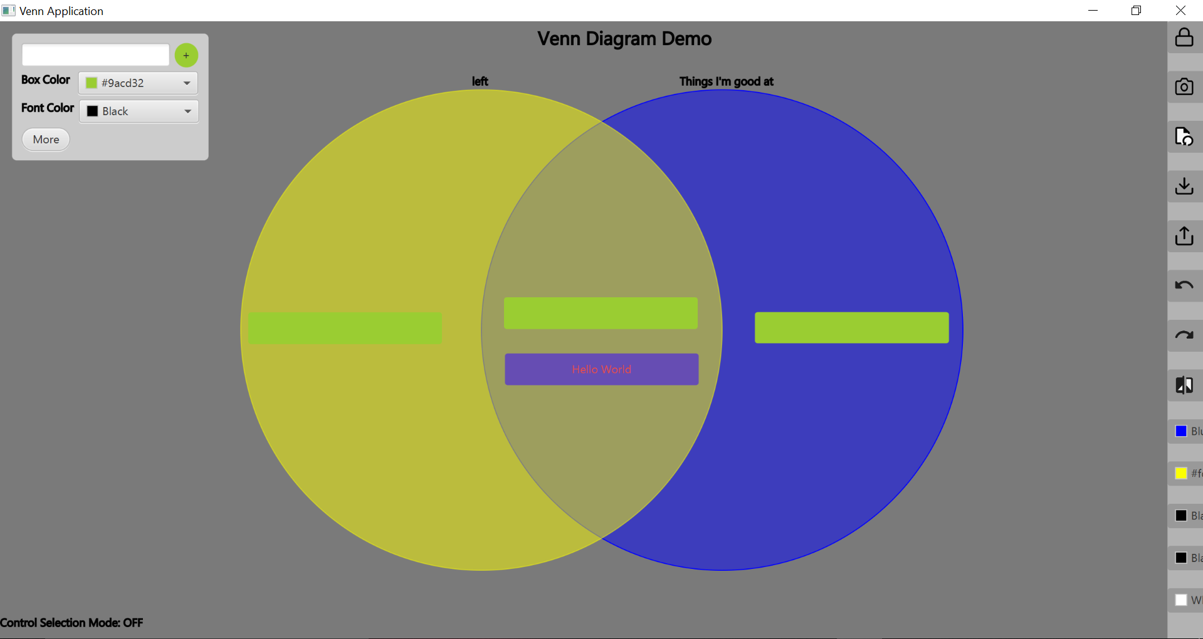

Fig: After dragging the three text boxes

Taking a screen shot

A screenshot can be taken anytime by clicking the ‘Screenshot’ button. This button takes a screen shot of the titles and Text Boxes only. The screenshot will be saved as a png image wherever the user prefers.

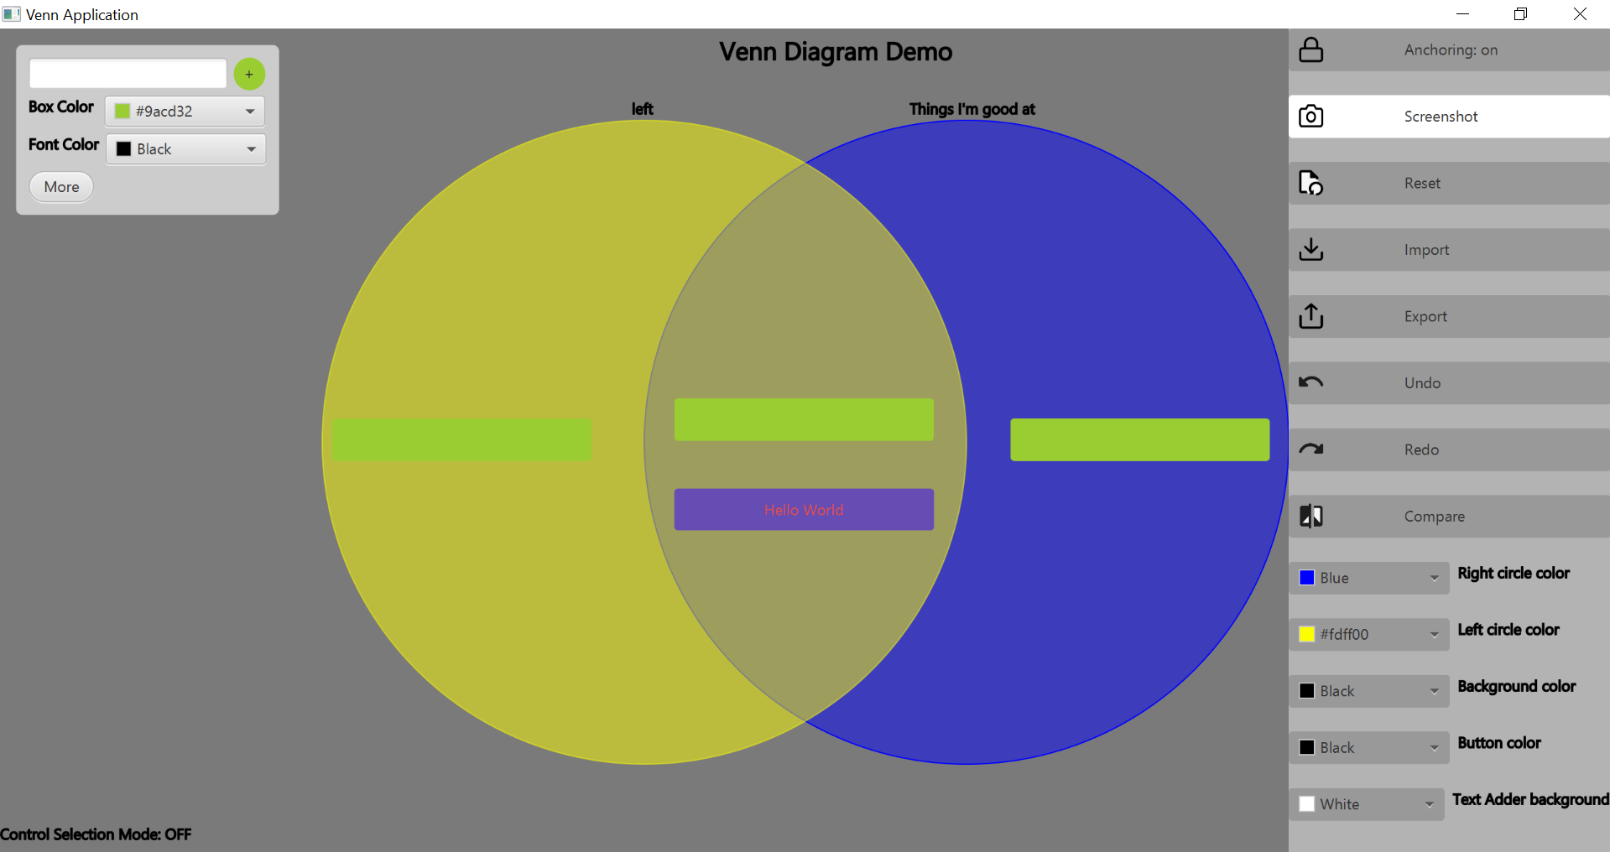

Fig: Hovering over the screenshot button

# User Case Scenario: Taking a screenshot

1. Click on the ‘Screenshot’ button located in the menu options on the right side of the screen.

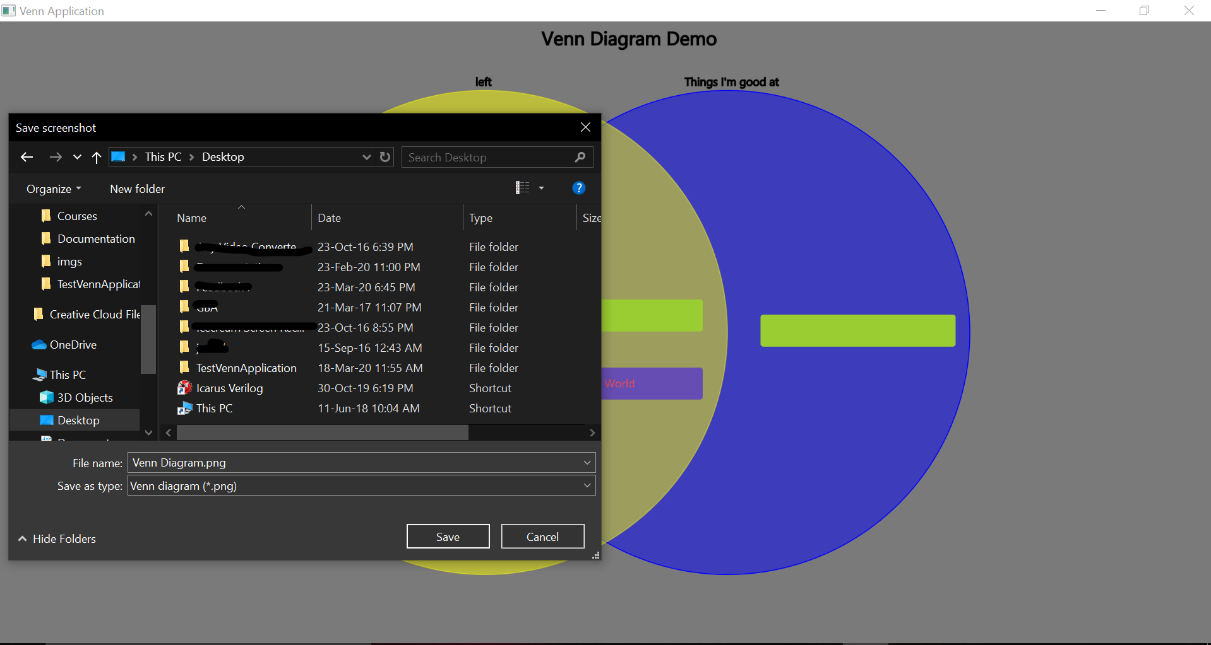

Fig: After clicking the screenshot button on a windows 10 OS

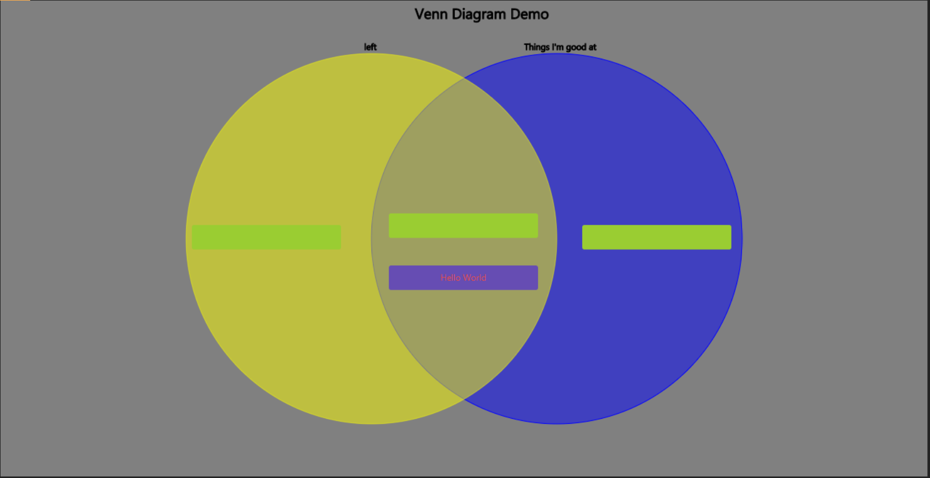

Fig: The screenshot that was saved and stored

Using the Multi-Selection options

There are two ways to select multiple Text Boxes. For the standard selection, the user can just click and drag the mouse around the Text Boxes they wish to either move or delete and then just click the option in the popup window.

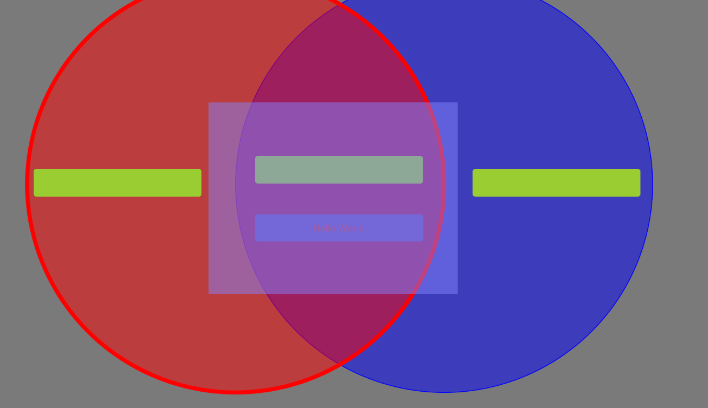

Fig: clicking and dragging the mouse around the Text Boxes

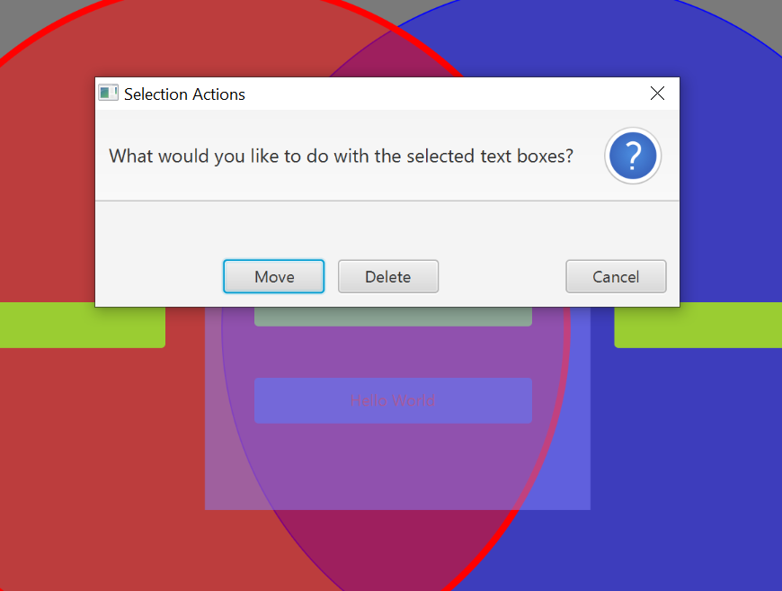

Fig: popup window

The other way to select and move multiple Text Boxes is by pressing control to toggle control selection mode, click on all Text Boxes, and then move any of the selected Text Boxes.

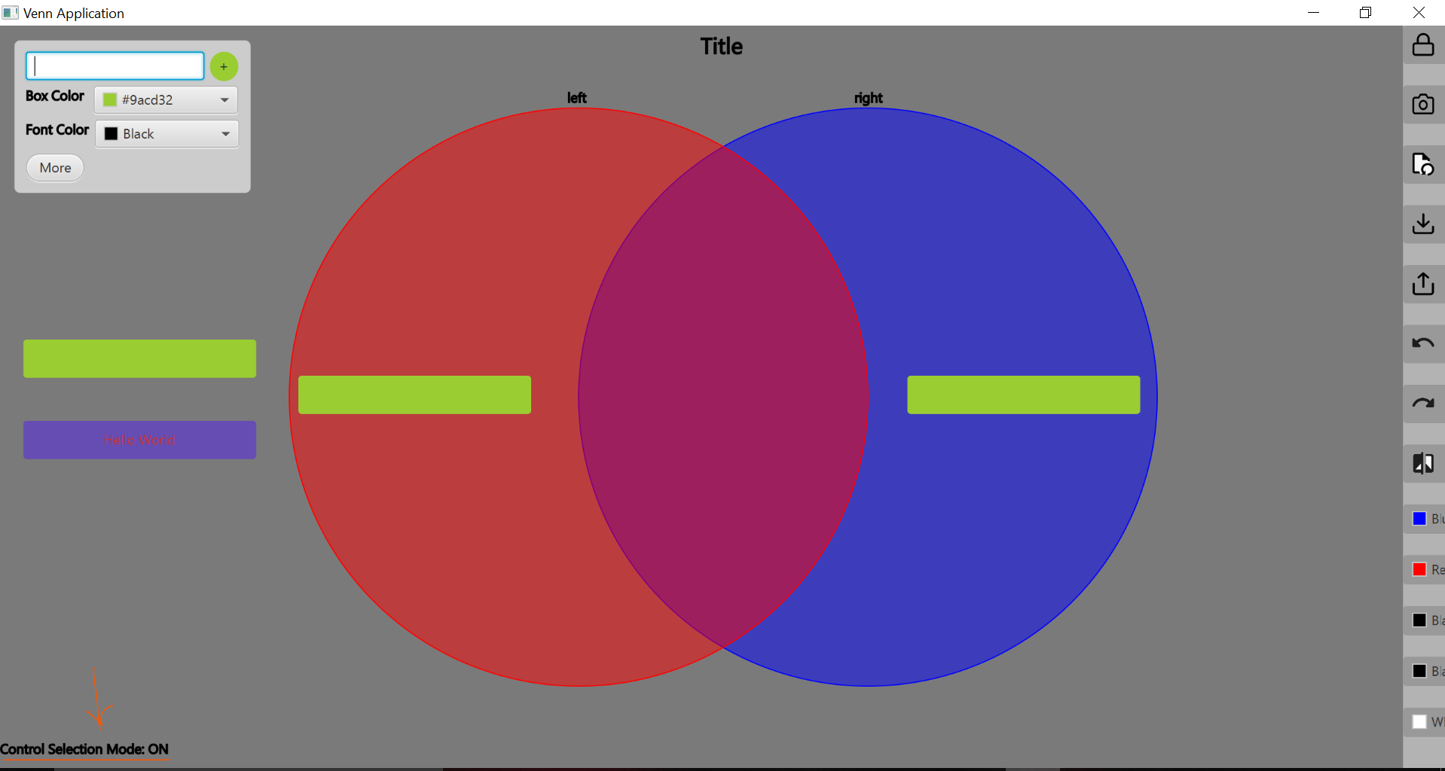

Fig: Control Selection Mode toggled on when control was pressed



Fig: The two Text Boxes highlight after clicking in control selection mode

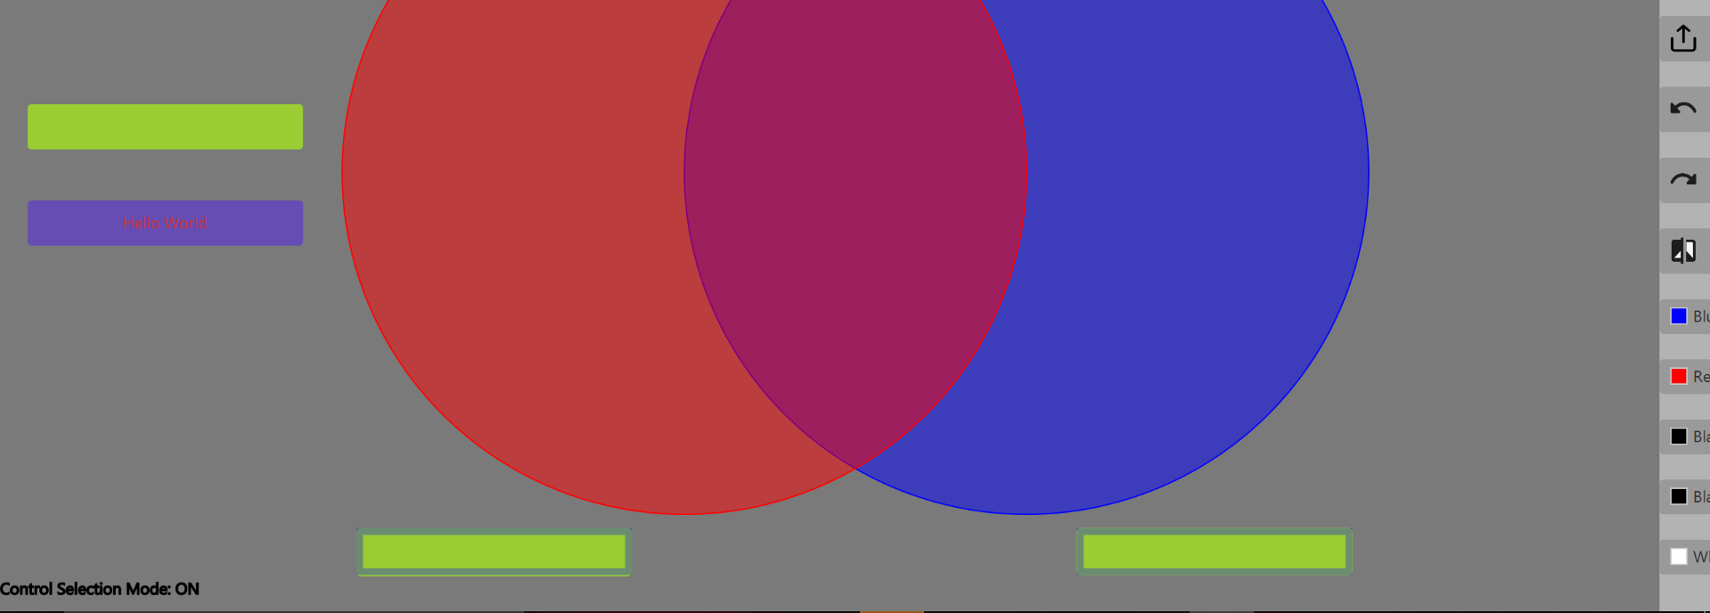

Fig: Moving the Text Boxes down together