The game of pong

This program is implementatios of game of pong on MZ_APO hardware. It’s not exactly the original, just inspired.

For controls refer Manual.

Structure of the program:

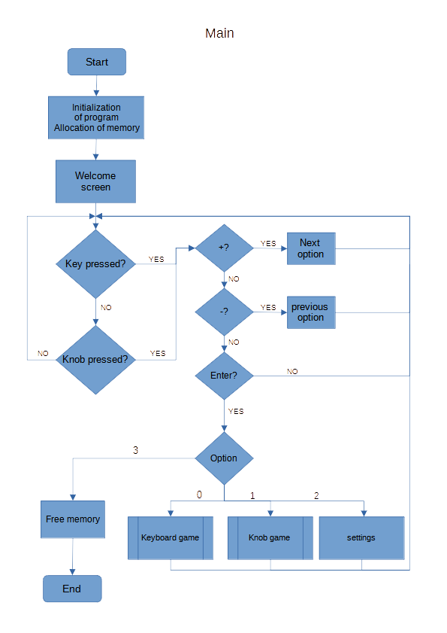

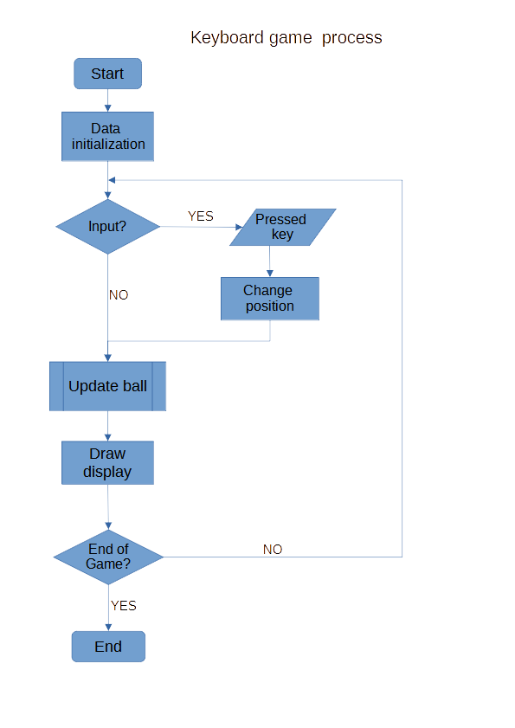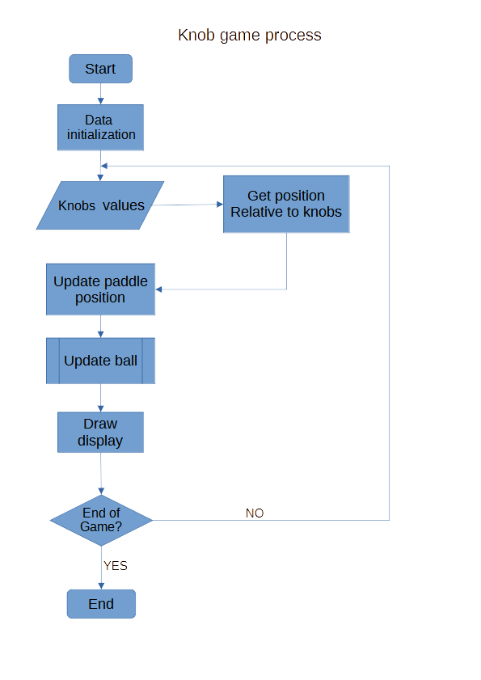

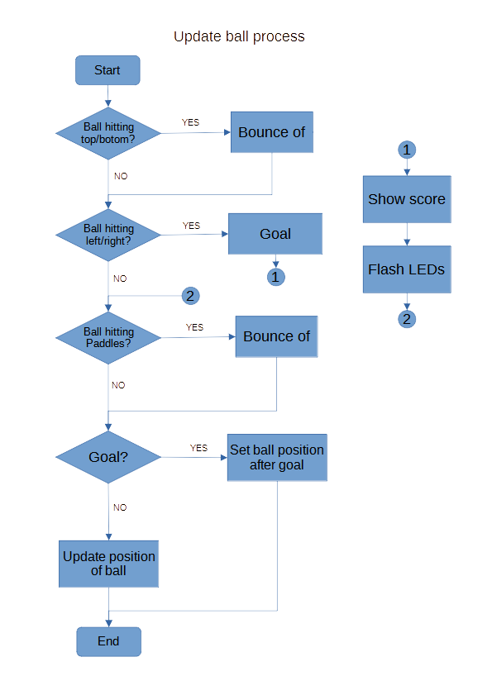

Compilation:

For compiling the program use given Makefile.

You have to be connected to MZ_APO.

You have to know the adress of MZ_APO board – IP adress.

Run the program with terminal command:

TARGET_IP = ‚**board IP**’ make run