## Step 1

RolePlayV10.sln

_name is an instance field of Warrior

Name is a property of Warrior

public Warrior() is the constructor of Warrior

## Step 2

It creates two warriors and prints their names

## Step 3 & 4

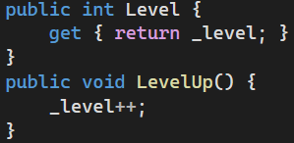

## Step 5

