## Step 1

DiceGame.sln

## Step 2

There are two die instances and they both get created in the cups constructor getting a random value from their own constructor

## Step 3

## Step 4

We would need to make another die instance field, create it in the constructor, count it within total value and add it to the shake method

## Step 5

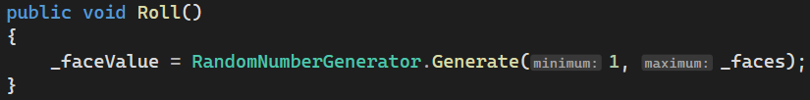

## Step 6

  
