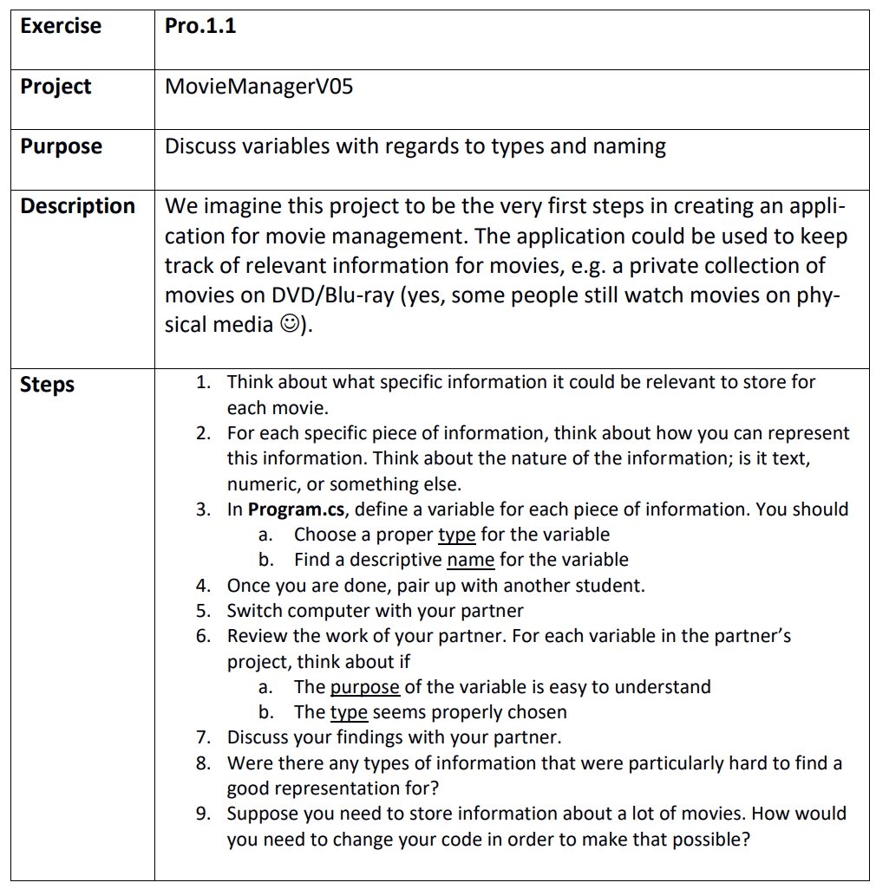

## Step 1

We could store the following:

* The title of the movie
* Which director made it
* Whether it won an Oscar
* Its duration in minutes
* It’s IMDB rating
* It’s year of production

## Step 2

How we can represent the information:

* The title is text
* The director is either a name or a more detailed object
* Whether it won an Oscar is either true or false
* Its duration in minutes is an integer number or maybe a decimal number
* Its IMDB rating is a decimal number
* Year of production is an integer number but might represented as text in some cases

## Step 3

MovieManagerV05.sln