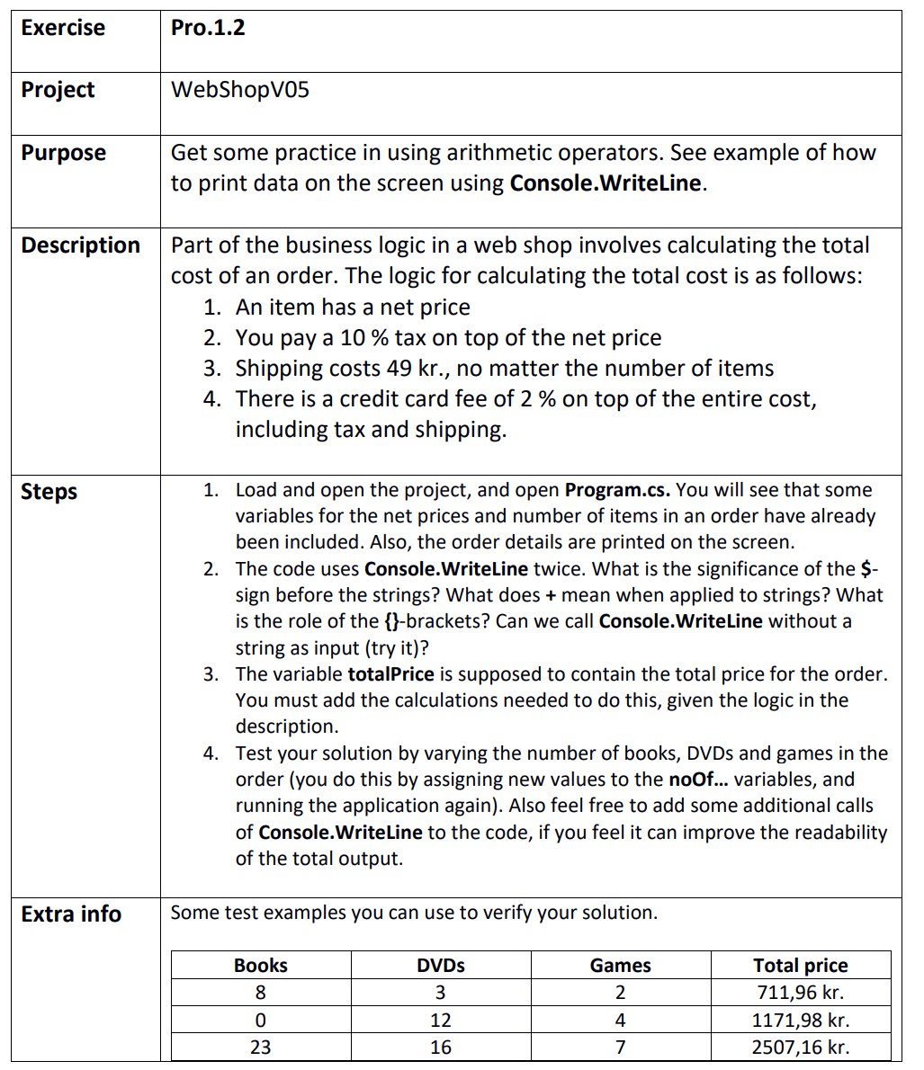

## Step 1

WebShopV05.sln

## Step 2

The significance of ‘$’ before the strings is to let the program know that string interpolation is used (enables variables inside of the strings)

The ‘+’ between strings means that we use string concatenation (if one of the sides Is not a string it will be converted and then the two strings will be put together as one string)

The role of the ‘{}’ brackets is to indicate that a variable or value is used inside a string with ‘$’ in front so it knows where to interpolate

Console.WriteLine also takes other inputs than string and will try to convert the value to a string

## Step 3

WebShopV05.sln

## Step 4

Test:







Extra writeline:

