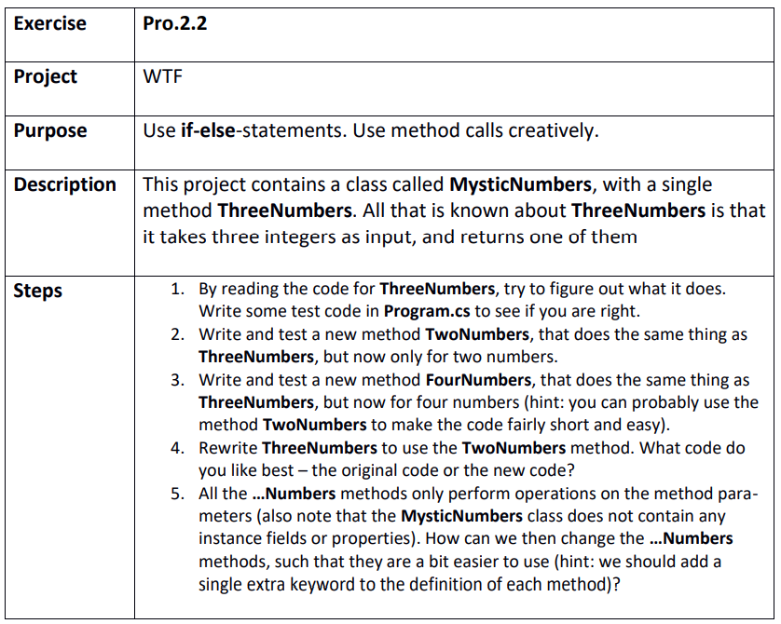

Step 1
WTF.sln
ThreeNumbers seem to compare alle three numbers and return the greatest of them
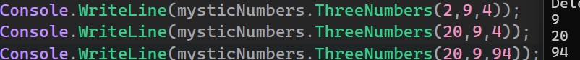
That was right

Step 2
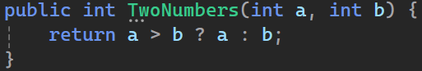

Step 3
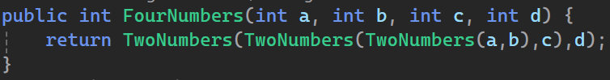

Step 4
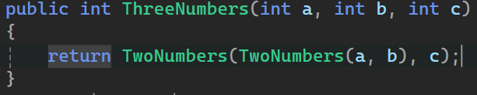
I like this version

Step 5
We should make the methods static since they don’t have any instance specific values

