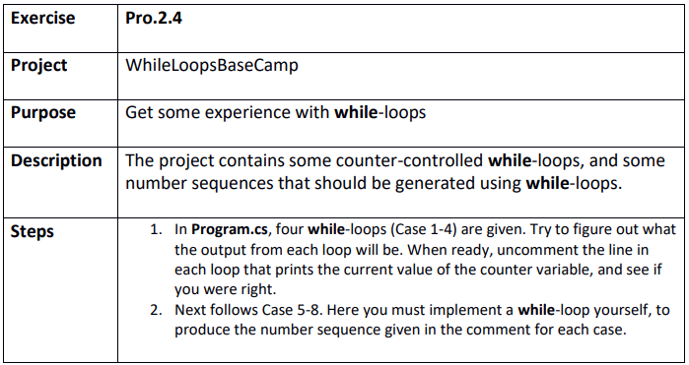

Step 1
WhileLoopsBaseCamp.sln
Case 1 guess: 1, 3, 5, 7, 9, 11, 13, 15, 17, 19
Case 1 answer: 1, 3, 5, 7, 9, 11, 13, 15, 17, 19
Case 2 guess: 1, 2, 4, 8, 16
Case 2 answer: 1, 2, 4, 8, 16
Case 3 guess: 15, 16, 17, 18, 19
Case 3 answer: 15, 16, 17, 18, 19
Case 4 guess: 10, 9, 8, 7, 6, 5, 4, 3, 2, 1, 0
Case 4 answer: 10, 9, 8, 7, 6, 5, 4, 3, 2, 1, 0

Step 4

