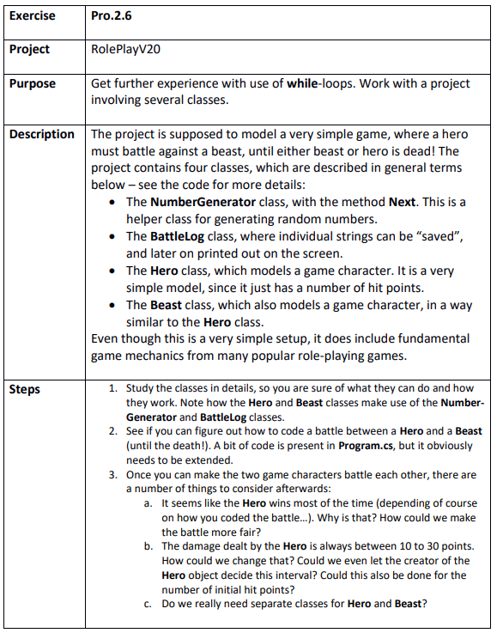

Step 1
RolePlayV20.sln

