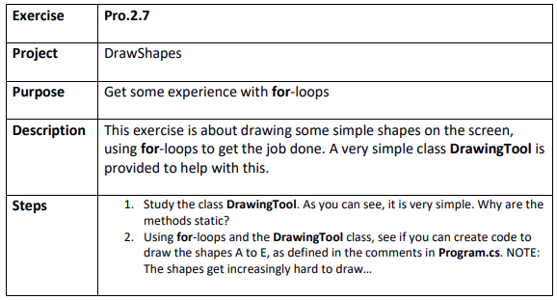

Step 1
DrawShapes.sln

Step 2

