NOTE: You can also test the program on provided data.txt files which can be found in “3 waveguides” and “4 waveguides” folders.

1: From the cell selection window on the left, select the waveguides you want to find length of.

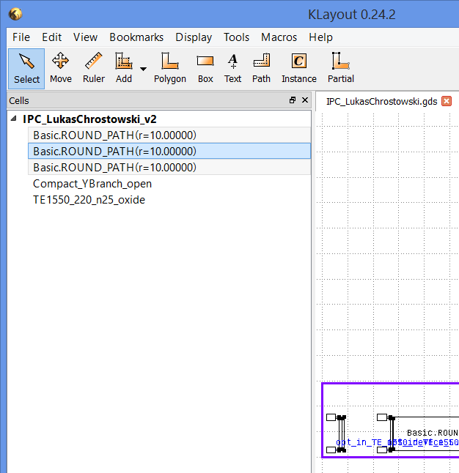

2: Right click and select save selections As

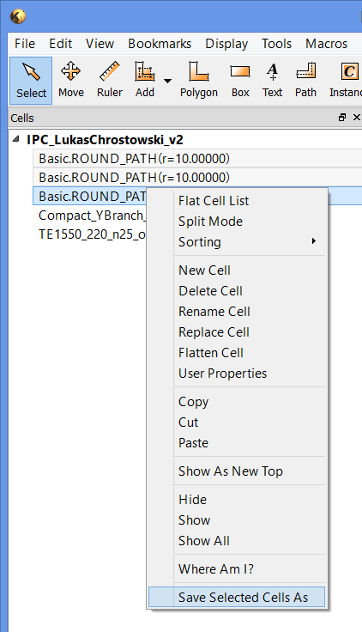

3: Save it as data.txt in the same folder as the program

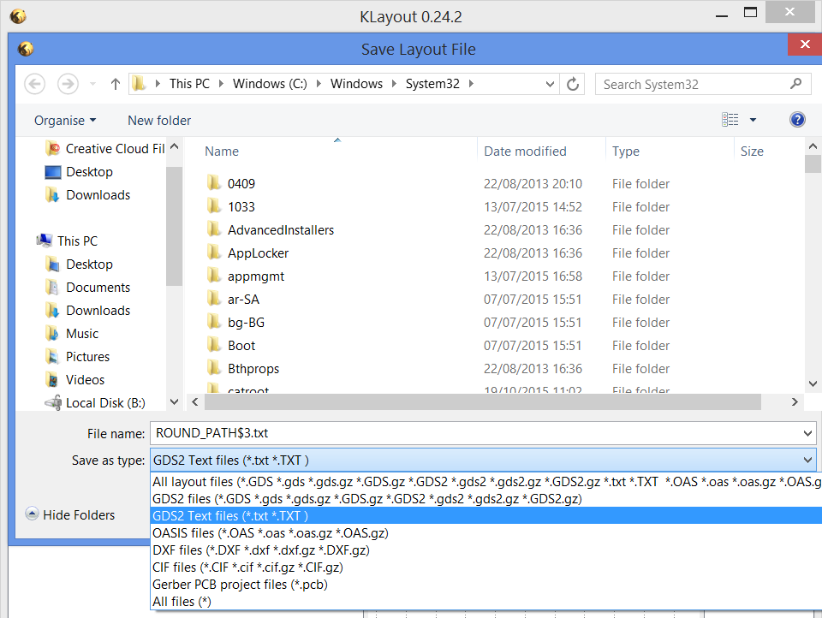

4. Run the program

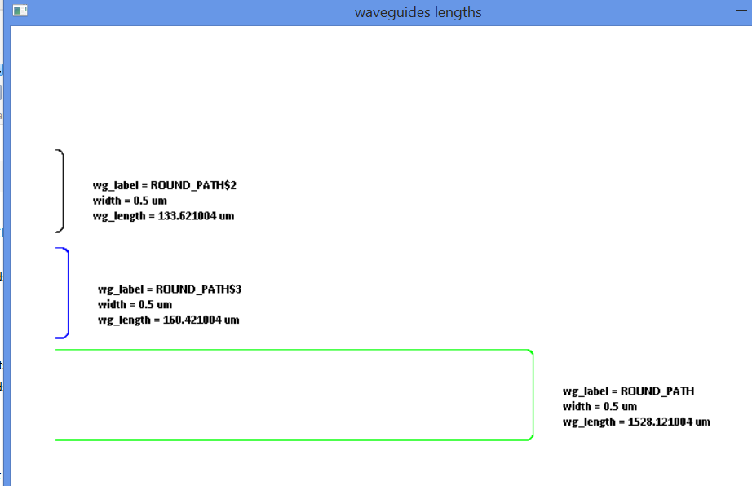

In case you are confused about which waveguide is which, make a note of the waveguide label and match it with the instance or path properties in klayout.

From Instance Properties:

select a wg from the bends (the silicon layer part) and press 'q'

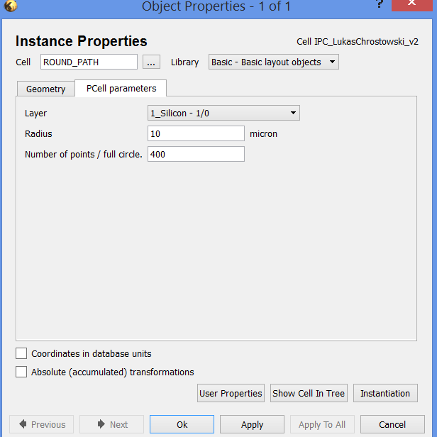

From Path properties:

double click a wg from the guiding shape area (black enclosure)

