Supplement to
Sea urchins facilitate carbon cycling

Luka Seamus Wright*^{1,2,3}, Markus Molis⁴, Juan Vicente de Miguel⁴, Anea Rakvåg⁴, Thomas Wernberg^{1,2,5}, Karen Filbee-Dexter^{1,2,5}

¹Oceans Institute, University of Western Australia, Perth, Australia
²School of Biological Sciences, University of Western Australia, Perth, Australia
³CSIRO Oceans and Atmosphere, Perth, Australia
⁴Department of Arctic and Marine Biology, The Arctic University of Norway, Tromsø, Norway
⁵Institute of Marine Research, His, Norway
*luka.wright@research.uwa.edu.au, luka@wright.it, orcid.org/0000-0002-1273-6256

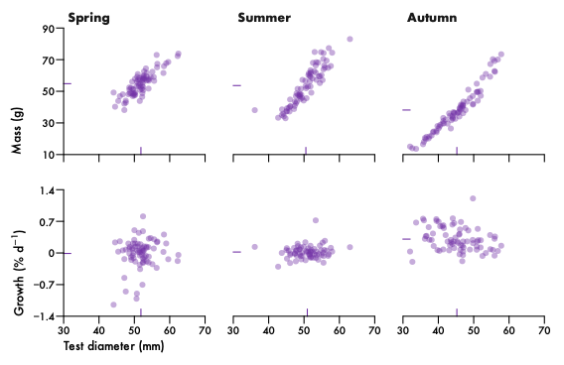
Figure S1. Sea urchin size and growth. Initial mass and relative growth in relation to test diameter for each experimental season. Points are individual urchins (n = 75 per season). In summer, 7 urchins died before final mass could be determined so the sample size for summer growth is lower (n = 68). Coloured ticks denote means.
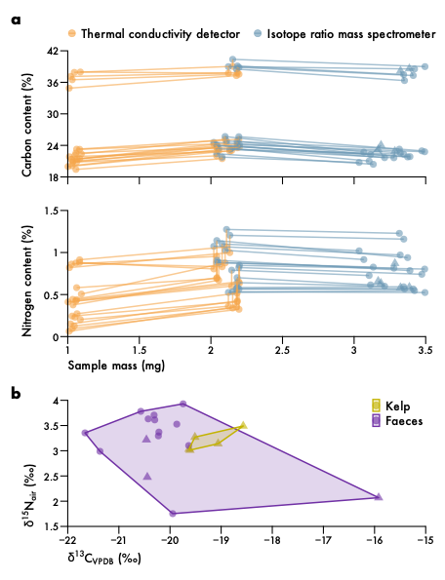
Figure S2. Elemental analysis. a, Carbon and nitrogen content in relation to sample mass and analysis method. Lines connect technical replicates for the same sample. Triangles denote replicates that were additionally oven dried. b, Carbon and nitrogen isotope ratios. Triangles denote low-nitrogen samples with unreliable nitrogen isotope ratios.

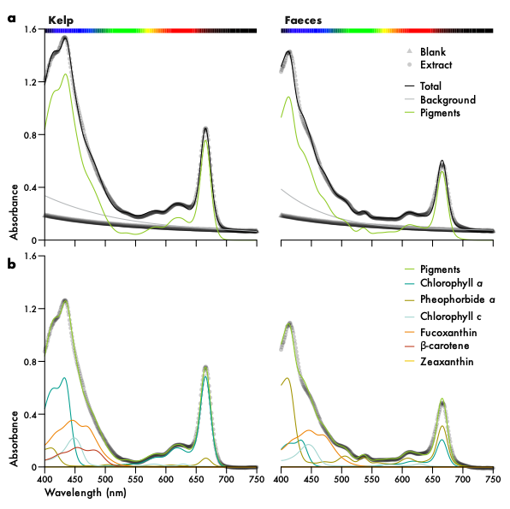
Figure S3. Spectral deconvolution of pigment absorbance. a, Example absorbance spectra for 96% ethanol blanks and pigment extracts. Points are measurements at 1-nm resolution and lines are spectra of background (blank + microplate), pigment and total (background + pigment) absorbance, modelled as the sum of Gaussian functions. b, Deconvolution of total pigment into individual pigments by non-negative least squares. Pheophytin a, violaxanthin and antheraxanthin were not detected in these samples. Points are measurements after subtraction of modelled background absorbance.
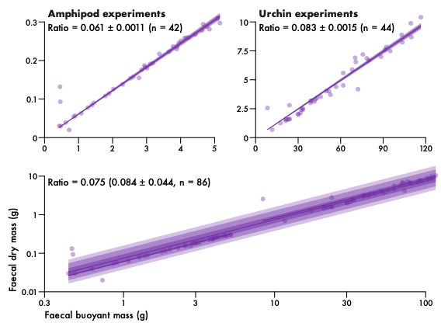
Figure S4. Sea urchin faecal mass relationship. Faecal mass was measured at two orders of magnitude (top panel) and analysed across orders of magnitude (bottom panel). The ratio was determined for each order of magnitude (mean ± standard deviation) as well as across orders of magnitude (median and mean ± standard deviation). Lines and intervals are medians and the central 50, 80 and 90% of posterior probability for predictions of the mean.

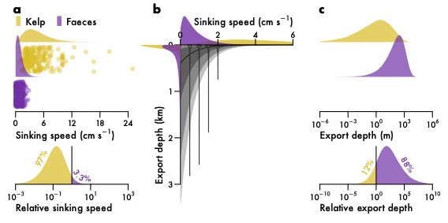
Figure S5. Carbon export in the form of kelp laminae and sea urchin faeces. a, Sinking speeds for kelp and faeces. Points are measurements collated from the literature (n = 224 for kelp and n = 296 for faeces). Probability distributions are kernel density estimates of predicted observations (top panel) and the faeces–kelp ratio (bottom panel). Percentages denote probabilities either side of the identity line. b, Relationship between sinking speed and export depth. Violins are particle tracking depths for four sinking speeds, 150 days after release along the Norwegian coast (n = 3.5 million particles). The line and intervals are the median and central 50, 80 and 90% of probability for predicted observations. Probability distributions along the axes match those in a and c. c, Predicted export depth for kelp and faeces, derived by propagating a through b.

