Exercise 5 - Demos

Sources:

http://mathworld.wolfram.com/BezierCurve.html

http://mathworld.wolfram.com/B-Spline.html

https://en.wikipedia.org/wiki/B-spline

https://bsplines-eth.renuo.ch/

http://www.idav.ucdavis.edu/education/CAGDNotes/Bernstein-Polynomials.pdf

## Moving the tangent of a bspline endpoint 1

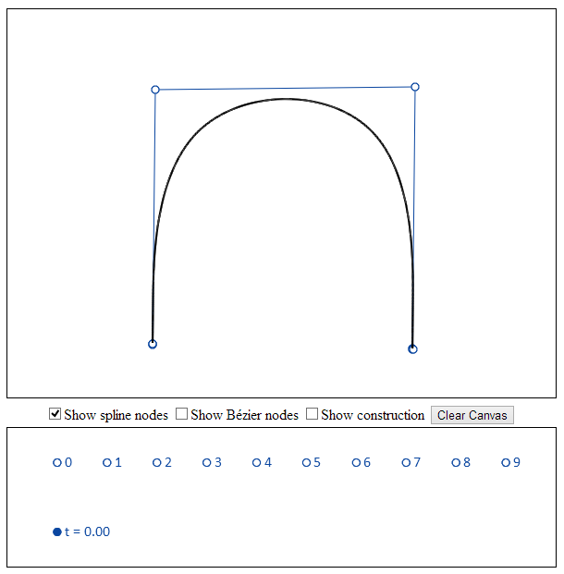

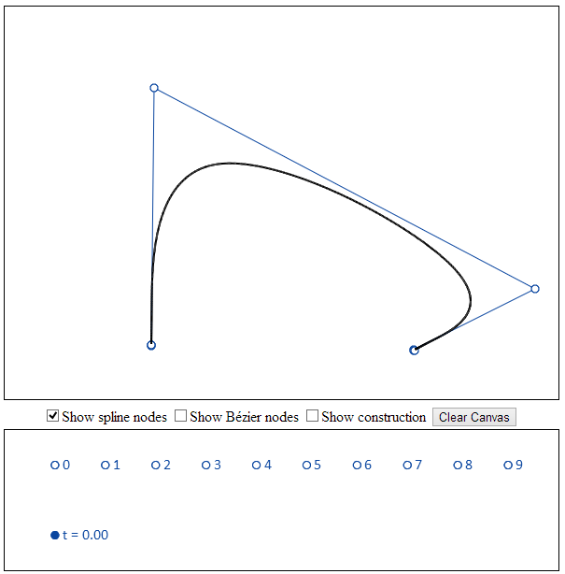

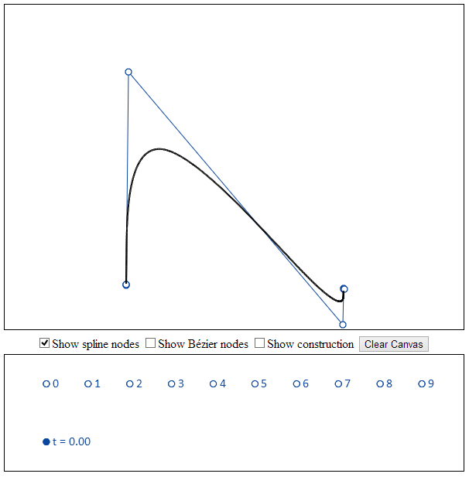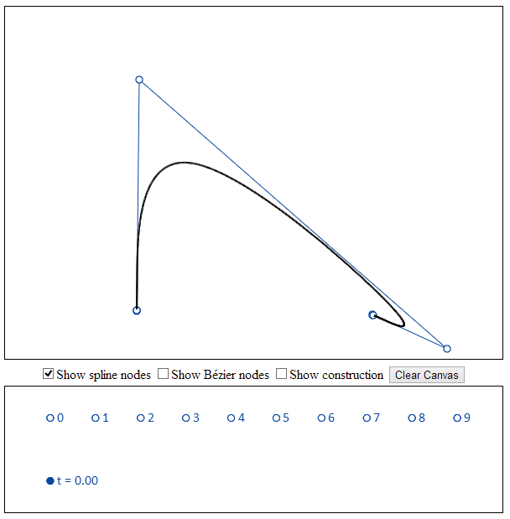

# Moving the tangent of a bspline endpoint 2

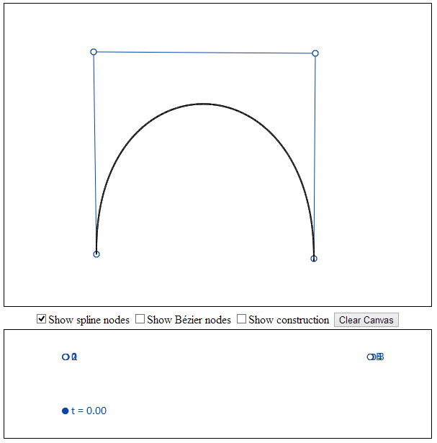

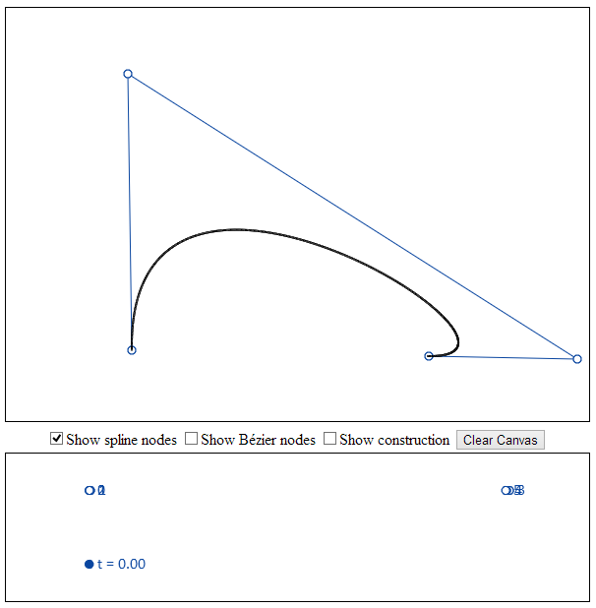

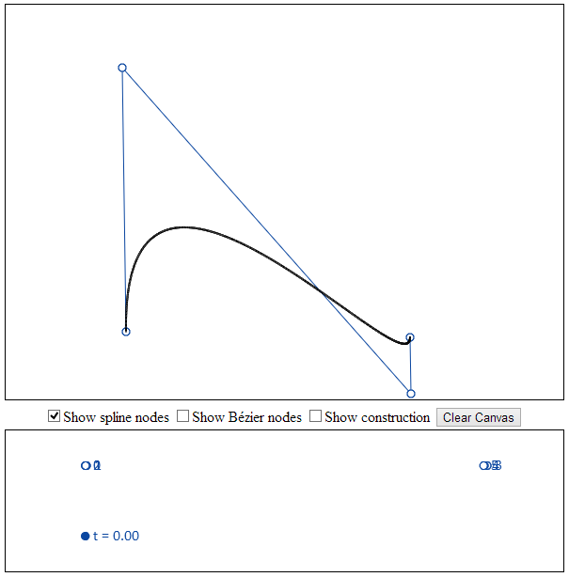

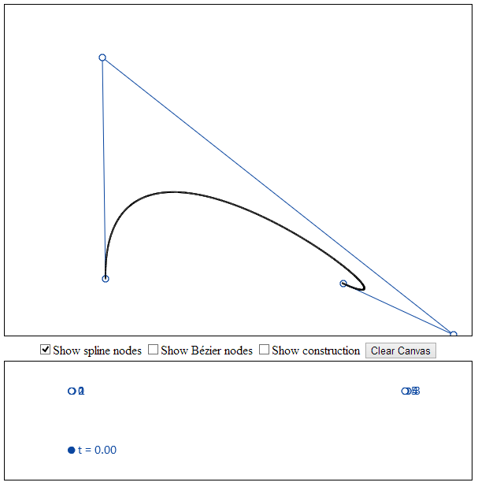

# Bernstein Polynominals

