**ChooseBundle**

1. Description

This API is for checking which bundle should be recommended to the customer, based on his answers. It checks which bundle is available to the customer based on the rules set and in case there are multiple available bundles, it recommends the one with the highest value.

1. Input & Output

It takes user’s answers in JSON format and returns 201 Created response with a JSON representation of recommended bundle. Input JSON has three fields – Age, Student and Income. All of them have limits on what they can be. Example input:

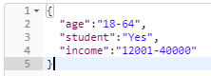

Output bundle has name and value fields, as well as list of products that are included in the bundle and set of rules that must be respected in order to qualify for the bundle. Example output:

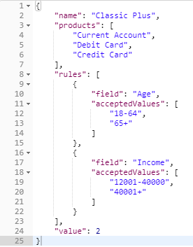



1. Process

The calculation process is straightforward – bundles are put in a list, sorted by value and each checked against the predetermined rules, the first one that passes is recommended to the user.

1. Classes used

Controller - ChooseBundleController.cs, Functions - GetBundle.cs, Populate.cs, Models – Answers.cs, AnswersContext.cs, Bundle.cs, RecommendedBundle.cs, Rule.cs.

1. Unit testing

GetBundle.cs class unit tested in GetBundleTest.cs.

1. API testing

API was tested with Postman program. A few samples of testing:

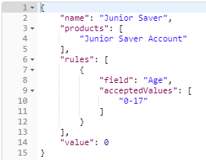Junior Saver:

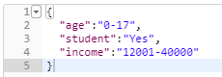



Gold:

