**Verify**

1. Description

This API is for checking if requested bundle can be offered to the client, based on his answers, requested products and the rules by which said products can be offered to the client.

1. Input & Output

Input takes a JSON of user answers as ChooseBundle API and a list of products that user has requested. Output returns either response 200, if the bundle can be offered, or a response 400 with a reason code why it cannot be offered.

1. Process

First, the process checks if there are more than one account in the user’s request. If not, it loops through all the products, checking their rules, until one that does not meet the requirements is found. If no ‘faulty’ products are found, a 200 response is returned as well as the bundle representation in JSON.

1. Classes used

Controller - VerifyController.cs, Functions - Verify.cs, Models – WantedBundle.cs, WantedBundleContext.cs.

1. Unit testing

Class Verify.cs is unit tested in VerifyTest.cs.

1. API testing

The API was tested with Postman. Some of the samples on how the API is called:

The person is too young for the account requested:

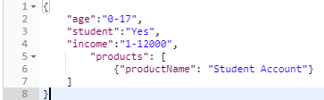

 

More than one account:

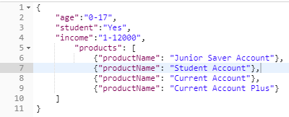





The request is fine:

