# 01_WithoutSSR

## Create

Ng new TestNgApp

## Run

Yarn

Yarn start

# 02_WithSSR (Universal)

## Changes

Main.server.ts -----------------------→ app/app.server.module.ts

Server.ts

Webpack.server.js

Tsconfig.server.json

Change angular.cli.json

* Add new “Apps” section

Package.json

* Add new scripts
* Add @angular/platform-server
* Add @nguniversal/common
* Add @nguniversal/express-engine
* Add @nguniversal/module-map-ngfactory-loader
* Add express

## Run

Yarn

Yarn build:ssr

Yarn serve:ssr

# Main difference between project **with SSR and without SSR.**

## Size of build

Without SSR

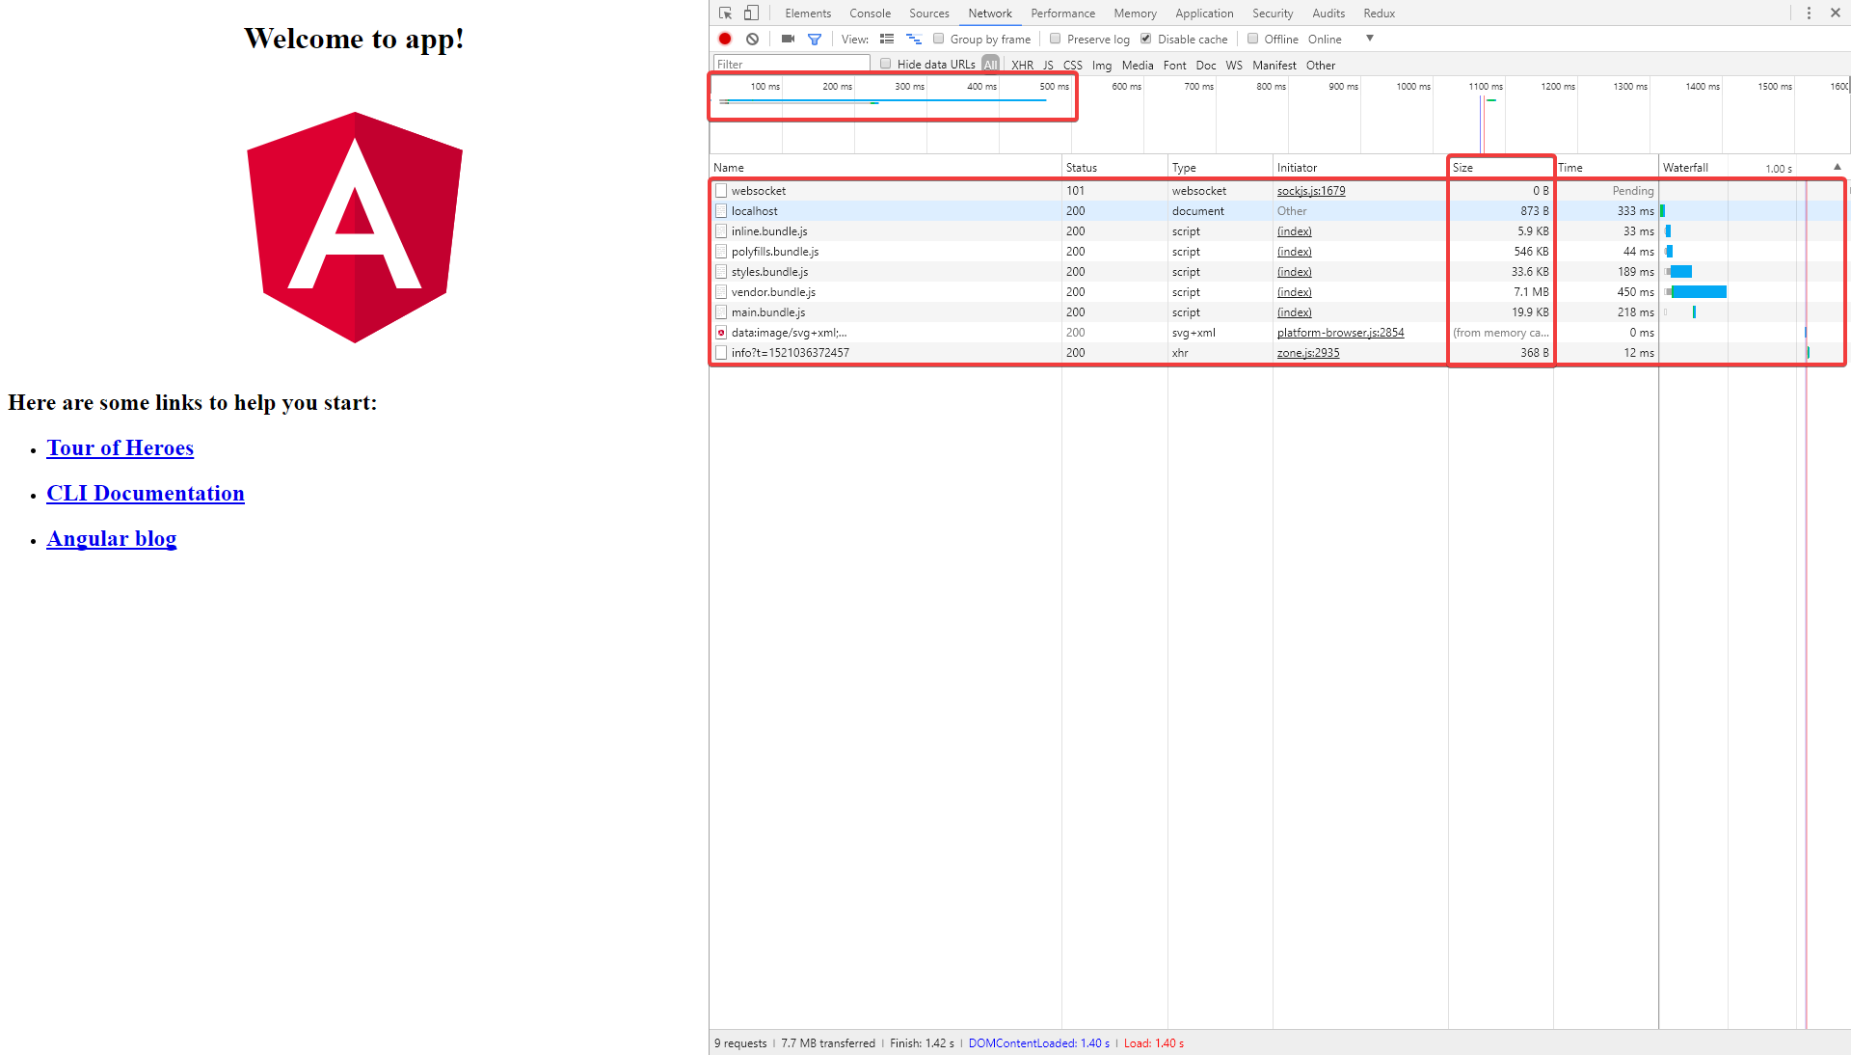

With SSR

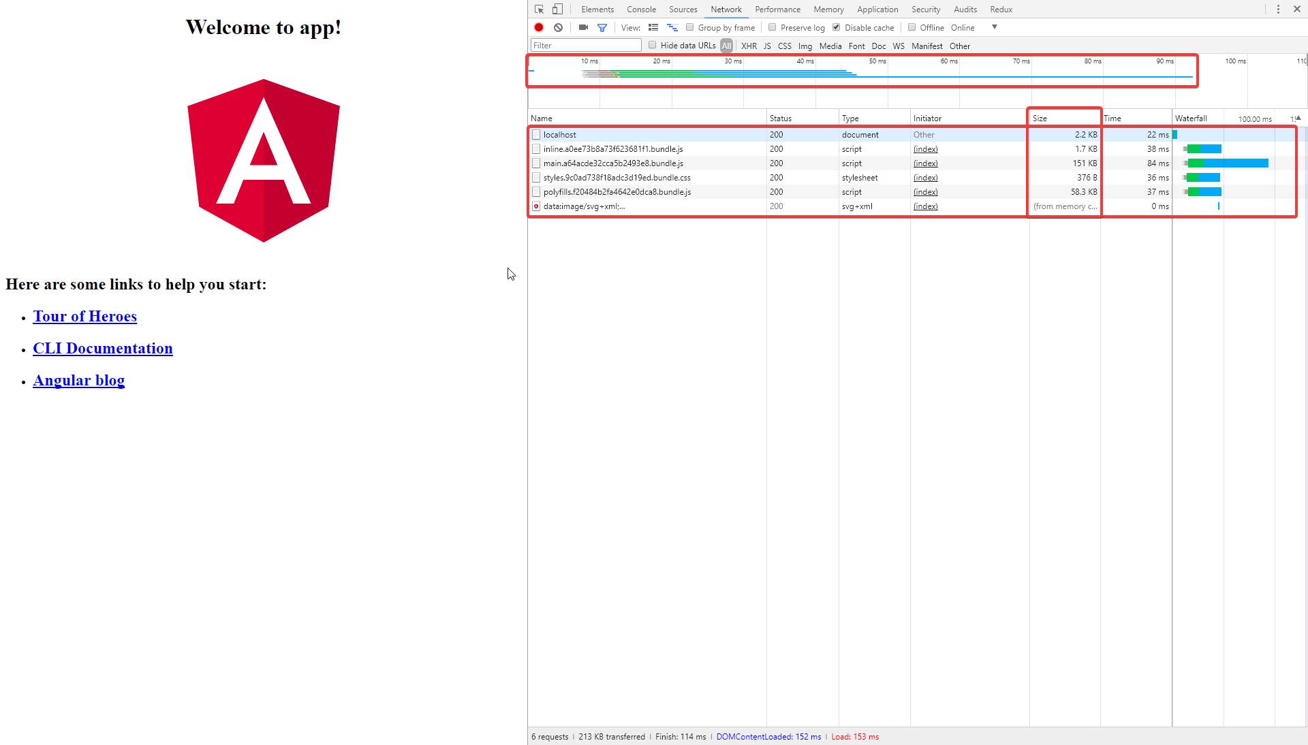

## Prerendering

Without SSR

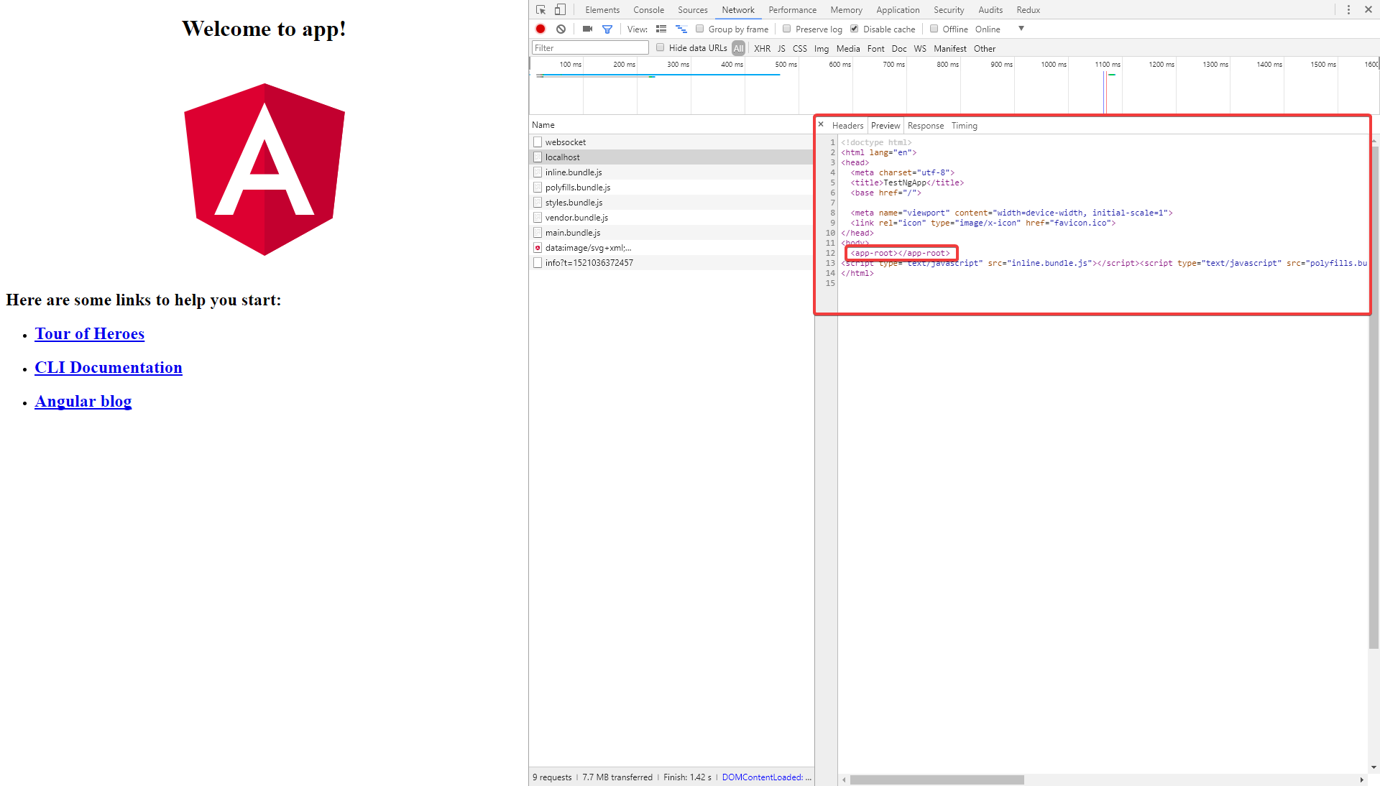

With SSR

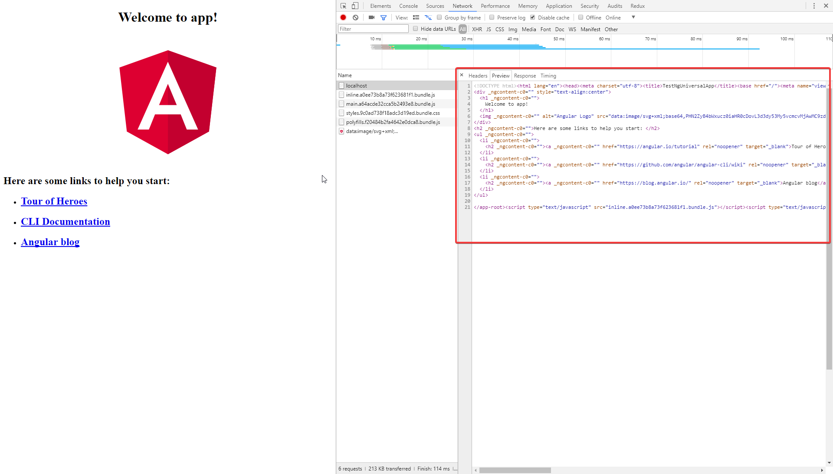

## BUG

SEE !! data are prerendered, but also are called from client side

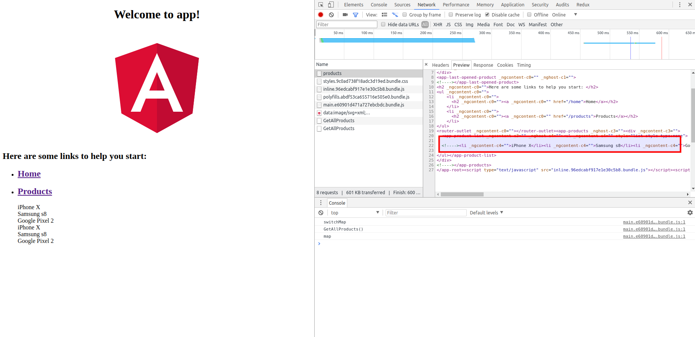

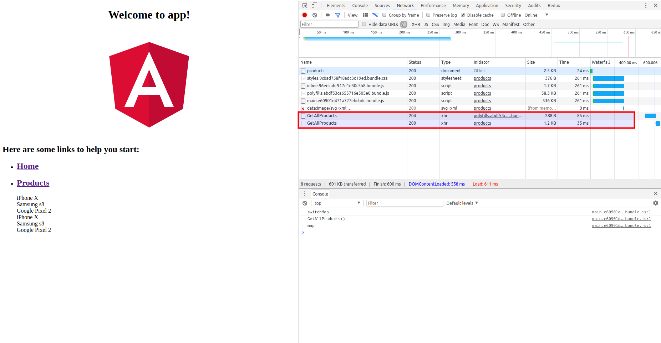

### SOLUTION

Add ServerTransferStateModule

Add BrowserTransferStateModule

Edit app.componet.ts – ADD TransferState

Edit main.ts – ADD waiting for complete DOM document ready.

WHOALAAAAAAA!!!

