# 01_Basic

Originally from 00_ngRX/Test04

Goto <http://localhost:4000/products>

SEE !! data are prerendered, but also are called from client side

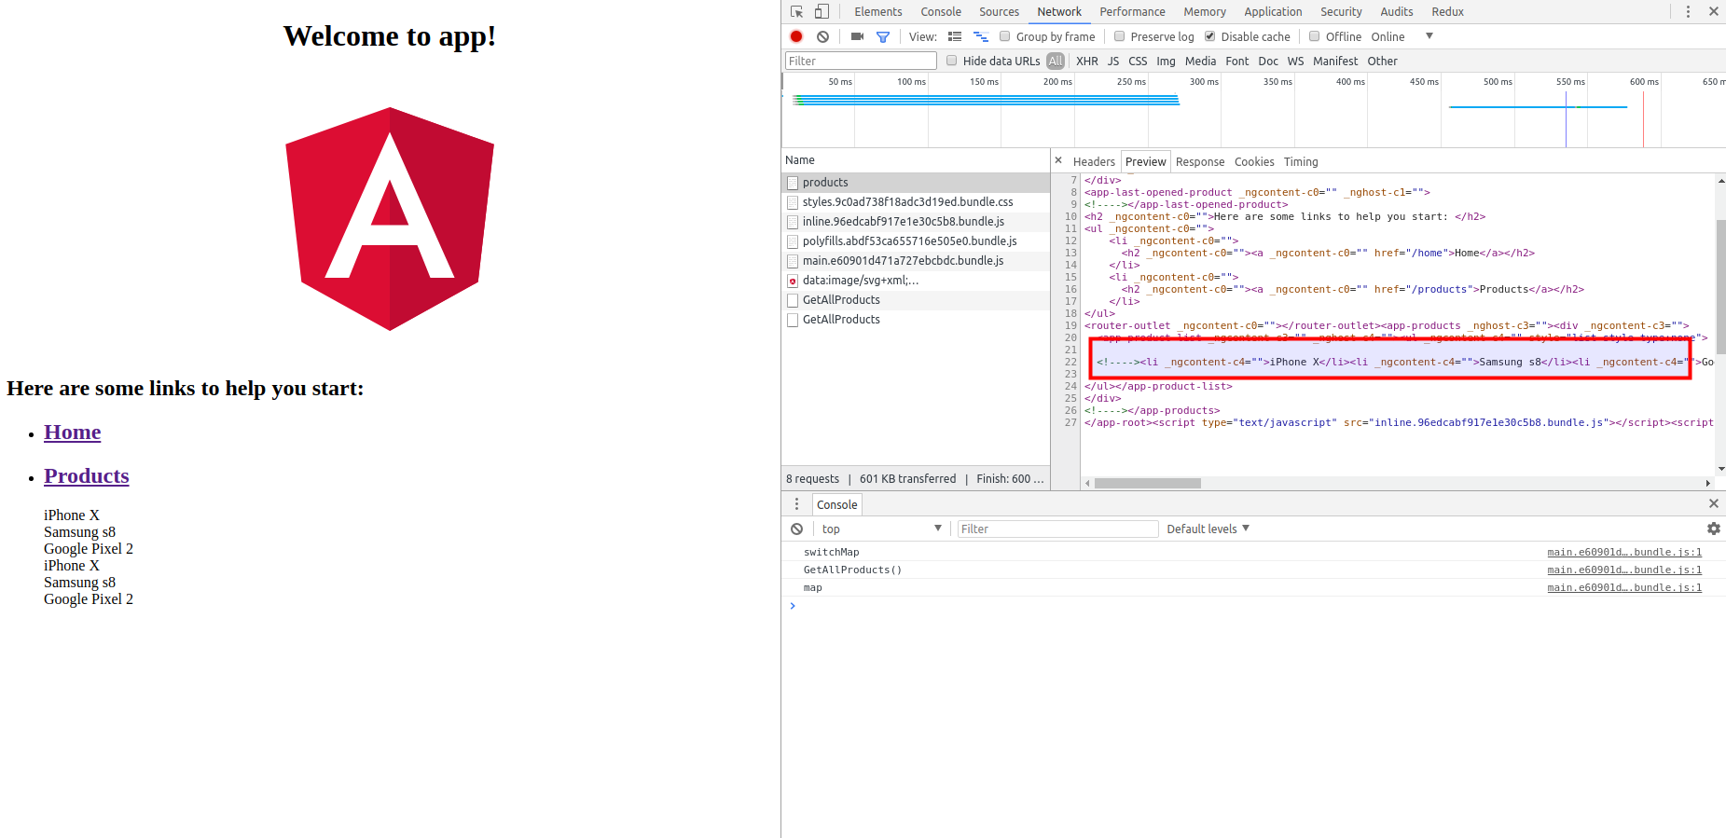

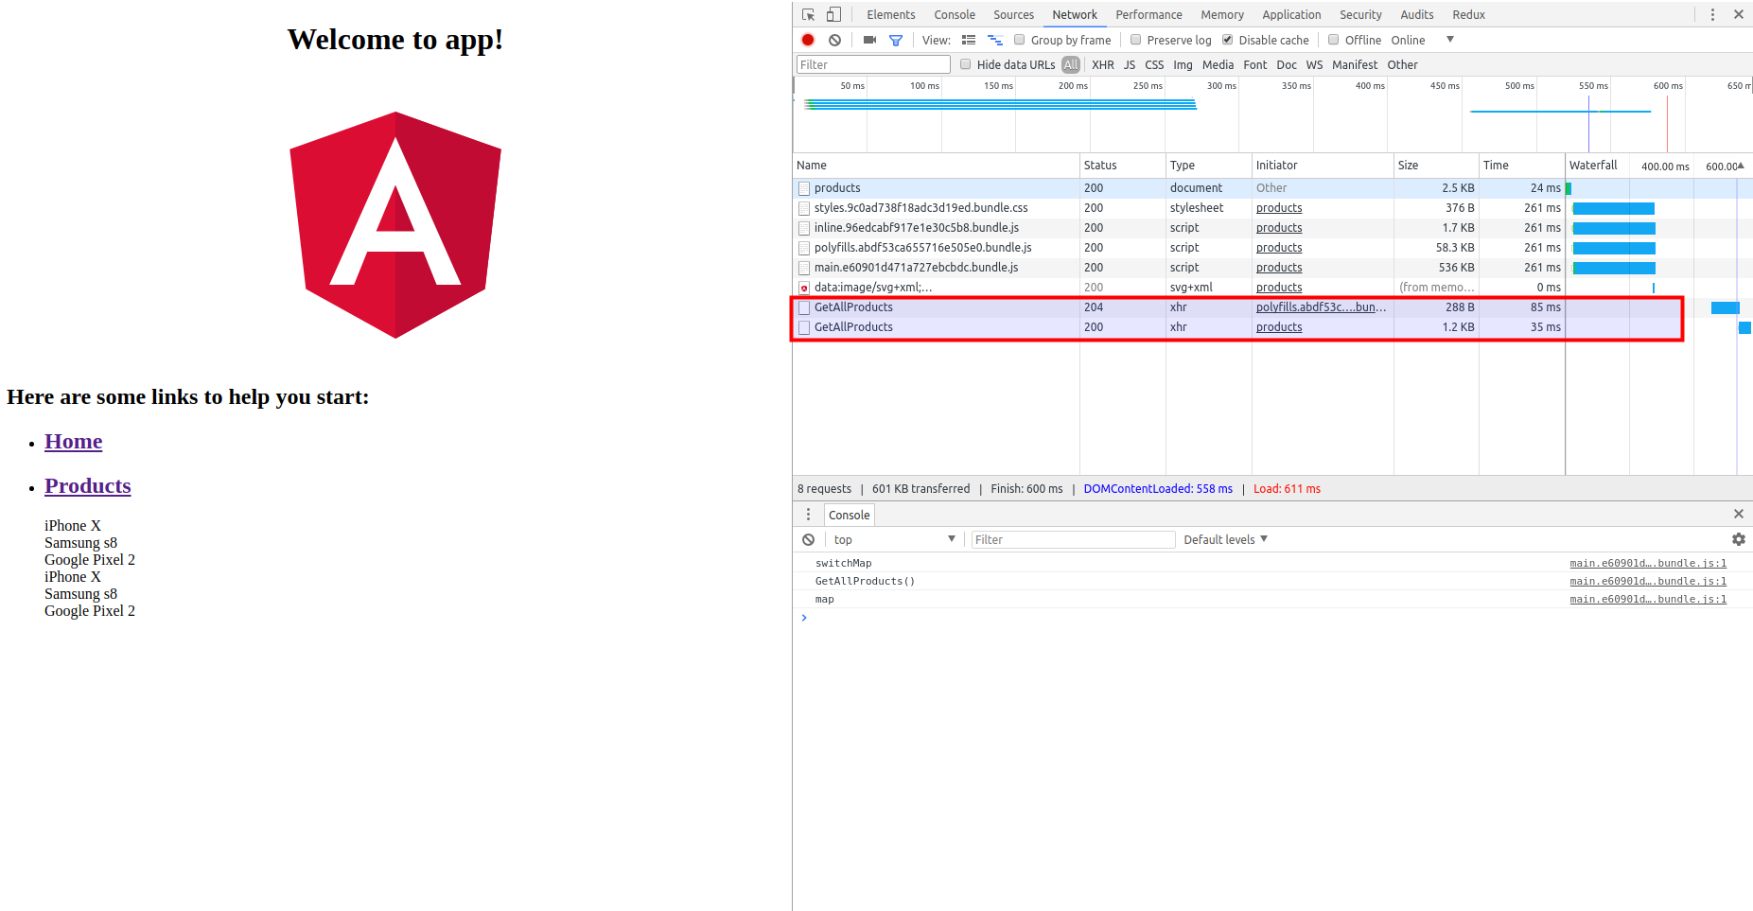

# 02_Refactoring

ADD transferState

by <https://github.com/hallowatcher/angular-universal-ngrx-example>

# 03_Refactoring

ADD transferState

by Alza.Web