
NORTHWIND ANALYTICS
Quarterly Business Review
Second quarter, fiscal year 2026
Document | QBR-2026-Q2 · Revision C
Prepared by | Strategy & Insights team
Distribution | Board, executive staff, regional directors
Date issued | 20 August 2026

Executive summary
Revenue grew for the sixth consecutive quarter, closing at 12.8 million USD against a plan of 12.1 million. Growth was broad-based rather than concentrated: every region finished ahead of plan, and the Asia-Pacific business posted the largest relative gain at 29 percent quarter over quarter. Gross margin expanded by 1.4 points as the platform migration retired the last of the legacy hosting contracts.
Two areas need attention before the next cycle. Services delivery remains capacity-constrained, with a backlog now averaging eleven weeks, and marketplace take-rate has drifted below target as promotional pricing was extended twice. Both are addressed in the roadmap on page four.

At a glance
- Total revenue of 12.8M USD, up 17.4% year over year and 5.8% ahead of plan.
- 1,601 active accounts at quarter end; net revenue retention of 114%.
- Monthly churn improved from 3.1% in January to 1.9% in June.
- Gross margin of 68.2%, the highest recorded since the company began reporting.
- Headcount grew by 34, of which 21 joined delivery and support functions.

Scope and method
Figures are drawn from the consolidated ledger as at 30 June 2026 and have not yet been audited. Regional revenue is stated at constant currency using the January rate table, so the totals here will differ slightly from the statutory accounts. Customer counts exclude trial and internal tenants.

1. Financial performance
The chart below compares regional revenue for the two most recent quarters. North America remains the largest contributor in absolute terms, but its share of the total fell from 43 to 41 percent as the other three regions grew faster. Figures are unaudited and stated in millions of US dollars at constant currency.
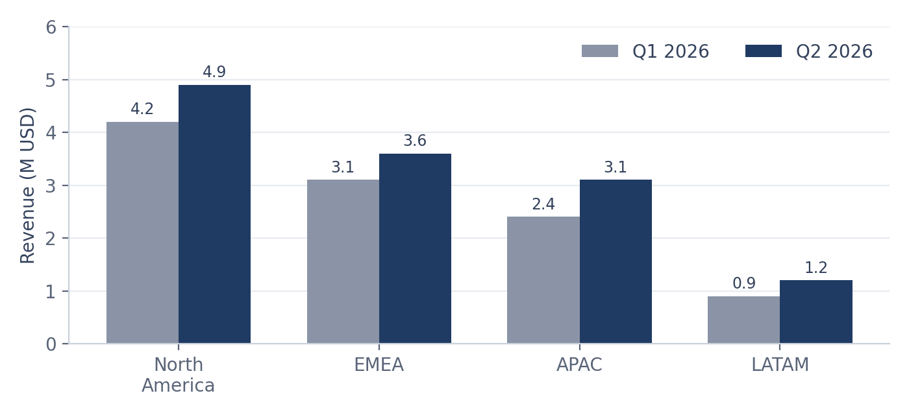
Figure 1 — Revenue by region, Q1 2026 compared with Q2 2026 (millions USD).

Summary of results
Metric | Q2 2026 | Q1 2026 | Plan | Variance
Total revenue (M USD) | 12.80 | 10.60 | 12.10 | +5.8%
Gross margin | 68.2% | 66.8% | 67.0% | +1.2 pts
Operating expenses (M USD) | 6.91 | 6.02 | 6.70 | −3.1%
Services backlog (weeks) | 11.0 | 8.5 | 7.0 | −57%
Net revenue retention | 114% | 109% | 110% | +4 pts
Note: variance is measured against plan, not against the prior quarter. Backlog variance is unfavourable because a longer backlog is worse.

What moved the margin
Margin expansion came from three identifiable sources. None of them is a one-off, though the hosting saving will not repeat at the same magnitude next quarter because the migration is now complete.
- Legacy hosting contracts retired in May, removing roughly 210 thousand USD of monthly fixed cost.
- Support automation deflected 31% of tier-one tickets, holding support headcount flat against 18% account growth.
- Higher subscription share in the mix, which carries an 81% gross margin against 44% for services.
  - Partly offset by overtime in delivery, which added 140 thousand USD of unplanned cost.

2. Customers and growth
Account growth and churn moved in the right directions simultaneously, which is unusual — rapid acquisition normally dilutes retention for a quarter or two. The mid-market segment is the main driver, and the cohort onboarded after the March release has so far churned at roughly half the rate of the preceding cohort.
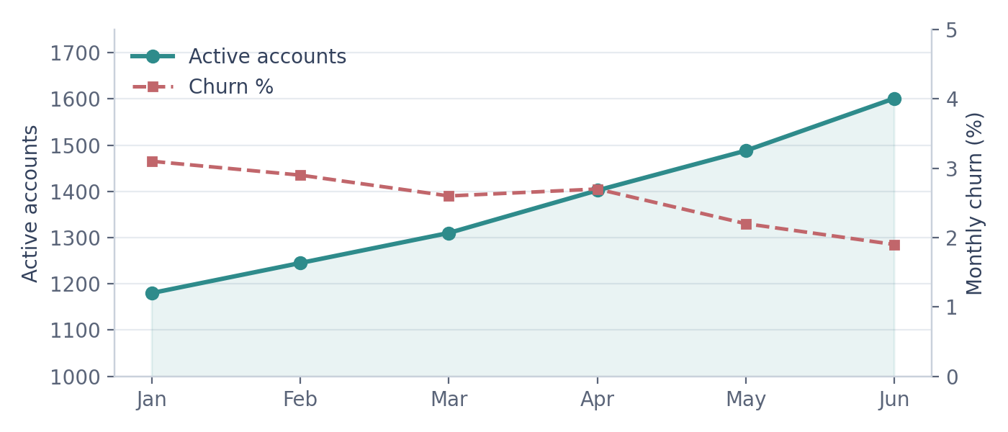
Figure 2 — Active accounts and monthly churn rate, January to June 2026.

Where the revenue comes from
Subscriptions remain the anchor of the business, and their share is growing as marketplace promotions unwind. The mix below reflects recognised revenue for the quarter.
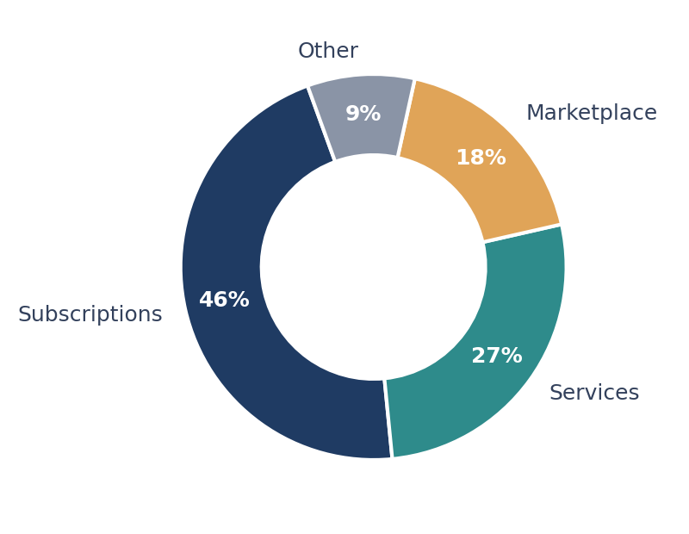
Figure 3 — Revenue mix by line of business, Q2 2026.
“The migration paid for itself two quarters earlier than we forecast, and it is the single reason margin moved this much.” — R. Havlíček, Chief Financial Officer

3. Roadmap and next steps
The following commitments were agreed at the quarterly planning session. Each has a named owner and a checkpoint date; status is reviewed every second Thursday.
Initiative | Owner | Target | Status
Expand delivery capacity by 12 consultants | M. Dvořák | Oct 2026 | On track
Retire promotional marketplace pricing | S. Okonkwo | Sep 2026 | At risk
Launch APAC data residency region | A. Tanaka | Jan 2027 | Planning
Automated onboarding for mid-market | L. Ferreira | Nov 2026 | On track

Actions before the next review
- Publish the revised services capacity model and circulate it to regional directors.
- Model three take-rate scenarios for the marketplace and recommend one by 15 September.
- Complete the security assessment required for the Tokyo region.
- Reforecast the full-year outlook once September actuals are closed.

Principal risks
Risk | Likelihood | Impact | Mitigation
Delivery backlog delays renewals | High | High | Contract three partner firms for overflow work
Take-rate erosion in marketplace | Medium | Medium | Sunset promotional tiers on a published schedule
APAC residency rules tighten further | Low | High | Bring the Tokyo region forward to Q4 if signalled

Appendix — document contents
Executive summary and highlights 1
Financial performance and summary of results 2
Customers, growth and revenue mix 3
Roadmap, actions and appendix 4

This document is a sample produced to demonstrate layout elements: headings, justified body text, bulleted and numbered lists, shaded tables, embedded charts and images, a pull quote, dot-leader entries, and running headers and footers with page numbering.
Approved by the executive committee · Northwind Analytics s.r.o. · Prague

