SYNAGENT RESEARCH STATUS
SynLlama comparison, agent correction evidence, and 1M-row QLoRA training
Prepared for: THG Lab project discussion
Updated: August 30, 2026
Branch: lukasmki/SynAgent: synagent-full-pipeline
Training: Lawrencium job 25306635 - running at 79.6% when captured

Executive summary
Three connected workstreams are now operational:
- SynAgent pipeline: a real Pydantic AI agent has called the complete
chemistry workflow: molecule generation, retrosynthesis, validation, building-block correction, reaction-step correction, and application of fixes.
- SynLlama comparison: all 10,000 supplied SynLlama pathways for 1,000
ChEMBL targets were rescored under four clearly separated validation rules. The same generated pathways score 30.65% under the published strict rule and 65.23% under SynAgent's reactant-order-aware, analog-aware validator.
- Fine-tuning infrastructure: the Lawrencium environment, 1M-row dataset,
base model cache, SLURM scripts, 50-step QLoRA smoke test, and 200-step four-A40 full-parameter timing run have completed successfully. A separate one-epoch 1M-row QLoRA run is actively training as job 25306635 on four A40 GPUs.
The 65.23% result is a validation-method improvement on unchanged SynLlama outputs, not evidence that SynLlama itself generated better chemistry. The real correction pilot is n=50 and improved SynAgent's paired analog-aware pass rate from 52% to 78%; it is promising pilot evidence, not yet a paper-scale generalization claim.

1. End-to-end SynAgent workflow
The implemented workflow is:
User request
-> generate_molecules (SmileyLlama)
-> retrosynthesis (SynLlama)
-> validate_route (RDKit reaction execution)
-> fix_building_blocks
-> fix_step
-> apply_fixes
-> corrected route and structured validation result
The orchestrating model selects tools through Pydantic AI. Tool execution was verified from structural ToolCallPart and ToolReturnPart records, not merely from printed text. The uncropped conversation in chembl-benchmark/screenshots/full-pipeline-with-repair.png shows all six tools and a route moving from two of three valid steps to three of three valid steps.

2. Product-validation correction
The product tool previously required exact canonical-SMILES equality. It now:
- checks exact canonical-SMILES equality;
- computes radius-2, 4096-bit Morgan fingerprints when exact matching fails;
- selects the generated product with the highest Tanimoto similarity;
- approves an analog only when similarity is strictly greater than 0.60; and
- records the match type, matched product, and similarity in the structured
result.
Exact-only scoring remains available. The SynLlama paper also uses 4096-bit Morgan similarity, but it compares the final reconstructed analog with the target. Applying the threshold to an individual reaction-step product is a new SynAgent heuristic and must be labeled as such.

3. Complete 10,000-path comparison
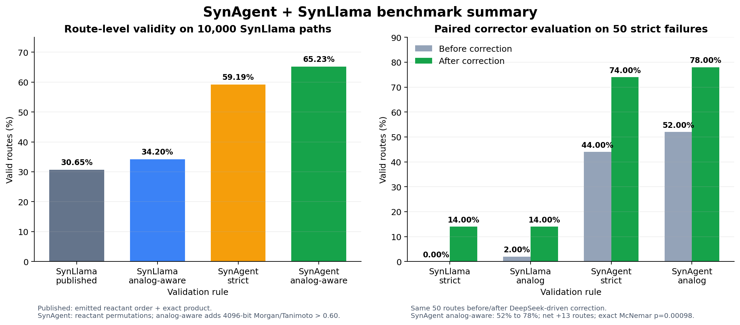
Figure 1. Full 10,000-path validator comparison and paired n=50 correction pilot.
Scoring system | Valid routes | Rate
SynLlama: emitted reactant order + exact product | 3,065 / 10,000 | 30.65%
SynLlama: emitted order + analog-aware product | 3,420 / 10,000 | 34.20%
SynAgent: reactant permutations + exact product | 5,919 / 10,000 | 59.19%
SynAgent: permutations + analog-aware product | 6,523 / 10,000 | 65.23%

The largest difference comes from reactant ordering. RDKit reaction templates match reactants positionally; SynLlama can emit chemically compatible reactants in a different order. SynAgent tries compatible permutations before rejecting the route. Analog matching adds a second, smaller gain.

4. Genuine agent-correction pilot
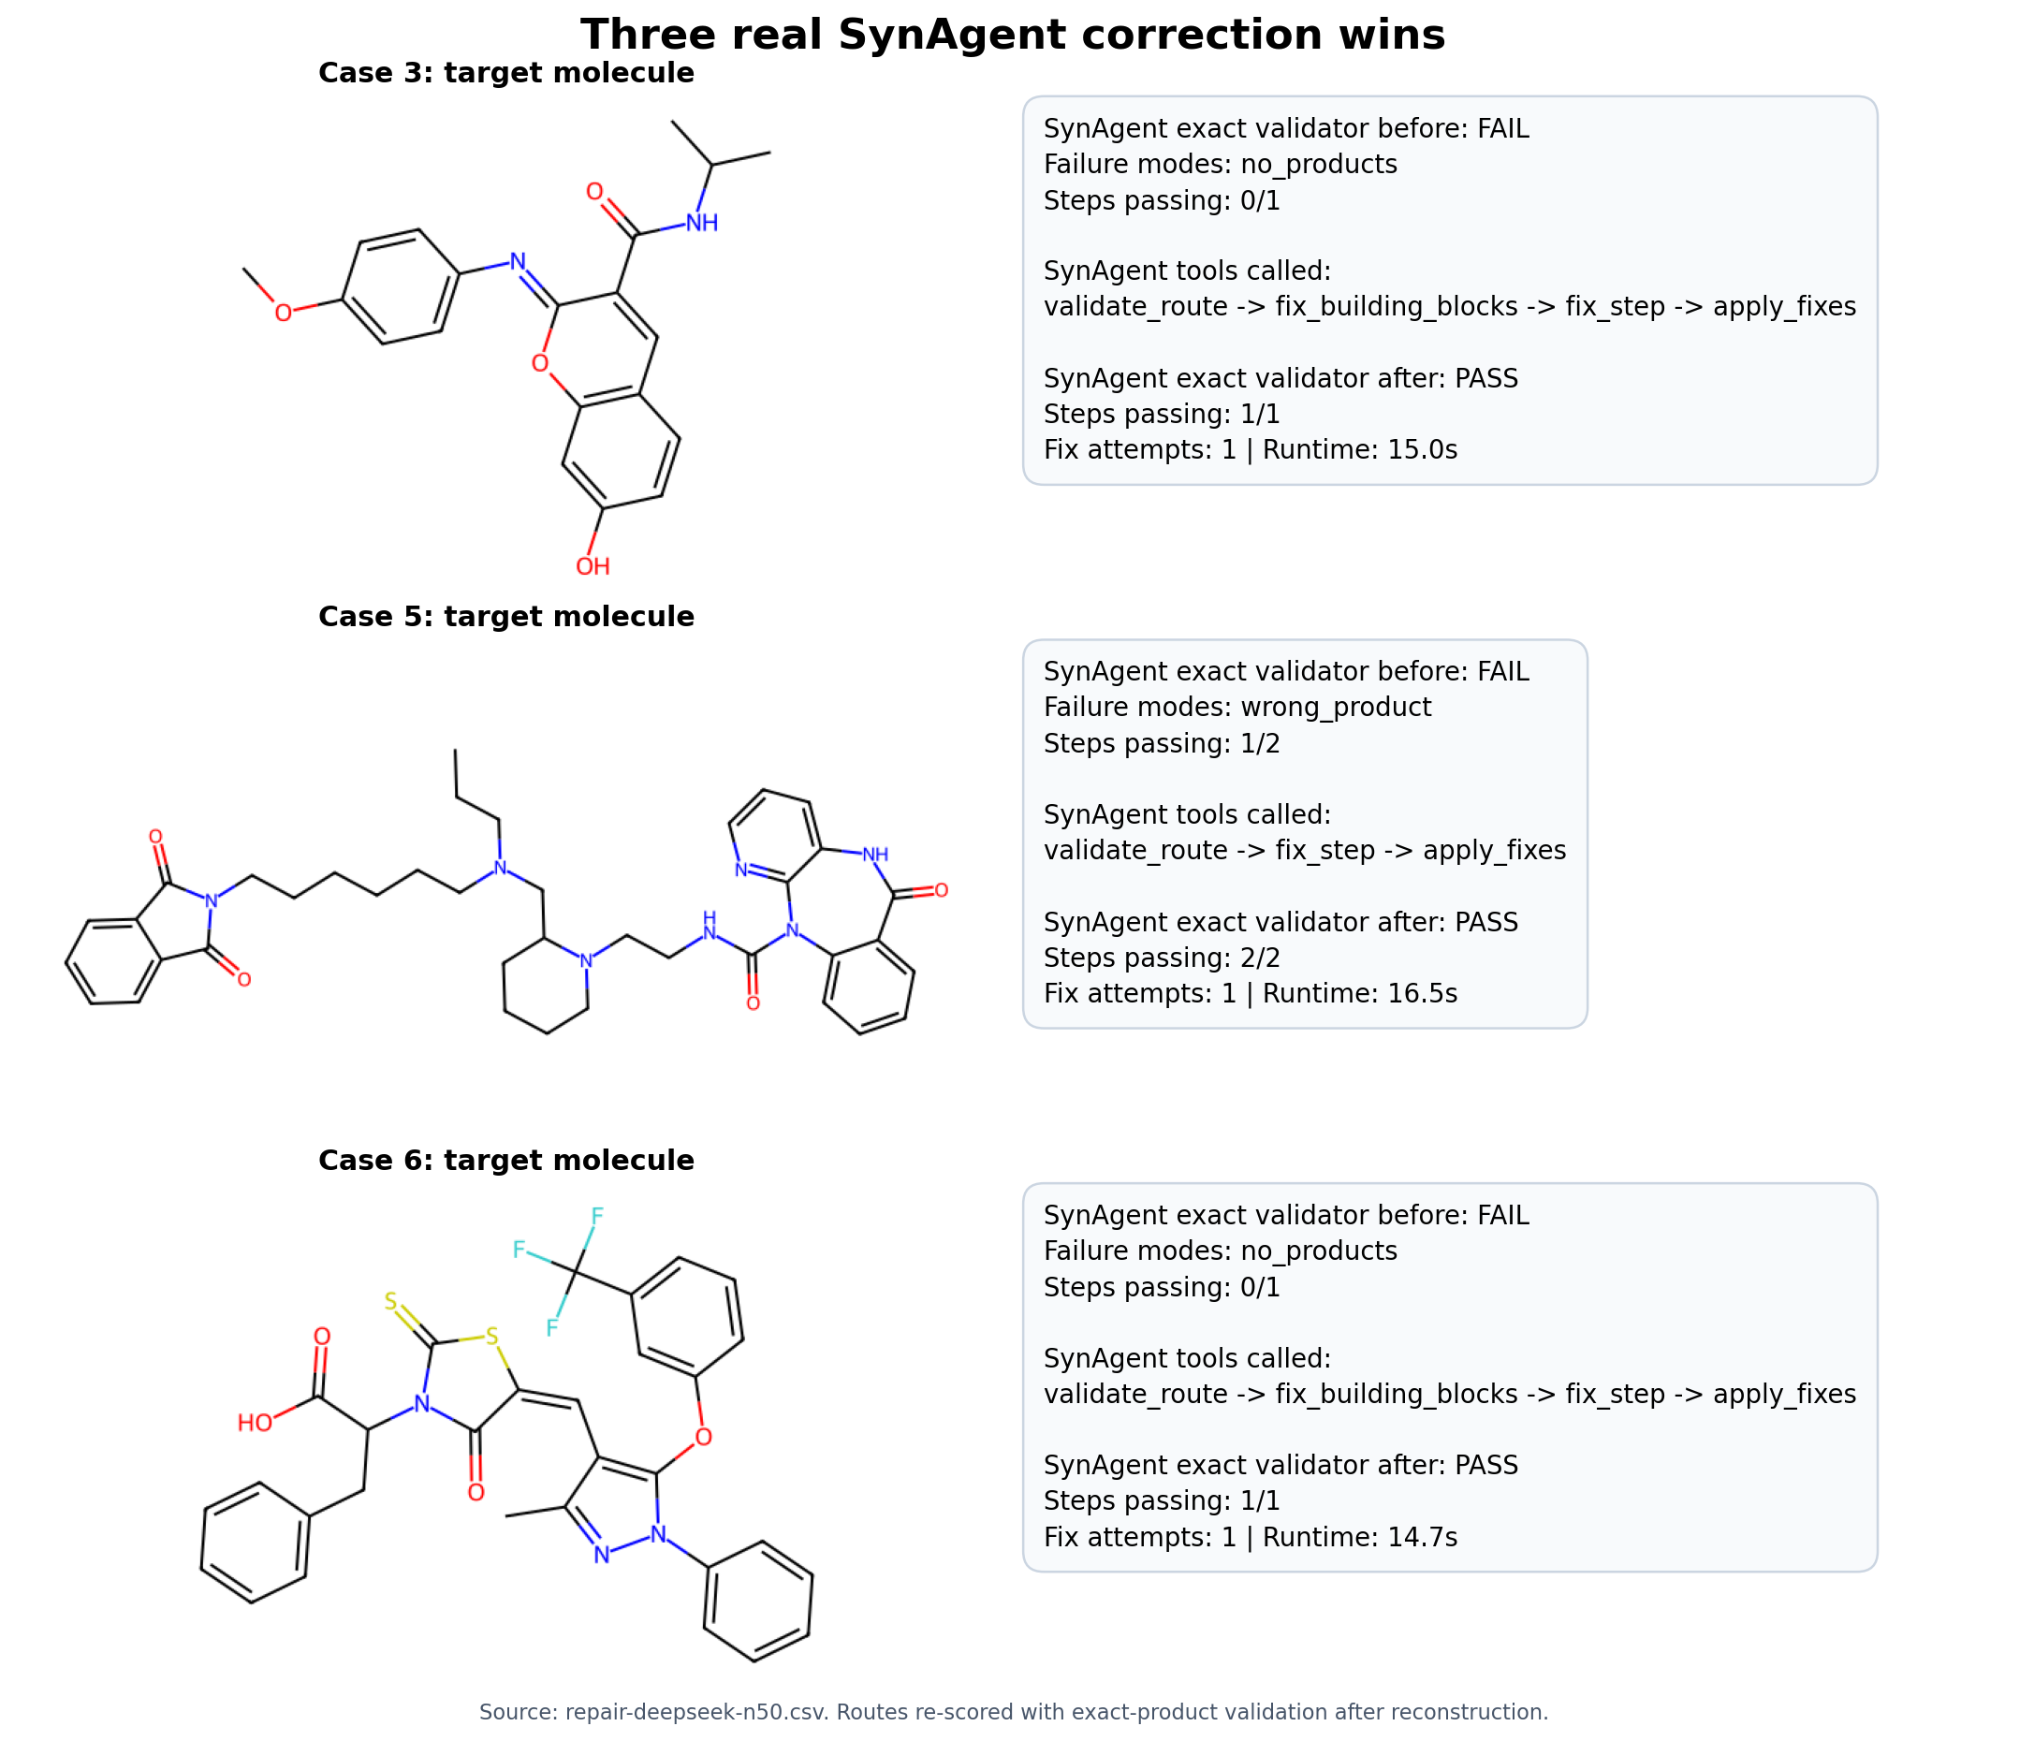
Figure 2. Three representative fail-to-pass corrections from the genuine agent batch.
The paired n=50 experiment used real DeepSeek-orchestrated Pydantic AI conversations. Routes were drawn from the strict-failure pool with seed 42 and limited to responses no longer than 1,400 characters.
Metric | Before | After | Net change
SynLlama strict | 0% | 14% | +7 routes
SynLlama analog-aware | 2% | 14% | +6 routes
SynAgent strict | 44% | 74% | +15 routes
SynAgent analog-aware | 52% | 78% | +13 routes / +26 points

For the primary SynAgent analog-aware comparison, 14 routes changed from fail to pass, one changed from pass to fail, 25 passed both, and 10 failed both. The exact paired McNemar p-value is 0.00098. Tool invocation occurred in 48 of 50 runs after retry logic, and seven of the original strict failures became strict passes. Agent behavior was observed to be nondeterministic, so a paper-quality study should use fixed settings and repeated trials.

5. Image and evidence guide

Primary PI figures
- chembl-benchmark/comparison-2026-08-27/synagent-vs-synllama-summary.png
presents the four full-dataset rates and the paired n=50 correction result.
- chembl-benchmark/comparison-2026-08-27/three-synagent-wins.png presents
three fail-to-pass routes from the real correction batch. The underlying 15 exact-product wins are stored in winning-cases.json.
- chembl-benchmark/screenshots/full-pipeline-with-repair.png is the strongest
visual proof of actual agent execution because it contains the uncropped six-tool conversation and corrected result.

Pipeline sequence screenshots
- 1_generate.png: SmileyLlama molecule generation tool call.
- 2_route.png: SynLlama retrosynthesis tool call and returned pathway.
- 3_validate.png: deterministic route validation.
- 4_fix.png: correction-tool invocation.
- 5_full_conversation.png: conversation overview.
- full-pipeline-with-repair.png: complete uncropped evidence.

Diagnostic figures and examples
- fig4_ordering.png: demonstrates the emitted-order versus
permutation-aware validation finding.
- fig2_errors.png: summarizes failure categories rather than hiding negative
outcomes.
- fig3_agent_tools.png: summarizes tool invocation and correction behavior.
- product_1_validate.png and product_2_correct.png: product-failure example
before and after correction.
- reactant_1_validate.png and reactant_2_correct.png: reactant-failure
example before and after correction.
- smiles_1_validate.png and smiles_2_correct.png: malformed-SMILES example
before and after correction.
fig1_validity.png is retained as a historical artifact but should not be used for reporting; its original denominator logic rendered an incorrect 100% bar. The corrected PI figure is synagent-vs-synllama-summary.png.

6. Fine-tuning work completed

Infrastructure and data
- Lawrencium login, modules, Python environment, CUDA/PyTorch, Axolotl, and
SLURM submission were validated.
- The staged training subset contains exactly 1,000,000 rows (about 1.5 GB).
- The 8B Llama 3.1 Instruct base-model cache is stored on scratch, not the login
node.
- The QLoRA smoke job completed 50/50 steps with exit code 0 and produced a
168 MB adapter.
- The four-A40 full-parameter timing job completed 200/200 steps with exit code
0 and produced seven complete model shards totaling 32.1 GB.
The timing run covered about 6,400 examples, or 1.65% of one 1M-row epoch. Its average loss moved from 0.600 over the first 20 steps to 0.085 over the final 20. This proves optimization and checkpoint writing worked, but it does not prove held-out chemistry quality.

Measured full-parameter throughput
- 0.5 rows/second, or approximately 1,733 rows/hour;
- 1M rows: approximately 577 hours (24 days);
- 2M rows: approximately 48 days; and
- all 5.86M rows: approximately 141 days.
Full-parameter training is bottlenecked by FSDP CPU offload. For that reason, the real 1M-row experiment uses QLoRA rather than spending approximately 24 days on a single full-parameter epoch.

7. Real 1M-row QLoRA run
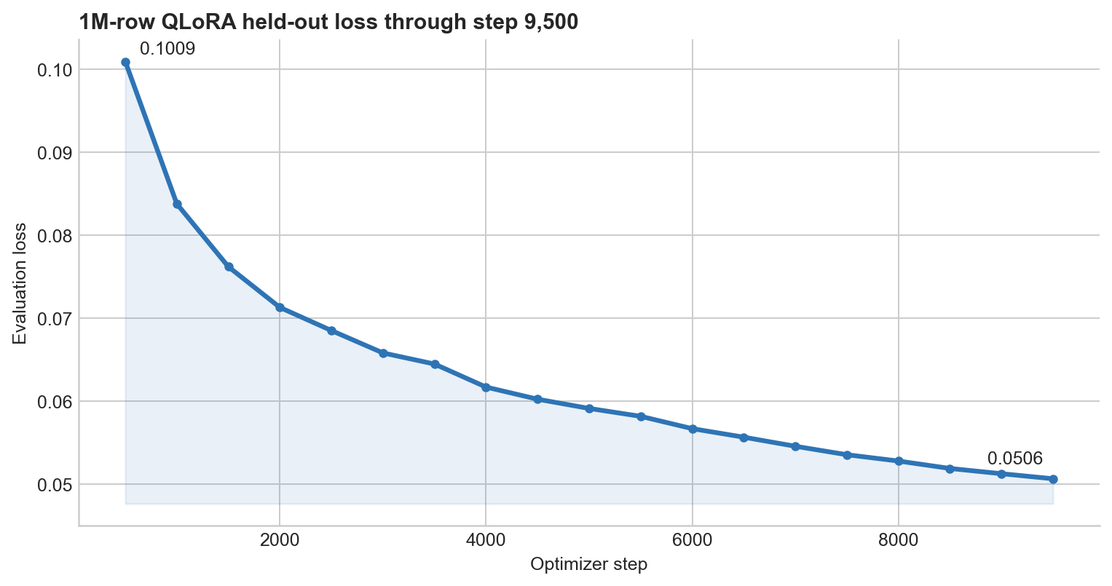
Figure 3. Held-out evaluation loss decreased monotonically from step 500 through step 9,500.
The production-scale pilot is running as Lawrencium job 25306635 with:
- one node and four NVIDIA A40 GPUs;
- one epoch over 1,000,000 rows;
- sequence length 2,048 and sample packing;
- LoRA rank 16, alpha 32, dropout 0.05;
- effective global batch size 32;
- 2,000-example validation split;
- evaluation and checkpoints every 500 steps; and
- a separate output directory:
/global/scratch/users/asanil/runs/qlora_1M_20260827.
The run does not overwrite the smoke adapter or timing model. Its SLURM log is /global/home/users/asanil/lawrencium/qlora_1m_25306635.out.

Verified live status at 12:31 PM PDT on August 30
- SLURM state: RUNNING, with all four A40 GPUs allocated on n0000.es1;
- progress: 9,622 / 12,090 steps (79.6%), epoch 0.80;
- elapsed training time: approximately 55 hours;
- current steady-state rate: approximately 20 seconds per optimizer step;
- estimated remaining training time: approximately 14 hours;
- recent training loss: generally 0.04-0.06;
- held-out evaluation loss: 0.10089 at step 500, decreasing monotonically to
0.05064 at step 9,500; and
- recoverable checkpoints: steps 8,500, 9,000, and 9,500, each containing a
roughly 168 MB adapter plus optimizer and trainer state.
Mean logged training loss decreased from 0.6006 over the first 100-step logging window to 0.0484 over the most recent 500-step window. The decreasing held-out loss is encouraging evidence that training is learning the dataset rather than merely completing steps. Final quality still requires generation-based held-out evaluation after the job finishes.

8. Claims appropriate for presentation
On the complete 10,000-route ChEMBL output set, SynAgent's reactant-order-aware and analog-aware validator accepts 65.23% of routes, compared with 30.65% under the strict emitted-order SynLlama rule. This is an evaluation and correction improvement on the same generations. In a genuine n=50 agent-correction pilot, SynAgent's analog-aware paired pass rate improved from 52% to 78%.
Do not claim that the SynLlama model became 34.58 percentage points more accurate, that a Tanimoto score proves synthetic feasibility, or that the n=50 repair rate generalizes to every failed route.

9. Work needed for a paper-quality result
- Evaluate at least 400 stratified failed routes, including product,
reactant, reaction, invalid-SMILES, and route-length strata.
- Repeat correction trials because tool selection was nondeterministic.
- Compare the final QLoRA checkpoint against the untouched base model on a
held-out set using valid-SMILES rate, instruction following, property error, route validity, and scaffold diversity.
- Have a synthetic chemist blindly review a representative subset.
- Report negative outcomes, parser failures, runtime, and hosted-model cost.
- Confirm the original SynLlama generation settings before claiming a direct
model comparison.

Reproducibility
The branch contains the full 10,000-row path-level CSV, paired n=50 CSV, machine-readable summary, 15 winning cases, analysis scripts, tests, figures, and screenshots. The implementation suite passed 33 tests with 2 live tests skipped. No API keys are stored in the repository.
Key artifacts for review:
- docs/chembl-benchmark/comparison-2026-08-27/PI_REPORT.md: concise
interpretation and presentation-safe language;
- baseline-10000-path-level.csv: one scored row for every supplied pathway;
- synagent-repair-n50-paired.csv: paired before/after correction outcomes;
- winning-cases.json: all 15 exact-product fail-to-pass cases;
- compare_synllama_synagent.py: complete reproducible scoring procedure;
- docs/chembl-benchmark/screenshots/: genuine pipeline and diagnostic UI
evidence; and
- docs/chembl-benchmark/comparison-2026-08-27/: final figures in PNG and PDF
formats.
Scientific context:
- SynLlama paper: https://pmc.ncbi.nlm.nih.gov/articles/PMC12047903/
- ACS publication: https://pubs.acs.org/doi/10.1021/acscentsci.5c01285
The final QLoRA adapter, its completed SLURM accounting, and generation-based held-out evaluation should be appended after job 25306635 reaches a terminal state.

