CITS3401 – Data Warehousing

Project 1 Submission

Name: Lukas Rohwer Student Number: 0000000
Name : Harrison Chambers Student Number: 24328083

Introduction
Airline data holds significant importance as it offers insights into the geographic movements of people around the world. What this means is it provides valuable information about flight routes, schedules, passenger demographics, and preferences, which airlines can leverage to optimize their operations and enhance customer experiences.(https://www.kaggle.com/datasets/iamsouravbanerjee/airline-dataset/data). Researchers and analysts can use this data to study market trends, assess environmental and political impacts, and develop strategies for sustainable growth within the industry.

This project aims to design and implement a data warehouse using real-world datasets to support analytical queries and extract meaningful insights. The warehouse is constructed following dimensional modelling principles, with a focus on capturing passenger-level flight activity. In addition to supporting business intelligence queries, the project applies association rule mining techniques to identify patterns related to flight outcomes, particularly focusing on factors influencing flight delays and cancellations. The outcomes of this project are intended to provide actionable insights for stakeholders, national governments, international governing bodies, airline companies, and passengers.

Business Queries
In order to help build and assess the effectiveness of the data warehouse design we created several example queries that would be expected.

1. Find out if there’s a relationship between GDP_per_Capita and the delay and cancellation rate of flights in 2022.

Gross domestic product (GDP) per capita is often used as a proxy for measuring infrastructure quality and investment capacity; Wealthier nations may have better airport systems, staffing, and logistics than poorer nations. Therefore, analysing the effects of GDP on the flight delay and cancelations will provide insight on if this wealth has a positive effect on delay and cancelation rates or not.

2. Find out if pilot performance (in terms of on time rate) is affected by different countries, airport types, and weather conditions?

Pilot performance is an important measurement for airline companies and stakeholders in assessing their current staff, as well as potential influencing factors for future hiring. However, often pilot performance is not individual, and is affected by outside factors such as airport types, weather conditions, and regions. Therefore, in order to properly assess their performance effectively these other conditions must be weighted as well.

3. Find out how flight delays vary over different months and seasons across different continents.

Due to how seasons work with geographical locations, continents experience their seasons at different times of the year. In order to model how flight delays are affected over the months, it’s important to consider the different seasons and holidays. Airports would find this information useful as working out when there’s extra logistical challenges due to busy periods will help airport bodies deploy countermeasures such as increased staffing in order to reduce the number of delayed flights.

4. Find out if specific airports, regions and countries are more significantly prone to flight delays and cancellations than others.

When booking flights, future passengers often have to think about the eventuality that their flight is delayed or cancelled. This is usually to help decide between insurance, alternative arrangements, and dates to fly. Knowing if the airport, region, or country you are flying to has a higher-than-average delay or cancel rate might inform the passenger on if they should plan ahead for these more likely than average eventualities.

5. Find out if countries with larger populations tend to lead to an increase in flight delays or not.

We would expect countries with higher populations to have an increase in flights, which can affect delays in two ways. Either the higher number of flights booked would lead to more delays and cancellations due to the number of people the airports are dealing with, or the airports will have been designed and built expected this higher cycle and as such we would not expect to see an increase in delays.

Initial design of the data warehouse
In order to design the data warehouse in a structured and efficient way, Kimball’s four-step dimensional modelling process was followed throughout the design stage. These steps (identifying the business process, defining the grain, selecting dimensions, and identifying facts) served as a useful framework guiding the modelling decisions.

The business process modelled in this data warehouse is passenger-level flight activity, capturing both operational and demographic characteristics associated with each flight event. We decided that the grain of the fact table would be defined as one record per passenger per flight per departure date. This represents the lowest level of detail available in the dataset and ensures maximum analytical ability. By adopting this specific granular level, the data warehouse is capable of supporting highly detailed queries, such as analysing delay patterns across specific passenger demographics, airports, or time periods. Although this level of granularity may introduce increased query execution time due to larger data volumes, it was deemed acceptable given the analytical objectives of the system. Moreover, we expect the primary users of the warehouse – such as airline stakeholders and governing bodies – are expected to prioritise depth and accuracy of insights over larger query latency.

During the initial exploration of the dataset, we analysed the relationships between attributes and how they related with each other in order to determine appropriate dimension groupings. The following core assumptions were made to ensure consistency during the modelling process:
- Each pilot is uniquely identified by their combination of first and last name. Records containing identical names are assumed to refer to the same pilot.
- Passenger age is assumed to remain constant throughout the dataset. That is, if a passenger appears in multiple records, their age does not change over time.
- Each pilot operates at most one flight per day from a given airport. Therefore, multiple passenger records associated with the same pilot, airport, and date are treated as a single flight from the pilot’s perspective in relevant analyses.
These assumptions were necessary due to limitations in the dataset, such as the absence of explicit pilot identifiers.

Based on the structure of the dataset, we decided to split the initial file into four main dimensions: Passenger, Pilot, Flight Status, and Airport.

Dim_Passenger
This dimension captures the demographic attributes relating to a passenger in the data warehouse. It consists of:
- Passenger ID: Unique identifier for each passenger (PK)
- FName: First name of the passenger
- LName: Last name of the passenger
- Gender: Gender of the passenger
- Age: Age of the passenger
- Nationality: Nationality of the passenger

Dim_Pilot
This dimension captures the demographic attributes relating to a pilot in the data warehouse. It consists of:
- PilotID: Unique identifier for each passenger (PK)
- FName: First name of the pilot
- LName: Last name of the pilot

Due to the absence of a natural primary key, we introduced PilotID as a surrogate key in order to create a method of uniquely identifying pilots for any current or future expectations of the data warehouse.

Dim_Status
This dimension represents categorical outcomes of flights: if either the flight is on time, cancelled, or delayed. It consists of:
- StatusID: Unique identifier for each possible flight status (PK)
- FlightStatusID: Either on time, cancelled, or delayed.

Dim_Airport
This dimension represents the geographic and operational attributes of the departure airports. In order to enhance the data warehouse’s analytical ability, we included the airpots.csv external dataset. The dimension consists of:
- IATA: The IATA code of the airport where the passenger boarded, this is unique (PK)
- AirportName: Name of the airport where the passenger boarded
- Municipality: The municipality of where the airport is situated
- Region: The region of where the airport is situated
- Country: Name of the country the airport is situated
- Continent: Continent where the airport is situated
- AirportType: The type of airport it is
- Latitude: The latitude ordinate of where the airport is situated
- Longitude: The longitude ordinate of where the airport is situated
- Elevation: The elevation ordinate of where the airport is situated

A concept hierarchical structure was utilised in order to enable roll-up and drill-down operations in OLAP analysis and was defined as follows:

AirportName → Municipality → Region → Country → Continent

Additionally, geographic coordinates (latitude, longitude, and elevation) were included to support analysis and visualisation. This integration of external data significantly improves the analytical depth of the warehouse, enabling more granular geographic insights for supporting advanced queries.

In order to further enrich the data warehouse and expand the possible advanced queries it could handle, we decided to include the use of an external data set (BLANK) which included the information of ever countries GDP per capita and the total population of those countries. We decided this would be significantly useful in analysing how this factors affected the initial flight data provided. This lead us to create another dimension that connected to the airport dimension:
Dim_Country
This dimension consists of:
- CountryName: The unique identifier for each country (PK)
- CO2Emissions: The co2 emissions level of the country
- Precipitation: average precipitation (in mm)
- GDP_per_Capita: The GDP per capita of the country
- Total_Population: The total population of the country

To connect the dimensions and reflect the defined grain above, a central fact table, Fact_Booking, was created. This table records each passenger’s flight event and links all relevant dimensions. It consists of:
- BookingID (PK): Unique identifier for each record
- PassengerID (FK) → Dim_Passenger
- AirportID (FK) → Dim_Airport
- PilotID (FK) → Dim_Pilot
- FlightStatusID (FK) → Dim_Status
- Date: Departure date of the flight

This structure enables the data warehouse to support multi-dimensional analysis by connecting passenger demographics, geographic location, operational staff, and flight outcomes within a single unified model. Furthermore, the inclusion of hierarchical structures within dimensions enables OLAP operations such as roll-up and drill-down, which are essential for exploring trends at varying levels of granularity. The integration of external datasets enhances data richness and allows the warehouse to answer more complex and meaningful business queries.

Schema Diagram
Given the presumed design of the data warehouse, we created a Schema diagram in order to better understand the flow of information through the data warehouse, and how the tables/data relates. A snowflake schema was selected due to its ability to represent more complex warehouses, query efficiency, and suitability for OLAP workloads compared to a star (or other forms of schemas) that, although can offer more normalised options, are more complex and not required for this project.

A schema diagram was developed to illustrate the relationships between the fact table and its associated dimensions, providing a clear view of how data flows through the warehouse. A snowflake schema was selected, as it extends the star schema by normalising dimension tables, particularly for hierarchical attributes such as airport location (municipality, region, country, and continent) and country information (gdp, and population). This reduces data redundancy and improves consistency when managing shared attributes. As well as this, the snowflake schema supports OLAP operations such as roll-up and drill-down by structuring hierarchical data more effectively. While a star schema offers simpler structure and faster query performance, the snowflake schema was chosen due to its ability to better represent complex relationships and integrate enriched external datasets.

Dim_Airport
IATA
AirportName
Municipality
Region
Country
Continent
Type
Latitude
Longitude
Elevation
Dim_Passenger
PassengerID
FName
LName
Gender
Age
Nationality

Fact_Booking
BookingID
PassengerID
IATA
PilotID
FlightStatus
Date

Dim_Pilot
PilotID
FName
LName

Dim_Country
CountryName
Precipitation
CO2Emiisons
GDP_per_Capita
Total_Population

Dim_FlightStatus
FlightStatusID
FlightStatus

StarNet Diagrams/Query footprints
The following StarNet diagram was developed to visually represent the dimensional structure of the data warehouse and to illustrate how the various business queries can be supported through the integration of multiple dimensions. At the centre of the StarNet lies the core fact table, which captures passenger-level flight activity. Surrounding this are several dimensions that represent key analytical perspectives, including passenger demographics, airport location, pilot information, flight status, and country-level economic and environmental factors. Each branch of the StarNet represents a dimension and its associated concept hierarchy. Additional dimensions such as passenger age, gender, and nationality enable segmentation of flight performance across demographic groups, whilst enriched country-level attributes such as GDP per capita, population, CO₂ emissions, and precipitation allow for more advanced analytical queries that explore external influencing factors.

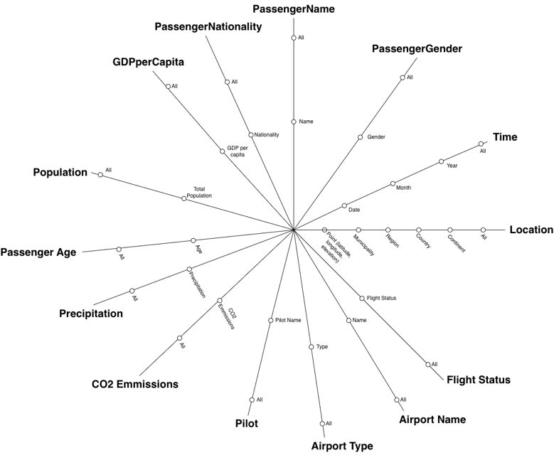

The StarNet also serves as a foundation for defining query footprints. Each business query traverses specific dimensions and hierarchies illustrated in the diagram, and for each of the business queries below that were discussed at the beginning of the project, please see a query footprint detailing how the information will talk to each other.

1. Find out if there’s a relationship between GDP_per_Capita and the delay and cancellation rate of flights in 2022.

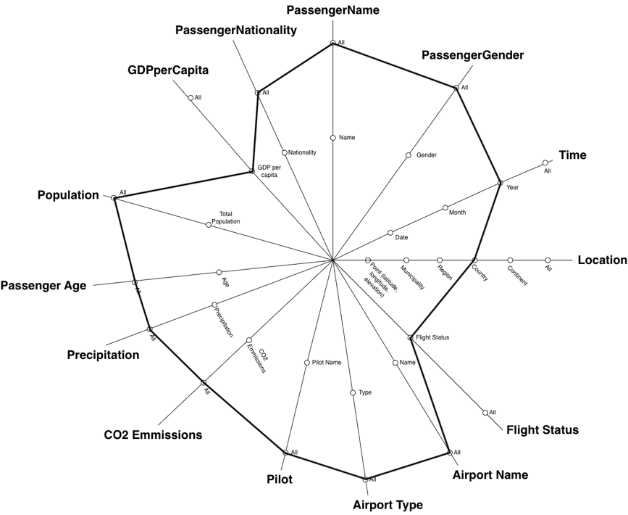

2. Find out if pilot performance (in terms of on time rate) is affected by different countries, airport types, and weather conditions?

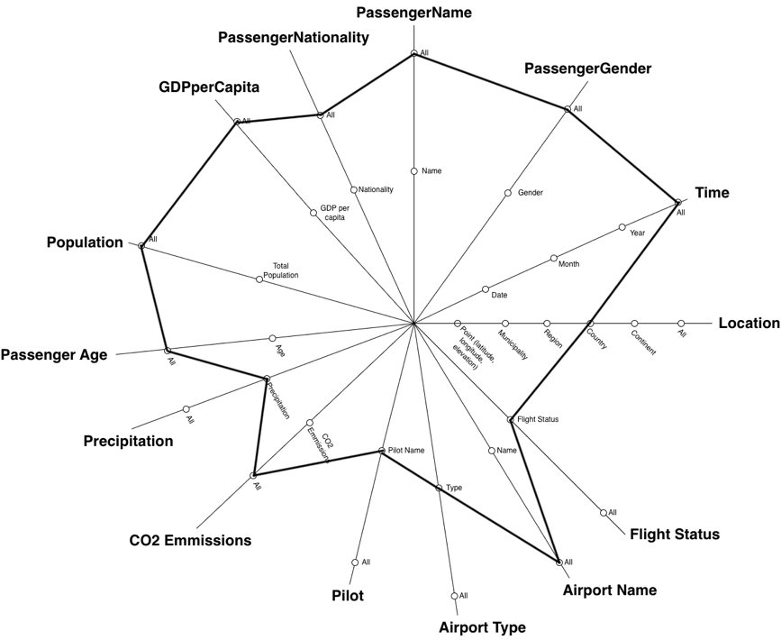

3. Find out how flight delays vary over different months and seasons across different continents.

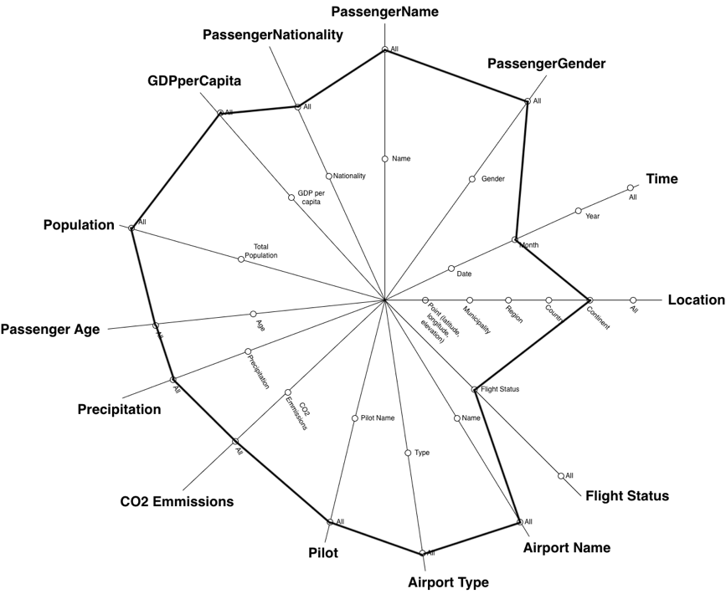

4. Find out if specific airports, regions and countries are more significantly prone to flight delays and cancellations than others.

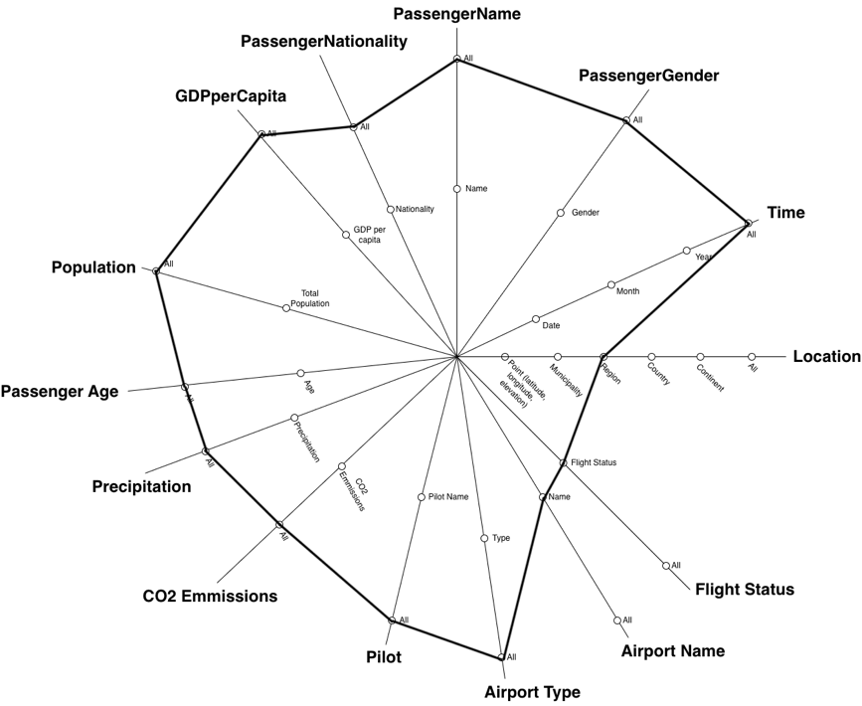

5. Find out if countries with larger populations tend to lead to an increase in flight delays or not.

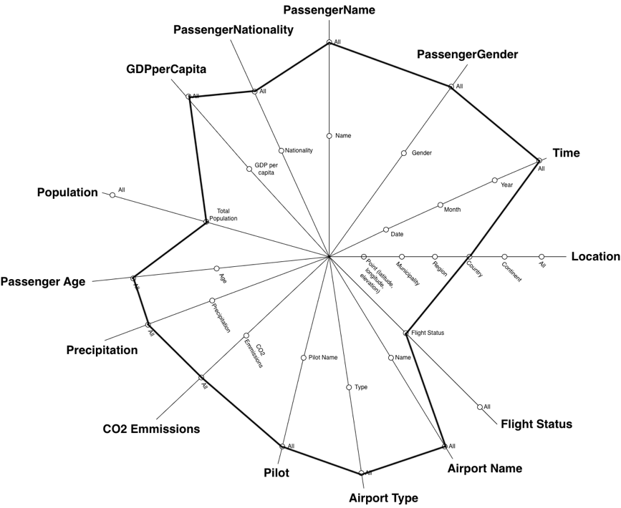

Population of the data warehouse
The Extract, Transform, Load (ETL) process was designed to ensure data quality, consistency, and analytical usability within the data warehouse. The process was implemented using Python, primarily using the pandas library for data manipulation. In order to guide the ETL process to ensure this quality, consistency, and analytical usability we used the following main ETL principles as the framework basis for the process:
- Data quality first: Invalid and inconsistent records are identified and handled early in the process.
- Consistency and standardisation: Attribute naming conventions and formats (ie dates) are standardised to ensure compatibility across tables.
- Minimal redundancy: Dimension tables are deduplicated to avoid unnecessary duplication of data, and information that is deemed useless for the data warehouses scope is removed.
- Extensibility: External datasets are integrated to enrich the analytical capability of the warehouse.
- Referential integrity: Foreign key relationships are preserved through careful key generation and mapping.
Below details the step-by-step process we took for our ETL phase, along with screenshots illustrating key points.

We first imported the primary dataset, Airline Dataset Updated - v2.csv, into a pandas DataFrame and treated it as the core transactional dataset (which we referred to as booking as each row contained information for a booking between a passenger and the airline).

Data Cleaning: Initial data cleaning focused on identifying and removing invalid or inconsistent records. The dataset structure was inspected using .info() to identify the missing values, and we checked for any invalid IATA airport codes by checking against the standard three-letter IATA format using regular expressions. These rows were then dropped to ensure that only valid and reliable records were retained for downstream processing. We considered alternative solutions to dropping the rows, such as using the information from other, complete, rows to reverse estimate the values missing, however we opted against this as we decided we did not have enough complete rows to estimate the missing values accurately enough for the scope/uses of this project/data warehouse.

Passenger Dimension Construction: Relevant passenger attributes were extracted and renamed to follow consistent naming conventions. We checked for any duplicate instances in order to confirm that each passenger was uniquely identified by their PassengerID, allowing direct construction of the dimension without further deduplication later down the line.

Airport Dimension Construction: The airport dimension was initially constructed using attributes from the primary dataset. We corrected the mislabelled Arrival Airport attribute and renamed it to represent the IATA code of the departure airport. To enhance this dimension, the external airport.csv data was integrated. We did this using a primary join with the IATA codes, and a fallback join using airport names for the unmatched records. Before merging, duplicate entries in the external dataset were removed to ensure data integrity. This allowed the additional attributes such as municipality, region, airport type, and geographic coordinates to be incorporated, significantly enriching the dimension.

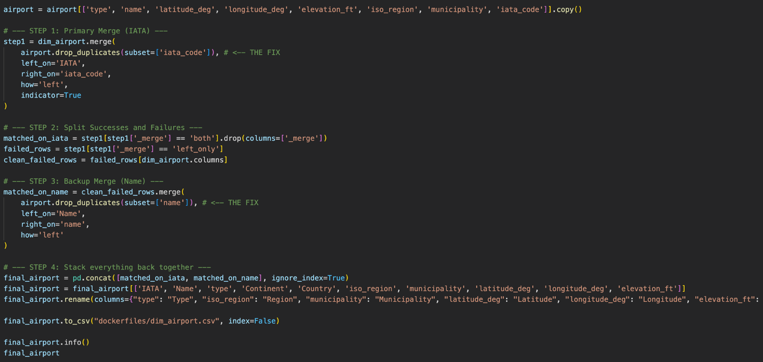

Pilot Dimension Construction: We needed to create a primary key for the pilot data as there was an absence of a natural unique identifier. In order to do this, we first removed duplicate pilot names under the assumption that identical names represent the same individual and created a surrogate key (PilotID). For the dimension, we opted to split up the pilot first and second names to ensure compliance with first normal form.

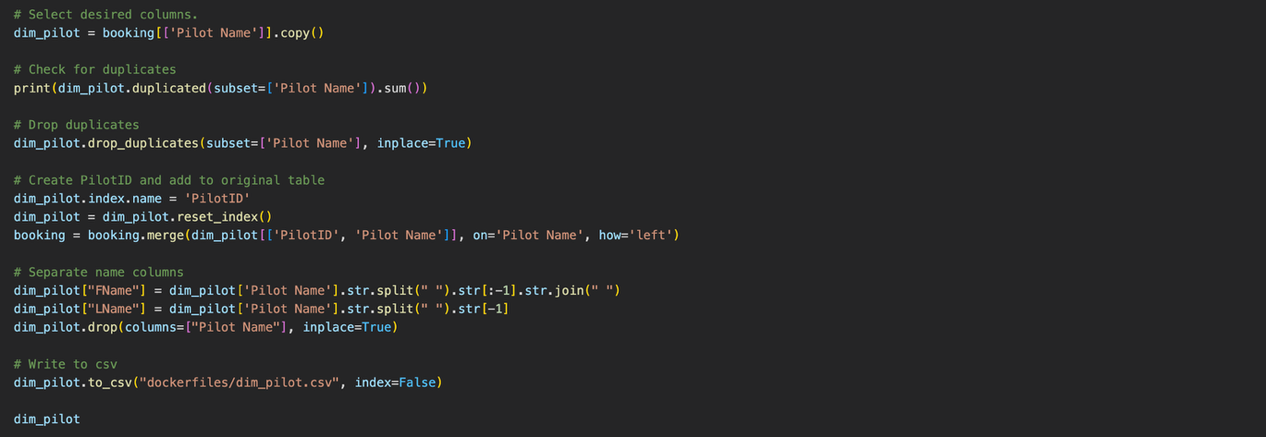

Flight Status Dimension Construction: We created a small categorical dimension by extracting the unique flight status values. Each status was assigned a unique identifier (FlightStatusID), which was then mapped back to the booking dataset to maintain referential integrity. We did this as we deemed it appropriate to put flight status into a separate dimension in order to comply with the principles surrounding fact tables, that values should always be numerical and measures.

Fact Table Construction: The fact table was constructed to align with the defined grain of one record per passenger per flight per departure date that we have kept at the front of all major stages of the data warehouse creation and implementation. We selected the relevant foreign keys and attributes from the primary booking dataset, and generated a unique BookingID for each record. We also felt it was appropriate at this time to standardise the date formats to ensure consistency and continuarity as we had decided to keep the date information as part of the booking fact table as a date may have zero or more bookings, so a date dimension or fact table would create unnecessary complications. This table serves as the central structure linking all dimensions.

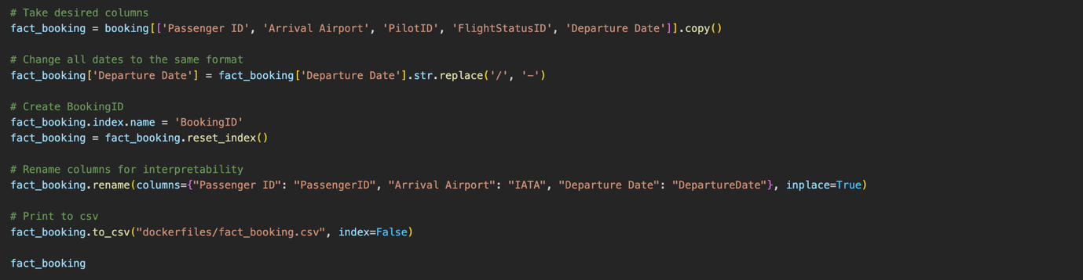

Data Enrichment, Country-Level Indicators: To further enhance the analytical capability of the data warehouse, we incorporated the World Development Indicators dataset (BLANK). The dataset was reshaped using a pivot_table operation to create a country-level dimension. During this initial part of creating the country dimension, we replaced placeholder for null/missing values “..” to empty strings to prepare for the next steps. From this dataset we wanted to take the GDP per capita, Total population, Average precipitation, and CO₂ emissions per capita.



Next, we dealt with country name inconsistencies using a mapping dictionary and missing countries were appended with null values to maintain referential integrity. These attributes enable advanced queries linking macroeconomic and environmental factors to flight performance.

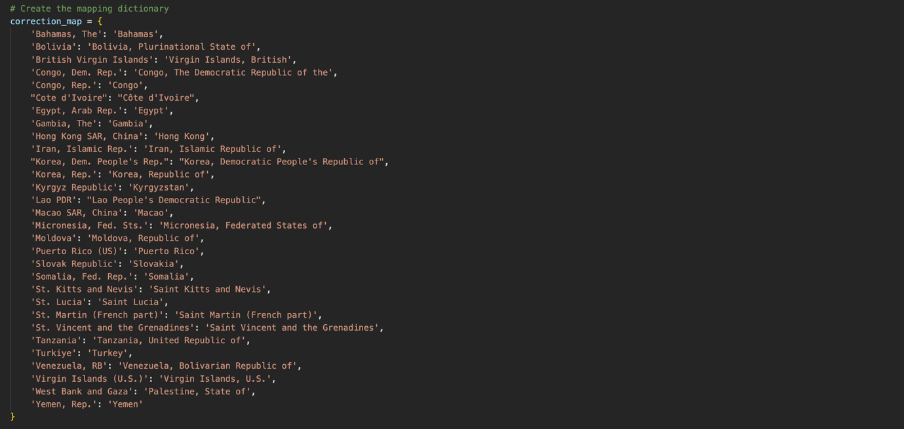

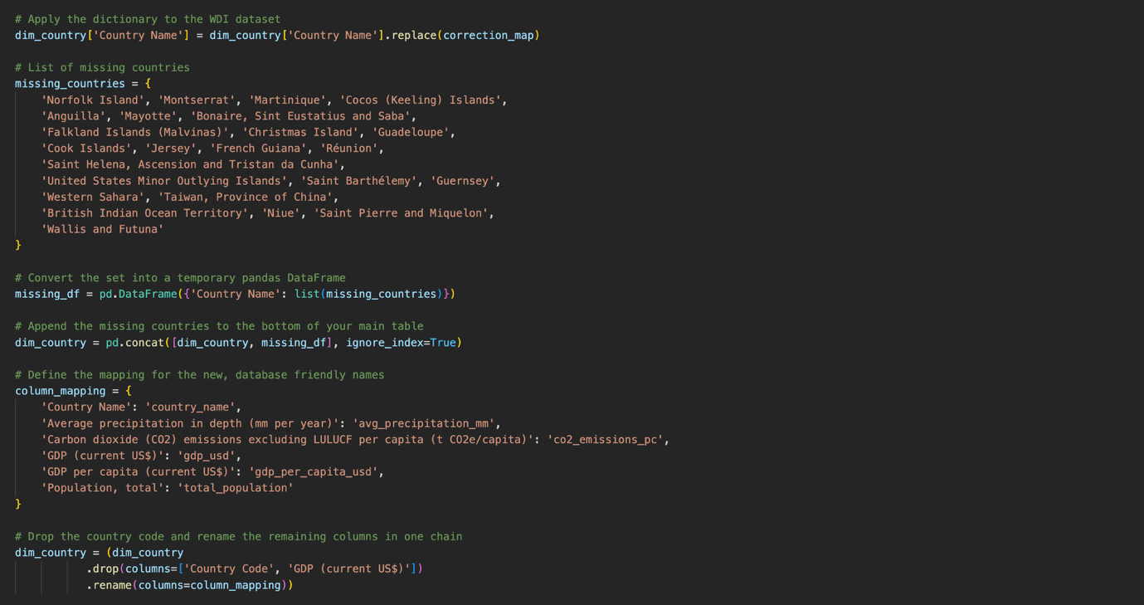

All dimension and fact tables were exported as CSV files and prepared for loading into PostgreSQL. Dimension tables were loaded first, followed by the fact table, ensuring that all foreign key constraints could be satisfied.

Query results and their visualisation
Present the findings from your business queries using appropriate charts, graphs, and other visualisations. Ensure the insights are clearly communicated and easily understandable to stakeholders.

Association rules mining
See the Association Rules Mining section in project description.

