Exercise 1_Morse

s214417 Lukas Schou

s214413 Christian Cederhorn

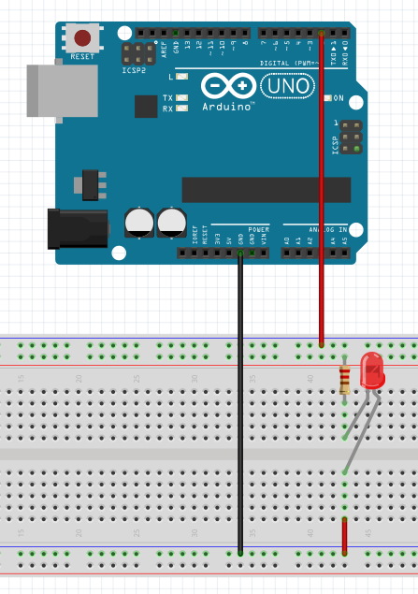

Questions

* 1a: Morse code uses 5 ”bits” for representing numbers 0-9, how many bits are needed if you would use binary? Why is this not possible in Morse code?

4 bits are needed for the numbers 0-9. 4 bits actually represent the numbers 0-15.

It is not possible because the 4 bits are reserved for the whole alphabet, so there are not enough bits for both the alphabet and the numbers 0-9.

* 1b: Try setting ledpin = LED BUILTIN, what happens?

The built in LED on the Arduino lights up instead of the external LED

* 1c: What is the value of a after the loop?

The value of a after the loop is 32, each equation in the loop is given as:

1+1=2

2+2=4

4+4=8

8+8=16

16+16=32