PROJECT TEST CONCEPT

  - Project need access to the GTest and GMock files framework
  - Good practice is dividing test files according to the source code files
  - Only one file can have main function
  - main function should have following code:
::testing::InitGoogleTest(&argc, argv);
return RUN_ALL_TESTS();

  - Each testing files should include gtest.h framework file

#include <gtest/gtest.h>

  - test file, which test particular source file, should include its header

#include <myPrint.h>

  - If source code is in C language, extern include keyword should be used

extern "C" {
#include <myPrint.h>
}

  - Test files are created in C++ language
  - Tests naming convention should be fixed in order to filtering, e.g. from myMath
module, test name start from myMath_*. It simplifies test execution filtering
  - Debugging tests in GDB is possible and very useful
  - It is good practice to create test project, only with testing files, as external project. Source files can be linked

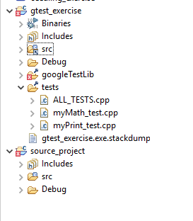

ECLIPSE TOOL CONFIGURATION
  - CDT plugin download eclipse CDT version or CDT plugin
  - install C/C++ Unit plugin "C/C++ unit testing support"
  - C/C++ compiler, recommended install cygwin and create project for cygwin compiler
(on Windows 10 platform)
  - install cygwin, Devel

CREATE PROJECT IN ECLIPSE IDE

Create project for unit tests

gtest_exercise
C++ project
Cygwin
g++

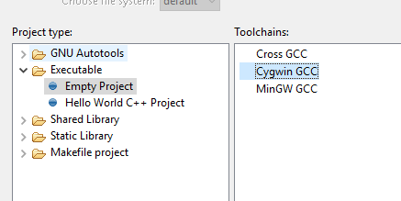

Google test and google mock library

  - download gtest and gmock framework from github library
https://github.com/google/googletest

  - launch python script:
python gtest/googlemock/scripts/fuse_gtest_files.py directory_to_lib_path_in_project
e.g.
python gtest/googletest/scripts/fuse_gtest_files.py ut_training/gtest_exercise/googleTestLib

  - Eclipse: refresh project

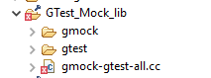

- include library folder to the compiler:
go to the Project Explorer
context menu (right click) on gTestLib folder

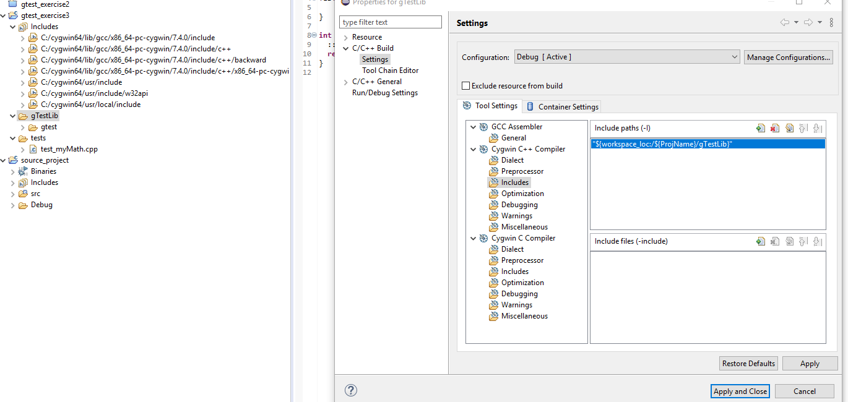

  - exclude library from the "release"
context menu: resource configuration
exclude

Add source project

go to the Project Explorer
context menu (right click)
link to the sources (in the external project), Browse
select src location

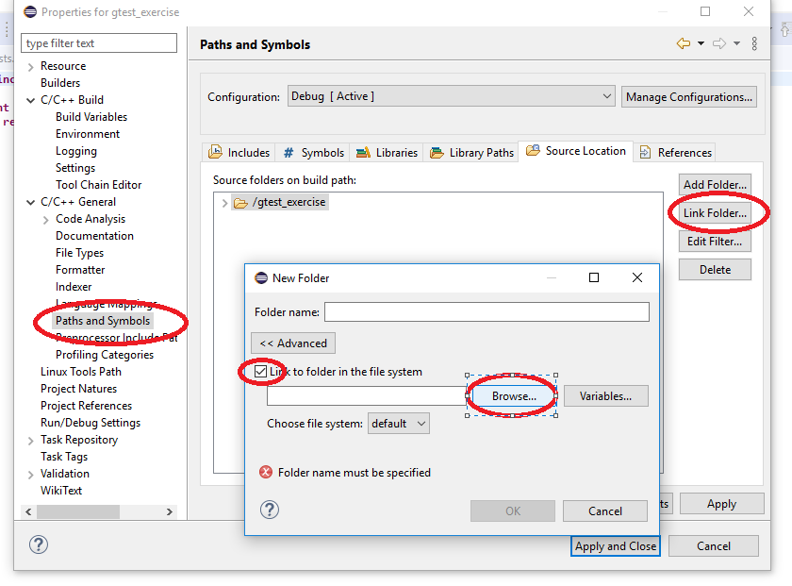

browse folder location with source and header files
test project has linked source src file

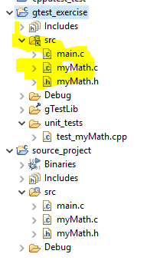

Include sources and library into /test directory
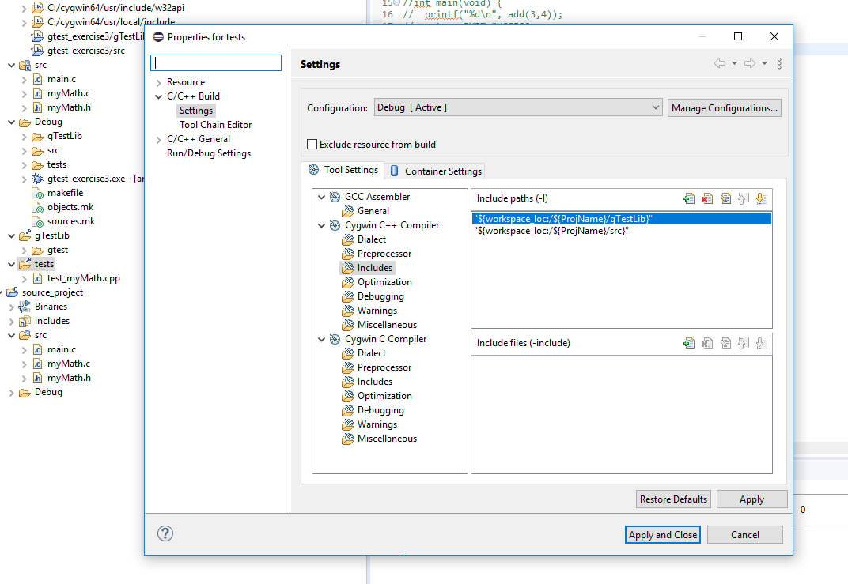

5. Add pthread library.
