**INSTYTUT PODSTAW INFORMATYKI**

**POLSKA AKADEMIA NAUK**

**STUDIA PODYPLOMOWE**

**PROGRAMOWANIE NA PLATFORMIE .NET**

Łukasz Dejko

Global Repository – aplikacja webowa do komunikacji

z repozytorium kont, serwerów i systemów.

Praca wykonana pod kierunkiem:

Pana Wiktora Wandachowicza

Warszawa dnia 17/12/2019

**OŚWIADCZENIE**

Oświadczam, że złożoną pracę końcową pod tytułem: Global Repository – aplikacja webowa do komunikacji z repozytorium kont, serwerów i systemów.

Napisałem samodzielnie. Jednocześnie oświadczam, że praca ta:

1. nie narusza praw autorskich osób trzecich w rozumieniu ustawy z dnia 4 lutego 1994 roku o prawie autorskim i prawach pokrewnych (tekst jednolity Dz. U. 2006 nr 90, poz. 631 z późn. zm.);
2. nie zawiera informacji i danych uzyskanych w sposób nielegalny, a w szczególności informacji zastrzeżonych przez inny podmiot albo stanowiących tajemnicę przedsiębiorstwa;
3. nie była wcześniej przedmiotem innych procedur związanych z uzyskaniem dyplomów/świadectw lub tytułów zawodowych wyższych uczelni. Nadto oświadczam, że treści zawarte w pisemnym egzemplarzu pracy oraz w egzemplarzu tej pracy w formie elektronicznej, złożonych przeze mnie, są jednobrzmiące.

Przyjmuję do wiadomości, że w przypadku stwierdzenia popełnienia przeze mnie czynu polegającego na przypisaniu sobie autorstwa istotnego fragmentu lub innych elementów cudzej pracy, lub ustalenia naukowego, właściwy organ stwierdzi nieważność postępowania w sprawie nadania mi tytułu zawodowego (art. 193 ustawy z dnia 27 lipca 2005 r. Prawo o szkolnictwie wyższym, tekst jednolity Dz.U. z 2012 r., poz. 572 z późn. zm.).

………………………………

data i podpis

**List of contents**

Description of the project assumptions

Objective of the project

Identification of market needs

Technical data concerning used technologies

User documentation

Conclusions

Bibliography

1. **Description of the project assumptions**

The source code of the project is available at the following links :

1. Database project

<https://github.com/lukaszFD/IPI-PAN_WEB_API/tree/master/GlobalRepository/DB_GlobalRepository>

1. Database model in Entity Framework

<https://github.com/lukaszFD/IPI-PAN_WEB_API/tree/master/GlobalRepository/DB_ModelEFCore>

1. Web Api project

<https://github.com/lukaszFD/IPI-PAN_WEB_API/tree/master/GlobalRepository/GR_WebApi>

* 1. **Objective of the project**
     1. The purpose of the project is to create a system that will be an interface of web communication with the repository of accounts storing information about: systems, servers and access. It will be a bridge between other systems and will manage only this information.
     2. The second purpose of this project will be to design a very flexible interface in which changes can be implemented quickly and with little involvement of the development team.
  2. **Identification of market needs**

Global repository of accounts is a product available internally in the largest corporations that want to transparently manage user accounts where information about servers and systems is stored. The application is to be used by other programmers as a flexible tool for implementation in their environments. One of such environments is a portal to order access to specific servers or purchase new operating systems installed on these servers. Flexibility and simplicity in using this repository is the key to success in programming your own interfaces, and the main arguments are :

1. The user documentation is available in the web communication and contains a description of all the columns that are available in the global repository.
2. Programmers who will develop a global repository have a simplified task due to the description of all the methods and classes that are included in the EF database project and the WebApi project.
3. Global repository contains reports: data audit, reconciliation of data coming from external sources, errors in data reconciliation.
4. The repository is very flexible, and the implemented mechanism of paging and limiting returned data is executed in multiple threads.
5. Programmers who will analyze errors have a simplified task because every operation performed in web api is logged.
   1. **Technical data and used technologies.**

During the design and programming works I used the most popular tools provided by Microsoft, Datadeo and Github.

Installed tools :

1. Microsoft SQL Server Express (64-bit) version 14.0.1000.169
2. Microsoft Visual Studio Community 2019 version Version 16.4.1
3. Datadeo version 7.5.4
4. GitHub Desktop version Version 2.2.4

Technologies used:

1. Programming language C# version 7.3
2. Database : Entity Framework Core 2.2
3. Web Api project made in .Net Core 2.2
4. Database project made on : SQL Server 2017
5. **User documentation** 
   1. For proper operation of Web Api it is necessary to provide the password and login of registered users in the header of the query. The profile of the user who has the ability to create other user accounts is the Global Repository Administrator. There can be many administrators. Before you start using the repositories, you should apply for such access. Each company has a different interface to process such queries. Data on user types is stored on a global repository database.
   2. A Swagger interface has been implemented to show users how the Global Repository WebApi works.

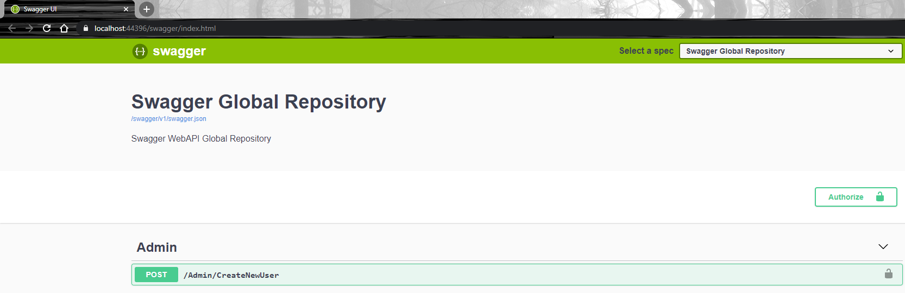

* 1. Password and login should be entered after clicking on the "Authorize" button in the upper legal corner.

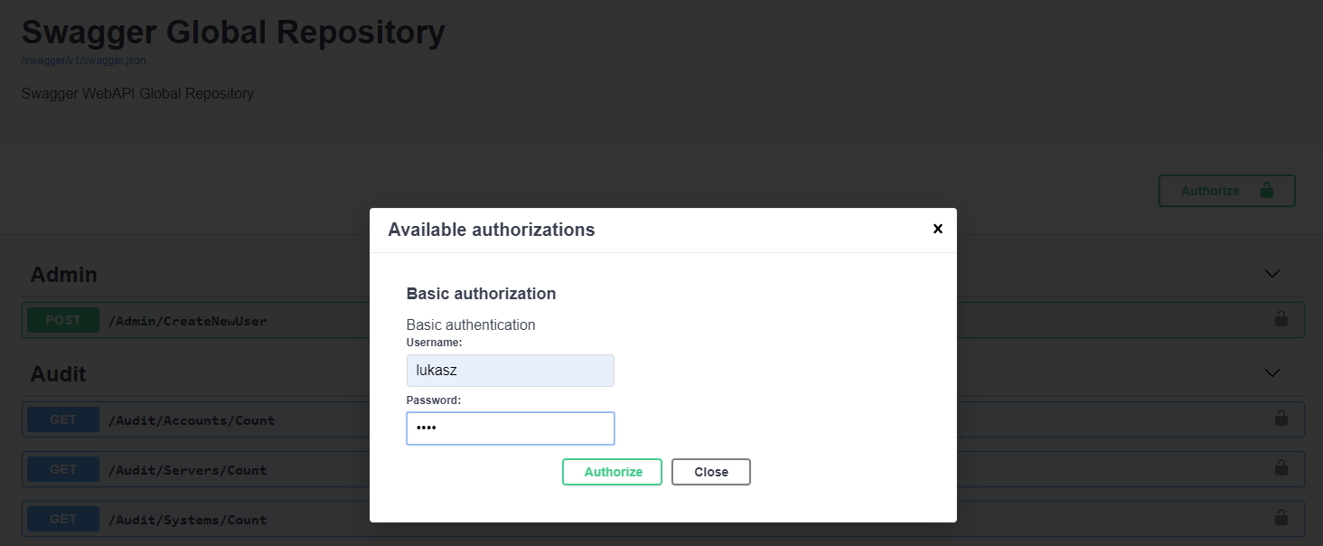

1. **Conclusions**

Training material which I received during the postgraduate studies "Programming on the .Net platform" and workshops with specialists in object-oriented programming allowed me to create a web application "Global Repositories" of accounts, servers and systems. One of the biggest advantages of such projects is to learn the basic principles of object-oriented programming on the .net platform, project management and source code management. Currently, the level of my advancement in the design and development of web applications has definitely increased.

Web application which I created is a simple but comprehensive solution for every company that in its portfolio manages data and information about the infrastructure. With simplicity in access to data and the ability to easily check the documentation on how to use Web Api "Global Repository" is a very easy tool to implement in any system.

While working on the application I encountered many problems, especially related to the lack of experience in using the capabilities offered by the .Net Core platform. I encountered many optimization and functional difficulties. Therefore, I used Microsoft documentation, online courses and actively used the "Stackoverflow" platform. However, not all the plans and assumptions contained in the Vision document were implemented.

Despite minor complications, I managed to create a very good web application. I can certainly say that the design of the database, the entity framework database model and the application itself is at a high level of code advancement.

1. **Bibliography**
   1. Microsft's documentation on .Net Core 2.2

<https://docs.microsoft.com/pl-pl/aspnet/core/?view=aspnetcore-2.2>

* 1. Stackoverflow

<https://stackoverflow.com/questions/59321310/easy-basic-page-numbering-and-limiting-the-size-of-returned-data-in-the-net-cor>

* 1. Course C#, .net Core WebApi on YouTube

<https://www.youtube.com/channel/UC-ptWR16ITQyYOglXyQmpzw>

* 1. Microsoft’s database project documentation

<https://docs.microsoft.com/en-us/visualstudio/data-tools/create-a-sql-database-by-using-a-designer?view=vs-2019>

* 1. Język C# 6.0 i platforma .NET 4.6 Troelsen Andrew, Japikse Phiplip