Global Repository WebAPI

Vision

Version 1.3

**List of contents**

1. Introduction………………………………………………………………………………..2
2. Positioning……………………………………………………………………...…………2
   1. Problem Statement…..…………………………………………………………….2
3. Stakeholder Descriptions …………………………………………………………………2
   1. Stakeholder Summary……………………………………………………………..2
   2. User Environment…………………………………………………………………3
4. Product Overview…………………………………………………………………………3
   1. Needs and Features………………………………………………………………..3
   2. Other Product Requirements………………………………………………………4
   3. Requirements not implemented…………………………………………………...4
   4. Design restrictions………………………………………………………………...5
   5. Requirements relating to the working environment……………………………….5
5. Database design……………………...……………………………………………………6
   1. Main tables of the repository……………………………………………………...6
   2. Audit tables………………………………………………………………………..7
   3. Reconciliation tables for web-based communication data………………………..7
6. Related documents ………………………………………………………………………..8
7. Document history………………………………………………………………………….8

# Introduction

The document concerns a project implemented at postgraduate studies at the Polish Academy of Sciences in the field of: "Programming on the .NET platform". This document is used to present the system of web communication with the repository of accounts that stores information about : systems, servers and accesses. This system will be a bridge between other systems and will only manage this information and will be used for statistical and change reporting purposes. In this project I will use the latest technologies available in Microsoft.

# Positioning

## Problem Statement

|  |  |
| --- | --- |
| The problem of | The problem with current interfaces is the performance and ease of implementation of changes. |
| affects | The users of this interface will be business users who want to manage data by transferring and receiving data using json files. |
| a successful solution would be | The assumption of this project will be to design a very flexible interface in which changes can be made quickly and with a small contribution from the development team. |

# Stakeholder Descriptions

## Stakeholder Summary

| **Name** | **Description** | **Responsibilities** |
| --- | --- | --- |
| Programmers | Programmers who have the skills to implement such systems and data processing. | 1. They will read the user documentation before using the system. 2. In order to ensure proper functioning of the system, it is necessary to create a login and password that will be used during the authorization of queries. 3. During the implementation of the system, they will test all new solutions on the development environment. |

## User Environment

# The web communication environment is so flexible that it will be possible to use this interface on all platforms, but it will be mainly Microsoft environment. The user will be able to use the application through the mechanisms of web pages. There are no limitations as to the choice of the Internet browser.

# The environment in which the web communication interface will be built is .net Core MVC, and the main programming language to be used on the beckend side will be C# and on the database side TSQL. The user documentation will be created using HTML.

# Environment version : ASP.NET Core 2.2

# Database environment version : SQL Server 2017

# Database model mapping : Entity Framework Core

# Product Overview

## Needs and Features

Priority markings:

1 - the minimum that the created application will have

2 - functionalities that are expected to be implemented

3 - functionalities that will be implemented after the production implementation of the application

|  |  |  |  |
| --- | --- | --- | --- |
| **Need** | **Priority** | **Features** | **Planned Release** |
| Database design (tables, constraints) | 1 |  | December 2019 |
| Create sequences and triggers that support database events | 1 |  | December 2019 |
| Implementation of the database model in the interface project | 1 |  | December 2019 |
| Creation of the login and authorization process | 1 |  | December 2019 |
| Creating user documentation accessible from the web api level | 1 |  | December 2019 |
| Saving Web Api errors and user activity to a log file. | 1 |  | December 2019 |
| The ability to create accounts from the administrator level. | 1 |  | December 2019 |
| Error and exception handling for Web Api | 1 |  | December 2019 |
| Multithreaded query processing in web Api | 1 |  | December 2019 |

## Other Product Requirements

|  |  |  |
| --- | --- | --- |
| **Requirement** | **Priority** | **Planned Release** |
| User changes in data reconciliation will be saved in audit tables (sql server) | 1 | December 2019 |
| Simultaneous operation of multiple users at the same time in Web Api | 1 | December 2019 |
| Possibility of downloading a report on errors in data reconciliation | 1 | December 2019 |
| Implementation of the Swagger interface for Web Api tests | 1 | December 2019 |
| Creation of a database design with the possibility of easy implementation of these solutions by the built-in interface Visual Studio 2019 | 1 | December 2019 |

## Requirements not implemented

|  |
| --- |
| **Requirement** |
| Connection to Active Directory |
| Sending e-mail correspondence confirming the changes. |
|  |

**4.4 Design restrictions**

The main obstacle is the time in which the project will be implemented. The implementation of functionalities with priority 3 may not be possible within the set time frame. The second limitation is the small experience of the person who designed and implemented the project. This may cause the work to be incomplete. A significant difficulty may also be the fact that the creator of this document runs several other projects at the same time. This fact may lead to unsystematic reporting on the progress of work and a greater number of errors, especially in the testing phase.

**4.5 Requirements relating to the working environment**

These requirements include software maintenance costs and time costs associated with the need to monitor system operation, view logs from user traffic and solve emerging errors. It will also be necessary to undertake optimization actions in the event of a sudden increase in the number of users.

# Database design

**5.1 Main tables of the repository**

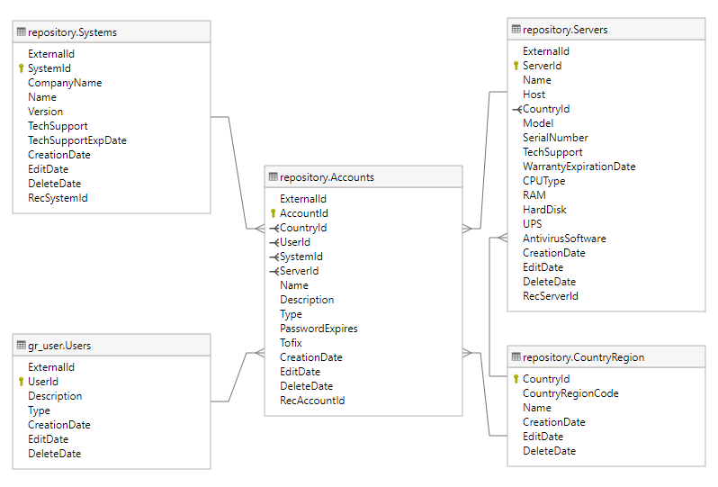

# 5.2 Audit tables

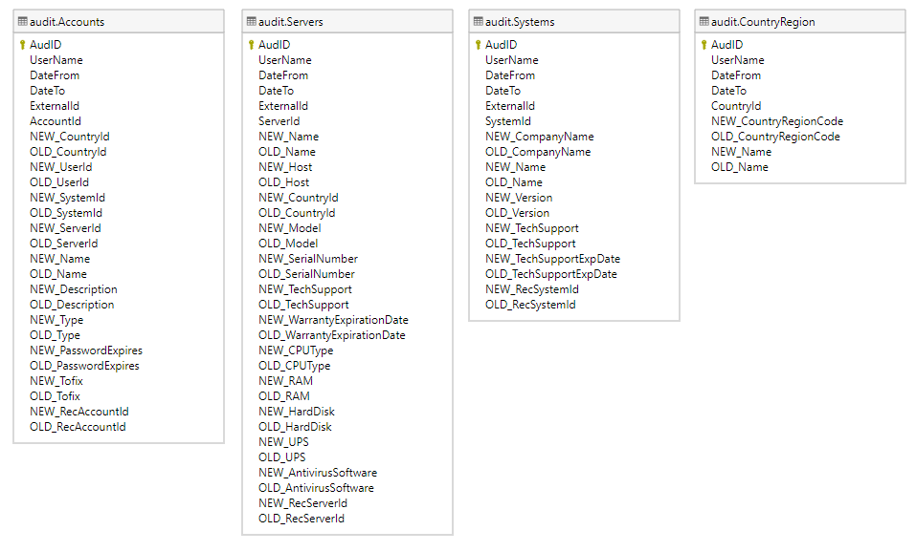

**5.3 Reconciliation tables for web-based communication data**

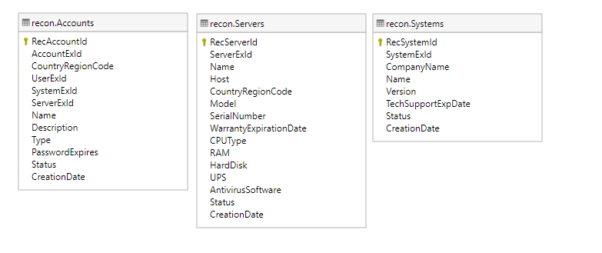

# Related documents

The Project Vision is the first document to present a description of the project's functionality and its implementation plan. Currently, there are no other documents related to the Project Vision.

# Document history

|  |  |  |  |
| --- | --- | --- | --- |
| **Date** | **Version** | **Description** | **Author** |
| 18/05/2019 | 1.0 | Creation of the Vision Document | Łukasz Dejko |
| 01/09/2019 | 1.1 | Change of the database environment. | Łukasz Dejko |
| 02/12/2019 | 1.2 | Adding a database schema and updating the vision document. | Łukasz Dejko |
| 17/12/2019 | 1.3 | Final version of web api | Łukasz Dejko |