Tworzenie stacków

Import-export

<http://website-export-import-website-dev-s3website-ph0b4wvlefsc.s3-website.eu-central-1.amazonaws.com/>

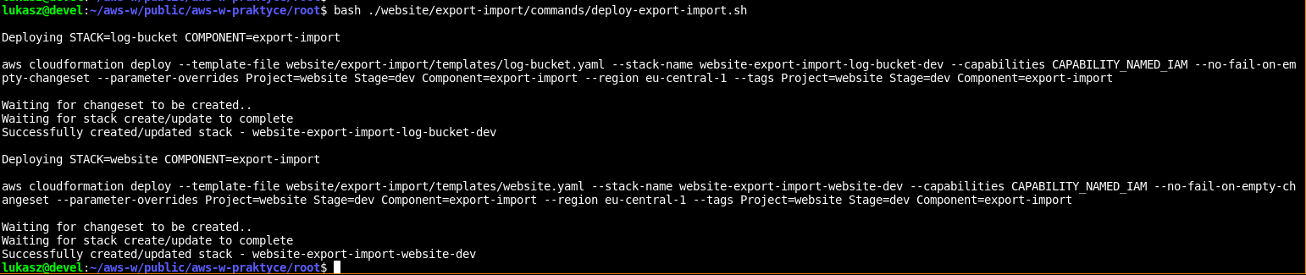

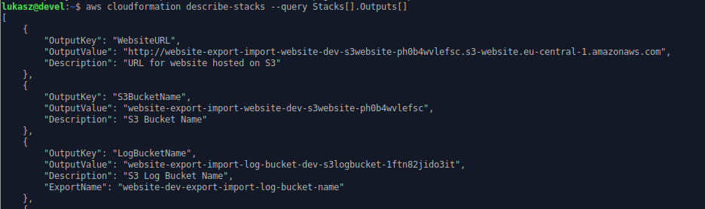



Parametrized

<http://website-parametrized-website-dev-s3website-abtz3gmo1sum.s3-website.eu-central-1.amazonaws.com/>

