E-Commerce System Architecture
MCP Documentation Server
25 listopada 2025
Table of Contents

E-Commerce System Architecture Documentation

Overview
This document describes the architecture of our e-commerce platform, including system boundaries, external integrations, and internal components.

System Context
The following diagram shows the high-level context of our e-commerce system:
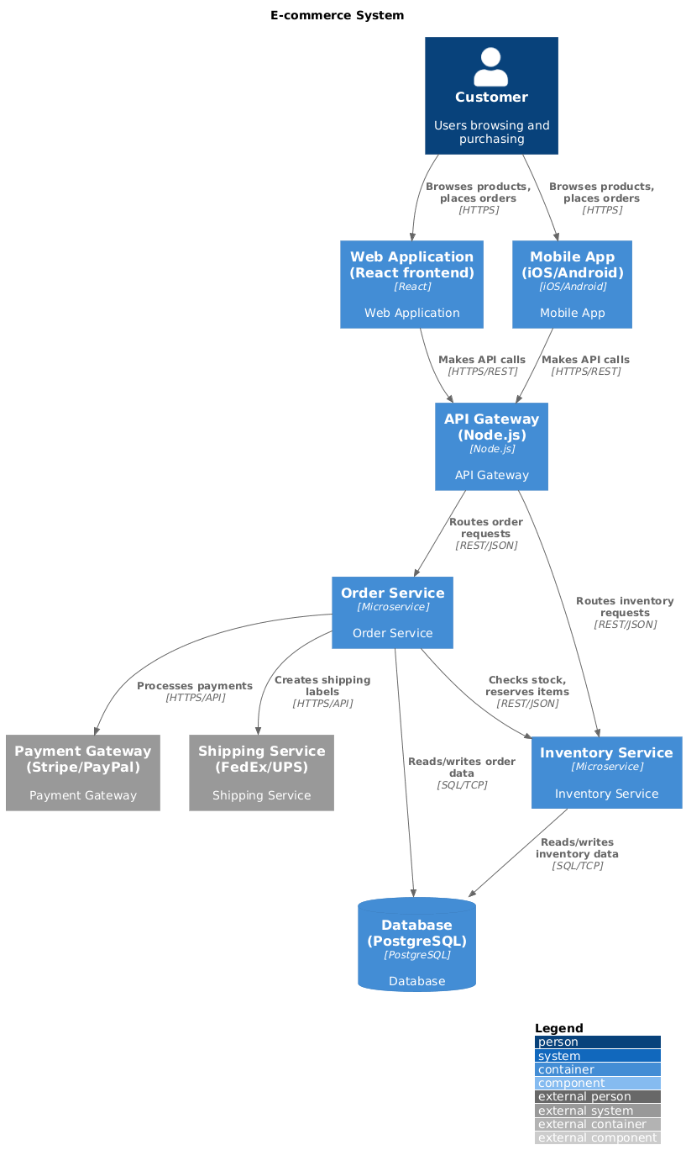
C4 Context Diagram
Figure 1: C4 Context Diagram showing external systems and main e-commerce platform

External Systems
- Users: Customers browsing and purchasing products
- Payment Gateway: External payment processing (Stripe/PayPal)
- Shipping Service: External delivery service (FedEx/UPS)

System Boundary
The E-Commerce Platform includes: - Web Application (React frontend) - Mobile App (iOS/Android) - API Gateway (Node.js) - Order Service - Inventory Service - Database (PostgreSQL)

Architecture Decisions

Technology Stack
- Frontend: React.js for web, React Native for mobile
- Backend: Node.js with Express for API Gateway
- Services: Python for business logic services
- Database: PostgreSQL for primary data store
- Cache: Redis for session management

Communication Protocols
- HTTPS for external communication
- REST API for service-to-service communication
- WebSocket for real-time updates

Next Steps
- Implement microservices architecture
- Add monitoring and logging
- Set up CI/CD pipeline
- Deploy to production

