CLOUDCORE SOLUTIONS
Advanced Cloud & Data Analytics
Response to Request for Proposal
Migration & Modernisation of Manga's Data Architecture to the Cloud
The Manga DataHub — a cloud-native AWS data lakehouse
Submitted to: Manga S.L. — Barcelona, Spain
IE University · MBD-EN2025 · Data Analytics in the Cloud · Group Work Option B
Prepared by: Andrea Alarcón Valles · Mateus Carneiro · Tina Jannasch ·
Ricardo Liévano Pedroza · Luka Tcheishvili · Nicklas Urban
v2.0 — Final Proposal · Confidential

Table of Contents
1. Executive Summary 3
2. High-Level Architecture 4
3. Low-Level Architecture 5
4. Project Implementation 6
5. Sample Use Cases 8
6. Future Improvements 9
Appendix 10

1. Executive Summary
Manga stands at an inflection point. With annual revenues of €280 million across 100+ stores worldwide, the brand has a strong foundation — yet growth of only 3.5% trails the market, online sales grew just 1.2% year-over-year, and the company spends roughly twice as much as competitors for half the analytical output. The root cause is architectural: independent ETL pipelines triggered by daily cron jobs, aggregated into Excel files shared once per day, cannot power the real-time, personalised experiences modern retail demands.
CloudCore Solutions proposes the Manga DataHub — a cloud-native AWS data lakehouse that replaces this legacy stack with a unified, scalable, secure platform built around three strategic pillars:
- Unify — centralise every data source into a single governed platform, replacing siloed pipelines and manual Excel reporting.
- Accelerate — cut time-to-insight from 24 hours to sub-second, enabling live inventory, sales dashboards, and fraud detection.
- Enable — deliver the ML features on Manga's roadmap (recommendations, dynamic pricing, demand forecasting, virtual assistant) impossible today.
The solution is built entirely on AWS using open-source tooling (Apache Airflow, Apache Spark, open Parquet) to guarantee portability and eliminate vendor lock-in — directly addressing the CTO's concerns. Three isolated environments (Dev, Pre-Prod, Prod) are provisioned from identical Infrastructure-as-Code templates, with anonymised production samples in non-production. Security is designed in from day one: column-level access control, automated PII scanning, KMS encryption, and full GDPR audit trails.
Expected outcomes within 12 months: a 40–60% reduction in infrastructure cost versus the colocation model, real-time reporting replacing the daily batch cycle, and the first ML use cases live within six months of kickoff.

Current State vs. Manga DataHub
Dimension | Current State | With Manga DataHub
Reporting lag | 24 hours (daily batch) | Sub-second (real-time streaming)
Infrastructure cost | ≈2× competitor average | Projected 40–60% reduction
BI access | Manual Excel files | Self-service dashboards
ML capabilities | None | Forecasting, recommendations, pricing
Data environments | Single (production only) | Dev / Pre-Prod / Prod (isolated)
GDPR compliance | Unclear | Automated PII scanning & masking

2. High-Level Architecture
The Manga DataHub is organised into five core layers with three cross-cutting concerns and a clear separation between batch and streaming paths. This conceptual view is technology-agnostic; each decision is grounded in foundational cloud-analytics principles.

Architectural Layers
- Data Sources — POS/ERP transactional data, web & mobile event streams, CRM/loyalty records, and external APIs spanning structured, semi-structured, and unstructured modalities.
- Ingestion — a streaming path for real-time events and a batch path for scheduled loads, plus a decoupled API-connector layer so new sources are added without touching existing pipelines.
- Storage — the Lakehouse — a three-zone medallion model: Raw (immutable system of record), Curated (cleaned, validated, PII-masked), and Serving (pre-aggregated, query-optimised).
- Processing — distributed transformation, DAG-based orchestration replacing all cron jobs, automated post-pipeline data-quality checks, and a central catalog for lineage and discovery.
- Consumption — self-service BI dashboards, a managed ML environment with a feature store, and secure versioned APIs for partners and AI agents.

Cross-Cutting Concerns
Security & Compliance (encryption, RBAC, PII detection, GDPR audit, threat detection), Infrastructure-as-Code & Automation (version-controlled, three identical environments), and Cost & Sustainability (auto-scaling, lifecycle archiving, per-service carbon tracking) apply across every layer — not as optional add-ons.

Design Principles
Principle | Application in Manga DataHub
Separation of Concerns | Each layer has a single responsibility; storage is decoupled from compute.
Modularity | New sources, jobs, and models are isolated modules — a failure in one does not cascade.
Elasticity | Compute scales automatically; a Fashion-Week spike needs no manual intervention.
Scalability | Handles current volumes and the 10× growth from international expansion.
Open Standards | Parquet, Airflow, Spark — open formats and tooling at every layer; no lock-in.
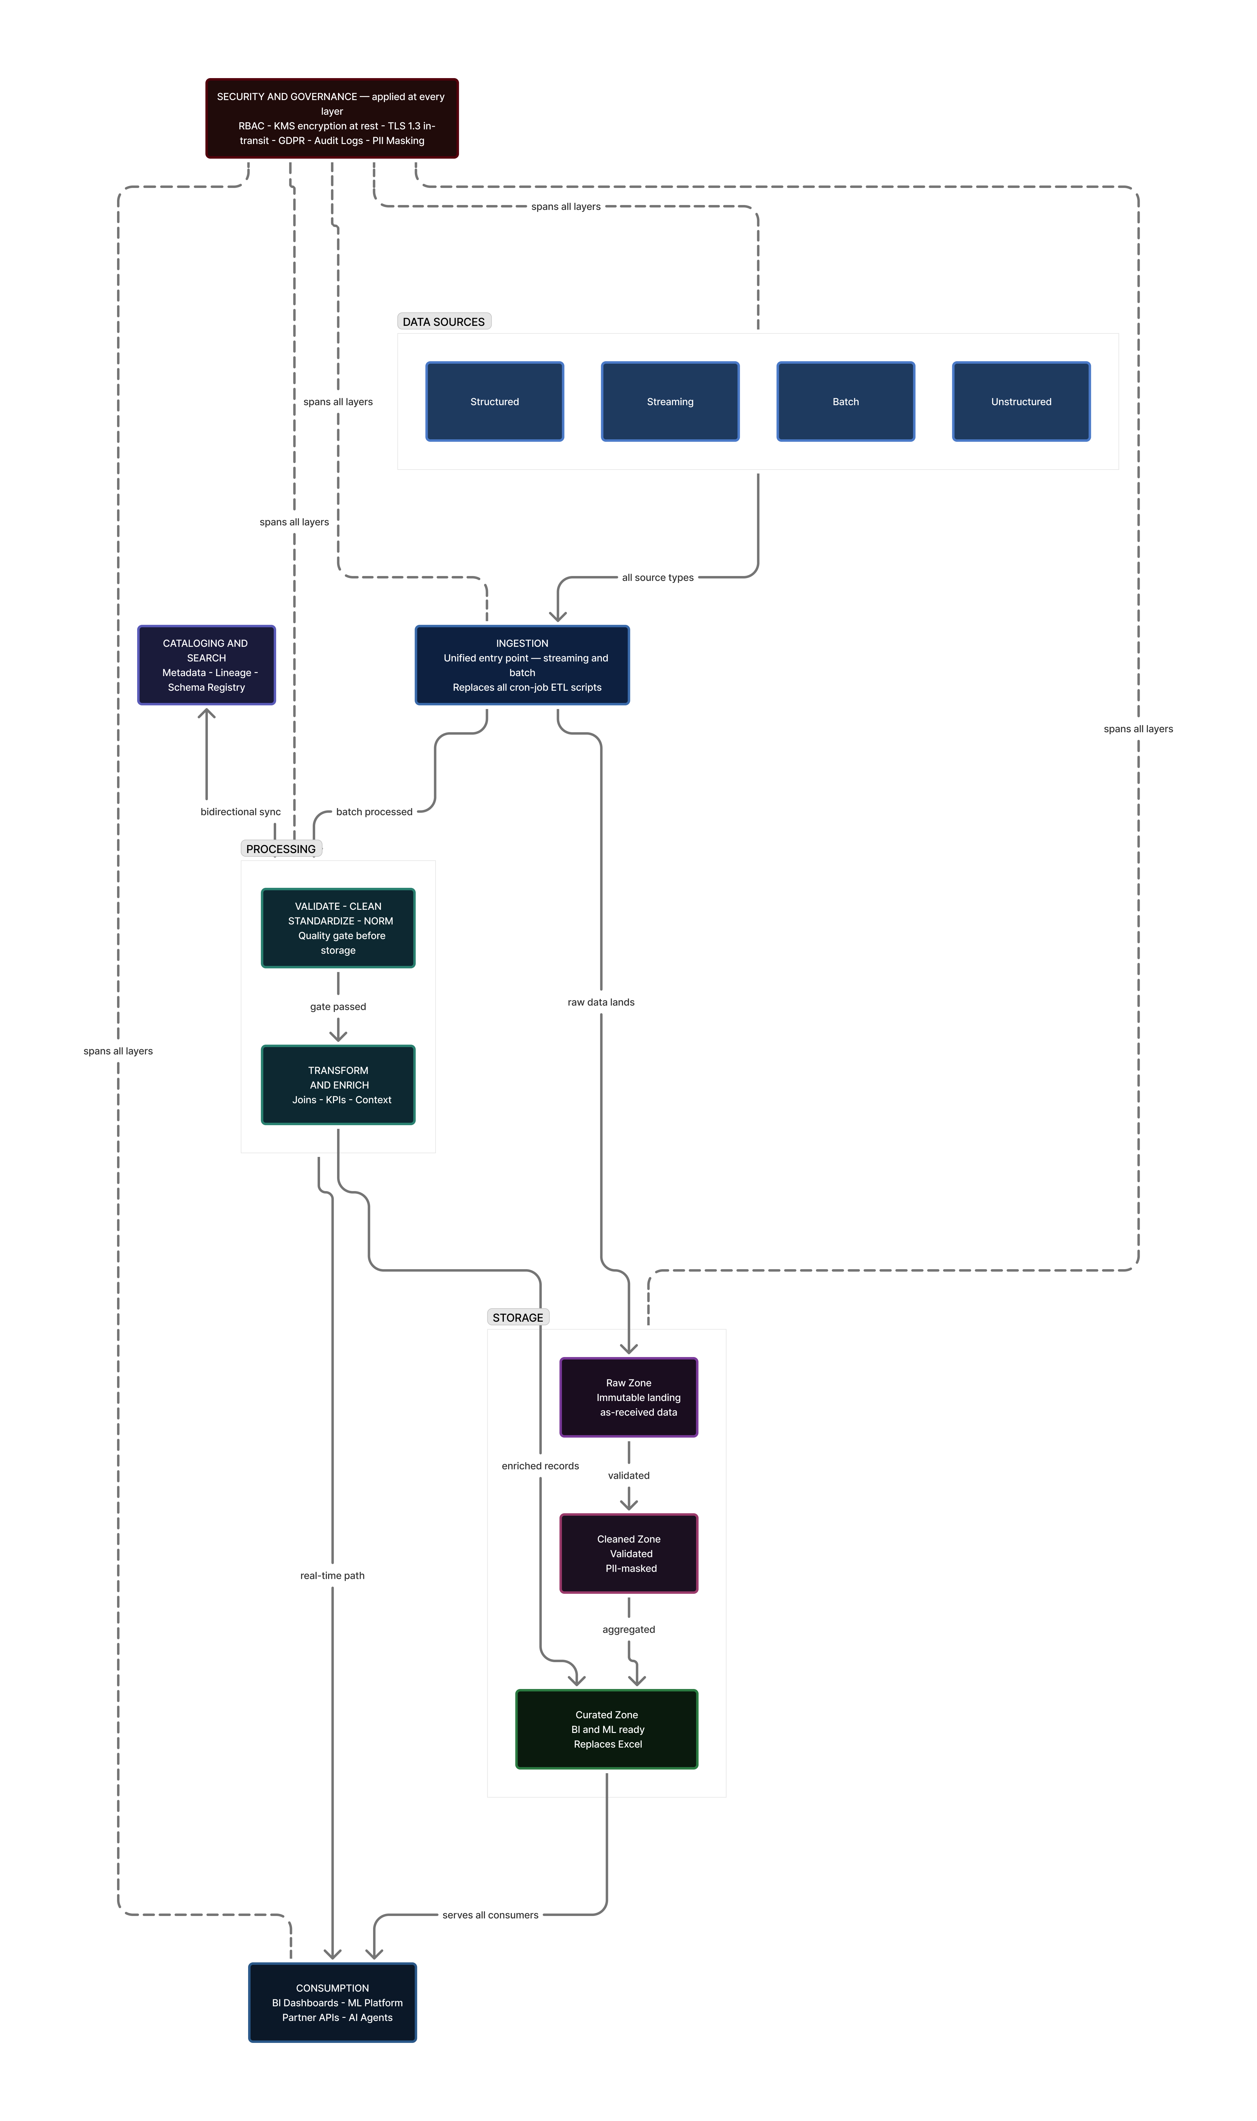
Figure 1 — High-Level Architecture (technology-agnostic).

3. Low-Level Architecture
The conceptual layers map to specific AWS services, each chosen for performance, operational reliability, cost model, and requirement fit.

Ingestion
- Amazon Kinesis Data Streams + Firehose — sub-second ingestion of POS and web events; Firehose delivers micro-batches to S3 in Parquet (R1, R3).
- AWS Glue ETL — managed Spark replacing hand-coded batch scripts; job bookmarks prevent duplicate processing (R1, R3).
- AWS Lambda + EventBridge — serverless connectors for third-party APIs; new sources are new functions, no pipeline changes (R7).
- AWS DMS — one-time historical migration plus CDC replication for zero-loss cutover (R3, R4).

Storage
- Amazon S3 — three-zone lakehouse — Raw, Curated (PII-masked Parquet), Serving; Intelligent-Tiering cuts cold-storage cost; open format means zero lock-in (R1, R6).
- Amazon Redshift — columnar warehouse; Spectrum queries S3 directly; RA3 decouples compute and storage (R1, R6).
- Amazon DynamoDB — sub-10ms lookups for ML inference and the virtual shopping assistant (R1, R7).

Processing & Governance
- Glue Data Catalog, Amazon MWAA (Airflow orchestration replacing cron), Glue Data Quality, Lake Formation (column/row RBAC, GDPR), and Amazon Macie (ML-powered PII scanning).

Consumption & Cross-Cutting
- Consumption: QuickSight (BI), SageMaker (ML), Comprehend (NLP sentiment), Athena (serverless SQL), API Gateway + Lambda (versioned external APIs).
- Cross-cutting: IAM + KMS (TLS 1.3, encryption at rest), Terraform/CDK (IaC), CloudWatch + SNS (monitoring), AWS Organizations (isolated accounts), Carbon Footprint Tool (R8).
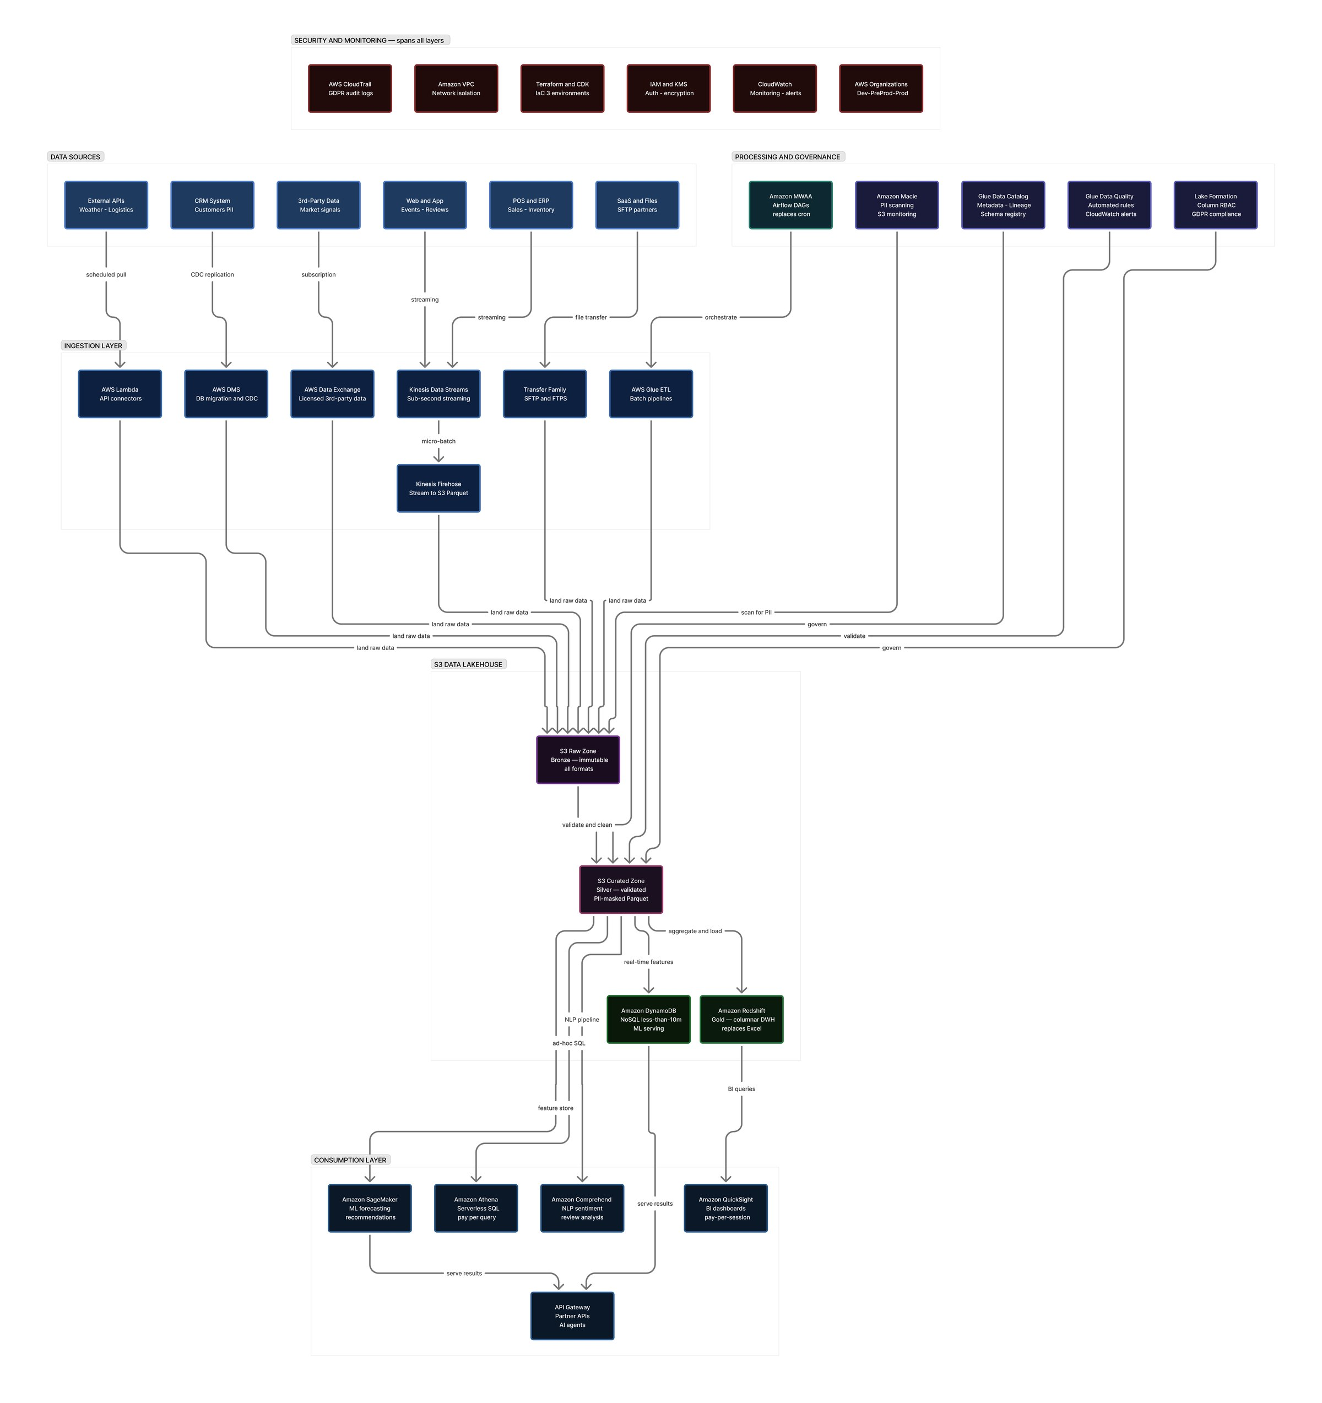
Figure 2 — Low-Level Architecture mapped to AWS services.

4. Project Implementation

Requirements Traceability (R1–R8)
Req. | Requirement | How it is addressed
R1 | Unified multi-modal platform | S3 lakehouse + Redshift + DynamoDB store all data modalities; Kinesis (streaming) and Glue (batch); a single Glue Catalog provides unified access.
R2 | Multi-environment setup | AWS Organizations provisions Dev / Pre-Prod / Prod from identical Terraform templates; Glue masking + Lake Formation replicate anonymised samples to non-prod.
R3 | Automation & IaC | MWAA replaces cron with monitored DAGs; Terraform/CDK automates infrastructure; Glue bookmarks and S3 lifecycle policies automate the data lifecycle.
R4 | Security & high availability | IAM least-privilege, KMS encryption, Lake Formation RBAC, Macie PII scanning, CloudTrail audit, multi-AZ; target 99.9% uptime.
R5 | Data quality | Glue Data Quality rules run post-pipeline; failures trigger CloudWatch/SNS alerts before bad data reaches consumers.
R6 | Cost optimisation | Pay-per-use vs. fixed colocation; Intelligent-Tiering, Spot Glue, Redshift RIs, QuickSight per-session — projected 40–60% reduction (see figure).
R7 | Extensibility & interoperability | Decoupled Lambda connectors, API Gateway, open Parquet/Airflow formats, and versioned APIs for backward compatibility.
R8 | Sustainability | EU renewable-heavy regions; serverless and auto-scaling eliminate idle resources; Carbon Footprint Tool quantifies improvement.

Cost Impact
Replacing the fixed colocation model with AWS pay-per-use is projected to reduce annual infrastructure cost by roughly 57% — from about €1.30M to €0.56M per year, saving on the order of €0.74M annually. The figure below breaks the saving down by category.
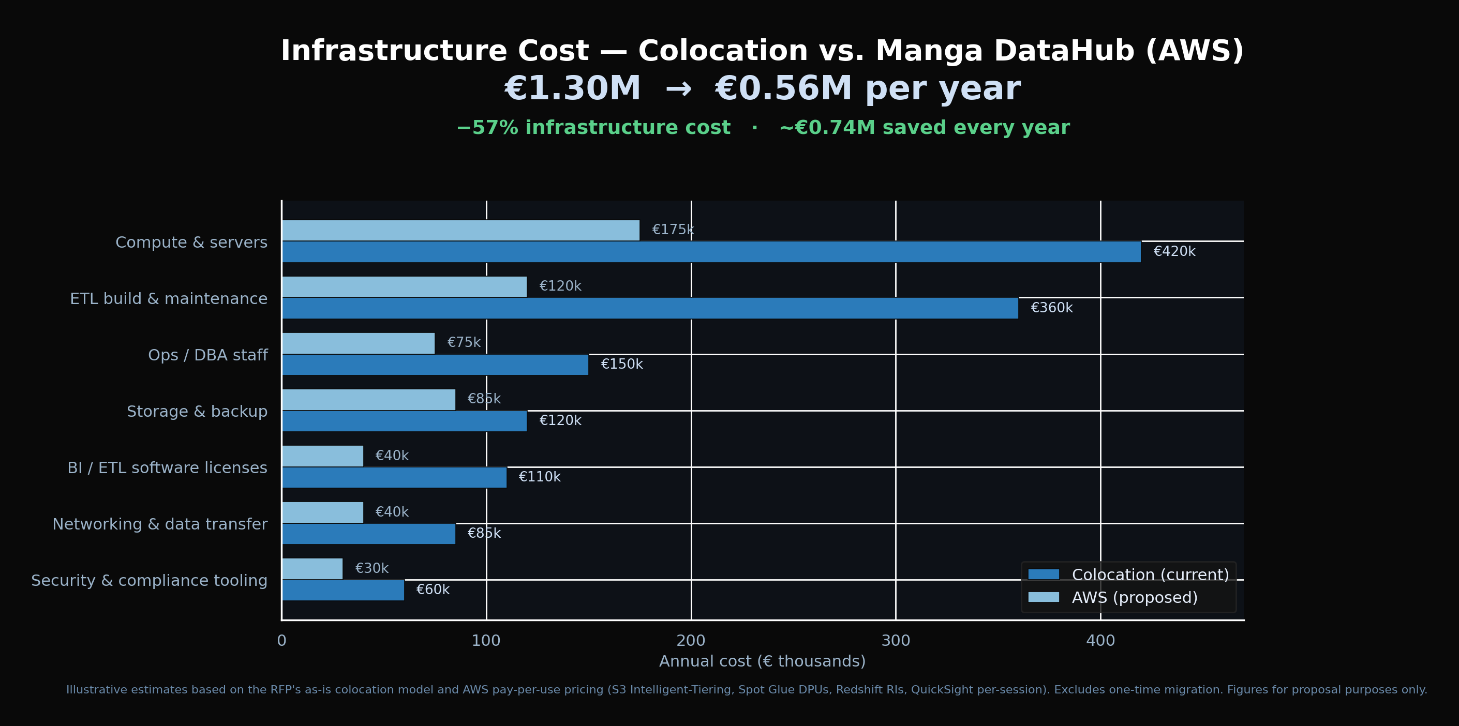
Figure 3 — Projected annual infrastructure cost: colocation vs. Manga DataHub (illustrative).

Methodology & Timeline
CloudCore applies a DataOps methodology — iterative, test-driven, with CI for both pipelines and infrastructure code. Data contracts are validated between layers, and a quality gate blocks promotion from Curated to Serving until thresholds are met. Delivery runs across three phases over nine months.
Phase | Months | Key milestone
1 · Foundation | 1–3 | AWS account structure, Terraform baseline, Dev live, DMS migration, Catalog + MWAA, first batch pipelines.
2 · Build & Validate | 4–6 | Pre-Prod live, Kinesis streaming, Glue DQ + Lake Formation, QuickSight replacing Excel, first ML model.
3 · Prod Cutover & ML | 7–9 | Production live, colocation decommissioned, recommendations + dynamic pricing live, security audit, handover.

Key Risks & Mitigations
- Migration data loss — DMS CDC runs in parallel for 4 weeks; automated row-count and checksum reconciliation before cutover.
- Vendor lock-in (CTO) — open-source tooling at every layer; architecture documented as cloud-portable.
- GDPR non-compliance — Lake Formation + Macie in Phase 1; a DPIA completed before any personal data enters the platform.

5. Sample Use Cases
Three end-to-end use cases demonstrate the architecture using Manga's actual data sources, each spanning ingestion through business outcome.

5.1 Demand Forecasting
Glue joins sales history with external factors (weather, holidays, events, campaigns); features land in a SageMaker Feature Store; DeepAR retrains weekly via an MWAA DAG, producing 7/14/28-day forecasts per SKU per store that drive automated replenishment. Projected impact: −30% stockouts, −20% overstock write-offs.

5.2 Product Recommendation Engine
Real-time purchase events stream through Kinesis into a customer-product interaction matrix; SageMaker trains a collaborative-filtering model; results are filtered against live inventory (DynamoDB) and served via API Gateway at ≤5ms. Projected impact: +12–18% average order value.

5.3 Sentiment-Driven Merchandising
Review events stream via Kinesis; Amazon Comprehend scores sentiment; Glue aggregates by product, store, and rolling 7-day window; QuickSight surfaces declining products and SNS alerts the buying team. Projected impact: 2–3 weeks' earlier warning on quality issues.
Two further use cases extend the same platform: a dynamic pricing engine (+3–7% gross margin) and return-rate optimisation (−10–15% return-processing cost).

6. Future Improvements

Short-Term (Months 10–18)
- Real-time, session-level personalisation across web and in-store touchpoints (reuses Kinesis + DynamoDB).
- Supply-chain smart labels — RFID/smart-label streams for item-level inventory.
- Advanced data quality — Great Expectations-style suites with statistical distribution checks.

Medium-Term (Months 18–30)
- Virtual shopping assistant on Amazon Bedrock (RAG over catalog, inventory, purchase history).
- External data monetisation — anonymised retail-trend data via an API marketplace.
- Data mesh — domain teams own and publish data products through the shared catalog.

Long-Term (30+ Months)
- AI-agent ecosystem via Bedrock Agents; federated ML across partners without sharing raw data; board-reportable carbon-neutrality roadmap.

Appendix

A. References
- Precedence Research — Retail Analytics Market Size, Share & Trends, 2024–2034.
- NTT Data — Mango Case Study: AWS Cloud Migration.
- AWS — Kinesis, Glue, SageMaker, Lake Formation developer documentation.
- Manga DataHub interactive platform (CloudCore Solutions) — live on Vercel.

B. Generative AI Acknowledgement
This document was produced with the assistance of generative AI tools in accordance with IE University MBD-EN2025 course guidelines. AI assistance supported drafting and refining written sections, validating AWS service recommendations, and producing supporting visualisations. All architectural decisions, analysis, and rationale were reviewed, validated, and approved by the team, which retains final responsibility for all content.

C. Team Contributions
Member | Primary responsibilities
Andrea Alarcón Valles | Executive Summary, document coordination, stakeholder analysis, final editing.
Mateus Carneiro | High-Level Architecture, conceptual design, architecture diagrams.
Tina Jannasch | Low-Level Architecture, AWS service selection and cost rationale.
Ricardo Liévano Pedroza | Project Implementation, R1–R8 mapping, risk register, timeline.
Luka Tcheishvili | Data-source analysis, sample use cases, pipeline design, interactive web app.
Nicklas Urban | Future Improvements, GitHub repository, deployment, presentation lead.

