RFP RESPONSE
Migration and Modernisation of Mango Data Architecture to the Cloud

Prepared by:
CloudForge Analytics
IE University · MBD-EN2025 · Cloud Analytics · Group Work B

€280M  Annual Revenue | 100+  Physical Stores | +3.5%  Current Growth | 2×  Cost vs Competitors

June 2026 · Confidential

1. Executive Summary

Mango's current data infrastructure — a collection of siloed, cron-triggered ETL pipelines aggregating daily into Excel files — is fundamentally incompatible with the real-time, AI-powered retail environment of 2026. With annual revenues of €280M, 100+ global stores, and online sales growing at only 1.2% year-over-year, the urgency to modernise is not optional: it is existential.

CloudForge Analytics proposes a comprehensive, cloud-native AWS Data Lakehouse that replaces Mango's legacy colocation model with a unified, scalable, and AI-ready platform. Our proposal is built on three strategic pillars:

⚡ UNIFY — One Platform, All Data
A single governed data lakehouse ingesting all six data domains (Sales, Customers, Inventory, Reviews, Shipping, External Factors) through both streaming and batch pipelines. Siloed databases and fragmented ETL scripts are retired in favour of a central, catalogued, and self-service platform accessible to all business units.

🚀 ACCELERATE — From 24-Hour Lag to Sub-Second Insights
Amazon Kinesis replaces daily cron jobs for high-velocity sources, reducing time-to-insight from 24 hours to sub-second for POS transactions and web events. Amazon QuickSight replaces manual Excel aggregation with real-time, self-service dashboards accessible to the entire organisation.

🤖 ENABLE — ML-Powered Retail Innovation
Amazon SageMaker, Comprehend, and DynamoDB power five production-grade use cases: product recommendations (+12–18% AOV), demand forecasting (−30% stockouts), sentiment-driven merchandising, dynamic pricing (+3–7% margin), and return rate optimisation (−15% logistics costs). These capabilities are simply impossible on the current architecture.

Value Proposition
Our solution directly addresses the strategic priorities of each key stakeholder at Mango. For Marta Ríos (COO), it delivers a comprehensive, end-to-end modernisation with a solid business case and measurable KPIs. For Manuel Ortega (CFO), it projects 40–60% infrastructure cost reduction versus the colocation model through pay-per-use cloud economics, automated right-sizing, and S3 Intelligent-Tiering. For Javier Medina (CTO), the architecture is deliberately built on open standards — Apache Airflow (MWAA), open Parquet/Delta formats, and Terraform IaC — eliminating vendor lock-in concerns. For Laura Smith (InfoSec), security is built-in from day one: Lake Formation RBAC, Macie PII scanning, KMS encryption, and GDPR audit trails are non-negotiable foundations, not afterthoughts. For Alex Lee (Head of Data & AI), this is the modern, robust DataOps platform that finally matches Mango's ambition.

Key Differentiators
- Open-first architecture: Apache Airflow, Parquet, Delta Lake — no proprietary lock-in at any layer
- Security by design: GDPR compliance, PII masking, and RBAC configured before any data enters the platform
- Proven AWS retail stack: Kinesis, Glue, SageMaker, and QuickSight deployed successfully by retailers such as Zalando, Farfetch, and About You
- Infrastructure-as-Code: Terraform templates provision identical Dev / Pre-Prod / Prod environments in under 30 minutes
- Quantifiable ROI: Projected 40–60% cost reduction, with sustainability metrics tracked via the AWS Carbon Footprint Tool

Requirements Coverage Summary
ID | Requirement | How Addressed | Key AWS Services
R1 | Unified Multi-modal Platform | Kinesis streaming + Glue batch; S3 lakehouse stores structured, semi-structured, and unstructured data | Kinesis, Glue ETL, S3, Redshift, Glue Catalog
R2 | Multi-Environment Setup | AWS Organizations: three isolated accounts (Dev/Pre-Prod/Prod) from single Terraform template; anonymised PII samples replicated automatically | AWS Organizations, Terraform/CDK, Lake Formation
R3 | Automation | MWAA (Airflow) replaces all cron jobs; Terraform IaC; EventBridge schedules; Glue job bookmarks | MWAA, Terraform/CDK, EventBridge, AWS Glue
R4 | Security & High Availability | IAM least-privilege, KMS encryption, Lake Formation RBAC, Macie PII scanning, Multi-AZ deployments, 99.9% SLA | IAM, KMS, Lake Formation, Macie, CloudWatch
R5 | Data Quality | Glue Data Quality rules run post-pipeline; null checks, range validation, referential integrity, freshness alerts | Glue Data Quality, CloudWatch, SNS
R6 | Cost Optimisation | Pay-per-use vs fixed colocation; S3 Intelligent-Tiering; Spot Instances; Redshift Reserved; projected 40–60% saving | S3 Intelligent-Tiering, Spot Instances, QuickSight
R7 | Extensibility & Interoperability | Decoupled Lambda connectors; versioned API Gateway; open Parquet format; backwards-compatible schema registry | API Gateway, Lambda, Glue Catalog, Open formats
R8 | Sustainability | AWS Carbon Footprint Tool; EU green regions; serverless eliminates idle resources; quantifiable vs colocation baseline | AWS Carbon Footprint Tool, Serverless services

2. High-Level Architecture

The proposed architecture follows the canonical cloud data platform lifecycle: Data Sources → Ingestion → Processing → Storage → Consumption, governed at every layer by a unified Security & Governance framework. The design is technology-agnostic at the conceptual level, grounded in four foundational principles: scalability, elasticity, modularity, and separation of concerns.

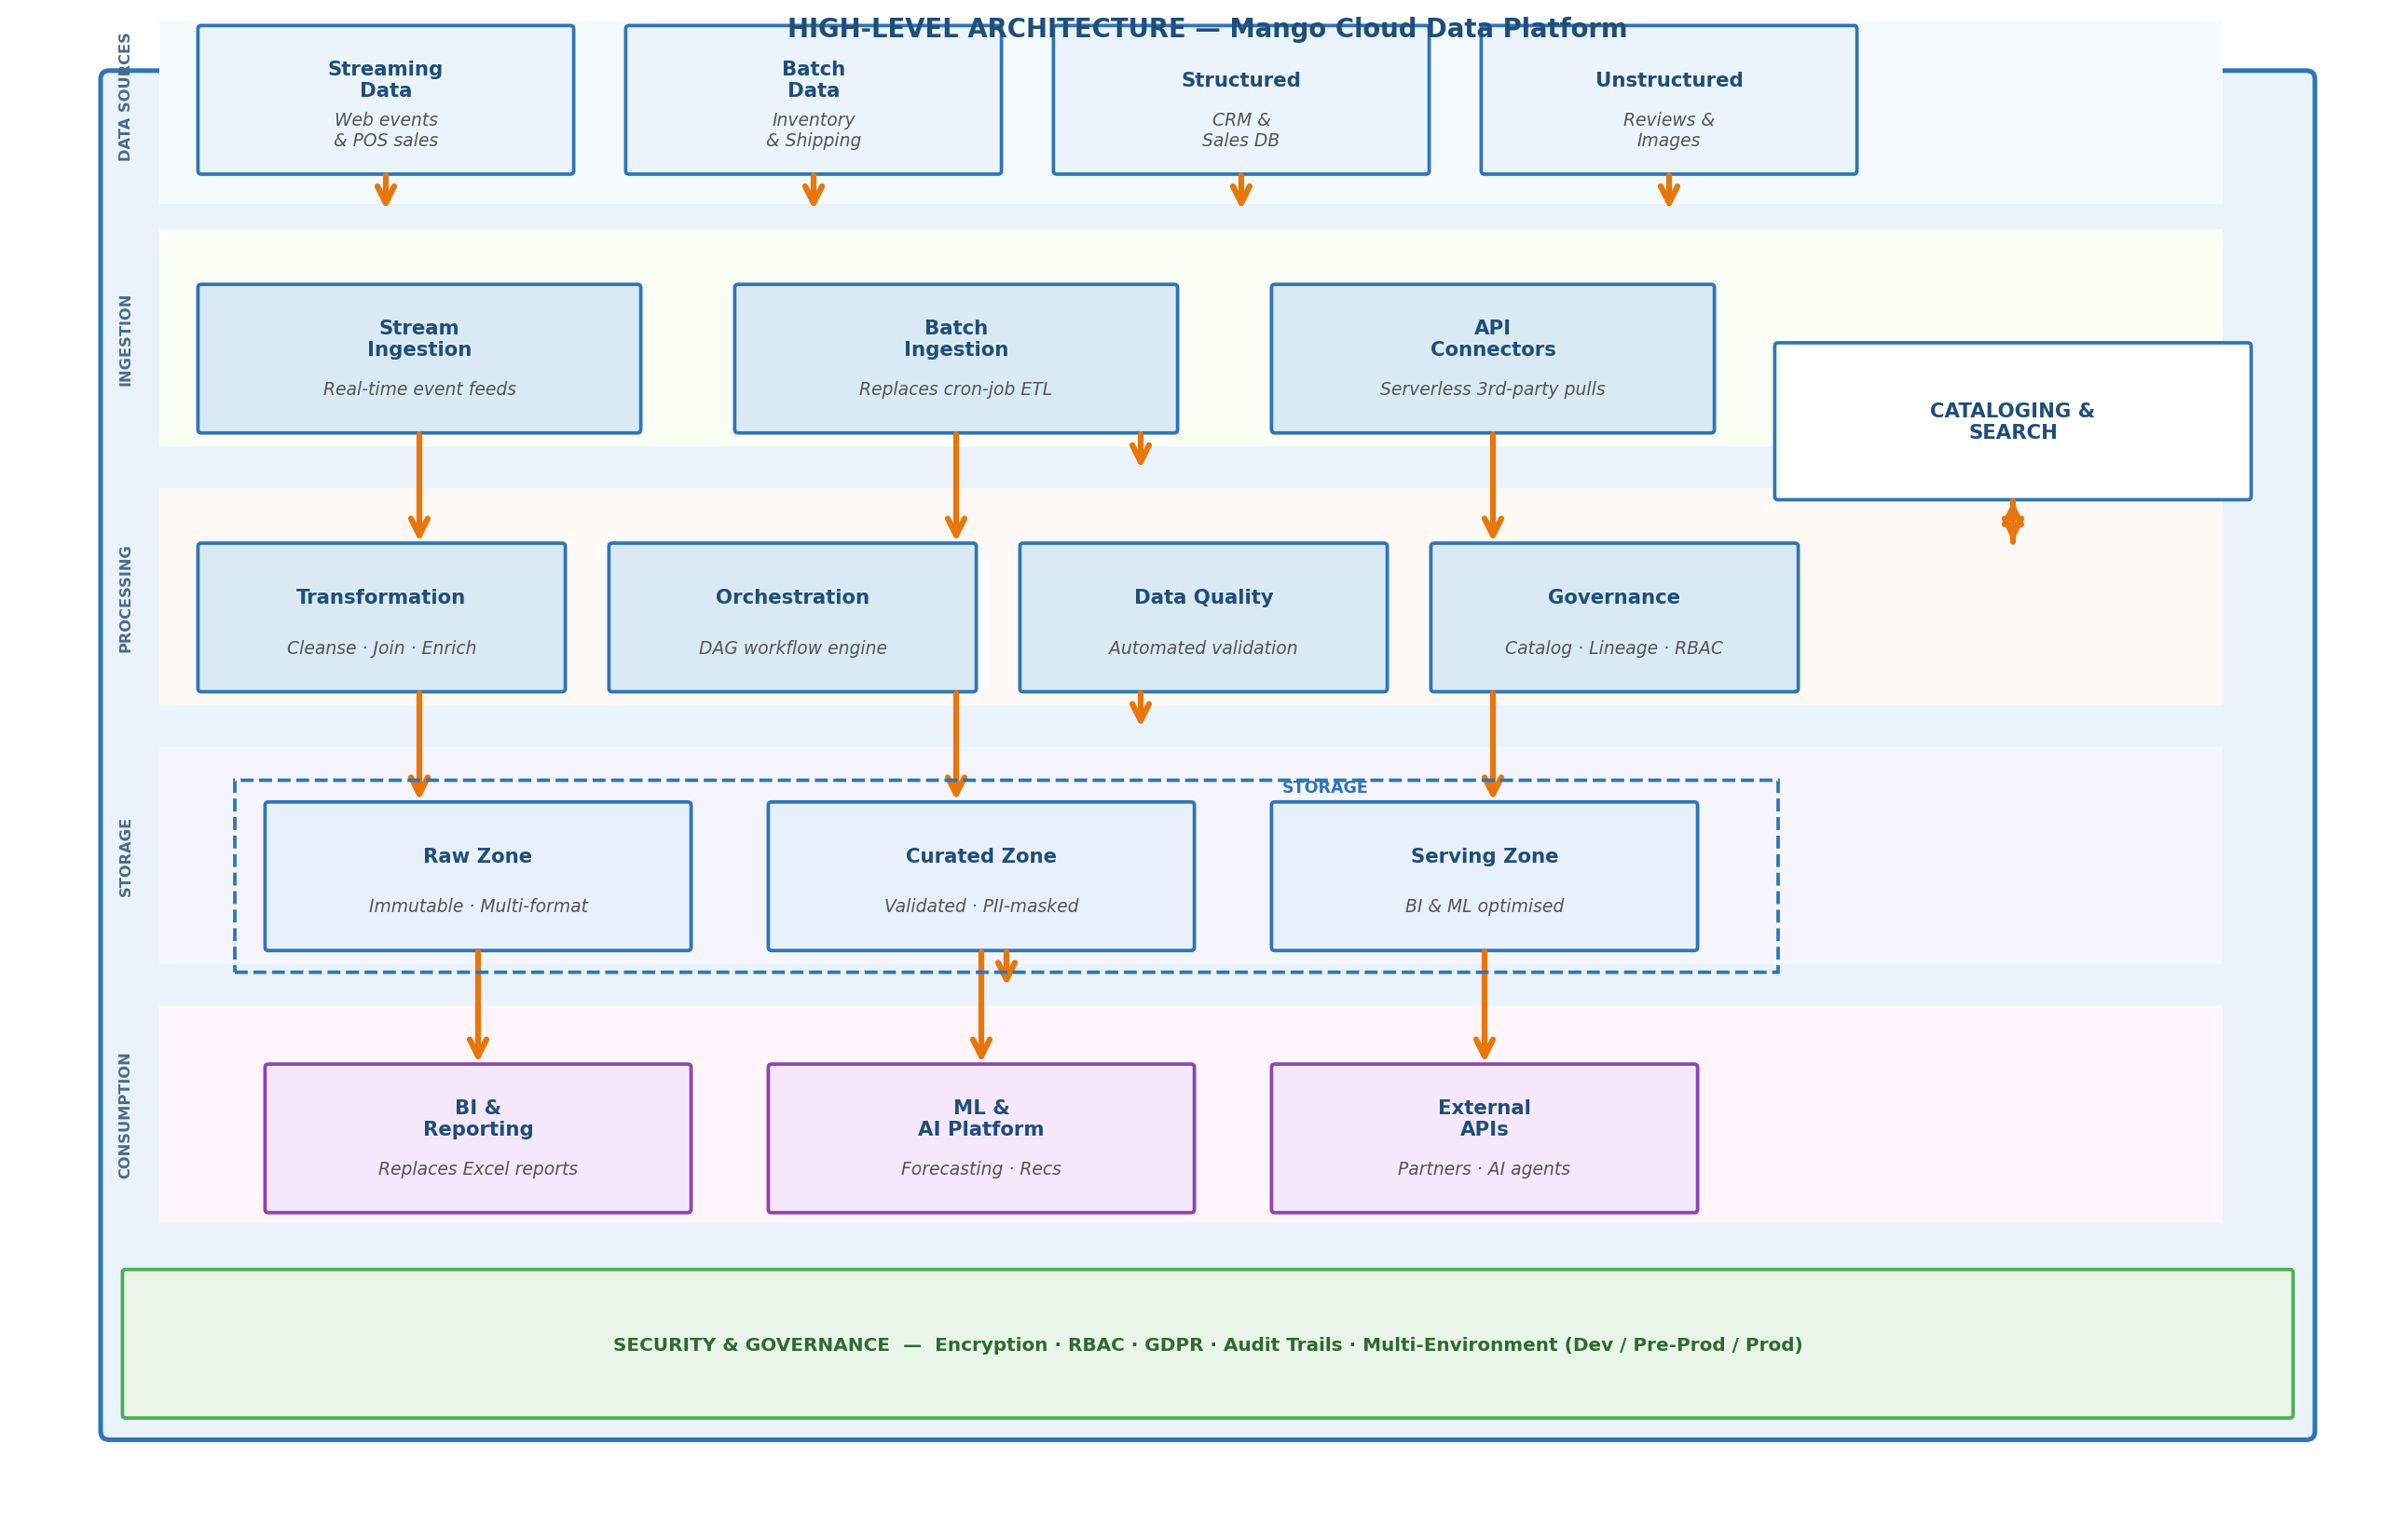
Figure 1 — High-Level Architecture: Conceptual Data Platform Design

Architectural Layers
Data Sources encompasses all six Mango data domains: streaming data from the e-commerce platform and POS systems, batch data from warehouses and shipping partners, structured data from CRM and ERP systems, and unstructured data including customer reviews and product images. The heterogeneity of sources is a defining characteristic that shaped every downstream decision.

The Ingestion layer replaces Mango's fragile, team-managed cron jobs with managed, monitored pipeline services. Three ingestion patterns are employed: stream ingestion for sub-second event processing, batch ingestion with job bookmarks to prevent duplicate processing, and serverless API connectors for third-party sources. Each connector is decoupled — a failure in the Shipping API does not affect the CRM sync.

The Processing layer applies four sequential concerns: Transformation (cleansing, joining, enriching), Orchestration (dependency-aware DAG scheduling replacing cron), Data Quality (automated validation rules with alerting before bad data reaches downstream), and Governance (centralised catalog with lineage, RBAC, and GDPR audit trails). Separation of these concerns into distinct components makes each independently testable and replaceable.

Storage follows the medallion architecture with three zones: Raw (immutable landing, full reprocessing capability), Curated (validated, PII-masked, catalogued — the single source of truth), and Serving (pre-aggregated, query-optimised for BI and ML). A separate Cataloging & Search layer maintains metadata, schema registries, and data lineage across all zones. Decoupling storage from compute is the primary mechanism for both cost optimisation and elasticity.

The Consumption layer serves three distinct consumer types: BI & Reporting (replacing manual Excel reports with real-time, self-service dashboards), ML & AI Platform (managed end-to-end model lifecycle for all five use cases), and External APIs (secure, versioned API exposure for logistics partners, marketing platforms, and AI agents — explicitly listed in Mango's RFP).

Security & Governance is a horizontal concern applied at every layer rather than bolted on at the perimeter. Encryption at rest and in transit, column- and row-level access control, PII detection and auto-masking, and immutable audit logs are configured before any data enters the platform. Three identical environments (Dev, Pre-Prod, Prod) are provisioned from a single Infrastructure-as-Code template, ensuring consistency and enabling peer-reviewed infrastructure changes.

3. Low-Level Architecture

The following diagram maps each conceptual layer to specific AWS services, selected for their managed-service model (reducing operational burden), open-standard compatibility (addressing the CTO's vendor lock-in concern), and demonstrated performance at retail scale. Every service selection is traceable to one or more of the eight RFP requirements.

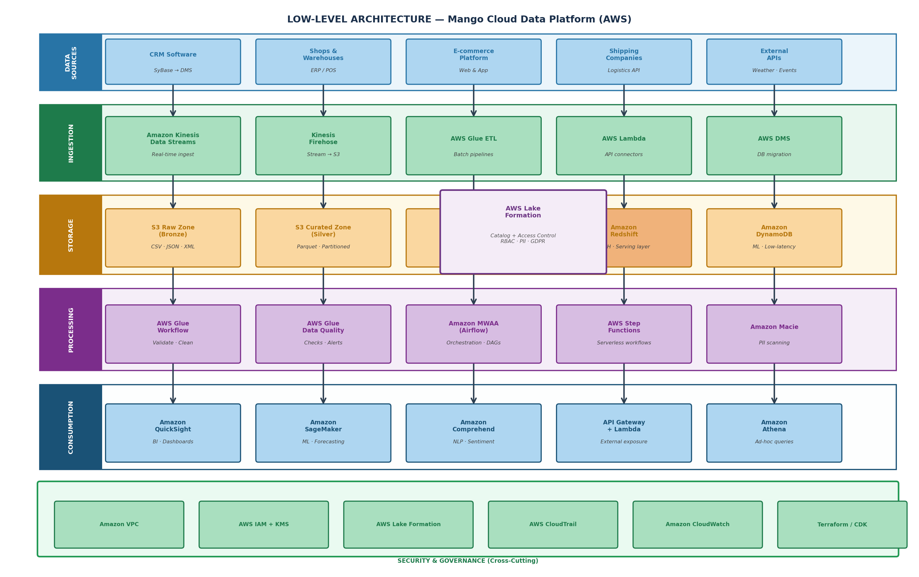
Figure 2 — Low-Level Architecture: AWS Service Map for Mango Cloud Data Platform

Ingestion Layer — Replacing the Cron-Job ETL
Amazon Kinesis Data Streams + Kinesis Firehose
The primary ingestion path for high-velocity sources (POS sales, web events, customer reviews). Kinesis Data Streams ingests at sub-second latency and auto-scales to handle Fashion Week spikes without manual intervention. Firehose delivers micro-batches to S3 with automatic Parquet conversion on the fly, eliminating the need for a separate format-conversion job. Directly addresses R1 (streaming) and R3 (automation). Cost model: pay per shard-hour and per GB ingested.

AWS Glue ETL
Replaces all hand-coded, team-specific ETL scripts with a managed Apache Spark runtime. Glue's built-in job bookmarks prevent reprocessing on restart, and the visual job designer reduces the Spark expertise barrier for Mango's data engineering team. Handles inventory batch loads (hourly), CRM syncs (daily), and historical data backfills. Addresses R3 (automation) and R5 (data quality integration). Cost: pay per DPU-hour.

AWS Lambda + EventBridge
Serverless functions poll third-party APIs (weather, logistics, holiday calendars) on EventBridge schedules. Each connector is an independent Lambda function — a new data source is a new function, with zero impact on existing pipelines. This directly implements R7 (extensibility). AWS DMS handles the one-time migration of on-premises databases (SyBase, Oracle, MySQL, SQLServer) with Change Data Capture for zero data loss at cutover.

Storage Layer — S3 Data Lakehouse
S3 Raw Zone (Bronze) → S3 Curated Zone (Silver) → Serving Zone (Gold/Redshift)
The three-zone medallion architecture is implemented on Amazon S3 with Apache Parquet as the open columnar format — ensuring no vendor lock-in. The Raw Zone stores data exactly as received, enabling full reprocessing when business logic changes. S3 Intelligent-Tiering automatically moves cold data to cheaper storage classes, directly addressing R6. The Curated Zone is the single source of truth: cleaned, deduplicated, and PII-masked via Lake Formation before any non-production environment can access it (R2). Amazon Redshift serves as the Gold layer for BI workloads: RA3 nodes decouple compute and storage scaling, and Redshift Spectrum queries S3 directly without data loading, minimising costs. Amazon DynamoDB provides sub-10ms key-value lookups for ML inference serving and the future virtual shopping assistant.

Processing Layer — Orchestration & Governance
Amazon MWAA (Managed Apache Airflow)
Fully managed Apache Airflow replaces all cron jobs with DAG-based pipelines. Airflow's open-source core directly addresses Javier Medina's vendor lock-in concern: Mango's DAG code is portable to any Airflow environment. Built-in dependency management, retry logic, SLA monitoring, and a visual UI give the data engineering team complete pipeline visibility. Cost: instance-based, sized to workload.

AWS Glue Data Quality + AWS Lake Formation + Amazon Macie
Automated validation rules (null constraints, range checks, referential integrity between sales and inventory, freshness thresholds) run after each pipeline stage. Failures trigger CloudWatch alarms before bad data reaches Redshift — directly addressing R5. Lake Formation provides fine-grained column- and row-level RBAC centralised under Laura Smith's InfoSec team. Amazon Macie continuously scans S3 for PII using ML-powered detection, sending findings to CloudWatch. Together these services address R4 (security) and support GDPR compliance.

Consumption Layer — From Excel to Intelligence
Amazon QuickSight
Managed BI replacing the daily Excel aggregation cycle entirely. The SPICE in-memory engine delivers fast queries on Redshift and S3. Pay-per-session pricing versus traditional per-seat BI licensing provides immediate cost savings for Mango's distributed user base. Built-in ML-powered anomaly detection and forecasting add analytical capabilities without additional tooling. Addresses R6 (cost) and R1 (unified access).

Amazon SageMaker + Comprehend + API Gateway
SageMaker delivers the end-to-end ML lifecycle for all five use cases: collaborative filtering for product recommendations, DeepAR time-series for demand forecasting, regression for dynamic pricing, and classification for return prediction. Amazon Comprehend processes customer review text automatically via managed NLP — no in-house ML expertise required. API Gateway with Lambda exposes curated datasets to logistics partners, marketing platforms, and AI agents (explicitly listed in Mango's RFP), implementing R7 (interoperability) and enabling future data monetisation.

4. Project Implementation

The implementation is structured in four phases over 12 months, each delivering tangible business value before the next phase begins. Infrastructure-as-Code is used from day one, ensuring every environment is consistent, peer-reviewed, and reproducible.

Phase 1 — Foundation (Months 1–3)
Deploy AWS Organizations with three accounts (Dev/Pre-Prod/Prod). Provision S3 lakehouse zones, IAM roles, KMS keys, VPC, and Lake Formation via Terraform. Migrate historical data from on-premises databases using AWS DMS. Implement the Glue Data Catalog and establish RBAC policies. Deliverable: functional data lakehouse with all historical data migrated and catalogued.

Phase 2 — Streaming & Batch Pipelines (Months 4–6)
Deploy Kinesis Data Streams and Firehose for POS and web event ingestion. Build Glue ETL jobs for CRM, Inventory, and Shipping batch loads. Configure MWAA DAGs replacing all cron jobs. Implement Glue Data Quality rules with CloudWatch alerting. Deliverable: all six data sources flowing into the lakehouse with automated quality monitoring.

Phase 3 — Consumption & ML (Months 7–9)
Deploy Amazon Redshift Serving layer. Build QuickSight dashboards replacing Excel reports. Train and deploy the first two SageMaker models: Product Recommendations and Demand Forecasting. Configure Amazon Comprehend for automated review sentiment. Deliverable: business users accessing real-time dashboards; first ML use cases in production.

Phase 4 — Advanced Use Cases & Hardening (Months 10–12)
Deploy Dynamic Pricing Engine and Return Rate Prediction models. Implement API Gateway for external partner exposure. Conduct a full security audit (Macie, GuardDuty, CloudTrail review). Perform load testing at peak retail volumes. Decommission on-premises colocation infrastructure. Deliverable: all five ML use cases live; colocation contract terminated; 40–60% cost reduction realised.

Addressing the Scope Requirements
- The single S3 lakehouse with Glue Catalog provides unified access across CRM, POS, ERP, web, and logistics sources. Kinesis handles streaming; Glue handles batch. All data types — structured, semi-structured, and unstructured — land in S3 and are catalogued centrally.R1 — Unified Multi-modal Platform:
- AWS Organizations provisions three isolated accounts from a single Terraform template. Anonymised production data (PII masked via Glue + Lake Formation) replicates automatically to Dev and Pre-Prod via S3 Cross-Account Replication. Peer-reviewed pull requests govern all infrastructure changes.R2 — Multi-Environment Setup:
- MWAA DAGs replace all cron jobs. Terraform provisions and scales infrastructure. Glue job bookmarks handle incremental loads. EventBridge triggers Lambda connectors. S3 Lifecycle policies archive cold data automatically. The entire data lifecycle is automated end-to-end.R3 — Automation:
- Multi-AZ deployments for Redshift, MWAA, and DynamoDB. S3 provides 11-nines durability. IAM least-privilege, KMS encryption, Lake Formation RBAC, and Macie PII scanning address all security dimensions. CloudWatch with SNS/PagerDuty alerts enable rapid incident response.R4 — Security & 99.9% Uptime:
- Glue Data Quality rules run automatically after every pipeline stage. Checks include null constraints on key fields, price range validation, referential integrity (sales ↔ inventory ↔ customers), and freshness thresholds. Quality scores are tracked over time in a dedicated DQ dashboard in QuickSight.R5 — Data Quality:
- Pay-per-use replaces fixed colocation costs. S3 Intelligent-Tiering, Spot Instances for non-critical Glue jobs, Redshift Reserved Instances, and QuickSight pay-per-session are the primary cost levers. Total projected saving: 40–60% versus the current colocation model.R6 — Cost Optimisation:
- New data sources are new Lambda functions — no existing pipeline is touched. API Gateway provides versioned REST and GraphQL endpoints for external consumers. Open Parquet format ensures all tools in the data ecosystem can consume the data natively.R7 — Extensibility & Interoperability:
- Deployment in EU-WEST-1 (Ireland) and EU-CENTRAL-1 (Frankfurt) regions, which operate with high renewable energy usage. Serverless components (Lambda, Firehose) consume zero resources at idle. AWS Customer Carbon Footprint Tool provides a quantitative emissions baseline for board-level ESG reporting.R8 — Sustainability:

5. Sample Use Cases

The following five use cases demonstrate the Mango Cloud Data Platform in production, covering the full spectrum from data ingestion through predictive analytics. Each use case is grounded in Mango's actual data sources (Appendix III) and directly enables one of the strategic features listed in the RFP.

UC1 — Product Recommendation Engine | Datasets: Sales, Customers, Inventory
A collaborative filtering model trained on purchase history (sales_sample.csv) and customer profiles (customers_sample.csv) generates personalised product recommendations. The model is trained weekly on SageMaker with features engineered by Glue from the Curated S3 zone. Real-time inference is served via a SageMaker endpoint, with results cached in DynamoDB for sub-10ms response times. The API Gateway exposes recommendations to the e-commerce front-end and the future virtual shopping assistant. Business impact: +12–18% Average Order Value based on retail industry benchmarks.

UC2 — Demand Forecasting | Datasets: Sales, External Factors, Inventory
SageMaker DeepAR produces time-series forecasts for each SKU and store combination, enriched with contextual signals from external_factors_sample.csv (weather, bank holidays, local events, fuel prices). Glue feature engineering joins sales history with external context, creating a training dataset spanning 24 months. The model retrains weekly via an MWAA DAG. Forecasts feed inventory replenishment workflows, reducing stockouts by an estimated 30% and overstock write-offs by 20%.

UC3 — Sentiment-Driven Merchandising | Datasets: Customer Reviews
Customer review text from customer_reviews_sample.csv streams via Kinesis to Amazon Comprehend, which assigns positive/neutral/negative sentiment scores in near-real-time. Glue aggregates scores by product, store, and week. QuickSight surfaces products with declining sentiment trajectories, alerting the buying team 2–3 weeks earlier than the previous weekly manual review cycle. Products with sustained negative sentiment trigger automatic review flagging workflows via SNS.

UC4 — Dynamic Pricing Engine | Datasets: Sales, Inventory, External Factors
A regression model trained on historical price elasticity data, current inventory levels, and contextual factors produces recommended prices per SKU in real-time. A Lambda function applies pricing guardrails (minimum margin thresholds, maximum discount caps) before writing approved prices to DynamoDB, which feeds both the POS system and the e-commerce pricing layer. Business impact: 3–7% gross margin improvement from optimised clearance and peak demand pricing.

UC5 — Return Rate & Logistics Optimisation | Datasets: Shipping, Sales, Customers
A binary classification model predicts return likelihood at the moment of purchase using delivery performance history (shipping_sample.csv), customer return rate history, and product attributes. High-risk orders trigger proactive interventions: enhanced packaging instructions and proactive delivery tracking communication. A QuickSight operations dashboard tracks logistics cost variance between delivery_price and actual_shipping_cost across all carriers, enabling data-driven carrier SLA negotiations.

6. Future Improvements

The architecture proposed is designed to be extensible. The following enhancements are scoped for phases 2 and 3 of the platform roadmap (Year 2 onwards), building on the foundation established in the initial 12-month implementation.

Real-Time Feature Store
Amazon SageMaker Feature Store will be introduced to manage ML features as first-class assets, shared across all models and updated in real-time via Kinesis. This eliminates duplicate feature engineering across use cases and enables online/offline consistency — a known failure mode in recommendation and pricing systems. Feature freshness is guaranteed for Fashion Week peak demand events.

Virtual Shopping Assistant (Conversational AI)
Amazon Bedrock with Retrieval-Augmented Generation (RAG) over the product catalog (stored in S3 and indexed in Amazon OpenSearch) will power a virtual shopping assistant. The assistant queries the Product Recommendation Engine and live inventory via DynamoDB, providing personalised, context-aware responses at scale. This directly addresses one of the features listed in the RFP's future capabilities section.

Data Mesh & External Monetisation
As Mango's data platform matures, individual business domains (Retail Operations, E-commerce, Logistics) can publish their own certified data products to an internal data marketplace via Amazon DataZone. Externally, selected datasets (anonymised trend signals, inventory forecasts) can be licensed to wholesale partners and market intelligence firms via API Gateway and AWS Data Exchange, creating a new revenue stream.

Multi-Region Active-Active Deployment
As Mango's international expansion accelerates, deploying active-active in a second AWS region (EU-CENTRAL-1 Frankfurt) with Global Accelerator-managed routing will improve latency for European markets and meet data residency requirements in specific jurisdictions. Amazon Aurora Global Database and DynamoDB Global Tables support sub-second replication with automatic failover, elevating the availability SLA from 99.9% to 99.99%.

CloudForge Analytics · Confidential · IE University MBD-EN2025 · June 2026

