Reflex Etest confirmation of EUCAST disc diffusion results for temocillin against Enterobacterales
Article type: Brief Report
Running title: Reflex MIC testing for temocillin susceptibility
Authors: Luke Bedford^{1,} David Enoch
Affiliations: ¹ [Department/Directorate of Microbiology, Trust/Institution name — insert], [City, Country — insert]
Corresponding author: Luke Bedford, [Department of Microbiology, full postal address — insert]. E-mail: [insert institutional e-mail]; Tel: [insert]
Keywords: temocillin; EUCAST; disc diffusion; Etest; minimum inhibitory concentration; antimicrobial susceptibility testing; Escherichia coli; Klebsiella; urinary tract infection
Word count (main text, Introduction–Discussion): [to be completed on finalisation; target ≤1500 words per JAC Brief Report limit] Tables: 1 Figures: 1 References: 7

Synopsis
Objectives: EUCAST susceptibility testing clinical breakpoints are available for Temocillin with both disc diffusion and E test methodologies. We assessed whether MIC testing added value after initial disc diffusion testing in blood culture samples tested at Cambridge University Hospitals NHS Trust
Methods: We retrospectively analysed routine microbiology data for E. coli, Klebsiella spp. (excluding K. aerogenes) and P. mirabilis isolates tested for temocillin susceptibility between 1 January 2023 and 21 October 2026. Of 13 359 isolates tested by disc diffusion, 613 (4.6%) also had an Etest and were included. Zone diameters and MICs were reinterpreted against EUCAST Breakpoint Table v16.1 (R: zone <17 mm/MIC >16 mg/L; I otherwise). Agreement was calculated overall and by organism; logistic regression quantified P(Etest-R) by zone diameter.
Results: Overall categorical agreement was 84.3% (517/613). Of 472 disc-I isolates, only 8 (1.7%) were reclassified as resistant by Etest. Of 141 disc-R isolates, 88 (62.4%) were reclassified as I. The pattern held in E. coli (64/93, 68.8% of disc-R reclassified) and K. pneumoniae (23/45, 51.1%). Each 1 mm increase in zone diameter reduced the odds of an Etest-R result by 39% (OR 0.61, 95% CI 0.54–0.67, P<0.001).
Conclusions: Disc-diffusion-susceptible (I) temocillin results are highly reliable and do not need routine Etest confirmation. However, most disc-resistant (R) isolates were not confirmed resistant by Etest. Reflex MIC testing should be considered before excluding temocillin as a treatment option on a disc-resistant result alone.

Introduction
Temocillin’s stability against most ESBLs and AmpC enzymes makes it an attractive carbapenem-sparing option for urinary-tract infections (UTIs) caused by ESBL-/AmpC-producing Enterobacterales,¹ with clinical cure rates similar to carbapenems in a matched case-control study (94% versus 99%).² Under EUCAST Clinical Breakpoint Table v16.1, temocillin breakpoints against Escherichia coli, Klebsiella spp. (excluding K. aerogenes) and Proteus mirabilis are validated only for urinary-tract-source infections — reflecting temocillin’s high urinary concentration^{3,4} — and the susceptible (S) category (MIC ≤0.001 mg/L/zone ≥50 mm) falls below what either disc diffusion or Etest can practically resolve. Routine results are therefore effectively a binary susceptible-with-increased-exposure (I; zone 17–49 mm) / resistant (R; zone <17 mm) call.
Prior studies report generally good, but imperfect, disc-diffusion/MIC agreement for temocillin: low major-error rates against the older, higher BSAC breakpoint;⁵ good interlaboratory category agreement using current EUCAST breakpoints, weaker for Proteus spp.;⁷ and, specifically relevant here, evidence that lowering the disc breakpoint to the current 17 mm EUCAST cutoff substantially reduced reported resistance and that zone-diameter reading immediately around that cutoff is prone to remeasurement variability.⁶ Whether reflex Etest confirmation is better targeted at disc-resistant isolates, disc-susceptible isolates, or neither, has not, to our knowledge, been directly reported. We addressed this using paired disc diffusion and Etest results from a single UK laboratory.

Methods
Microbiology results were extracted from the CHEQS laboratory information system for all temocillin tests performed between 1 January 2023 and 21 October 2026 (19 902 records, 18 985 specimens, 12 498 patients). Analysis was restricted to the three organism groups for which EUCAST validates a temocillin breakpoint: E. coli (excluding serotype O157 and mixed growth), Klebsiella spp. (excluding K. aerogenes) and P. mirabilis.³ Of 13 359 such isolates tested by disc diffusion, 613 (4.6%) also had a temocillin Etest and formed the paired cohort analysed here; 585/613 (95.4%) were blood cultures, the remainder body fluid, cerebrospinal fluid, sputum, swab or urine (each ≤12 isolates). Bacteraemia with these organisms is frequently secondary to a urinary source, but this was not confirmed case-by-case and is treated as an assumption, not a settled fact.
Rather than using the susceptibility category recorded at testing (which had occasional gaps), zone diameters and Etest MICs were reinterpreted directly against EUCAST v16.1 (R: MIC >16 mg/L or zone <17 mm; I: all other values).³ Etest “<”/“>” qualifiers were stripped and MICs capped at 256 mg/L. Categorical agreement was calculated overall and by organism. A logistic regression model (Etest R versus I, predictor: zone diameter) was fitted on the 613 paired isolates to quantify the probability of an Etest-R result by zone diameter. Analyses used R v4.3 (tidyverse, gt).
This work used retrospectively collected, routinely generated laboratory surveillance data for service evaluation and involved no change to patient care. [Insert local institutional policy reference / ethics committee waiver, as applicable.]

Results
Among the 613 paired isolates, 517 (84.3%) showed categorical agreement (Table 1). Of 472 disc-I isolates, 464 (98.3%) were confirmed I by Etest and only 8 (1.7%) were reclassified as R. Of 141 disc-R isolates, only 53 (37.6%) were confirmed R; 88 (62.4%) were reclassified as I. This asymmetry held in the two largest organism groups: E. coli (64/93, 68.8% of disc-R reclassified; 5/353, 1.4% of disc-I reclassified) and K. pneumoniae (23/45, 51.1%; 3/105, 2.9%). Numbers for K. oxytoca (n=12), K. variicola (n=3) and P. mirabilis (n=2) were too small to interpret separately.
Table 1. Agreement and discordance between EUCAST disc diffusion and Etest MIC interpretation, overall and by organism
Organism | n (paired) | n disc-I | I→R, n (%) | n disc-R | R→I, n (%)
Escherichia coli | 446 | 353 | 5 (1.4%) | 93 | 64 (68.8%)
Klebsiella pneumoniae | 150 | 105 | 3 (2.9%) | 45 | 23 (51.1%)
Klebsiella oxytoca | 12 | 10 | 0 (0%) | 2 | 0 (0%)
Klebsiella variicola | 3 | 2 | 0 (0%) | 1 | 1 (100%)
Proteus mirabilis | 2 | 2 | 0 (0%) | 0 | —
Overall | 613 | 472 | 8 (1.7%) | 141 | 88 (62.4%)
Logistic regression showed a steep, highly significant relationship between zone diameter and Etest result (coefficient −0.50, SE 0.052, P<0.001; McFadden R² = 0.51; training accuracy 94.5%): each 1 mm increase in zone diameter reduced the odds of an Etest-R result by 39% (OR 0.61, 95% CI 0.54–0.67). At the 17 mm breakpoint itself, fitted P(Etest-R) was 5.5%, falling to 1.3% by 20 mm and <0.1% beyond 25 mm (Figure 1). All eight disc-I/Etest-R discordant isolates had zone diameters within 8 mm of the breakpoint (17–25 mm), against a susceptible range extending to 34 mm — discordance was concentrated immediately adjacent to the cutoff, not spread unpredictably across it.
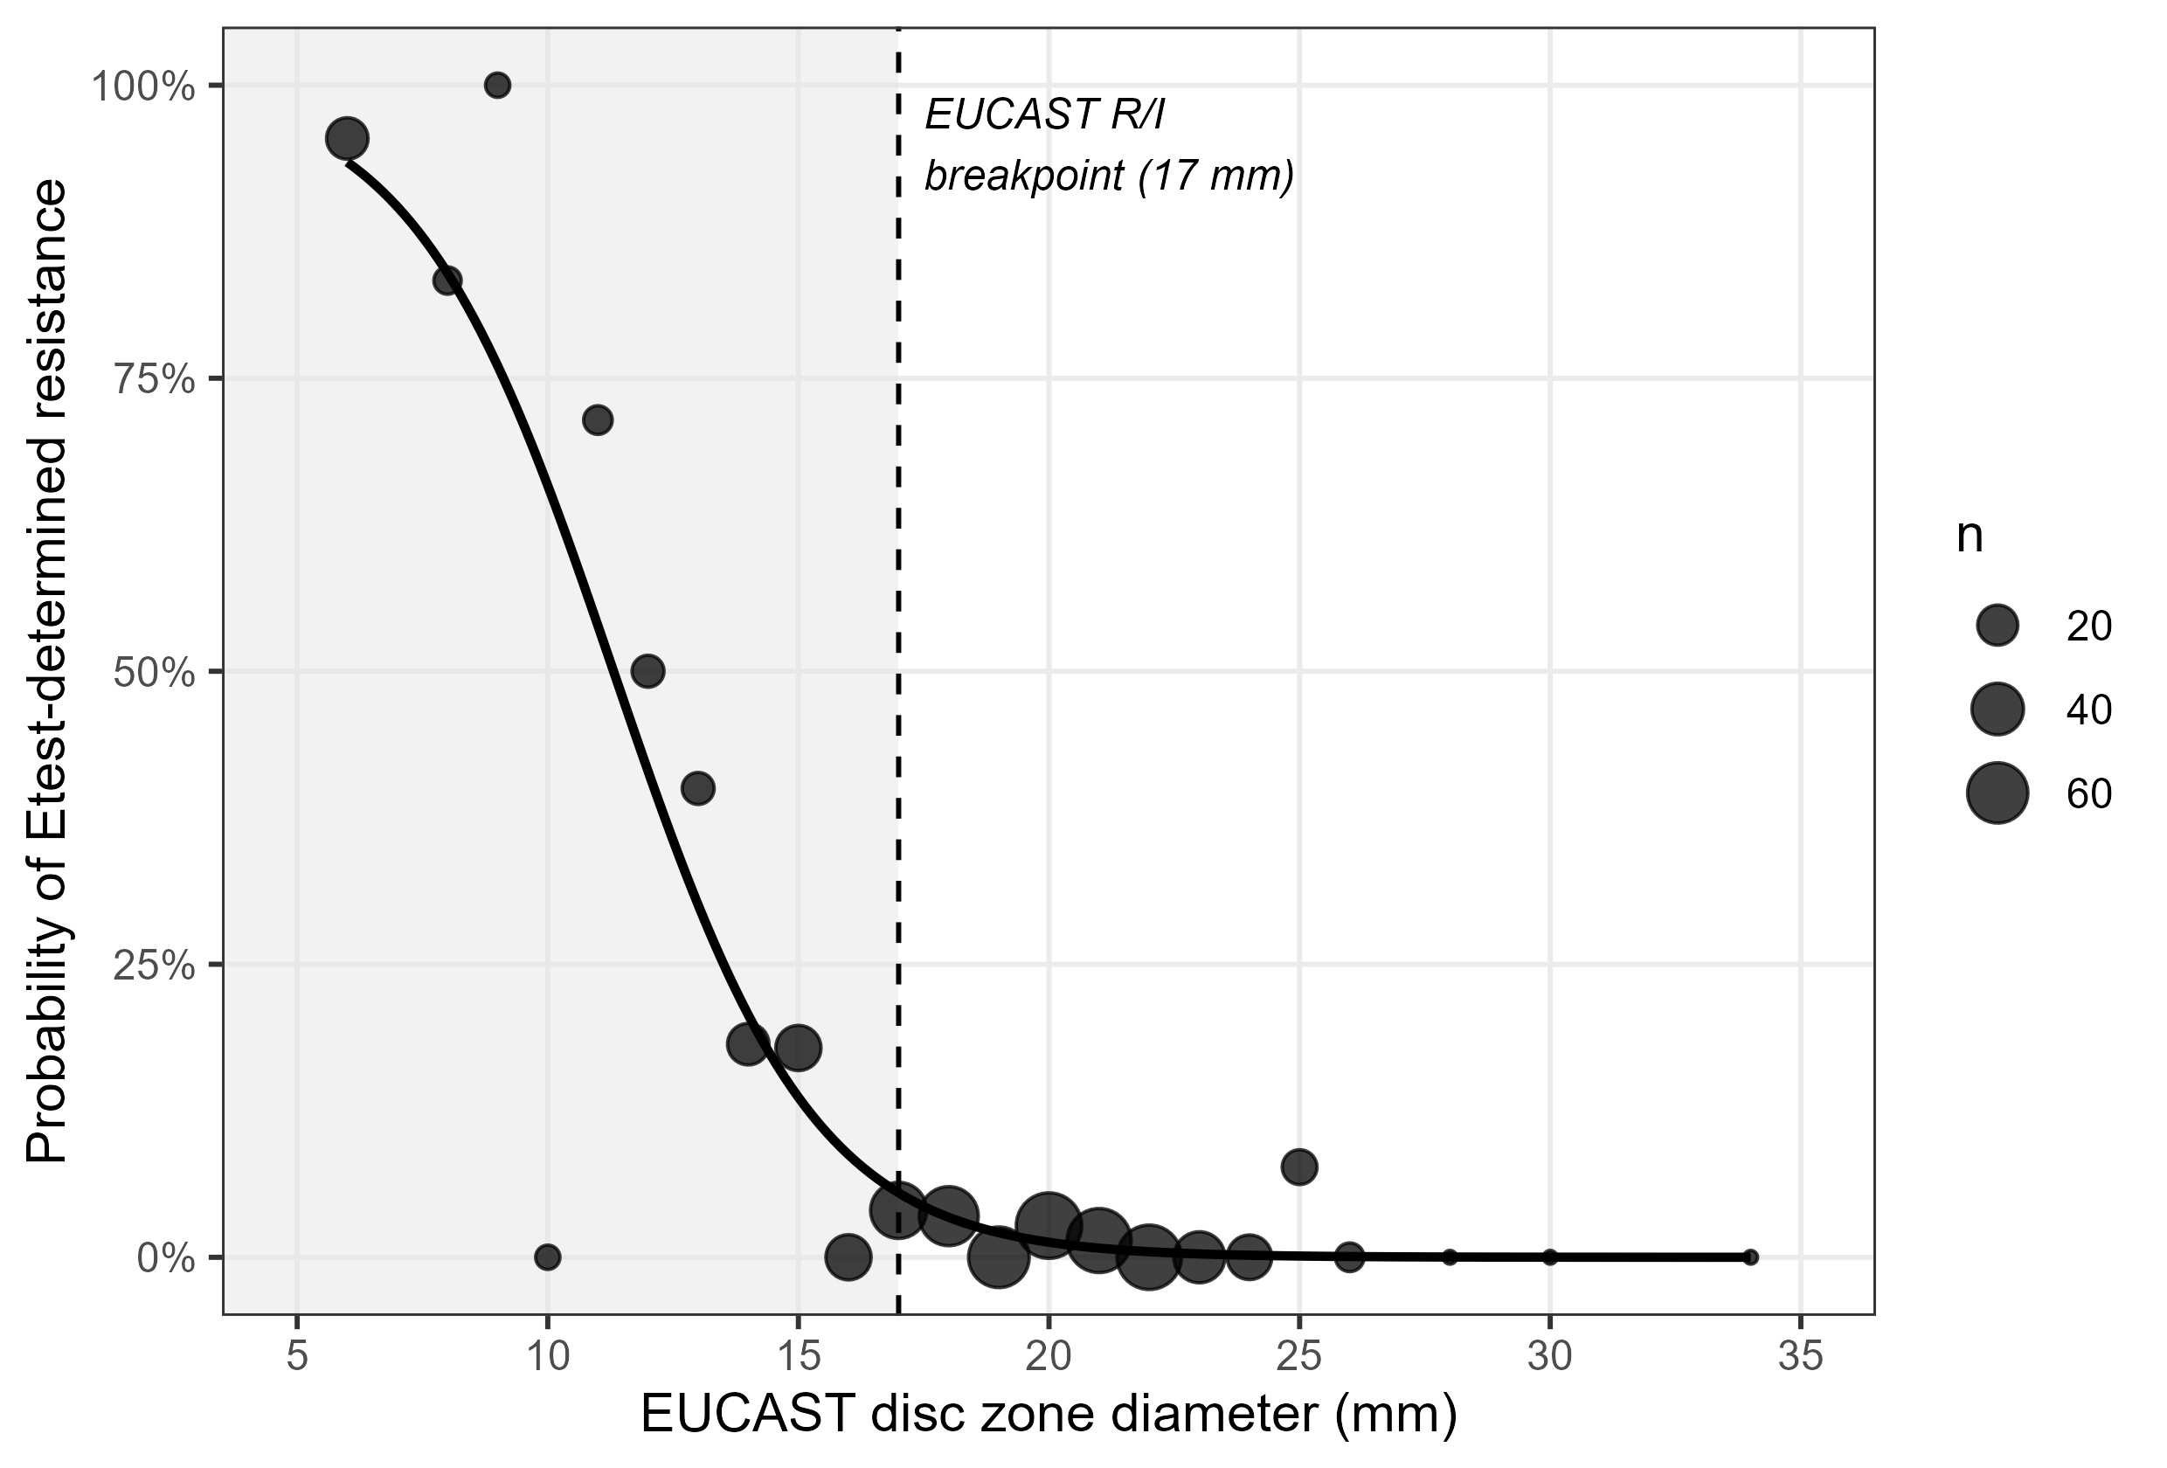

Discussion
Disc diffusion and Etest disagreed asymmetrically for temocillin. Disc-I results were highly reliable (98.3% confirmed; only 1.7% reclassified to R, clustered within a few millimetres of the breakpoint), supporting continued disc-only reporting for isolates called susceptible-with-increased-exposure, without routine Etest confirmation. By contrast, only 37.6% of disc-R isolates were confirmed R by Etest; 62.4% were reclassified as I. Because a disc-R result would ordinarily exclude temocillin as a treatment option,^{1,2} defaulting to disc diffusion alone risks unnecessarily discarding a viable carbapenem-sparing option in most disc-resistant isolates. We suggest reflex Etest (or equivalent MIC) confirmation specifically for disc-R temocillin results, without routine confirmation of disc-I results.
Our R→I rate is considerably higher than major-error rates reported against the older, higher systemic breakpoint,⁵ consistent with the lower EUCAST cutoff itself being a major driver: zone-diameter reading in the few millimetres around a revised breakpoint is known to be susceptible to remeasurement variability,⁶ and our discordant isolates clustered tightly around that cutoff rather than being spread across the full range — consistent with a narrow, measurement-sensitive transition zone rather than a generally unreliable method, and with interlaboratory data showing good overall category agreement for routine temocillin testing.⁷
Limitations: Etest was not ordered on a random sample (in blood isolates, 21.9% of Etest-tested isolates had zone <17 mm versus 8.3% of all blood isolates, suggesting reflex testing targeted smaller zones), which concentrates our training data at lower zone diameters without biasing the fitted zone-conditional relationship itself; 95.4% of paired results were blood cultures rather than urine, and urinary-tract-source causation was assumed, not confirmed, for bacteraemic cases; this is a single-centre, retrospective analysis not yet replicated against other MIC methods (e.g. broth microdilution); and we assessed analytical agreement, not treatment outcomes. Reflex MIC testing for disc-resistant temocillin results should therefore inform, rather than replace, overall clinical judgement.

Acknowledgements
None. [Amend if applicable, e.g. acknowledge laboratory staff who performed testing.]

Funding
[Insert funding statement, e.g. “This work was supported by departmental resources with no external funding.”]

Transparency declarations
None declared. [Confirm and amend as applicable.]

References
- Lupia T, De Benedetto I, Stroffolini G, et al. Temocillin: applications in antimicrobial stewardship as a potential carbapenem-sparing antibiotic. Antibiotics (Basel) 2022; 11: 493.
- Delory T, Gravier S, Le Pluart D, et al. Temocillin versus carbapenems for urinary tract infection due to ESBL-producing Enterobacteriaceae: a multicenter matched case-control study. Int J Antimicrob Agents 2021; 58: 106361.
- EUCAST. Breakpoint tables for interpretation of MICs and zone diameters, version 16.1, valid from 2026-06-24. Available at: https://www.eucast.org/fileadmin/eucast/pdf/breakpoints/v_16.1_Breakpoint_Tables.pdf.
- EUCAST. Temocillin: rationale document, version 1.0, 2020. Available at: https://www.eucast.org/fileadmin/eucast/pdf/rationale_documents/bacteria/Temocillin_rationale_document_v1.0_20200327.pdf.
- Alexandre K, Réveillon-Istin M, Fabre R, et al. Temocillin against Enterobacteriaceae isolates from community-acquired urinary tract infections: low rate of resistance and good accuracy of routine susceptibility testing methods. J Antimicrob Chemother 2018; 73: 1848–53.
- Farfour E, Le Brun C, Degand N, et al. Impact of revised breakpoints on the categorization of susceptibility of Enterobacterales to temocillin. JAC Antimicrob Resist 2023; 5: dlad114.
- Deckers C, Bélik F, Yin N, et al. Multicenter interlaboratory study of routine systems for the susceptibility testing of temocillin using a challenge panel of multidrug-resistant strains. Eur J Clin Microbiol Infect Dis 2023; 42: 1477–83.

Notes for the author before submission (delete this section in the final manuscript):
- Formatted as a JAC Brief Report per the current Author Guidelines (academic.oup.com/jac/pages/General_Instructions): ≤1500 words main text (Introduction–Discussion), structured Synopsis ≤250 words, ≤2 figures/tables combined (here: 1 table + 1 figure), ≤20 references, same section order as an Original Article (Synopsis, Introduction, Methods, Results, Discussion, Acknowledgements, Funding, Transparency declarations, References). Re-check these limits against the live guidelines before submission, as they are occasionally revised.
- Author affiliation, corresponding author contact details, ethics/governance statement, funding, transparency declarations and acknowledgements are still bracketed placeholders and must be completed — deliberately left blank rather than fabricated.
- References were retrieved via web search on 2026-11-03; their bibliographic details were taken from the citing source’s own summary rather than verified directly against the original PDFs. Cross-check each against the publisher page or PubMed before submission, particularly author lists abbreviated as “et al.” References 3–4 (EUCAST) should be checked against the versions in force at submission.
- JAC requires double line spacing and continuous line numbering (both applied in this Word file) and separate title-page/manuscript files for blinded peer review — the title page block above should be split into its own file before submission.
- Confirm the main-text word count (Introduction through end of Discussion) against the 1500-word Brief Report limit once author/affiliation details are finalised, since those additions are outside the counted text but placeholders elsewhere are not.

