Reflex Etest confirmation of EUCAST disc diffusion results for temocillin against Enterobacterales in blood cultures
Article type: Brief Report
Running title: Reflex MIC testing for temocillin in bacteraemia
Authors: Luke Bedford¹, David Enoch¹ [confirm author order and whether both share affiliation 1]
Affiliations: ¹ Clinical Microbiology, Cambridge University Hospitals NHS Trust [confirm exact department name and whether “NHS Trust” or “NHS Foundation Trust”], Cambridge, UK
Corresponding author: Luke Bedford, [Department of Microbiology, full postal address — insert]. E-mail: [insert institutional e-mail]; Tel: [insert]
Keywords: temocillin; EUCAST; disc diffusion; Etest; minimum inhibitory concentration; antimicrobial susceptibility testing; Escherichia coli; Klebsiella; urinary tract infection
Word count (main text, Introduction–Discussion): [to be completed on finalisation; target ≤1500 words per JAC Brief Report limit] Tables: 1 Figures: 1 References: 7

Synopsis
Objectives: EUCAST susceptibility testing clinical breakpoints are available for temocillin with both disc diffusion and Etest methodologies. We assessed whether MIC testing added value after initial disc diffusion testing in blood culture samples tested at Cambridge University Hospitals NHS Trust.
Methods: We retrospectively analysed routine microbiology data for blood culture isolates of E. coli, Klebsiella spp. (excluding K. aerogenes) and P. mirabilis tested for temocillin between 1 January 2023 and 21 October 2026. Of 3009 such blood isolates tested by disc diffusion, 585 (19.4%) also had an Etest and were included. Zone diameters and MICs were reinterpreted against EUCAST Breakpoint Table v16.1 (R: zone <17 mm/MIC >16 mg/L; I otherwise). Agreement was calculated overall and by organism; logistic regression quantified P(Etest-R) by zone diameter.
Results: Overall categorical agreement was 84.4% (494/585). Of 457 disc-I isolates, only 7 (1.5%) were reclassified as resistant by Etest. Of 128 disc-R isolates, 84 (65.6%) were reclassified as I. The pattern held in E. coli (62/88, 70.5% of disc-R reclassified) and K. pneumoniae (21/38, 55.3%). Each 1 mm increase in zone diameter reduced the odds of an Etest-R result by 39% (OR 0.61, 95% CI 0.54–0.67, P<0.001).
Conclusions: In blood culture isolates, disc-diffusion-susceptible (I) temocillin results are highly reliable and do not need routine Etest confirmation. However, most disc-resistant (R) isolates were not confirmed resistant by Etest. Reflex MIC testing should be considered before excluding temocillin as a treatment option on a disc-resistant blood culture result alone.

Introduction
Temocillin’s stability against most ESBLs and AmpC enzymes makes it an attractive carbapenem-sparing option for urinary-tract infections (UTIs) caused by ESBL-/AmpC-producing Enterobacterales,¹ with clinical cure rates similar to carbapenems in a matched case-control study (94% versus 99%).² Under EUCAST Clinical Breakpoint Table v16.1, temocillin breakpoints against Escherichia coli, Klebsiella spp. (excluding K. aerogenes) and Proteus mirabilis are validated only for urinary-tract-source infections — reflecting temocillin’s high urinary concentration^{3,4} — and the susceptible (S) category (MIC ≤0.001 mg/L/zone ≥50 mm) falls below what either disc diffusion or Etest can practically resolve. Routine results are therefore effectively a binary susceptible-with-increased-exposure (I; zone 17–49 mm) / resistant (R; zone <17 mm) call.
Prior studies report generally good, but imperfect, disc-diffusion/MIC agreement for temocillin: low major-error rates against the older, higher BSAC breakpoint;⁵ good interlaboratory category agreement using current EUCAST breakpoints, weaker for Proteus spp.;⁷ and, specifically relevant here, evidence that lowering the disc breakpoint to the current 17 mm EUCAST cutoff substantially reduced reported resistance and that zone-diameter reading immediately around that cutoff is prone to remeasurement variability.⁶ Whether reflex Etest confirmation is better targeted at disc-resistant isolates, disc-susceptible isolates, or neither, has not, to our knowledge, been directly reported. Blood cultures account for the great majority of paired disc diffusion/Etest temocillin testing at our institution, consistent with Etest being reserved for the clinically time-pressured setting of bacteraemia; we therefore addressed this question specifically in blood culture isolates, using paired results from a single UK laboratory (Cambridge University Hospitals NHS Trust).

Methods
Microbiology results were extracted from the CHEQS laboratory information system for all temocillin tests performed between 1 January 2023 and 21 October 2026 (19 902 records, 18 985 specimens, 12 498 patients, all specimen types). Analysis was restricted to blood culture isolates of the three organism groups for which EUCAST validates a temocillin breakpoint: E. coli (excluding serotype O157 and mixed growth), Klebsiella spp. (excluding K. aerogenes) and P. mirabilis.³ Blood was chosen because it accounted for the great majority of paired disc diffusion/Etest testing in this cohort; other specimen types (urine, swab, body fluid, etc.) each had ≤12 paired isolates, too few for separate meaningful analysis. Of 3009 blood culture isolates of these organisms tested by disc diffusion, 585 (19.4%) also had a temocillin Etest and formed the paired cohort analysed here — a substantially higher pairing rate than the 4.6% seen across all specimen types, consistent with Etest being reserved preferentially for bacteraemic isolates. Bacteraemia with these organisms is frequently secondary to a urinary source, but this was not confirmed case-by-case and is treated as an assumption, not a settled fact, when interpreting blood isolates against a breakpoint validated for urinary-tract-source infection.
Rather than using the susceptibility category recorded at testing (which had occasional gaps), zone diameters and Etest MICs were reinterpreted directly against EUCAST v16.1 (R: MIC >16 mg/L or zone <17 mm; I: all other values).³ Etest “<”/“>” qualifiers were stripped and MICs capped at 256 mg/L. Categorical agreement was calculated overall and by organism. A logistic regression model (Etest R versus I, predictor: zone diameter) was fitted on the 585 paired blood isolates to quantify the probability of an Etest-R result by zone diameter. Analyses used R v4.3 (tidyverse, gt).
This work used retrospectively collected, routinely generated laboratory surveillance data for service evaluation and involved no change to patient care. [Insert local institutional policy reference / ethics committee waiver, as applicable.]

Results
Among the 585 paired blood culture isolates, 494 (84.4%) showed categorical agreement (Table 1). Of 457 disc-I isolates, 450 (98.5%) were confirmed I by Etest and only 7 (1.5%) were reclassified as R. Of 128 disc-R isolates, only 44 (34.4%) were confirmed R; 84 (65.6%) were reclassified as I. This asymmetry held in the two largest organism groups: E. coli (62/88, 70.5% of disc-R reclassified; 5/347, 1.4% of disc-I reclassified) and K. pneumoniae (21/38, 55.3%; 2/96, 2.1%). Numbers for K. oxytoca (n=11), K. variicola (n=3) and P. mirabilis (n=2) were too small to interpret separately.
Table 1. Agreement and discordance between EUCAST disc diffusion and Etest MIC interpretation in blood culture isolates, overall and by organism
Organism | n (paired) | n disc-I | I→R, n (%) | n disc-R | R→I, n (%)
Escherichia coli | 435 | 347 | 5 (1.4%) | 88 | 62 (70.5%)
Klebsiella pneumoniae | 134 | 96 | 2 (2.1%) | 38 | 21 (55.3%)
Klebsiella oxytoca | 11 | 10 | 0 (0%) | 1 | 0 (0%)
Klebsiella variicola | 3 | 2 | 0 (0%) | 1 | 1 (100%)
Proteus mirabilis | 2 | 2 | 0 (0%) | 0 | —
Overall | 585 | 457 | 7 (1.5%) | 128 | 84 (65.6%)
Logistic regression showed a steep, highly significant relationship between zone diameter and Etest result (coefficient −0.50, SE 0.056, P<0.001; McFadden R² = 0.49; training accuracy 94.7%): each 1 mm increase in zone diameter reduced the odds of an Etest-R result by 39% (OR 0.61, 95% CI 0.54–0.67). At the 17 mm breakpoint itself, fitted P(Etest-R) was 5.1%, falling to 1.2% by 20 mm and to about 0.1% by 25 mm (Figure 1). All seven disc-I/Etest-R discordant isolates had zone diameters within 8 mm of the breakpoint (17–25 mm, median 18 mm), against a susceptible range extending to 34 mm — discordance was concentrated immediately adjacent to the cutoff, not spread unpredictably across it.
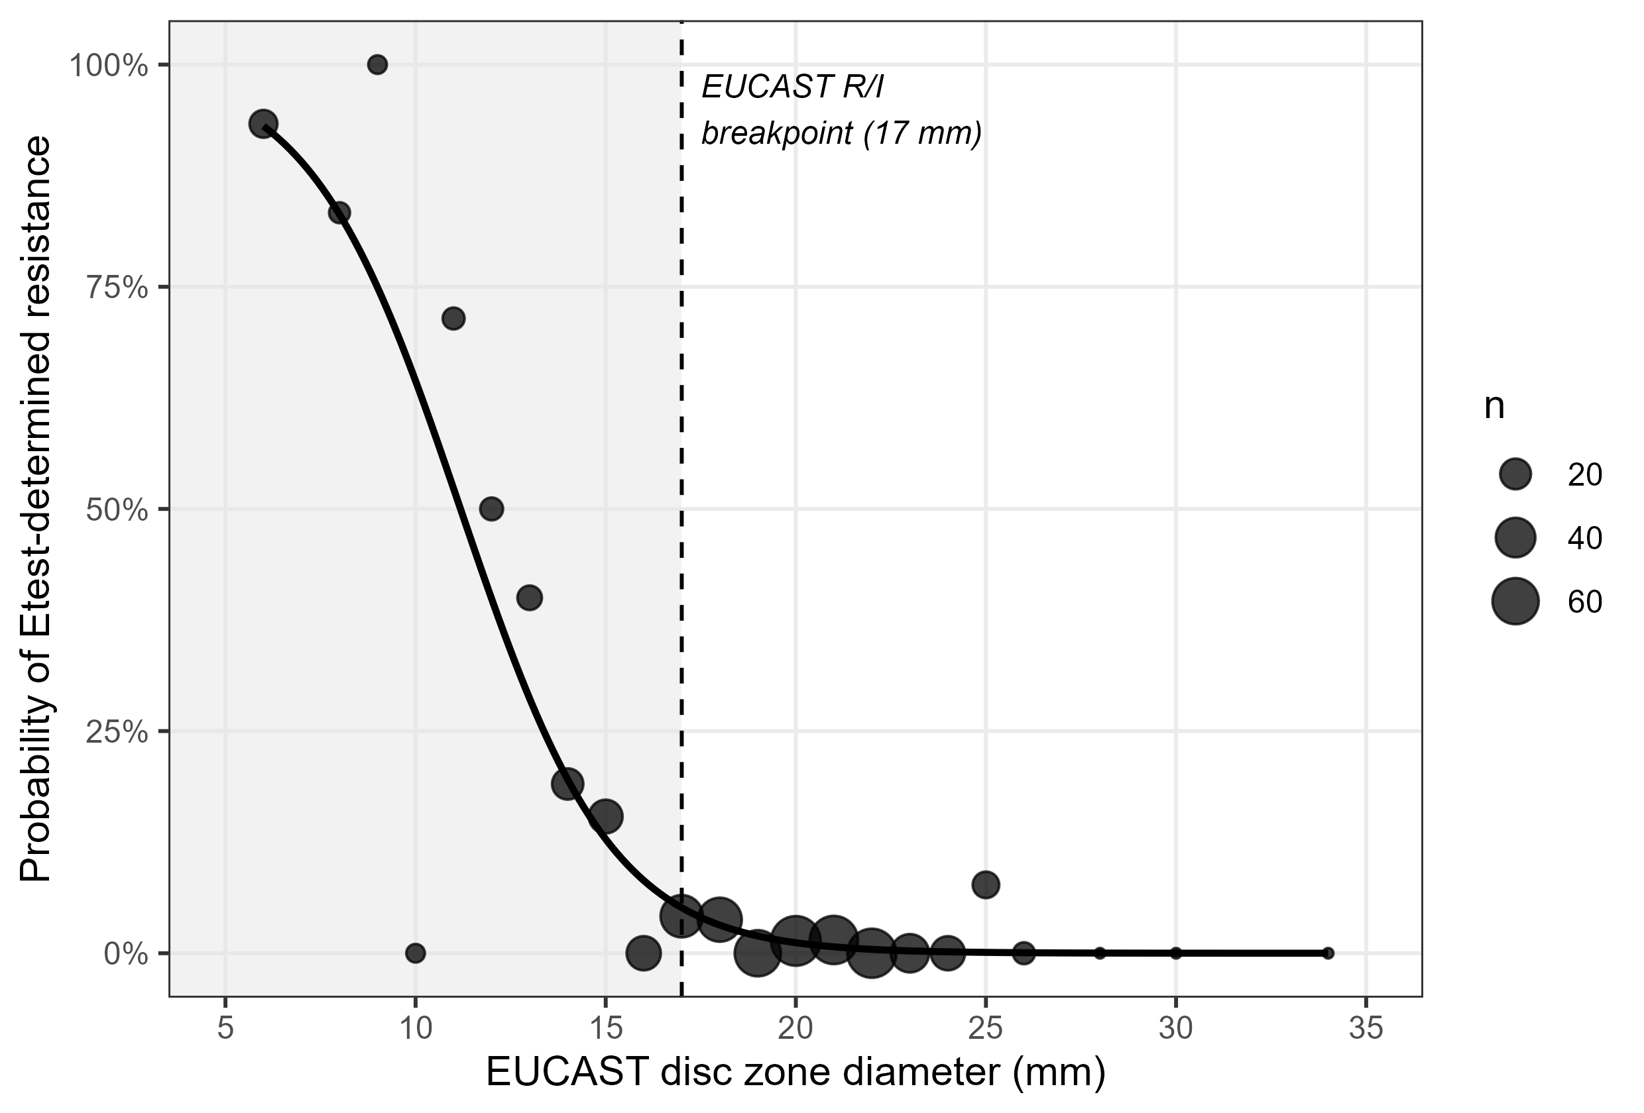

Discussion
In blood culture isolates, disc diffusion and Etest disagreed asymmetrically for temocillin. Disc-I results were highly reliable (98.5% confirmed; only 1.5% reclassified to R, clustered within a few millimetres of the breakpoint), supporting continued disc-only reporting for blood isolates called susceptible-with-increased-exposure, without routine Etest confirmation. By contrast, only 34.4% of disc-R isolates were confirmed R by Etest; 65.6% were reclassified as I. Because a disc-R result would ordinarily exclude temocillin as a treatment option,^{1,2} defaulting to disc diffusion alone risks unnecessarily discarding a viable carbapenem-sparing option in most disc-resistant bacteraemic isolates. We suggest reflex Etest (or equivalent MIC) confirmation specifically for disc-R temocillin results in blood cultures, without routine confirmation of disc-I results.
Our R→I rate is considerably higher than major-error rates reported against the older, higher systemic breakpoint,⁵ consistent with the lower EUCAST cutoff itself being a major driver: zone-diameter reading in the few millimetres around a revised breakpoint is known to be susceptible to remeasurement variability,⁶ and our discordant isolates clustered tightly around that cutoff rather than being spread across the full range — consistent with a narrow, measurement-sensitive transition zone rather than a generally unreliable method, and with interlaboratory data showing good overall category agreement for routine temocillin testing.⁷
Limitations: Etest was not ordered on a random sample of blood isolates (21.9% of Etest-tested blood isolates had zone <17 mm versus 8.3% of all blood isolates of these organisms, suggesting reflex testing preferentially targeted smaller, more resistant-looking zones), which concentrates our training data at lower zone diameters without biasing the fitted zone-conditional relationship itself; by restricting to blood cultures we could not assess whether these findings generalise to urine or other specimen types, which had too few paired isolates for separate analysis in this dataset; urinary-tract-source causation was assumed, not confirmed, for these bacteraemic isolates; this is a single-centre, retrospective analysis not yet replicated against other MIC methods (e.g. broth microdilution); and we assessed analytical agreement, not treatment outcomes. Reflex MIC testing for disc-resistant temocillin results in blood cultures should therefore inform, rather than replace, overall clinical judgement.

Acknowledgements
None. [Amend if applicable, e.g. acknowledge laboratory staff who performed testing.]

Funding
[Insert funding statement, e.g. “This work was supported by departmental resources with no external funding.”]

Transparency declarations
None declared. [Confirm and amend as applicable.]

References
- Lupia T, De Benedetto I, Stroffolini G, et al. Temocillin: applications in antimicrobial stewardship as a potential carbapenem-sparing antibiotic. Antibiotics (Basel) 2022; 11: 493.
- Delory T, Gravier S, Le Pluart D, et al. Temocillin versus carbapenems for urinary tract infection due to ESBL-producing Enterobacteriaceae: a multicenter matched case-control study. Int J Antimicrob Agents 2021; 58: 106361.
- EUCAST. Breakpoint tables for interpretation of MICs and zone diameters, version 16.1, valid from 2026-06-24. Available at: https://www.eucast.org/fileadmin/eucast/pdf/breakpoints/v_16.1_Breakpoint_Tables.pdf.
- EUCAST. Temocillin: rationale document, version 1.0, 2020. Available at: https://www.eucast.org/fileadmin/eucast/pdf/rationale_documents/bacteria/Temocillin_rationale_document_v1.0_20200327.pdf.
- Alexandre K, Réveillon-Istin M, Fabre R, et al. Temocillin against Enterobacteriaceae isolates from community-acquired urinary tract infections: low rate of resistance and good accuracy of routine susceptibility testing methods. J Antimicrob Chemother 2018; 73: 1848–53.
- Farfour E, Le Brun C, Degand N, et al. Impact of revised breakpoints on the categorization of susceptibility of Enterobacterales to temocillin. JAC Antimicrob Resist 2023; 5: dlad114.
- Deckers C, Bélik F, Yin N, et al. Multicenter interlaboratory study of routine systems for the susceptibility testing of temocillin using a challenge panel of multidrug-resistant strains. Eur J Clin Microbiol Infect Dis 2023; 42: 1477–83.

Notes for the author before submission (delete this section in the final manuscript):
- Formatted as a JAC Brief Report per the current Author Guidelines (academic.oup.com/jac/pages/General_Instructions): ≤1500 words main text (Introduction–Discussion), structured Synopsis ≤250 words, ≤2 figures/tables combined (here: 1 table + 1 figure), ≤20 references, same section order as an Original Article (Synopsis, Introduction, Methods, Results, Discussion, Acknowledgements, Funding, Transparency declarations, References). Re-check these limits against the live guidelines before submission, as they are occasionally revised.
- Analysis is now restricted to blood culture isolates throughout (Synopsis, Methods, Results, Table 1, Figure 1, Discussion), per your request — all counts were recomputed directly from the underlying data (n=585 paired blood isolates, versus n=613 across all specimen types previously), not derived from the earlier all-specimen-type figures.
- David Enoch has been added as a second author and the affiliation filled in as Cambridge University Hospitals NHS Trust, based on your own edits to the Synopsis — please confirm author order, David Enoch’s exact affiliation if different, and the Trust’s precise legal name (“NHS Trust” vs “NHS Foundation Trust”).
- Corresponding author contact details, ethics/governance statement, funding, transparency declarations and acknowledgements are still bracketed placeholders and must be completed — deliberately left blank rather than fabricated.
- References were retrieved via web search on 2026-11-03; their bibliographic details were taken from the citing source’s own summary rather than verified directly against the original PDFs. Cross-check each against the publisher page or PubMed before submission, particularly author lists abbreviated as “et al.” References 3–4 (EUCAST) should be checked against the versions in force at submission.
- JAC requires double line spacing and continuous line numbering (both applied in this Word file) and separate title-page/manuscript files for blinded peer review — the title page block above should be split into its own file before submission.
- Confirm the main-text word count (Introduction through end of Discussion) against the 1500-word Brief Report limit once author/affiliation details are finalised, since those additions are outside the counted text but placeholders elsewhere are not.

