Routine Etest confirmation of EUCAST disc diffusion results for temocillin against Enterobacterales: a retrospective concordance analysis
Running title: Reflex Etest confirmation for temocillin susceptibility
Authors: Luke Bedford¹
Affiliations: ¹ [Department/Directorate of Microbiology, Trust/Institution name — insert], [City, Country — insert]
Corresponding author: Luke Bedford, [Department of Microbiology, full postal address — insert]. E-mail: [insert institutional e-mail]; Tel: [insert]
Keywords: temocillin; EUCAST; disc diffusion; Etest; minimum inhibitory concentration; antimicrobial susceptibility testing; Escherichia coli; Klebsiella; urinary tract infection
Word count (main text): [to be completed on finalisation] Tables: 2 Figures: 1

Abstract
Objectives: Temocillin is reserved as a carbapenem-sparing option for urinary-tract infections caused by ESBL- and AmpC-producing Enterobacterales, but EUCAST has defined a single clinical breakpoint set that is not fully resolved by disc diffusion alone: the susceptible (S) breakpoint falls below what is achievable by either method, so routine results are effectively a binary susceptible-with-increased-exposure (I) / resistant (R) call. We assessed how often EUCAST disc diffusion and Etest MIC testing disagree on this I/R call, to determine whether Etest should be used routinely to confirm disc diffusion results.
Methods: We retrospectively analysed routine clinical microbiology data for Escherichia coli, Klebsiella spp. (excluding K. aerogenes) and Proteus mirabilis tested for temocillin susceptibility between 1 January 2023 and 21 October 2026. Of 13 359 isolates of these species tested by disc diffusion, 613 (4.6%) also had a temocillin Etest performed and were included in the paired analysis. Zone diameters and MICs were independently reinterpreted against EUCAST Clinical Breakpoint Table v16.1 (S ≥50 mm/≤0.001 mg/L; R <17 mm/>16 mg/L; I otherwise). Categorical agreement was calculated overall and by organism, and a logistic regression model was fitted to quantify the probability of Etest-determined resistance as a function of disc zone diameter.
Results: Overall categorical agreement was 84.3% (517/613). Of 472 isolates reported susceptible with increased exposure (I) by disc diffusion, only 8 (1.7%) were reclassified as resistant by Etest. In contrast, of 141 isolates reported resistant (R) by disc diffusion, 88 (62.4%) were reclassified as susceptible with increased exposure by Etest MIC. This pattern was consistent in the two largest organism groups, E. coli (64/93, 68.8% of disc-resistant isolates reclassified) and K. pneumoniae (23/45, 51.1%). Logistic regression confirmed a steep, highly significant relationship between zone diameter and probability of Etest resistance (odds ratio 0.61 per 1 mm increase in zone diameter, 95% CI 0.54–0.67, P<0.001; McFadden R² = 0.51).
Conclusions: EUCAST disc diffusion results reporting temocillin susceptibility with increased exposure (I) against E. coli, Klebsiella spp. and P. mirabilis are highly reliable and do not warrant routine Etest confirmation. However, more than three-fifths of isolates reported resistant (R) by disc diffusion were not confirmed resistant by Etest MIC. Reflex MIC testing should be considered before temocillin is excluded as a treatment option on the basis of a disc-diffusion-resistant result alone.

Introduction
Temocillin is a 6-α-methoxy penicillin with stability against most extended-spectrum β-lactamases (ESBLs) and AmpC enzymes, making it an attractive carbapenem-sparing option for urinary-tract infections (UTIs) caused by ESBL- or AmpC-producing Enterobacterales.¹ In a multicentre matched case-control study, temocillin achieved clinical cure rates similar to carbapenem comparators in ESBL-producing Enterobacteriaceae UTI (94% versus 99%, P=0.206), supporting its use as a carbapenem-sparing option.² Its clinical use has expanded alongside efforts to limit carbapenem consumption, but susceptibility testing for temocillin has features that complicate routine laboratory practice.
Under EUCAST Clinical Breakpoint Table v16.1, temocillin breakpoints against Escherichia coli, Klebsiella spp. (excluding K. aerogenes) and Proteus mirabilis are defined only for infections originating from the urinary tract — reflecting temocillin’s high urinary concentration, which EUCAST considers sufficient to achieve the “susceptible, increased exposure” exposure target with a standard dose provided infection is confined to the urinary tract^{3,4} — and are set such that the susceptible (S) category — MIC ≤0.001 mg/L or disc zone ≥50 mm — falls below what either disc diffusion or Etest MIC testing can practically resolve.³ In routine practice, essentially all isolates are therefore reported as either “susceptible, increased exposure” (I; MIC 0.001–16 mg/L, zone 17–49 mm) or resistant (R; MIC >16 mg/L, zone <17 mm), making temocillin susceptibility reporting functionally a binary R/I decision at a single breakpoint.
Prior work has generally reported good, though imperfect, agreement between disc diffusion and MIC-based methods for temocillin. In a large collection of community-acquired urinary Enterobacteriaceae isolates tested against the former, higher (8 mg/L) systemic BSAC breakpoint, both disc diffusion and Etest showed low major-error rates (0.7%) against agar dilution as the reference method, with no very major errors.⁵ A more recent multicentre interlaboratory comparison using the current EUCAST breakpoints found category agreement of around 90% or better for most routine methods (disc diffusion, Etest, Vitek® 2), with weaker performance specifically for Proteus spp.⁷ Separately, lowering the disc diffusion breakpoint from 20 mm to 17 mm to align with EUCAST has been shown to substantially reduce reported resistance (from 11.3% to 4.7% in one French multicentre study), and re-reading of isolates with zone diameters close to the revised cutoff reclassified a meaningful proportion (11.7% of isolates measuring 18–21 mm) from susceptible to resistant on remeasurement — highlighting that zone-diameter reading immediately around the breakpoint is itself a source of variability.⁶
Disc diffusion is the routine primary method in most UK diagnostic laboratories because of its lower cost and workload, with Etest MIC testing typically reserved for reflex or confirmatory use. Whether that reflex-only use of Etest is clinically justified against the current EUCAST breakpoints — and in particular, whether it should instead be targeted specifically at disc-resistant isolates rather than disc-susceptible ones, or performed on neither — has not, to our knowledge, been directly reported. We addressed this question using routinely collected paired disc diffusion and Etest results from a single UK laboratory information system.

Materials and methods

Setting and data source
Microbiology results were extracted from the CHEQS laboratory information system for all temocillin susceptibility tests (disc diffusion and/or Etest) performed between 1 January 2023 and 21 October 2026. The extract comprised 19 902 individual temocillin test records from 18 985 specimens and 12 498 patients.

Inclusion criteria
Analysis was restricted to the three organism groups for which EUCAST validates a temocillin breakpoint: E. coli (excluding the O157 serotype and mixed-growth isolates), Klebsiella spp. (excluding K. aerogenes, for which no temocillin breakpoint is defined) and P. mirabilis.³ Of 13 359 isolates of these organisms tested by disc diffusion over the study period, 613 (4.6%) had both a disc diffusion zone diameter and an Etest MIC recorded for temocillin and formed the paired comparison cohort reported here; the remainder had disc diffusion only. The great majority of paired results (585/613, 95.4%) came from blood cultures, with the remainder from body fluid, cerebrospinal fluid, sputum, swab and urine specimens (each ≤12 isolates). Enterobacterales bacteraemia, particularly with E. coli, Klebsiella spp. and Proteus spp., is frequently secondary to a urinary source; we treat this as a reasonable but unconfirmed assumption rather than a verified fact, since specimen type alone does not establish the clinical source of infection, and note it as a limitation below.

Susceptibility interpretation
Rather than relying on the susceptibility category recorded at the time of testing — which had occasional gaps — disc zone diameters and Etest MICs were re-interpreted directly against the EUCAST v16.1 breakpoints for temocillin (S: MIC ≤0.001 mg/L or zone ≥50 mm; R: MIC >16 mg/L or zone <17 mm; I: all other values).³ Etest values reported with “<” or “>” qualifiers had the qualifier stripped, and MICs were capped at 256 mg/L (the top of the tested range). Three disc zone values considered implausible (>50 mm, almost certainly transcription errors) were excluded from supplementary zone-diameter analyses but are not relevant to the breakpoint comparison reported here, as none fell within the paired cohort.

Statistical analysis
Categorical agreement between the EUCAST disc diffusion interpretation and the Etest interpretation was calculated overall and stratified by organism, reported as the number and percentage of agreements, and of discordant results in each direction (disc-I reclassified as Etest-R, and disc-R reclassified as Etest-I). To characterise the relationship between zone diameter and the probability of an Etest-resistant result, a logistic regression model was fitted with Etest result (R versus I) as the outcome and disc zone diameter as the sole predictor, using the 613 paired isolates. All analyses were performed in R v4.3 (R Foundation for Statistical Computing, Vienna, Austria) using the tidyverse and gt packages.

Ethics
This work used retrospectively collected, routinely generated laboratory surveillance data for the purpose of service evaluation and did not involve any change to patient care. [Insert local institutional policy reference / confirmation of service-evaluation registration or research ethics committee waiver, as applicable.]

Results

Overall agreement
Among the 613 isolates with paired disc diffusion and Etest results, 517 (84.3%) showed categorical agreement between the two methods (Table 1). Of 472 isolates reported susceptible with increased exposure (I) by disc diffusion, 464 (98.3%) were confirmed I by Etest and only 8 (1.7%) were reclassified as resistant. Of 141 isolates reported resistant (R) by disc diffusion, only 53 (37.6%) were confirmed R by Etest; the remaining 88 (62.4%) were reclassified as susceptible with increased exposure.
Table 1. Categorical agreement between EUCAST disc diffusion and Etest MIC interpretation for temocillin (n = 613)
EUCAST disc diffusion | Etest: I | Etest: R | Total | % reclassified by Etest
I (susceptible, increased exposure) | 464 | 8 | 472 | 1.7%
R (resistant) | 88 | 53 | 141 | 62.4%
Total | 552 | 61 | 613

Agreement by organism
The discordance pattern was consistent across the two organism groups with sufficient numbers for meaningful comparison (Table 2). Among disc-resistant E. coli isolates, 64/93 (68.8%) were reclassified as I by Etest; among disc-resistant K. pneumoniae isolates, 23/45 (51.1%) were reclassified. Disc-susceptible (I) isolates were reclassified as resistant in only 1.4% of E. coli and 2.9% of K. pneumoniae cases. Numbers for K. oxytoca (n=12), K. variicola (n=3) and P. mirabilis (n=2) were too small to draw separate conclusions.
Table 2. Agreement and discordance by organism
Organism | n (paired) | n EUCAST-I | I→R, n (%) | n EUCAST-R | R→I, n (%)
Escherichia coli | 446 | 353 | 5 (1.4%) | 93 | 64 (68.8%)
Klebsiella pneumoniae | 150 | 105 | 3 (2.9%) | 45 | 23 (51.1%)
Klebsiella oxytoca | 12 | 10 | 0 (0%) | 2 | 0 (0%)
Klebsiella variicola | 3 | 2 | 0 (0%) | 1 | 1 (100%)
Proteus mirabilis | 2 | 2 | 0 (0%) | 0 | —
Overall | 613 | 472 | 8 (1.7%) | 141 | 88 (62.4%)

Relationship between zone diameter and Etest result
Logistic regression of Etest result on disc zone diameter showed a steep, highly significant relationship (zone diameter coefficient −0.50, SE 0.052, P<0.001; intercept 5.66, SE 0.77, P<0.001; McFadden R² = 0.51; training classification accuracy 94.5%). Each 1 mm increase in zone diameter was associated with a 39% reduction in the odds of an Etest-resistant result (odds ratio 0.61, 95% CI 0.54–0.67). At the EUCAST breakpoint itself (17 mm), the fitted probability of an Etest-resistant result was 5.5%, falling to 1.3% by 20 mm and below 0.1% beyond 25 mm (Figure 1). The eight discordant disc-I/Etest-R isolates all had zone diameters within 8 mm of the breakpoint (range 17–25 mm, median 19 mm), consistent with discordance being concentrated immediately adjacent to the cutoff rather than occurring unpredictably across the full susceptible range (up to 34 mm in this dataset).
Figure 1. Predicted probability of an Etest-resistant result by EUCAST disc zone diameter, fitted by logistic regression (solid line; shaded region indicates disc-diffusion-resistant zones, <17 mm). Points show the observed proportion of Etest-resistant results at each observed zone diameter, sized by the number of isolates at that value (n = 613).
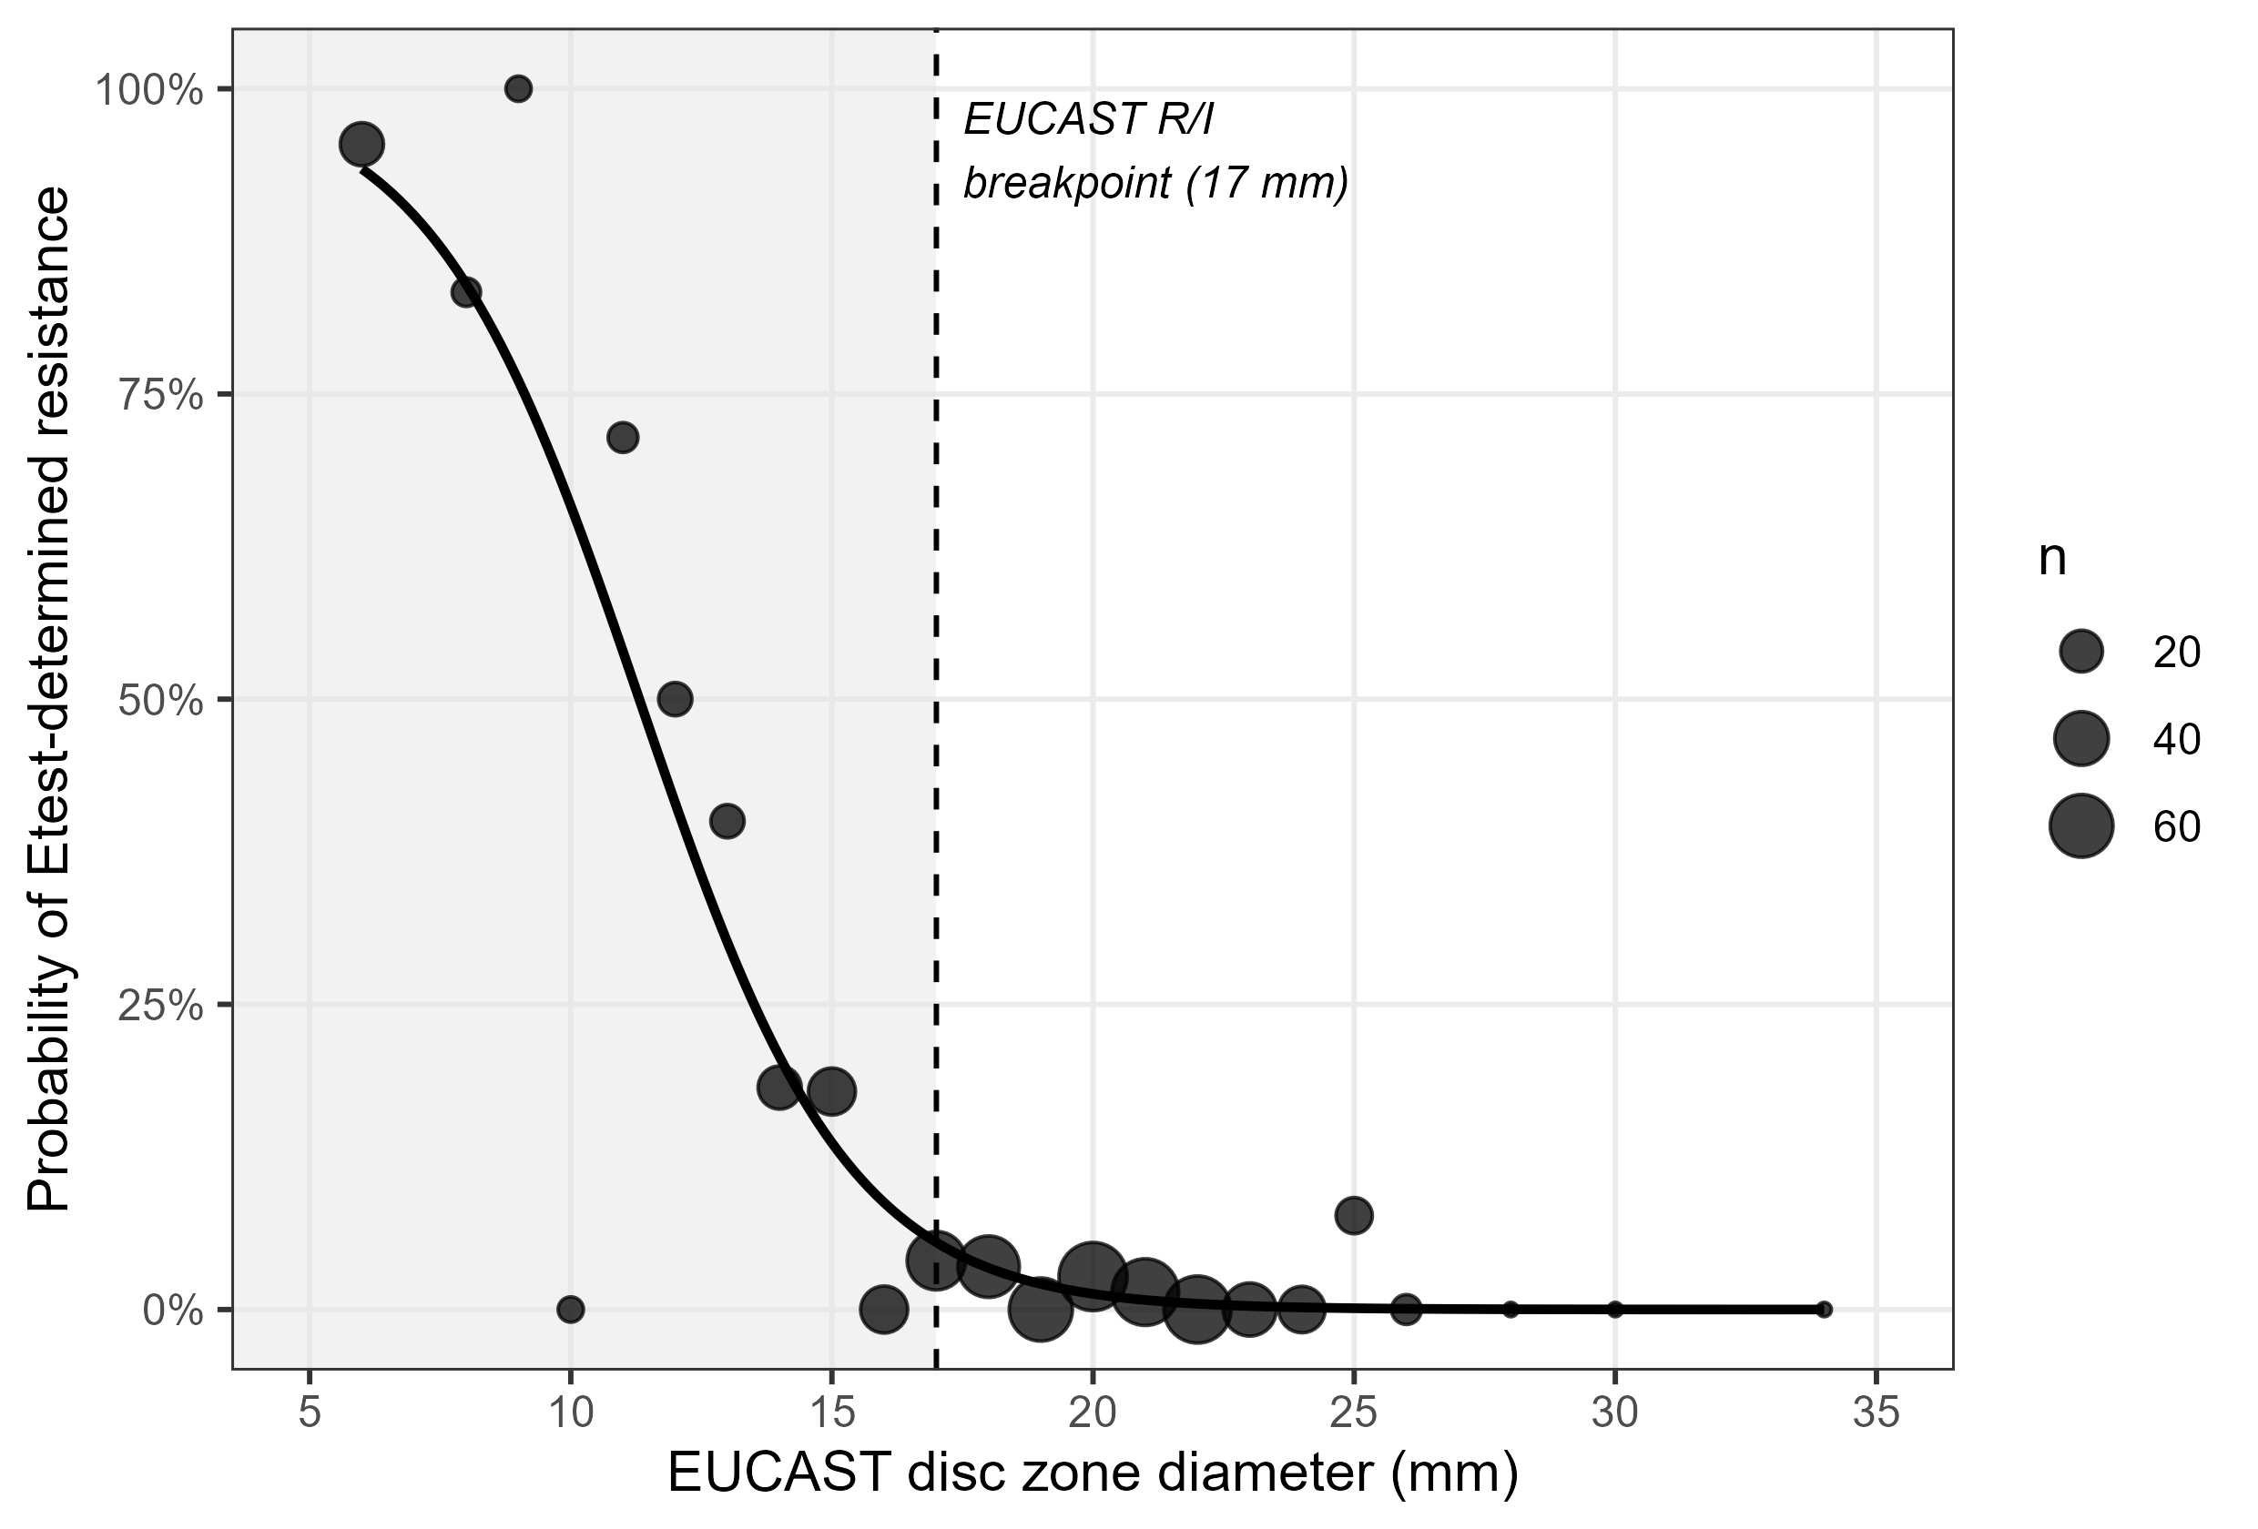

Discussion
This analysis found a clear asymmetry in how often EUCAST disc diffusion and Etest MIC testing disagree for temocillin, depending on the direction of the disc diffusion result. Disc-diffusion-susceptible (I) results were highly reliable: only 1.7% were reclassified as resistant by Etest, and the small number of discordant results clustered immediately around the breakpoint rather than being spread across the susceptible range. This supports continued routine use of disc diffusion alone for isolates reported susceptible with increased exposure, without a need for reflex Etest confirmation.
By contrast, disc-diffusion-resistant (R) results were confirmed by Etest only 37.6% of the time; the majority (62.4%) were reclassified as susceptible with increased exposure. This is a clinically important discordance: a disc-diffusion-resistant result would ordinarily exclude temocillin as a treatment option, yet Etest MIC testing shows that most such isolates in this dataset in fact fall within the usable “increased exposure” range. Given temocillin’s role as a narrower-spectrum, carbapenem-sparing agent for ESBL- and AmpC-producing Enterobacterales,^{1,2} defaulting to the disc diffusion result alone risks unnecessarily excluding a viable, carbapenem-sparing treatment option in a majority of resistant-by-disc cases. We therefore suggest that laboratories consider reflex Etest (or equivalent MIC) confirmation specifically for isolates reported resistant to temocillin by disc diffusion, while reserving disc diffusion alone — without routine MIC confirmation — for isolates reported susceptible with increased exposure.
This R-to-I discordance rate is considerably higher than the major-error rates reported for temocillin disc diffusion against the historical, higher systemic breakpoint,⁵ which is consistent with the breakpoint revision itself being a major driver: previous work has shown that lowering the disc diffusion breakpoint to the current, lower EUCAST cutoff substantially reduces reported resistance and that zone-diameter reading in the few millimetres around such a revised cutoff is prone to measurement variability on remeasurement.⁶ Our own finding that all eight disc-I/Etest-R discordant isolates had zone diameters within 8 mm of the breakpoint (versus a susceptible range extending to 34 mm) is consistent with this picture of a narrow, measurement-sensitive transition zone rather than a uniformly unreliable method, and aligns with interlaboratory data showing good, though organism-dependent, category agreement for routine temocillin testing methods more broadly.⁷
Several limitations should be weighed in applying these findings. First, Etest was not performed on a random sample of isolates: among blood isolates (the only specimen type with sufficient paired data to check), 21.9% of Etest-tested isolates had a zone diameter <17 mm compared with only 8.3% of all blood isolates, indicating that Etest was preferentially ordered for isolates with smaller, more resistant-looking zones — a plausible reflex-testing pattern in the laboratories contributing to this dataset. This selection does not bias the fitted relationship between zone diameter and Etest result conditional on zone diameter, but it does mean the training data are concentrated at lower zone diameters and sparser at higher ones, and we did not verify that the same relationship holds unchanged for specimen types other than blood. Second, 585/613 (95.4%) of paired results came from blood cultures rather than urine, whereas the EUCAST breakpoint is explicitly validated for infections originating from the urinary tract; we consider Enterobacterales bacteraemia with a presumed urinary source (urosepsis) to be a reasonable basis for interpreting these results under the urinary-tract breakpoint, but this was not confirmed at the level of individual cases and should be treated as an assumption rather than a settled fact.³ Third, this is a retrospective, single-centre analysis, and the discordance rates we report — particularly the high rate of R-to-I reclassification — should be replicated in other settings and against other MIC methods (for example, broth microdilution) before being generalised into formal testing algorithms. Finally, we did not assess the clinical consequences (e.g. treatment outcomes) of either testing strategy; our conclusions relate to analytical agreement between methods rather than to directly demonstrated patient benefit, and clinical decision-making should continue to take the full clinical picture into account.
In summary, EUCAST disc diffusion for temocillin against E. coli, Klebsiella spp. (excluding K. aerogenes) and P. mirabilis reliably identifies susceptible-with-increased-exposure isolates without need for routine Etest confirmation, but a disc-diffusion-resistant result should prompt consideration of reflex MIC testing before temocillin is excluded as a treatment option.

Funding
[Insert funding statement, e.g. “This work was supported by departmental resources with no external funding.” or details of any grant.]

Transparency declarations
None declared. [Confirm and amend as applicable.]

Author contributions
L.B. designed the study, performed the data extraction, analysis and interpretation, and drafted the manuscript. [Amend/expand per actual contributions and add further authors as applicable.]

References
- Lupia T, De Benedetto I, Stroffolini G, et al. Temocillin: applications in antimicrobial stewardship as a potential carbapenem-sparing antibiotic. Antibiotics (Basel) 2022; 11: 493.
- Delory T, Gravier S, Le Pluart D, et al. Temocillin versus carbapenems for urinary tract infection due to ESBL-producing Enterobacteriaceae: a multicenter matched case-control study. Int J Antimicrob Agents 2021; 58: 106361.
- EUCAST. Breakpoint tables for interpretation of MICs and zone diameters, version 16.1, valid from 2026-06-24. Available at: https://www.eucast.org/fileadmin/eucast/pdf/breakpoints/v_16.1_Breakpoint_Tables.pdf.
- EUCAST. Temocillin: rationale document, version 1.0, 2020. Available at: https://www.eucast.org/fileadmin/eucast/pdf/rationale_documents/bacteria/Temocillin_rationale_document_v1.0_20200327.pdf.
- Alexandre K, Réveillon-Istin M, Fabre R, et al. Temocillin against Enterobacteriaceae isolates from community-acquired urinary tract infections: low rate of resistance and good accuracy of routine susceptibility testing methods. J Antimicrob Chemother 2018; 73: 1848–53.
- Farfour E, Le Brun C, Degand N, et al. Impact of revised breakpoints on the categorization of susceptibility of Enterobacterales to temocillin. JAC Antimicrob Resist 2023; 5: dlad114.
- Deckers C, Bélik F, Yin N, et al. Multicenter interlaboratory study of routine systems for the susceptibility testing of temocillin using a challenge panel of multidrug-resistant strains. Eur J Clin Microbiol Infect Dis 2023; 42: 1477–83.

Notes for the author before submission (delete this section in the final manuscript):
- Author affiliation, corresponding author contact details, ethics/governance statement, funding and transparency declarations are still bracketed placeholders and must be completed — these were deliberately left blank rather than fabricated.
- References 1, 2, 5, 6 and 7 were retrieved via web search on 2026-11-03 and their authors/titles/journal/volume/page/DOI details were taken from the citing source’s own summary of the article, not independently verified against the original PDFs — please cross-check each against the publisher page or PubMed before submission, particularly author lists, which were sometimes abbreviated (“et al.”) where the full list was not confirmed. References 3 and 4 (EUCAST) are populated from the project’s own documentation/the EUCAST website and should be checked against the versions actually in force at the time of submission.
- JAC’s author guidelines (check the current “Instructions to Authors” on the journal website before submission) specify double line spacing and continuous line numbering for the submitted Word file, a structured abstract of ≤250 words, Vancouver-style numbered references, and separate title-page/manuscript files for blinded peer review — apply these formatting requirements in Word, as they are not fully reproducible via automated conversion.
- Word count, number of tables/figures, and the exact Methods/Results split against JAC’s current word limits for Original Articles should be verified against the live author guidelines, as these limits are occasionally revised.

