Sprint Plan 2

Rent’s Planet

Completion date: Nov. 4 2016

Last Updated Nov. 4 2016

Sprint goal: Connect website to server through backend.

Scrum Meeting Times: Tues 10:45 am, Thurs 5:30pm, Friday 4:00 pm

Stories and Tasks:

* As a renter, I want to be able to post review information to this website
  + Tasks:
    - Configure hibernate library to help with database (Viraj, 8)
    - Build server-side application to be run on Tomcat (Darius and Luke, 13)
    - Write JS to make HTTP calls to server (Jack, 5)
    - Send forms to server (Jack, 8)
* As a future tenant, I want to be able to see other reviews people have posted about a certain address
  + Tasks:
    - Write JS to receive information from the server (Jack, 5)
* As a developer, I want to store and pull reviews in Database to save reviews.
  + Tasks:
    - Build hibernate functions to send transactions to database (Viraj 5)
    - Build java functions for rest service to call hibernate functions (Luke 3)
* As a product owner, I want a presentable website because I want people to easy to understand
  + Tasks:
    - Update the looks and style of website (Jarrett, 3)

Initial Burnup

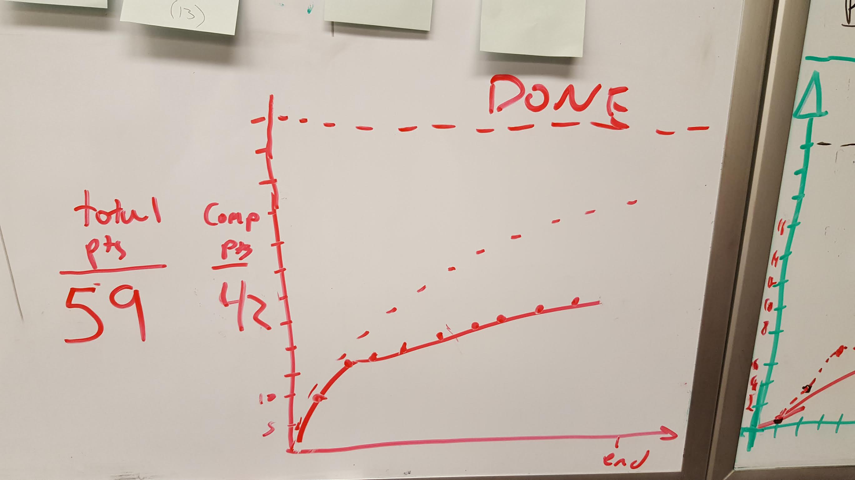

Initial Scrum Board

