2 Path traversal while uploading files

题目要求上传到PathTraversal目录下，PathTraversal为上级目录，因此文件名../跨目录上传到上级目录

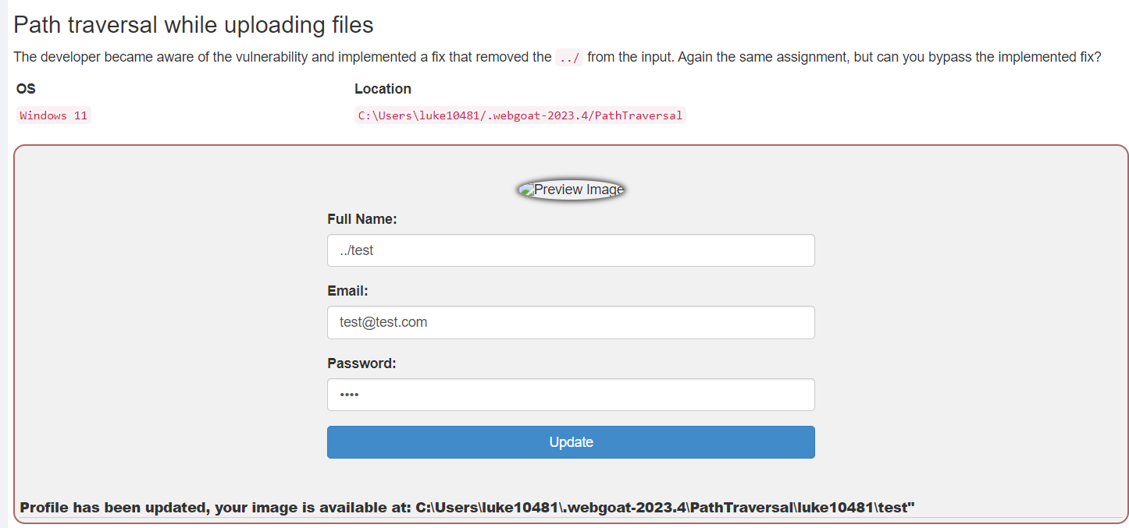

成功

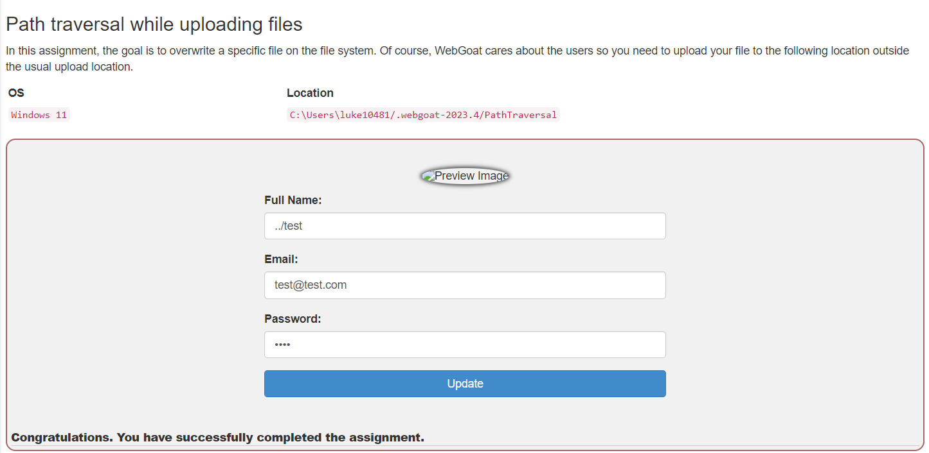3 Path traversal while uploading files

双写关键字

4 Path traversal while uploading files

抓包修改文件名为../发包，成功

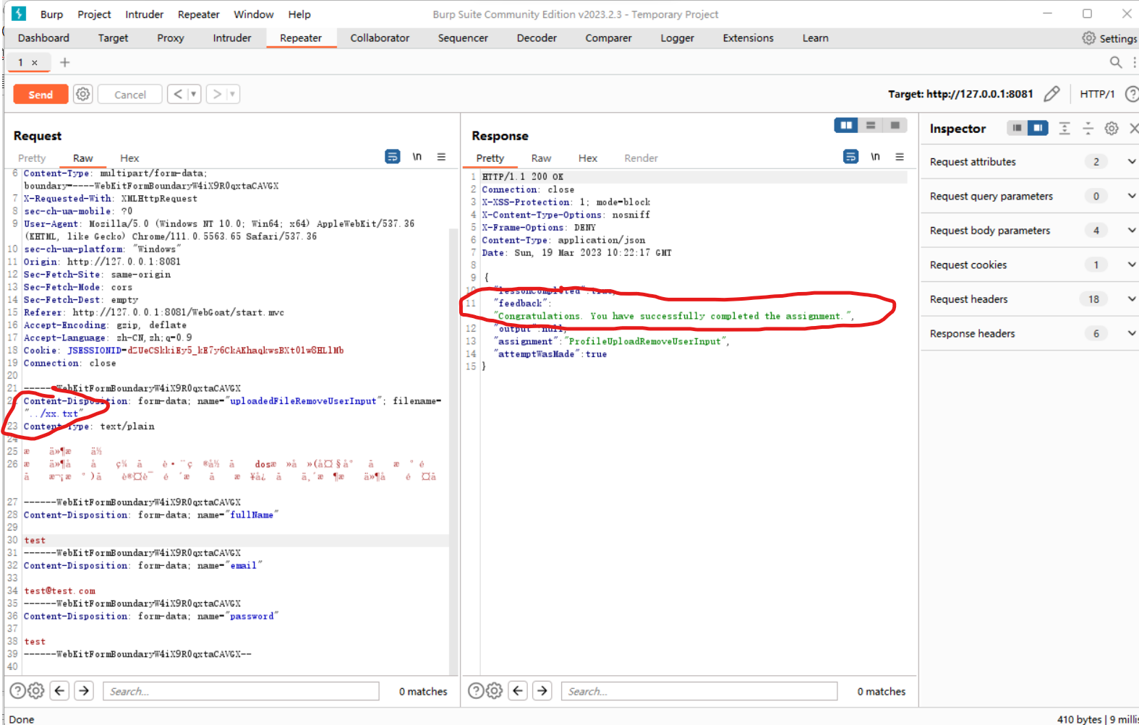

Retrieving other files with a path traversal