 | AIC Inc.  No. 152, Sec.4, Linghang N. Rd,  Dayuan District, Taoyuan City  Taiwan 337  T: +886-3-433-9188  F: +886-3-287-1818  www.aicipc.com

Design Validation Test Report
Reliability Test
SB202-SU / XP1-S202SUXX

Date |  |  | 2025 / 10 / 27
Doc. Number |  |  | RD251027A29
Doc. Version |  |  | A
Number of Pages |  |  | 15
Test Report Perform By |  |  | DQA Team
 | Approved By |  |  | Reviewed By | Tested By

© 1996-2025 AIC Inc. All rights reserved.
All other trademarks are the property of their respective companies.
CONFIDENTIALITY NOTICE: The information contained in this document is confidential, and may not be used, published or redistributed without the prior written consent of AIC Inc.

Table of Contents

1. Revision History 2

2. Introduction 2
2.1. Purpose 2
2.2. Scope 2
2.3. UUT Configuration 2
2.4. Test Equipment and Software 3

3. Summary 3
3.1. Test Item Result 3
3.2. Test Conclusion 4
3.3. Bug List 4
3.4. UUT Photo 4

4. Reliability Test Result 5
4.1. Environmental Qualification Test 5
4.1.1. Non-Operational Storage Test 6
4.1.2. Cold / Hot Start Test 6
4.2. Mechanical Structure Test 7
4.2.1. Operating Vibration Test 7
4.2.2. Operating Shock Test 8
4.2.3. Non-Operation Square Wave Shock Test Report 9
4.3. Other Test 10
4.3.1. Rotational Vibration Index Test 10

- Revision History
Revision | Description | Date | By
A | Initial version | 2025.10.27 | King.Huang
- Introduction
  - Purpose
This document is the DVT Test Report for the SB202-SU (XP1-S202SU02E01), the system’s configuration includes Sirius Main Board, GENUINE INTEL(R) XEON(R) Q3J1 1.2Ghz 350W *2pcs, Micron 16GB DDR5 RDIMM MTC10F1084S1RC56BD1*32 pcs, 3.5” Seagate 4TB SATA HDD ST4000NM024B*8pcs, Seagate 22TB SATA HDD ST22000NM0001E*8pcs(only for RVI Test),
2.5” WD SN650 Nvme SSD 7.68TB WUS5EA176ESP5E1*4pcs, 2.5” Seagate 2.5” 1TB SATA HDD ST1000NX0313*2pcs, M.2 (OS) Crucial P3 Plus 500GB SSD CT500P3PSSD8 *1pcs, SUNON Fan Module *4pcs and AcBel Power Module*2pcs.
  - Scope
To ensure system level products are capable of withstanding the varied environmental condition that may occur during operation/non-operation, and identify the reliability has been designed-in the product. The test specification and configuration are approved by PJM and customer to take precedence for test execution.
  - UUT Configuration
The table summarizes the Key part of UUT’s configuration for this test report as below.
Table 1: List of Test UUT’s configuration
No | Key Part | Manufacturer | PN/Revision. | S/N
1 | Mother Board | AIC | BMB-DPG0001AC01 | 422-25062800100012
2 | Backplane Board | AIC | BBP2FB20001AC01 | 422-24071701100018
 |  |  | BBP2HD10001AB02 | 422-24081400300055
3 | RISER CARD | AIC | BRC2PE20052AC01 | 422-24111100600006
 |  |  | BRC2PE20053AC01 | 422-24111100200113
4 | Fan Module | SUNON | VG80561BX-Q140-S9H | NA
5 | Power Module | AcBel | R1CA2202E | A00245200162000AGBFSM005
 |  |  |  | A00245200162100AGBFSM005
  - Test Equipment and Software
The following tables summarize all test equipment and software required for this test report. This information is also provided in the test condition table of each test case.
Table 2: List of Test Equipment
No | Test Equipment | Manufacturer | Model | Calibration Date | Due Date
1 | Vibration Tester | KING DESIGN | KD-9363-EM-1000-  F2K-50N250 | 2025/03 | 2026/03
2 | Drop Tester | KING DESIGN | KD-128A | N/A | N/A
3 | KSON Chamber | KSON | THS-D4T-100 | 2025/01 | 2026/01
4 | Walk-in Chamber | KSON | ATH-Z600 | 2025/08 | 2026/08
Table 3: List of Test Item with Software
No | Test Item | Test Software | Vender | Version | Remarks
1 | Non-Operational Storage Test | Iometer | Intel | 1.1.0
2 | Cold / Hot Start Test | QT Cycling Multi | AIC | N/A
3 | Operating Vibration Test | Iometer | Intel | 1.1.0
4 | Operating Shock Test | Iometer | Intel | 1.1.0
5 | Non-Operational Square Wave Shock Test | Iometer | Intel | 1.1.0
6 | Packaged Test | Iometer | Intel | 1.1.0
7 | Rotational Vibration Index Test | Iometer | Intel | 1.1.0
- Summary
  - Test Item Result
No | Test Item | Date | Results | Remark
1 | Non-Operational Storage Test | 2025/08/30~2025/09/11 | Pass
2 | Cold / Hot Start Test | 2025/10/21~2025/10/27 | Pass | Use RD solution can pass it.
3 | Operating Vibration Test | 2025/10/15~2025/10/16 | Pass
4 | Operating Shock Test | 2025/10/15~2025/10/16 | Pass
5 | Non-Operational Square Wave Shock Test | 2025/08/12~2025/08/12 | Pass
6 | Packaged Test | 2025/08/21~2025/08/22 | Pass
7 | Rotational Vibration Index Test | 2025/07/22~2025/10/14 | Pass | Use RD solution can pass it.
  - Test Conclusion
There is no abnormal in system function and physical damage during the test. The UUT can pass
these tests.

  - Bug List
Bug No. | Severity | Description/Execution Action | Status | Issue Owner | Remark
1 | High | After the Cold / Hot Start Test, there P0, P1 VR Inlet Over temperature issue,  RD solution is update BMC Version to 4A00SIR011202 for verifies, this test result is pass. | Close | BMC/Jethro Yeh
2 | High | After the RVI test, the 3.5” HDD performance has drop over 15%,  RD solution are add sound-absorbing cotton at the fan inlet, use these solution can pass it. | Close | ME/Jack Weng
  - UUT Photo
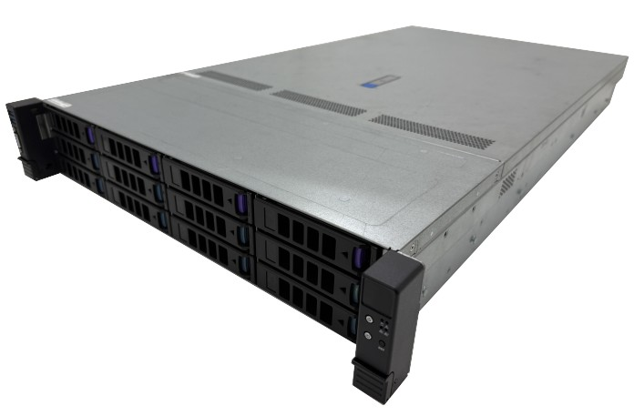
SB202-SU (XP1-S202SU02E01)
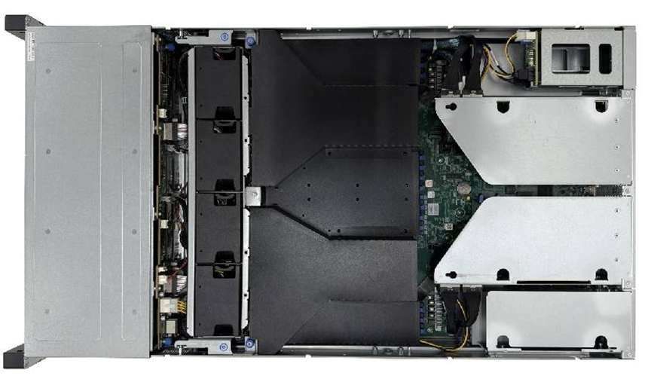
Top View

- Reliability Test Result
  - Environmental Qualification Test
    - Non-Operational Storage Test
      - Description
To ensure that there are no adverse effects to electrical function, mechanical structure or appearance by sustained storage and shipping temperature of extremes.

      - Test Procedure
- Pre-testing of the UUT shall test for electrical / mechanical functionality and appearance.
- Run diagnostics for a period of 2 hours on the systems before test.
- Record all test results and photographs for anomalies.
      - Pass/Fail Criteria
- Visual inspection was passed without any abnormal or above failure mechanisms:
- HDD/SSD tray deformation check
- Chassis deformation check
- Functional was passed without any failure or abnormal symptom:
- BMC SDR /SEL have no any abnormal record or status detect failure.
- Diagnostics (Iometer) have no any failure (error) occur
- All install device can be detected before and after test (device check by OS)
- No any subassembly noise.
- Without corrode
- The R.T.C specification is +/- 2 second per day. (Maximum allowable +/- 10 second per day).

      - Result
Test Result | Before Test | After Test
Physical Damage | Pass | Pass
Functional Check | Pass | Pass

Test Result | GOV.TIME | SYSTEM.TIME | TIME DIFFERENCE
RTC Check | 2025/09/11  PM:16:22:36 | 2025/09/11  PM:16:22:30 | Delay 6s
    - Cold / Hot Start Test
      - Description
This test is performed to verify the UUT can boot properly under high / Low temperature environment.

      - Test Procedure
- Pre-testing of the units shall test for electrical / mechanical functionality.
- Run diagnostics for a period of 2 hours on the systems before test.
- Ensure UUT's power management feature (AC Recovery) is set to “ON.
- Keep the UUT's status to AC power off at cold soak and hot soak (12Hrs).
- All samples shall be subjected to 300 cycles of power cycling at each temperature of extreme.
- Record all test results and photographs for anomalies.

      - Pass/Fail Criteria
- Functional was passed without any failure or abnormal symptom:
- BMC SDR /SEL have no any abnormal record or status detect failure.
- Diagnostics (Iometer) have no any failure (error) occur
- All install device can be detected before and after test (device check by OS)
- Indicator LEDs (power, HDD/SSD activity) have no any damage or incorrect action.
- UUT is able to successfully enter or exit from test program during power cycling process.
- UUT passed any test in pre- or post-test diagnostics suite:
- Check by QT cycling tool – CPU/Memory/HDD/Add-on card status if wrong with spec defined.

Test1:Without RD Solution
Test Result | Before Test | After Test
Physical Damage | Pass | Pass
Functional Check | Pass | Fail

Test2:With RD Solution
Test Result | Before Test | After Test
Physical Damage | Pass | Pass
Functional Check | Pass | Pass
  - Mechanical Structure Test
    - Operating Vibration Test
      - Description
Assess the impact to the system assembly functionality caused by external vibration and to identify any points of failure in the support of design improvements.

      - Test Procedure
- Install all the required devices into the system assembly
- Make sure mechanical structure and electrical functionality are normal before testing
- Clamp the system assembly firmly on the vibration table in any of the “X” direction
- Run Diagnostic Program during the test.
- Repeat the above process for the “Y” and “Z” vibration axes.
- Record all test results and photographs for anomalies.

      - Pass/Fail Criteria
- No Mechanical structure or electrical functionality are damaged:
- Check if FAN module eject
- Check if Screw loose
- Check if HDD / SSD tray eject
- System functional failure during vibration test or post diagnostics:
- BMC SDR /SEL have no any abnormal record or status detect failure.
- Diagnostics (Iometer) have no any failure (error) occur
- All install device can be detected before and after test (device check by OS)
- Physical damage to system or components that would disrupt operation.

      - Result
Test Result | Before Test | After Test
Physical Damage | Pass | Pass
Functional Check | Pass | Pass

    - Operating Shock Test
      - Test Procedure
- Install all the required devices into the system assembly.
- Make sure mechanical structure and electrical functionality.
- Apply the 11ms, 2G shock, each surface 3 times.
- Record any mechanical structure or electrical functionality anomalies.
- After the shock test, run diagnostics for electrical and mechanical functionality.
- Formally record all results, photograph any anomalies.

      - Pass/Fail Criteria
- No Mechanical structure or electrical functionality are damaged:
- Check if FAN module eject
- Check if Screw loose
- Check if HDD tray eject
- System functional failure during shock test or post diagnostics:
- BMC SDR /SEL have no any abnormal record or status detect failure.
- Diagnostics have no any failure (error) occur.
- All install device can be detected before and after test (device check by OS)
- Physical damage to system or components that would disrupt operation.

      - Result
Test Result | Before Test | After Test
Physical Damage | Pass | Pass
Functional Check | Pass | Pass

    - Non-Operation Square Wave Shock Test Report
      - Test Procedure
Install all the required devices into the system assembly.
Make sure mechanical structure and electrical functionality are normal before testing.
Apply G-Value and duration time by weight, 6 shocks total (1 per surface). For palletized
packaging, apply to bottom face only, one time, at the lowest test level.
After the shock test, run diagnostics for electrical and mechanical functionality
Formally record all results, photograph any anomalies.

      - Pass/Fail Criteria
No Mechanical structure or electrical functionality are damaged:
- Check if FAN module eject
- Check if Screw loose
- Check if HDD/SSD tray eject
System functional failure during vibration test or post diagnostics:
- BMC SDR /SEL have no any abnormal record or status detect failure.
- Diagnostics have no any failure (error) occur.
- All install device can be detected before and after test (device check by OS)
Physical damage to system or components that would disrupt operation.

      - Result
G-Value | Duration time | Packaged Weight
30 | 12ms | 30.53
Test Result | Before Test | After Test
Physical Damage | Pass | Pass
Functional Check | Pass | Pass

  - Other Test
    - Rotational Vibration Index Test
      - Description
Test is for the System under normal operating conditions and evaluates the effect of internal generated Rotational Vibration on HDD performance.

      - Test Procedure
- System under test shall be run for 10 minutes to allow the system to warm up to normal operating temperature and fan speeds to stabilize for ambient conditions.
- Set the system’s FAN duty 100 percent.
- Mount the baseline Test HDD on “HDD Test Block” that be placed on the table, run IOMeter program for 10 minutes, and save IOMeter HDD baseline data.
- Place unit on the table, install baseline Test HDD in first bay and fill the remaining bays with functional HDD’s of the same type.
- Repeat IOMeter test for 10 minutes and save IOMeter test result data (for each HDD bay)
- Record all test results and photographs for anomalies.

      - Pass/Fail Criteria
- PLV=Performance loss value (percentage)
- PLV=(1-(I/Os in the chassis/I/Os on a block))
- SATA system PLV shall be less than or equal to 15%
- SCSI or SAS system, using highest capacity hard drives available, PLV shall be less than or equal to 10%

Test1:Without RD Solution
Test Result | Before Test | After Test
Physical Damage | Pass | Pass
Functional Check | Pass | Fail

Test2:With RD Solution
Test Result | Before Test | After Test
Physical Damage | Pass | Pass
Functional Check | Pass | Pass

