 | AIC Inc.  No. 152, Sec.4, Linghang N. Rd,  Dayuan District, Taoyuan City  Taiwan 337  T: +886-3-433-9188  F: +886-3-287-1818  www.aicipc.com

Design Validation Test Report
Reliability Test
HA2026-HC / XP1-A202HCXX

Date |  |  | 2026 / 03 / 09
Doc. Number |  |  | RD260309A09
Doc. Version |  |  | A
Number of Pages |  |  | 11
Test Report Perform By |  |  | DQA Team
 | Approved By |  |  | Reviewed By | Tested By

© 1996- {{DATE_YEAR}} AIC Inc. All rights reserved.
All other trademarks are the property of their respective companies.
CONFIDENTIALITY NOTICE: The information contained in this document is confidential, and may not be used, published or redistributed without the prior written consent of AIC Inc.

Table of Contents

1. Revision History 2

2. Introduction 2
2.1. Purpose 2
2.2. Scope 2
2.3. UUT Configuration 2
2.4. Test Equipment and Software 3

3. Summary 4
3.1. Test Item Result 4
3.2. Test Conclusion 4
3.3. Bug List 4
3.4. UUT Photo 5

4. Reliability Test Result 6
4.1. Mechanical Structure Test 6
4.1.1. Operating Vibration Test 6
4.1.2. Non-operating Vibration Test 7
4.1.3. Operating Shock Test 8
4.1.4. Non-Operation Square Wave Shock Test Report 9
4.2. Packaged Test 10
4.2.1. Package Test 10

- Revision History
Revision | Description | Date | By
A | Initial version | 2026.03.09 | Piero Hsu
- Introduction
  - Purpose
This document is the DVT Test Report for the HA2026-HC (XP1-A202HC04D01), the system’s configuration includes Hercules Main Board, AMD EPYC™ 9654 CPU 3.55 GHz 360W *1pcs, 2.5” U.2 NVMe PHISON X200P 1.92TB *26pcs, M.2 SAMSUNG 970PRO MZ-V7P1T0 1TB *1pcs, Nidec Fan Module *12pcs, SUNON Fan Module *2pcs and GOSPOWER Power Module *2pcs.
  - Scope
To ensure system level products are capable of withstanding the varied environmental condition that may occur during operation/non-operation, and identify the reliability has been designed-in the product. The test specification and configuration are approved by PJM and customer to take precedence for test execution.
  - UUT Configuration
The table summarizes the Key part of UUT’s configuration for this test report as below.
Table 1: List of Test UUT’s configuration
No | Key Part | Manufacturer | PN/Revision. | S/N
1 | MB | AIC | BMB1UPG0002AB01 | 422-25031400110053  422-25031400110061
2 | Backplane Board | AIC | BBP-FB20006AB03 | NA
3 | Front-Rear IO-Display Board | AIC | BDB-LED0011B | NA
4 | IO Expander Board | AIC | BDB-IO00006AB01 | 504-25052000210054  504-25052000210055
5 | Network Card | AIC | BDB-LAN0004AB01 | 504-25052000110057  504-25052000110002
6 | CRPS Adapter Board | AIC | BDB-PWR0038AE01 | 504-25062600110040  504-25062600110001
7 | BBU | CELXPERT | A14500185601 | 918300002259390032  918300002259390029
8 | Fan Module | SUNON | PF40281BX-Q611-S9H | NA
 |  | NIDEC | R40W12BGNL9-07T41 | NA
9 | Power Module | GOSPOWER | G1505-3200W | 1505322NAA250500274  1505322NAA250500247
  - Test Equipment and Software
The following tables summarize all test equipment and software required for this test report. This information is also provided in the test condition table of each test case.
Table 2: List of Test Equipment
No | Test Equipment | Manufacturer | Model | Calibration Date | Due Date
1 | Vibration Tester | KING DESIGN | KD-9363-EM-1000-  F2K-50N250 | 2025/03 | 2026/03
2 | Drop Tester | KING DESIGN | KD-128A | N/A | N/A
3 | Shock Tester | SHINYEI | ASQ-1100 | 2024/12 | 2025/12
Table 3: List of Test Item with Software
No | Test Item | Test Software | Vender | Version | Remarks
1 | Operating Vibration Test | Iometer | Intel | 1.1.0
2 | Non-Operating Vibration Test | Iometer | Intel | 1.1.0
3 | Operating Shock Test | Iometer | Intel | 1.1.0
4 | Non-Operational Square Wave Shock Test | Iometer | Intel | 1.1.0
5 | Packaged Test | Iometer | Intel | 1.1.0

- Summary
  - Test Item Result
No | Test Item | Date | Results | Remark
1 | Operating Vibration Test | 2025/11/12~2025/11/12 | Pass
2 | Non-Operating Vibration Test | 2025/11/12~2025/11/12 | Pass
3 | Operating Shock Test | 2025/11/12~2025/11/12 | Pass
4 | Non-Operational Square Wave Shock Test | 2025/11/05~2025/11/06 | Pass
5 | Packaged Test | 2025/11/14~2025/12/23 | Fail
  - Test Conclusion
There were no abnormalities in system function or physical damage during the tests; however, the UUT could not pass the packaged test.

  - Bug List
No. | Severity | Description/Execution Action | Status | Issue Owner | Remark
#9613 | high | The cover had slight abrasion after the package test | Open | ME4/Hao
#10416 | high | Pull card interferes with EPE | Open | ME/Jay

  - UUT Photo
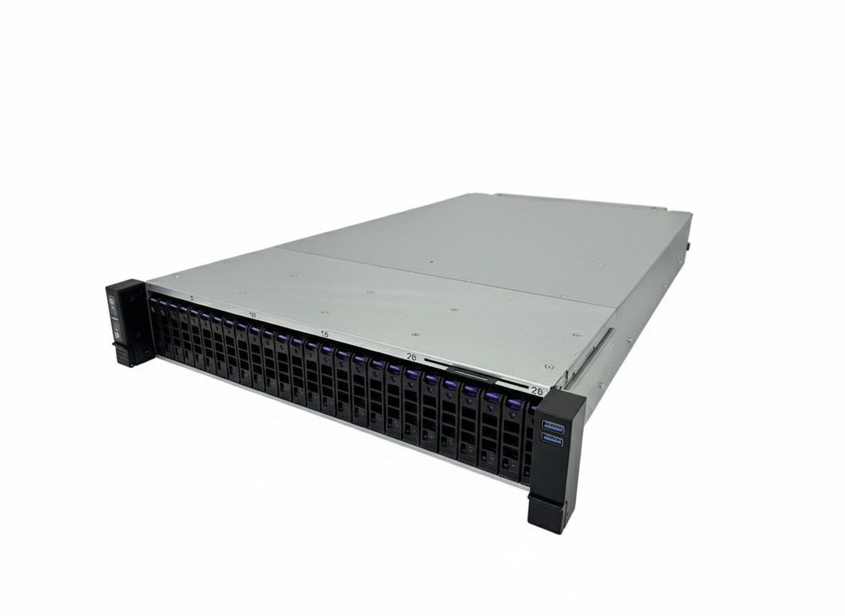
HA2026-HC (XP1-A202HC04D01)
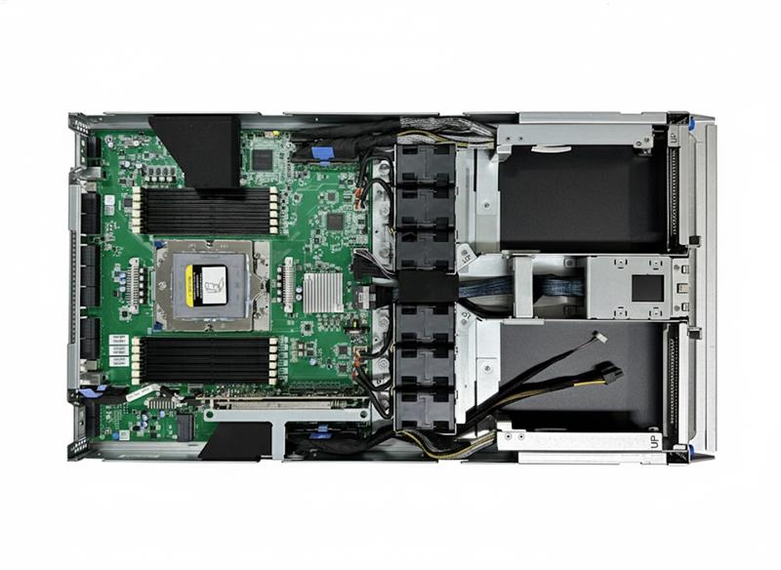
Node Top View

- Reliability Test Result
  - Mechanical Structure Test
    - Operating Vibration Test
      - Description
Assess the impact to the system assembly functionality caused by external vibration and to identify any points of failure in the support of design improvements.

      - Test Procedure
- Install all the required devices into the system assembly
- Make sure mechanical structure and electrical functionality are normal before testing
- Clamp the system assembly firmly on the vibration table in any of the “X” direction
- Run Diagnostic Program during the test.
- Repeat the above process for the “Y” and “Z” vibration axes.
- Record all test results and photographs for anomalies.

      - Pass/Fail Criteria
- No Mechanical structure or electrical functionality are damaged:
- Check if FAN module eject
- Check if Screw loose
- Check if HDD / SSD tray eject
- System functional failure during vibration test or post diagnostics:
- BMC SDR /SEL have no any abnormal record or status detect failure.
- Diagnostics (Iometer) have no any failure (error) occur
- All install device can be detected before and after test (device check by OS)
- Physical damage to system or components that would disrupt operation.

      - Result
Test Result | Before Test | After Test
Physical Damage | Pass | Pass
Functional Check | Pass | Pass

    - Non-operating Vibration Test
      - Description
Assess the impact to the system assembly functionality caused by external vibration and to identify any points of failure in the support of design improvements.

      - Test Procedure
- Install all the required devices into the system assembly
- Make sure mechanical structure and electrical functionality are normal before testing
- Clamp the system assembly firmly on the vibration table in any of the “X” direction.
- Perform the random vibration for a minimum of 10 minutes.
- After the vibration test, run diagnostics for electrical and mechanical functionality
- Repeat the above process for the “Y” and “Z” vibration axes
- Record all test results and photographs for anomalies.

      - Pass/Fail Criteria
- No Mechanical structure or electrical functionality are damaged:
- Check if FAN module eject
- Check if Screw loose
- Check if HDD / SSD tray eject
- System functional failure during vibration test or post diagnostics:
- BMC SDR /SEL have no any abnormal record or status detect failure
- Diagnostics (Iometer) have no any failure (error) occur
- All install device can be detected before and after test (device check by OS)
- Physical damage to system or components that would disrupt operation is unacceptable.

      - Result
Test Result | Before Test | After Test
Physical Damage | Pass | Pass
Functional Check | Pass | Pass

    - Operating Shock Test
      - Description

Assess the impact to the system assembly functionality caused by external shock and identify any points of failure in the support of design improvements.
      - Test Procedure
- Install all the required devices into the system assembly.
- Make sure mechanical structure and electrical functionality.
- Apply the 11ms, 2G shock, each surface 3 times.
- Record any mechanical structure or electrical functionality anomalies.
- After the shock test, run diagnostics for electrical and mechanical functionality.
- Formally record all results, photograph any anomalies.

      - Pass/Fail Criteria
- No Mechanical structure or electrical functionality are damaged:
- Check if FAN module eject
- Check if Screw loose
- Check if HDD tray eject
- System functional failure during shock test or post diagnostics:
- BMC SDR /SEL have no any abnormal record or status detect failure
- Diagnostics have no any failure (error) occur.
- All install devices can be detected before and after test (device check by OS)
- Physical damage to system or components that would disrupt operation.

    - Non-Operation Square Wave Shock Test
      - Description

Assess the impact to the system assembly functionality caused by external shock and identify any points of failure in the support of design improvements.
      - Test Procedure
Install all the required devices into the system assembly.
Make sure mechanical structure and electrical functionality are normal before testing.
Apply G-Value and duration time by weight, total shock 6 times for each surface 1 times
After the shock test, run diagnostics for electrical and mechanical functionality
Formally record all results, photograph any anomalies.

      - Pass/Fail Criteria
     No Mechanical structure or electrical functionality are damaged:
a. Check if FAN module eject
b. Check if Screw loose
c. Check if HDD/SSD tray eject
- System functional failure during vibration test or post diagnostics:
a. BMC SDR /SEL have no any abnormal record or status detect failure.
b. Diagnostics have no any failure (error) occur
c. All install device can be detected before and after test (device check by OS)
d. Indicator LEDs (power, HDD/SSD activity) have no any damage or incorrect action
- Physical damage to system or components that would disrupt operation

      - Result
G-Value | Duration time | System Weight L6 (kg)
30 | 12ms | 33.9
Test Result | Before Test | After Test
Physical Damage | Pass | Pass
Functional Check | Pass | Pass

  - Packaged Test
    - Package Test
      - Description
To assess the products that may occur improper falling during movement, the strong toughness with the safety condition is necessary for products assessed.

      - Test Procedure
- Turn on the system to perform the function test. Then turn off the system and remove key components if needed. Package the system for testing.
- Place the packaged product on the vibration table with Face 3 down. Run random vibration according to ISTA 2A profile for 30 minutes
- Flip the product so Face 1 (top) is down. Run random vibration for 10 minutes.
- Place the product so Face 2 or 4 is down. Run random vibration for 10 minutes.
- Place the product so Face 5 or 6 is down. Run random vibration for 10 minutes.
- Finish first vibration test and proceed to Drop Test.
- Perform corner drops on the weakest corner and 3 adjacent edges. Use ISTA 2A specified drop height.
- To perform a flat drop with impact on the front side.
- To perform a flat drop with impact on the rear side.
- To perform a flat drop with impact on the right side.
- To perform a flat drop with impact on the left side.
- To perform a flat drop with impact on the top side.
- To perform a flat drop with impact on the bottom side.
- Finish Drop Test and proceed to second vibration test.
- Repeat the random vibration sequence as in steps 8.2–8.5 for the second vibration test.
- After second vibration test, inspect product and packaging for visible damage without moving the product. Run electrical and mechanical diagnostics.
- Record all results and photograph any anomalies.

      - Pass/Fail Criteria
- Packaging materials continues to maintain product position.
- No Mechanical structure or electrical functionality are damaged:
a. Check if FAN module eject
b. Check if Screw loose
c. Check if HDD/SSD tray eject
- System fully functional after test without any abnormal or above failure mechanisms:
a. BMC SDR /SEL have no any abnormal record or status detect failure.
b. Diagnostics have no any failure (error) occur
c. All install device can be detected before and after test (device check by OS)
d. Indicator LEDs (power, HDD/SSD activity) have no any damage or incorrect action
- Physical damage to system or components that would disrupt operation.

      - Result

Package Drop Test
Weight(L6) | Drop Height | System condition
49.50kg | 31cm | Un-operation

Test Result | Before Test | After Test
Physical Damage | Pass | Pass
Functional Check | Pass | Pass

Package Vibration Test
Test Result | Before Test | After Test
Physical Damage | Pass | Fail
Functional Check | Pass | Pass

