- Test Purpose:
To assess the products that may occur 新字串improper falling during movement, the strong toughness with the safety condition is necessary for products assessed.

- Reference Documents:
■ Reference to the rule/standard: ISTA 2A(2008)
□ Customer Requirement:
□ Internal special requirement:

- Date Of Test:

Test Started | Test Completed
2025/11/14 | 2025/12/23

- Test Unit:
1 unit

- Tests Result:
□ Pass ■ Fail □ Reference
Conclusion
After the package vibration and drop tests conducted under ISTA 2A test conditions, the following issues were observed:
- The cover had slight abrasion after the package vibration test
- Pull card interferes with EPE
- Diagnostics Program:
Iometer 1.1.0
Visual inspection

- Test Equipment List and Test Location:
No. | Test Location | Test Equipment | Manufacturer | Model | Calibration Date | Calibration Due Date
1 | AIC Lab | Drop Tester | KING DESIGN | KD-128A | N/A | N/A
2 | AIC Lab | Vibration Tester | KING DESIGN | KD-9363-EM-1000-  F2K-50N250 | 2025/03 | 2026/03
- Test Procedure:
  - Turn on the system to perform the function test. Then turn off the system and remove key components if needed. Package the system for testing.
  - Place the packaged product on the vibration table with Face 3 down. Run random vibration according to ISTA 2A profile for 30 minutes
  - Flip the product so Face 1 (top) is down. Run random vibration for 10 minutes.
  - Place the product so Face 2 or 4 is down. Run random vibration for 10 minutes.
  - Place the product so Face 5 or 6 is down. Run random vibration for 10 minutes.
  - Finish first vibration test and proceed to Drop Test.
  - Perform corner drops on the weakest corner and 3 adjacent edges. Use ISTA 2A specified drop height.
  - To perform a flat drop with impact on the front side.
  - To perform a flat drop with impact on the rear side.
  - To perform a flat drop with impact on the right side.
  - To perform a flat drop with impact on the left side.
  - To perform a flat drop with impact on the top side.
  - To perform a flat drop with impact on the bottom side.
  - Finish Drop Test and proceed to second vibration test.
  - Repeat the random vibration sequence as in steps 8.2–8.5 for the second vibration test.
  - After second vibration test, inspect product and packaging for visible damage without moving the product. Run electrical and mechanical diagnostics.
  - Record all results and photograph any anomalies.

- Test Conditions:
  - Orientate the packaging so that the manufacturing joint (seam) is positioned at the S1& S3 of the viewer and define each surface of the package from S1 to S6 shown as below:

Drop Test Sequence

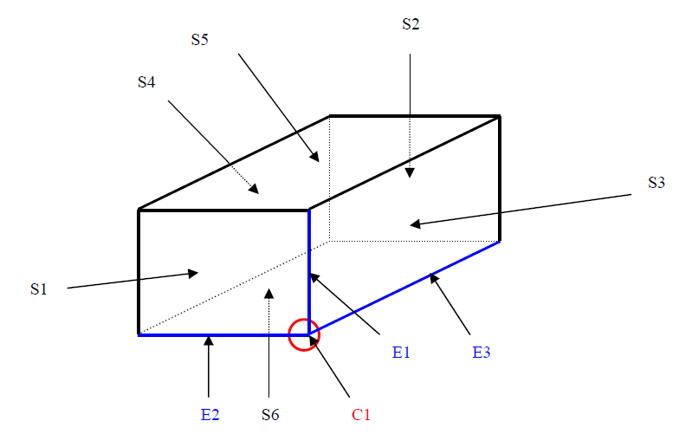

Drop Height Table

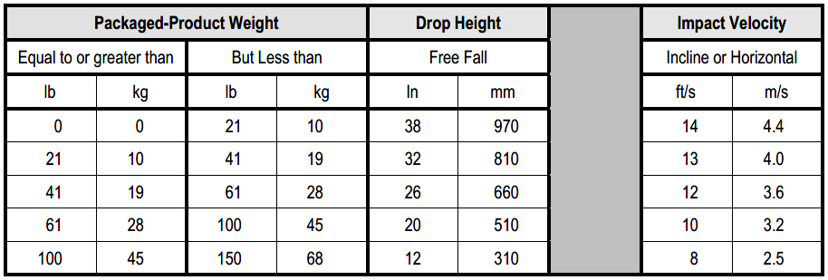
  - Random waveform
Frequency (Hz) | PSD (g²/Hz) | Test Time (Minutes) | Test Axis
1 | 0.0001 | Face 3 is down for 30 minutes  Face 1 is down for 10 minutes  Face 2 or 4 is down for 10 minutes  Face 5 or 6 is down for 10 minutes | Z axis
4 | 0.01
100 | 0.01
200 | 0.001
Nominal 1.15 Grms

- Pass/Fail Criteria:
  - Packaging materials continues to maintain product position.
  - No Mechanical structure or electrical functionality are damaged:

a. Check if FAN module eject

b. Check if Screw loose

c. Check if HDD tray eject
  - System fully functional after test without any abnormal or above failure mechanisms:

a. BMC SDR /SEL have no any abnormal record or status detect failure. Packaging materials continues to maintain product position.
b. Diagnostics have no any failure (error) occur
c. All install device can be detected before and after test (device check by OS)
d. Indicator LEDs (power, HDD activity) have no any damage or incorrect action
  - Physical damage to system or components that would disrupt operation.

- System Configuration:
  - Chassis configuration
Item | S/N Ver. | Quantity
HA2026-HC Chassis | XP1-A202HC03P01 (515-26010900600010) | 1
Front-Rear IO-Display Board | BDB-LED0011B | 1
Backplane | BBP-FB20006AB03 | 1
FAN Module | SUNON PF40281BX-Q611-S9H | 2
CRPS Adapter Board | BDB-PWR0038AE01 | 2
Power Module | GOSPOWER G1505-3200W | 2
  - System configuration

Node 1 /Node2
Item | Description | Quantity
M/B | Hercules Server Board (BMB1UPG0002AB01) | 2
BIOS Version | Herc0050 | 1
BMC Version | 4530HCL001301 | 1
CPU Type(*) | AMD EPYC™ 9654 CPU 3.55 GHz 360W | 2
DRAM Type(*) | Micron 16GB DDR5 RDIMM MTC10F1084S1RC56BD1 | 24
IO Expander Board | BDB-IO00006AB01 | 2
Network Card | BDB-LAN0004AB02 | 2
M.2(OS)(*) | SAMSUNG 970 Pro NVMe M.2 MZ-V7P1T0 1TB | 2
2.5” NVMe Type(*) | PHISON X200P 1.92TB | 26
FAN Module | NIDEC R40W12BGNL9-07T41 | 12
Software(*) | Iometer 1.1.0 | 1
OS Type(*) | Windows Server 2022 Datacenter | 1
(*) these devices were not installed on the system during the test.

- Detail Test Results:
12.1 Package Drop Test
Weight (L6) | Drop Height | System condition
49.50kg | 31cm | Un-operation

Test Result | Before Test | After Test
Physical Damage | Pass | Pass
Functional Check | Pass | Pass
12.2 Package Vibration Test
Test Result | Before Test | After Test
Physical Damage | Pass | Fail
Functional Check | Pass | Pass

- Failure Photo:
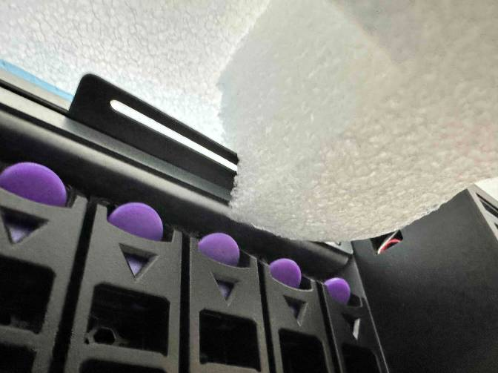 | 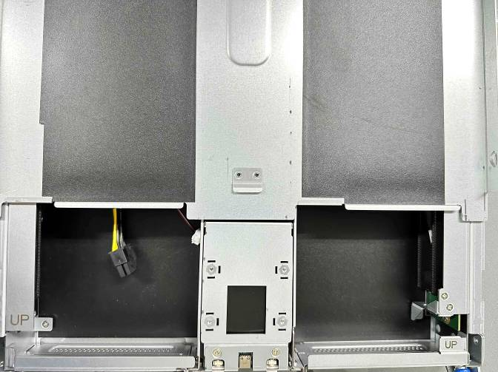
Pull card interferes with EPE | The cover had slight abrasion after the package vibration test

- Test Photo:

  - Before Test Check
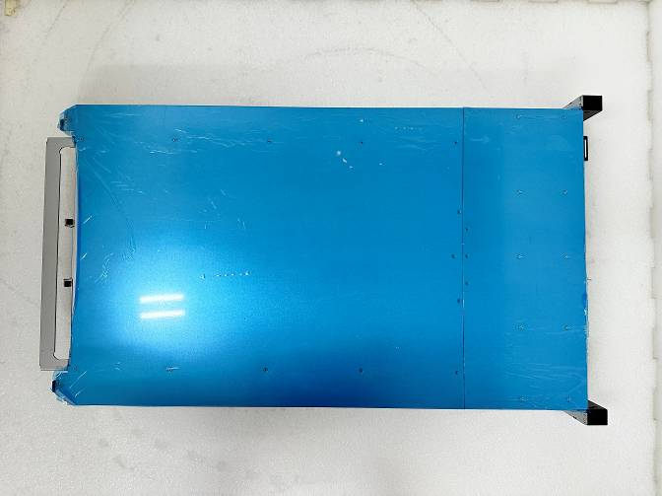 | 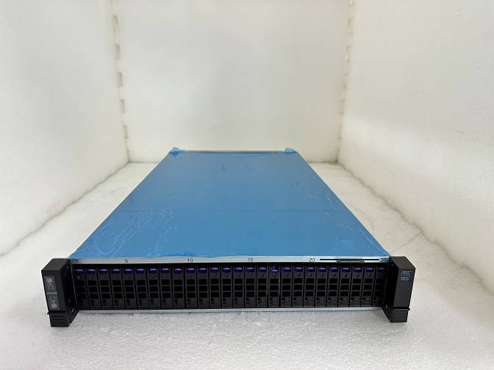
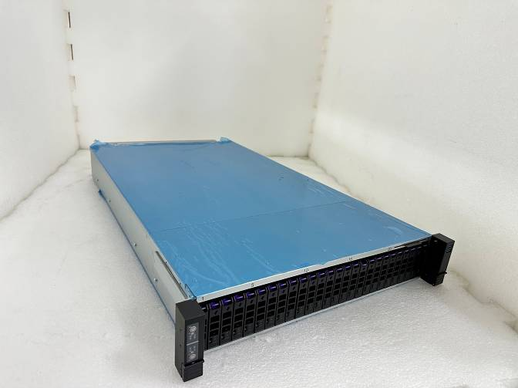 | 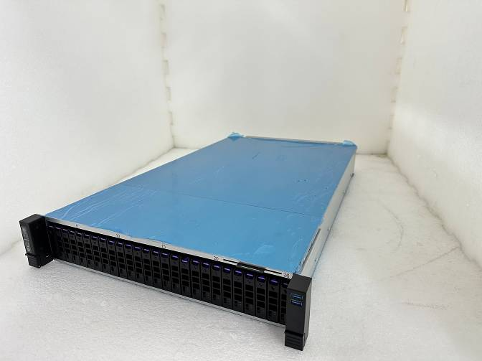
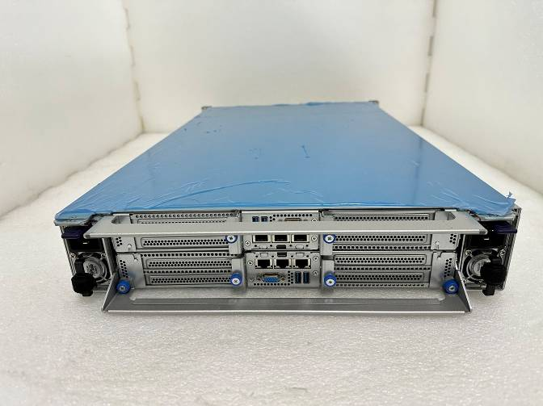 | 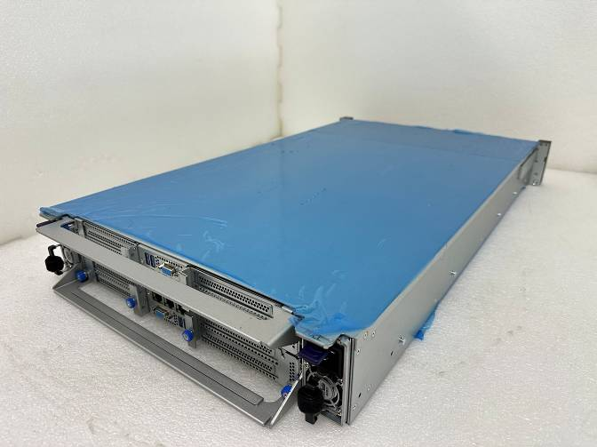
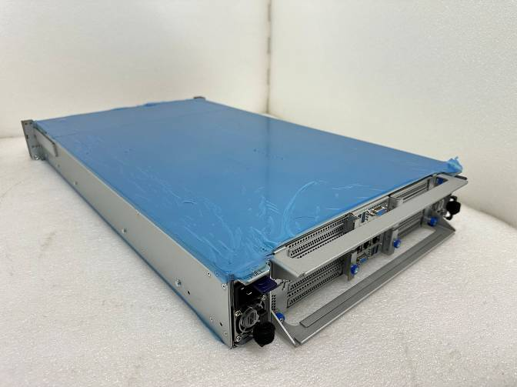 | 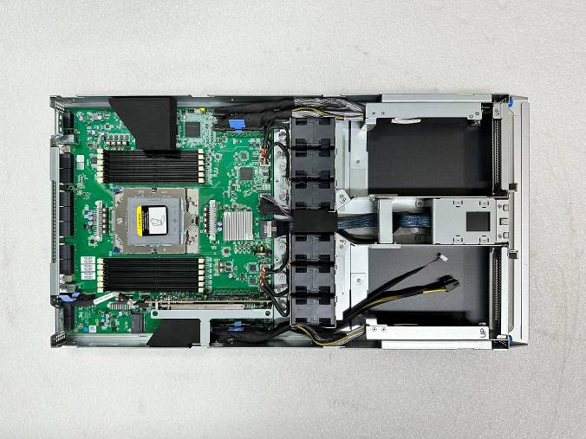
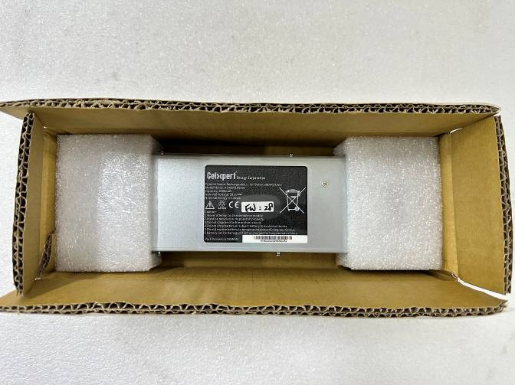 | 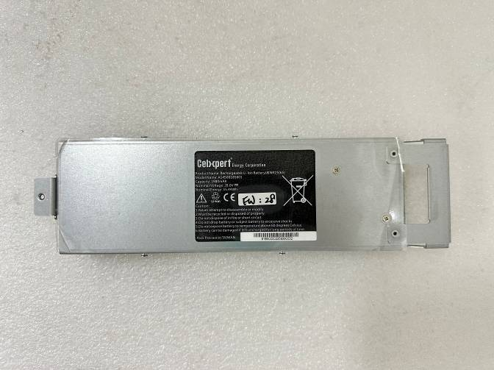
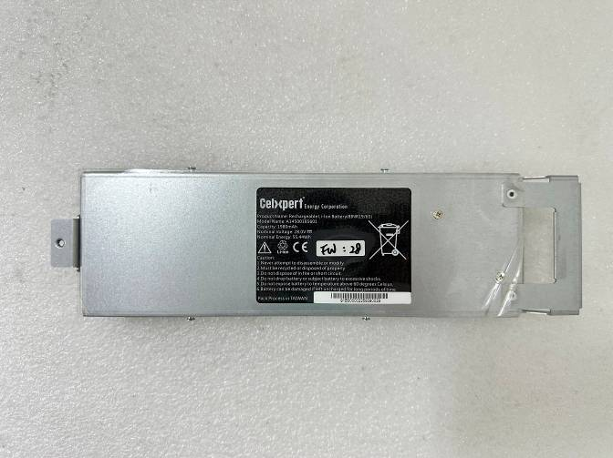 | 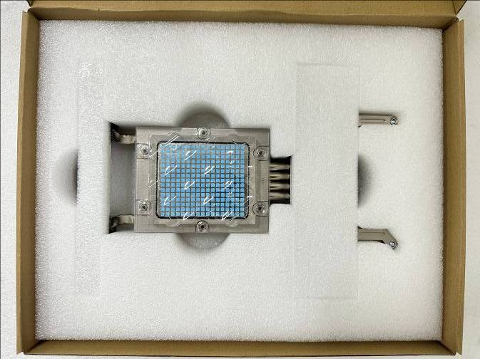
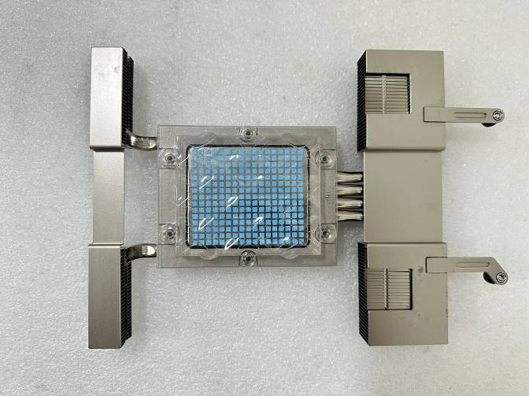 | 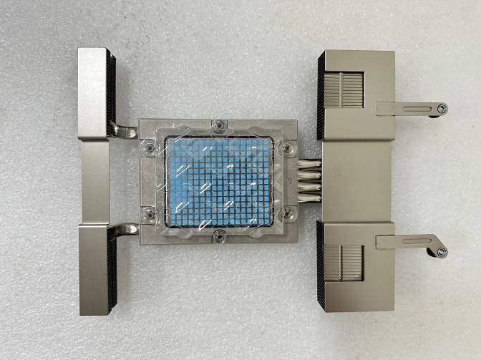

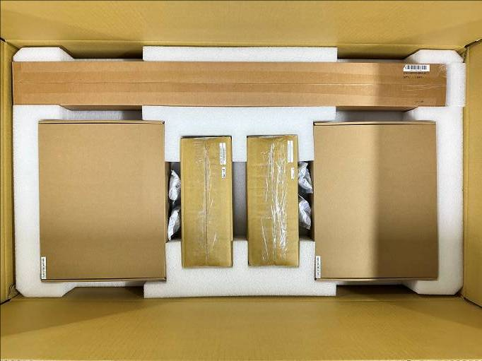

  - First Package Vibration Test
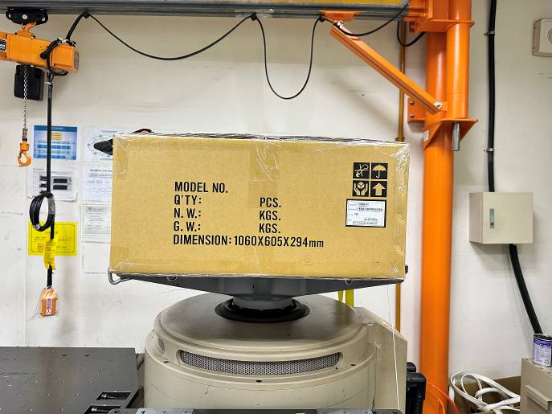 | 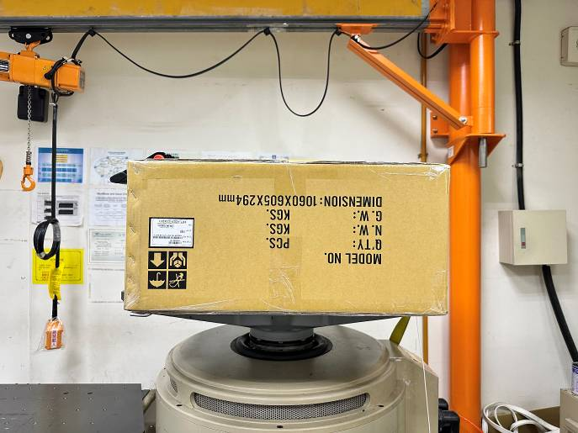
Step 1 (Face 3) | Step 2 (Face 1)
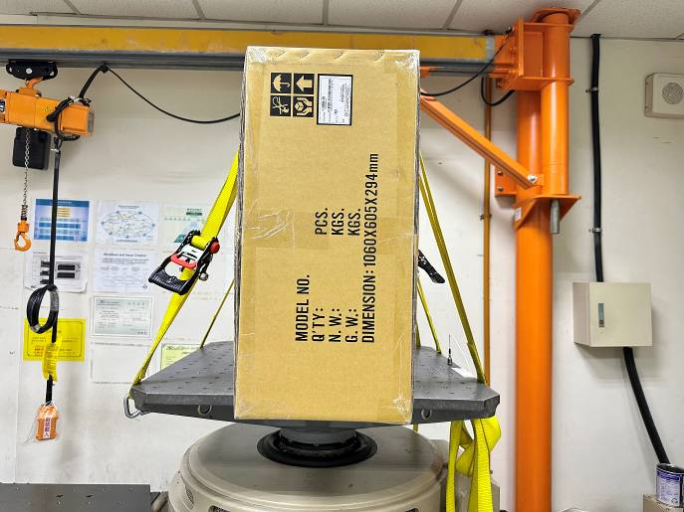 | 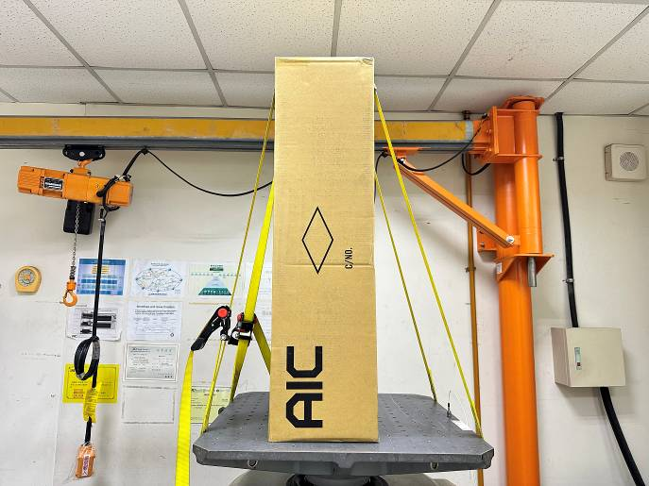
Step 3 (Face 4) | Step 3 (Face 5)
  - Package Drop Tes
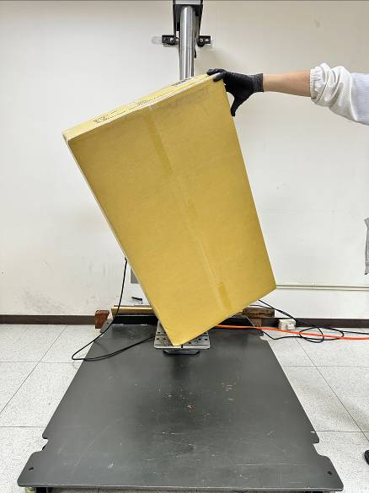 | 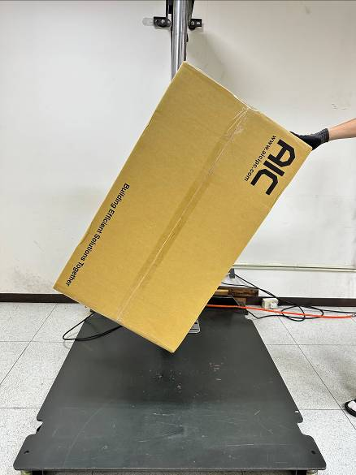 | 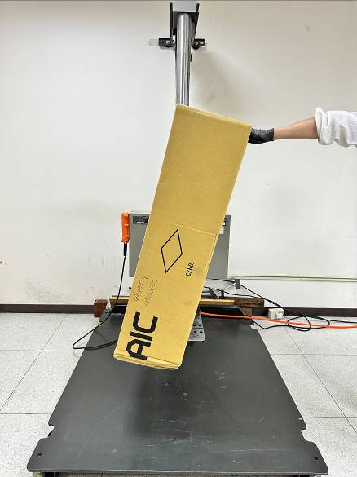
Corner 1 | Edge 1 | Edge 2
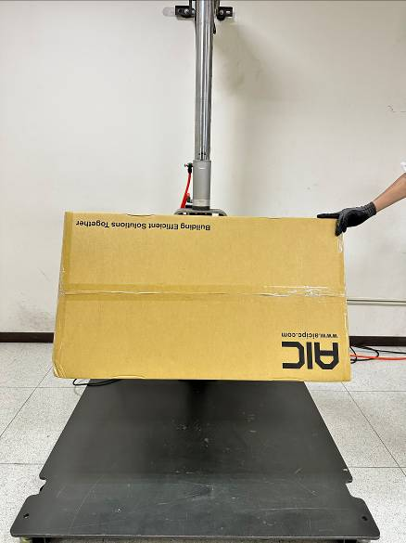 | 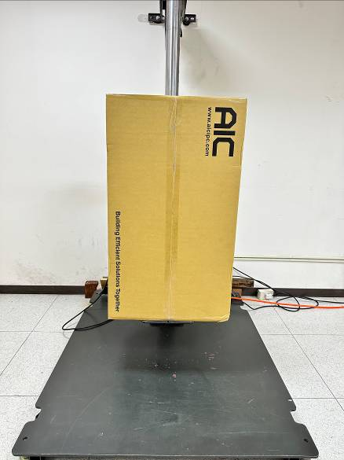 | 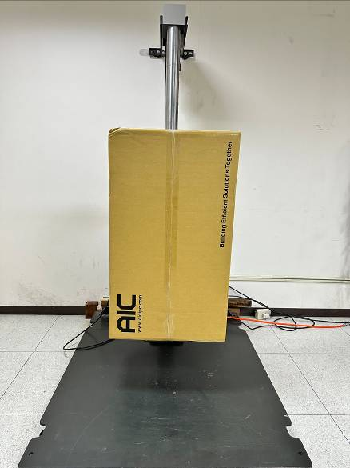
Edge 3 | Front | Rear
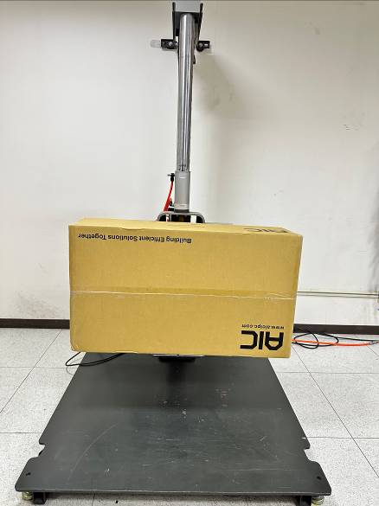 | 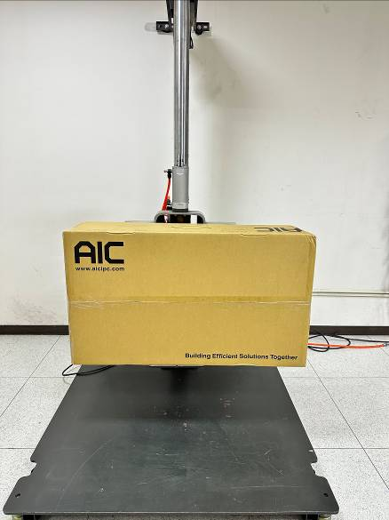 | 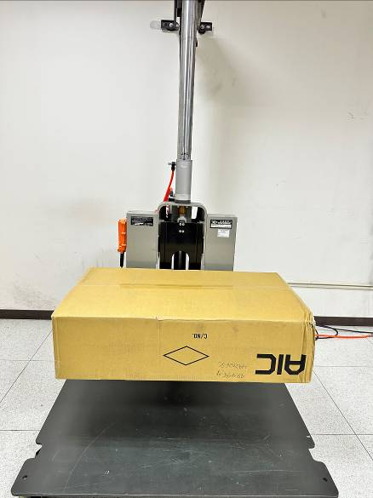
Right | Left | Top
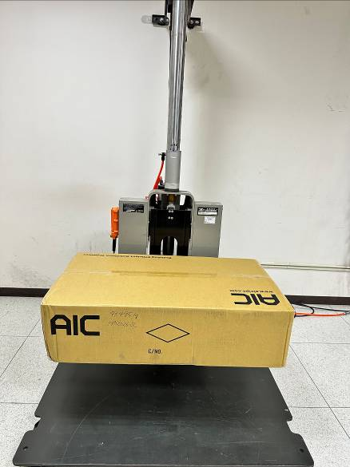
Bottom

  - Second Package Vibration Test
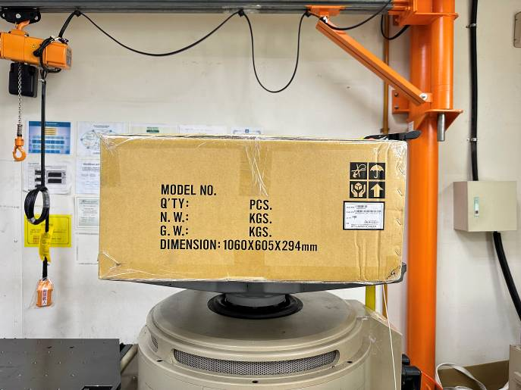 | 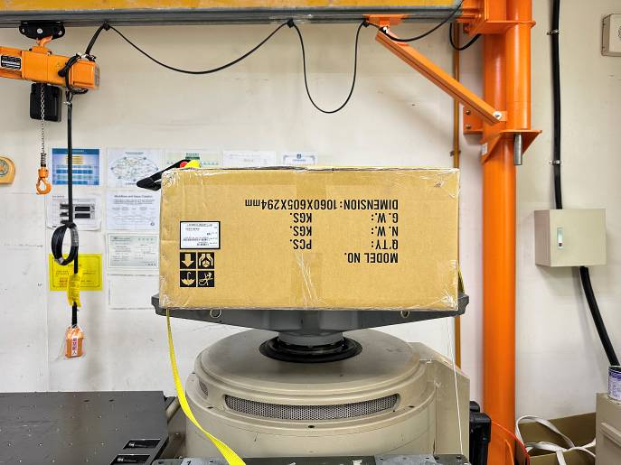
Step 1 (Face 3) | Step 2 (Face 1)
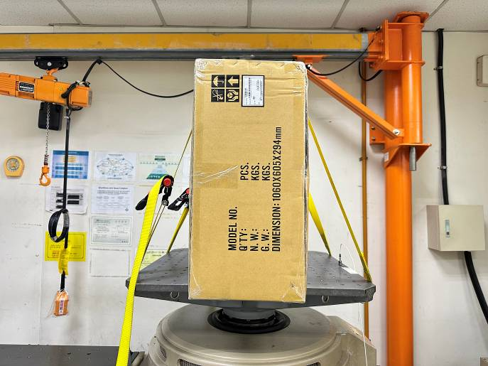 | 
Step 3 (Face 4) | Step 3 (Face 5)

  - After Test Check
 | 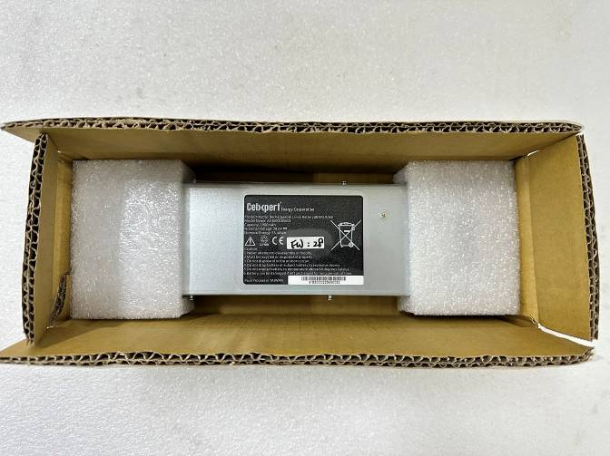
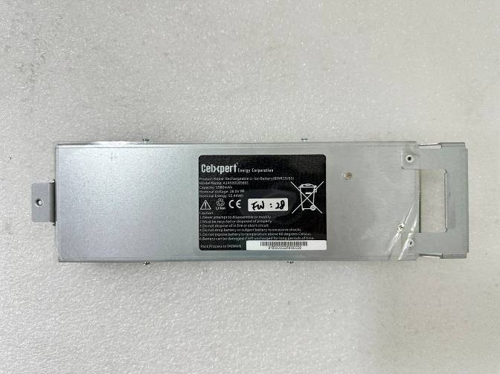 | 
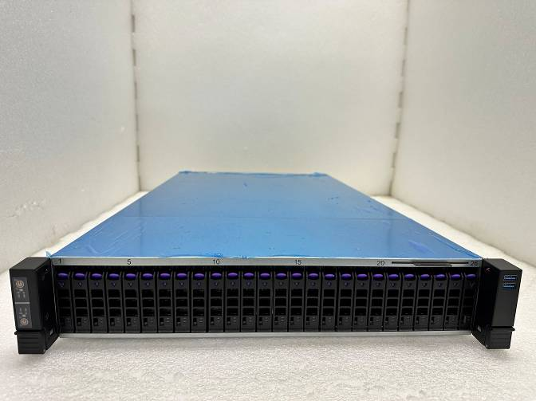 | 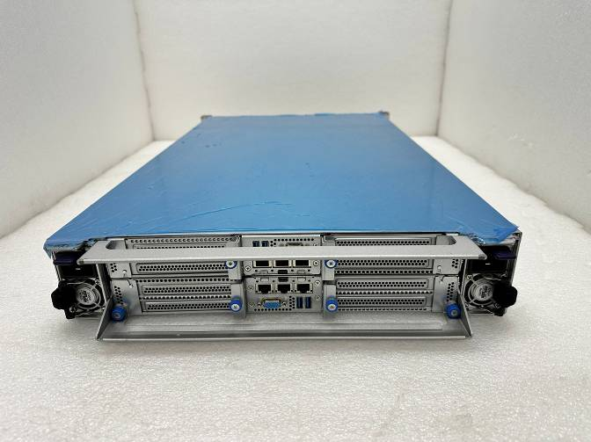
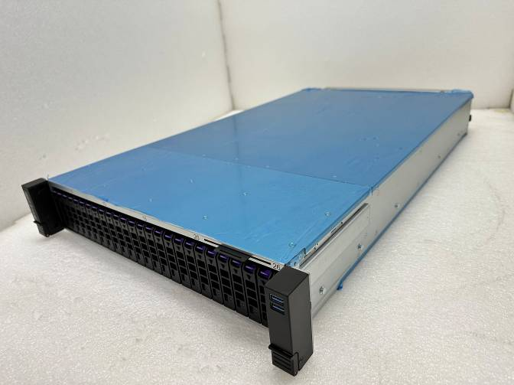 | 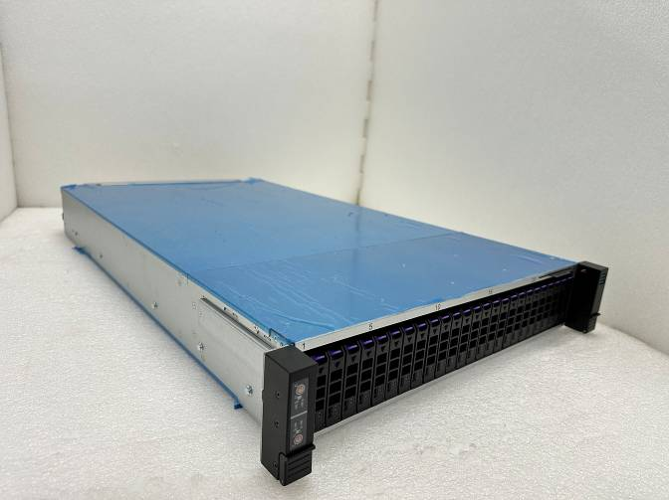
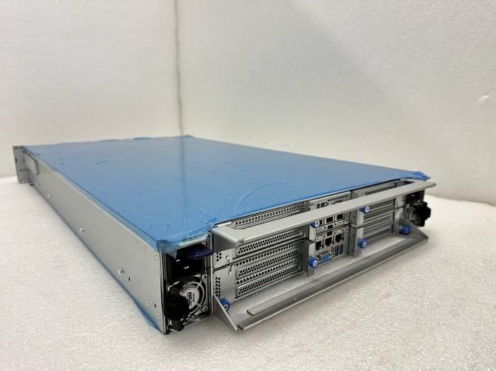 | 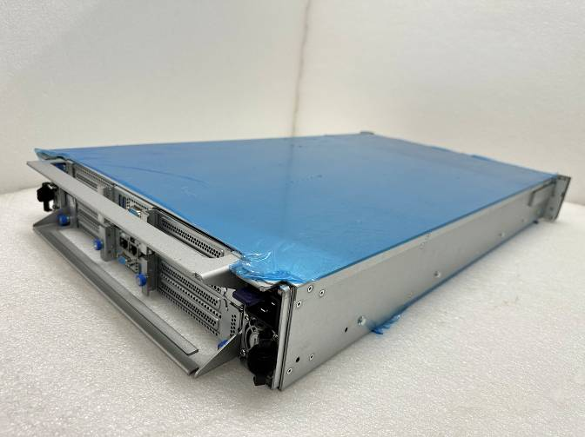
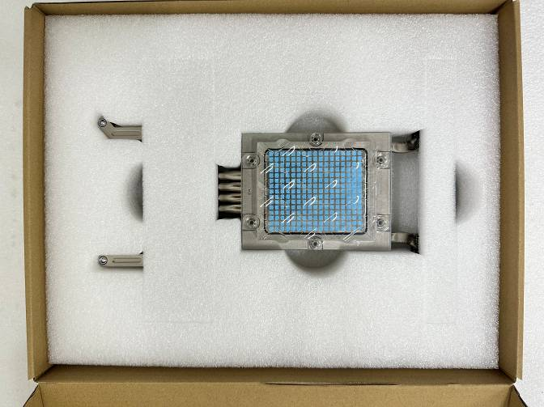 | 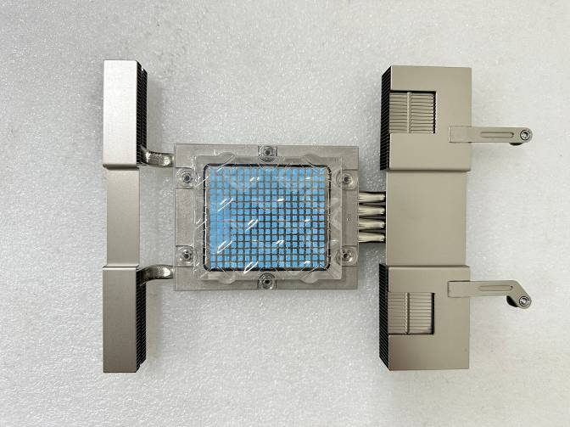
 | 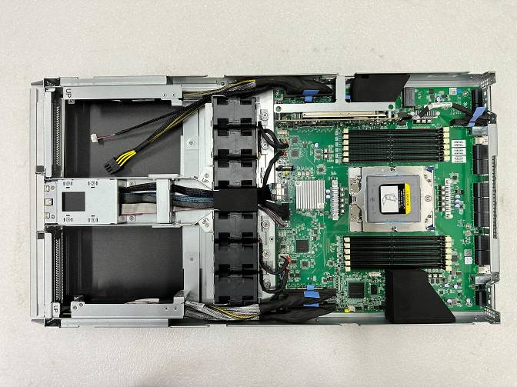

- Diagnostic Program Photo:
