ForkIt Mobile Application

CI360 – Mobile applicaion Development

Luke Dawes

2018

Contents

1. Introduction 2

1. Competitor Research 3

1.1. Yummly Recipes & Shopping List (Yummly) 3

1.2. Food Recipes 3

2. Project Management 4

2.1. Agile Methodology 4

3. Design Research 5

3.1. Cut the Clutter 5

3.2. Consider the Thumb Zone 5

3.3. Advance Wireframes 6

4. Technical Architecture 7

4.1. Main Activity (Create Account/Login/Skip) 7

4.2. Connecting Firebase to Android Studio Project 7

4.2.1. Firebase Authentication 7

4.2.2. Firebase Real-Time-Database 7

4.3. Search Activity 7

4.4. Favourite Activity 8

4.5. Shopping List Activity 8

5. Testing 9

6. Technical Challenges 10

6.1. Food2Fork Recipe API 10

7. Applications Strengths & Weaknesses 11

8. Future Development 12

9. Personal Reflection 13

Bibliography 14

# Introduction

ForkIt is a mobile application that allows users to search for recipe by the ingredients they have. Users can register which enables them to add recipes to a favourite list and create a shopping list for when they next attend a supermarket. User also have the choice to not register where they can still search for recipes but disabled from using the favourite and shopping list feature.

# Competitor Research

Food recipe mobile applications is a fairly new market that’s continuously growing with competing apps. To understand the competitors ForkIt will face, I research two of the top 10 free food recipe applications available on Google Play Store. In my planning documentation I discussed the competitor ‘All Recipes Fee’ which is the top food recipe app on the Google Play Store at this current time. Therefore, I will discuss the two following which are ‘Yummly Recipes & Shopping List’ and ‘Food Recipes’.

## Yummly Recipes & Shopping List (Yummly)

Yummly is a food recipe that contains over 1 million recipes and provides many features for the user to make their experience more enjoyable. The features include; add and organise favourite recipes, discover recommended recipes, personalise a diet plan and filer recipe search.

The features Yummly provides are well thought out and would meet the requirement needs for someone who wants to plan their meals according to their diet plan. I took it upon myself to read the reviews left by users of the app on the Google Play Store. One user went on to say that the application is not simple to use, and connection keeps dropping. From a developer’s prospective, this could mean that the user journey process is not clear and confuses the user, and there’s an error in their app that interrupts the connection to their database.

In comparison to ForkIt, Yummly has all the features ForkIt contains and more such as a ‘allergy’ filer in the recipe search, which is very popular in the user’s review. However, Yummly contains advertisements which can be a bother for users causing them to not use the app and the user journey it’s over complicated for users to have a simple experience. ForkIt is designed to be a simple app where users can search for a recipe with the ingredients they have, add recipes to favourites, and create a shopping list. Yummly, is a feature-rich app that requires a user to be dedicated using the features. Yummly also requires users to sign up or sign in which can cause users to not want to use the app, whereas ForkIt can be used without an account but limited to just searching for recipes which I believe will be useful to the target audience.

## Food Recipes

Food Recipes is the third most popular food recipe app available on the Google Play Store. The app contains 1,400 recipes but are limited to a list of categories mention on the Google Play Store. This application only provides the functionality of searching for a recipe by the dish name which displays the recipe in the sections. They are: about this recipe, Ingredients, Directions.

Food recipes is a simple app that has only one feature which is to search for a recipe. The app doesn’t require the user to create account nor doe it have the option. After reading the reviews on the Google Play Store, it was clear that majority of the users were happy with the experience of the app. However, some users discovered that the couldn’t find a recipe they previously use and request for the app to have a favourite recipe feature. One user also went to say that when they view a recipe and return the results list, they’re sent to top of the list which can be frustrating. This was certainly something to consider when developing ForkIt.

In comparison to ForkIt, Food Recipes is a simple app designed for users who just want to find a new technique to a dish know for a one-time use purpose. Because it has no account creating feature, it doesn’t invite the user to come back not does it provide a feeling of integration between the app and the user. Whereas ForkIt supports account creating and provided other features such as favouriting recipes and creating a shopping list which provides interaction, therefore the user is more likely to return and use the app.

# Project Management

To increase the chances of a successful project, I used different project management techniques to ensure that the project runs smoothly from pre-research to delivering the final deliverable.

## Agile Methodology

The agile methodology was used to plan and structure the process of my project because it accommodates changes that can happen throughout the project. Mobile application development can be very unpredictable and may require the need to go back to a previous stage in the project that may have been completed and make adjustments. The project plan created with agile in mind is as follows:

1. Competitor research.
2. Research and learn how to build basic activities in Android Studio.
3. Research Design.
4. Research how to connect Firebase to application.
5. Create all activities for application
   1. MainActivity – Sign up/Login/Skip activity.
   2. Search activity to search for recipe.
   3. Favourite activity to display favourite recipes of registered users.
   4. Shopping list activity for registered users to create a shopping list.
6. Add functionality to activities in back-end coding and continually test to ensure its in working order.
7. Test Application – if errors occur or something doesn’t work the way its suppose, correct errors/mistakes and repeat testing until its in working order.
8. Deliver application.

# Design Research

Researching the design of the mobile application was an important stage of the project because it will determine how I will design and structure the application that best suits the user’s needs. During my research, I came across a website that details the best mobile app design practices for 2018. The author, Nick, details several practices that will help any developer produce a user friendly mobile application but there were three practices that stood out for me.

## Cut the Clutter

Nick talks about UI’s that is compact with irrelevant information that can confuse the user. To have a superior design, UI clutter should be avoided so that the user is not overloaded with information. To avoid clutter, only display relevant information to the user in a step-by-step flow. Clutter free UI’s look cleaner and more appealing to the users, resulting in a user-friendly UI design (Babich, 2018).

This really helped me to see the bigger picture in design and to view it form a user perspective. Sometimes developers can fall into a trap and over crowd a screen which doesn’t seem crowed to them but to a user it does. This practice was defiantly considered when design the application.

## Consider the Thumb Zone

Nick also discusses designing an application that takes into consideration how the user uses their mobile device. Majority of mobile devices users use their thumbs to interact with the device, therefore it makes sense to design the applications that meets theses conditions. Nick goes on to say that the thumb only reaches a 3rd of the devices display screen which is known as the ‘natural thumb zone’. Other areas require stretching to reach that part of the display (Babich, 2018).

I also remember studying this in the ‘Human Computer Interaction’ module in my second year of university. This practice is important to consider when designing the mobile application because it will improve the chances of creating a user-friendly application.

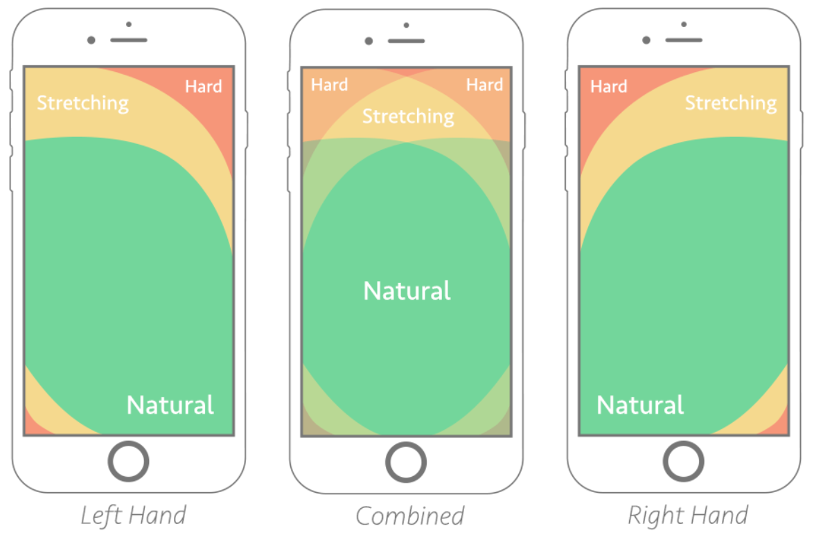

**Figure 1: Visual representation of safe zone on modern mobile device. Source:** [**https://www.smashingmagazine.com/2016/09/the-thumb-zone-designing-for-mobile-users/**](https://www.smashingmagazine.com/2016/09/the-thumb-zone-designing-for-mobile-users/)

## Advance Wireframes

Using my findings form the design research, I created detailed wireframes to have a visual representation of the UI design of the application.

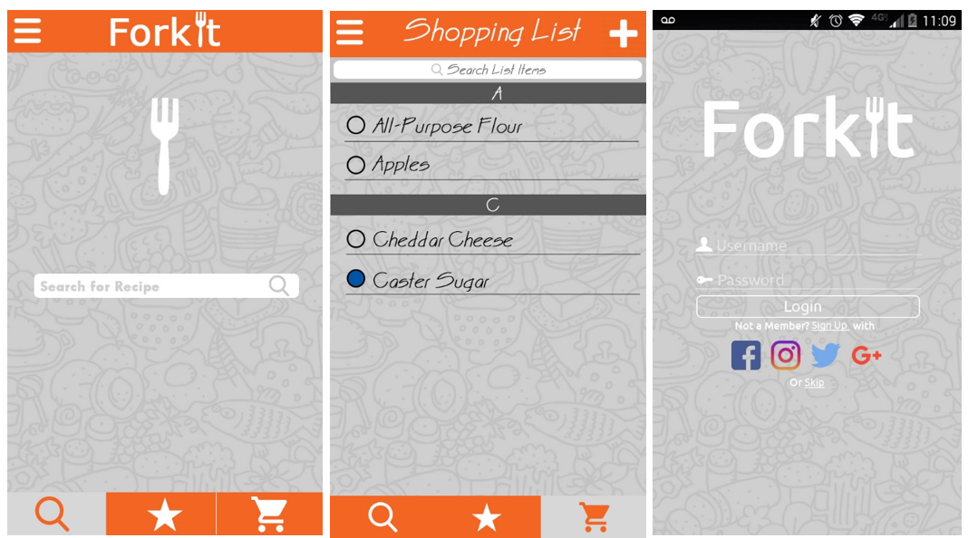

**Figure 2: Detailed wireframes for; search activity, shopping list activity, and main activity.**

# Technical Architecture

Developing and integrating the application to the mobile eco-system was a huge challenge in this project. I have a background of developing web-application that use complete different languages to mobile application development. After research, and familiarising myself with Java and XML, gradually I began to understand how to create activities and link them together.

## Main Activity (Create Account/Login/Skip)

The activity where users can create an account, login to an existing account, or skip the entire process and search for a recipe was the first to be created. With the main activity XML document created with a new project I changed the parent layout to a relative layout because it’s easier to position its child’s views. Within the parent relative layout, I created an image view that will show the application logo, and a horizontal linear view which will contain the text views and button. I used a horizontal linear because each view that’s added is placed in its own cell under each other. In this linear layout I added an email text field and password field. Underneath these text fields I created a vertical linear layout to display the sign up and login button next to each other. Under the linear layout containing the user input fields and buttons, I created a text view where the user can skip the sign-up process. Finally, I centred the horizonal linear layout to the middle of the screen, so it will always remain centred no matter how big the device screen size.

## Connecting Firebase to Android Studio Project

Trying to connect the features Firebase offer such as real-time database and authentication was an ongoing challenge for me and required a lot of trial and error.

### Firebase Authentication

To add Firebase authentication to the project, I followed the steps provided in the documentation on the Firebase website. However, after many attempts the project wouldn’t connect to the Firebase project I created therefore I took it upon myself to find another solution. What I found was a video that goes through the process of add authentication to the project.

Firebase and Android Studio are both products of Google in some way, therefore under the tool option in the android studio menu is a Firebase option. I used this to connect my project to Firebase which is done automatically (such as adding the relevant dependencies) once logged into the account that contains the Firebase project.

Once connected, I used the provide firebase methods to either create an account with the email and password data from the users input or login. I used condition to ensure all field are filled, check is email and password match, and to check if email address already take. If all condition are okay, the search activity is started.

### Firebase Real-Time-Database

To connect the real-time database to my project I used the same method used to connect authentication to my project. Android studio connect to my Firebase account and automatically connect my project to the real-time database and added the relevant dependencies.

## Search Activity

The search activity’s head was created using a vertical linear layout, text view and image view to show the app logo and sign-out/sign-up link. The application navigation was created using another vertical linear layout with 3 image views contains a search icon for search activity, a star icon for favourite activity, and shopping trolley for shopping list activity. Depending on the current activity will determine the colour of each item in the app nav, where the current activity will be a different colour from the rest. Each image view is coded to start the related activity when clicked on.

The search text box and button were created using an edit text and button view. They were placed inside a linear layout and centred to the screen. An on click listen was added to the search button which when clicked, will take the value of the user input and retrieve data from the recipe API according to what the user inputted. To get the data from the API I used a JSON object request. With the object request response, I pulled the data I needed, converted it to a string, created a text view and added the string to the text view. I then programmatically created a layout and appended the text view containing the data to the layout. I then used to the android animate feature to hide the search bar and button layout and show layout containing the response of the recipe request.

I created another onclick listen to the text view with the recipe details. When click, another request is sent to the API to get the recipe details of the clicked recipe. The recipe details are placed in a text view and appended to a programmatically created layout and animate to the view of the screen.

In this layout a text view with the text ‘Add to favourites’ is present and underline to inform the user is clickable. When clicked the recipe ID used to get from API is saved to the firebase database under the users uid.

To check if the recipe has been favourited already, I query to database to see if the recipe ID is present in the database, if not then ‘Add to favourites’ is shown. If it is then ‘Remove from favourites’ I show when if clicked, will remove the recipe ID form the database.

## Favourite Activity

This activity is shown when the star icon in the app navigation is clicked. Once created, I use a firebase database query to pull all the recipe ID’s of the user’s favourite recipes stored in the database. For each ID, I send a JSON object request to the API to get the recipe which is added to the activity the same why as in the search activity. Recipe details are also shown in the same what as in the search activity when the recipe is clicked on, aswell as the add and remove recipe from favourite function.

## Shopping List Activity

This activity is shown when the shopping icon in the app navigation is clicked. Once created, the database is quired to find if any items have been added to the shopping list child in the database. If not, then a ‘list empty’ text view is shown. However, if data is found then each item is added to a text view and appended to the layout with a remove link. If the remove link is clicked then it’ll remove the item from the database.

# Testing

Application testing was carried out consistently thought the development stage to ensure that each function works as it supposed it. Due to many actions being dependant on the result of another, it was important to continuously test the application.

I tested the application but running the project on an emulator and perform task to ensure that they work as they do. If not, then I will make changes and test until the outcome is as expected. Due to the agile style of the project management I was able to go back and add missing function such as the sign out link at the top of all activities, even though some had been completed by this time.

At the end of the development stage, I tested the application by perform all user task and making sure they work as it’s supposed to. If not, then I made adjustments and tested until I did.

# Technical Challenges

Throughout this project I faced many technical challenges that not only helped me to become a better programmer but pushed me to work harder and step out my comfort zone. Any challenge, big or small, I used Googled to search for a solution and found myself using Stack Overflow a lot and finding solutions guick.

## Food2Fork Recipe API

Prior to this project, I had never used or implement an API into an application. Of course, I knew what they were and what they are used for, but I never studied how to implement an API into an application. The document provide for the API was very vague and didn’t really explain how to implement the API to any application let alone an Android Studio one.

To overcome this problem, I search the internet for solutions to implementing an API to an Android Studio Project, but none seem to match the syntax described in the API documentation. After 10’s of hours of finding a solution I started to give up on attempting to implement an API to the app until I come across a website that discusses using a REST API.

While I was reading through the context, I started to see something familiar to the syntax describe in the API documentation. With m knew found knowledge I YouTube a guide on how to send a HTTP get request to a JSON REST API. I followed the YouTube video step by step by using the information provided in the documentation and I began to receive data back from the API. After testing and playing around with what I’ve just learned, it started to become familiar on how to use the HTTP get request to get the data from the API that I needed.

# Applications Strengths & Weaknesses

No application is perfect because there is always room for improvement in this continuously changing market. A strength of ForkIt application is that users are not required to register to use the app. Users can just search for a recipe by ingredients and not be forced or pressured into signing up. Another strength of the application is that its very simple to use and the user journey is not overly complicated.

On the other hand, ForkIt does contain some weakness such as only showing 30 recipe results when the user search for a recipe. Another weakness is the app is not responsive to device screens and images can become distorted inf viewed in a landscape mode.

# Future Development

There’s always room for improvement and I if I has more time there are a few features and function I would certainly consider implementing to the application. They are:

* Implement Tesco Grocery Search API – currently the user enters an item in the text area and adds that item to their shopping list. Originally, I planned to use the Tesco API to show results when the user types an item in the text area. The result will consist of products sold by Tesco matching the users input. When an item I selected, it’ll be added to the shopping list. The Tesco API also contains the price of their product therefore could also display the total of their basket if they were to buy the product from Tesco. This was not implement because I couldn’t figure how to implement the API into the application on time. However in my research I discover that it’s possible to used the Grocery Search API and another API to connect the app to a Tesco account and add the item directly to the Tesco basket on the account. This is also something I would certainly consider implementing.
* Add a picture of the recipe to the list of results when the user searches for a recipe.
* Add a clear all button on shopping list
* Allow users to sign up with Facebook, Google, LinkedIn. This was also a original feature but didn’t have time to implement

# Personal Reflection

From start to finish, the project has been a difficult journey but a very enlightening one at the same time. This project has challenged me in many ways, pushed me to leave my comfort zone and put my independent study skills to the test. Overall, I am very happy with the outcome of the project considering the circumstances I faced along the way and the time I had to produce my first mobile application. I believe I demonstrated all my skills learnt though this module and I hope it comes across to others.

# Bibliography

Babich, N., 2018. *The Guide to Mobile App Design: Best Practices for 2018 and Beyond.* [Online]   
Available at: https://www.uxpin.com/studio/blog/guide-mobile-app-design-best-practices-2018-beyond/  
[Accessed 29 05 2018].

https://stackoverflow.com/questions/3477581/android-add-a-view-to-a-specific-layout-from-code

https://www.youtube.com/watch?v=y2xtLqP8dSQ

Video used to implement recipe API