|  |
| --- |
| CSEMAD MOBILE APPLICATION DEVELOPMENT  Assessment 1 –  Phase 1 |
| Due 28 MAR 2025  Students: 20219568, x  Authored by: Luke Gardiner, Richard Avery |

TASK 1 – LEAN CANVAS

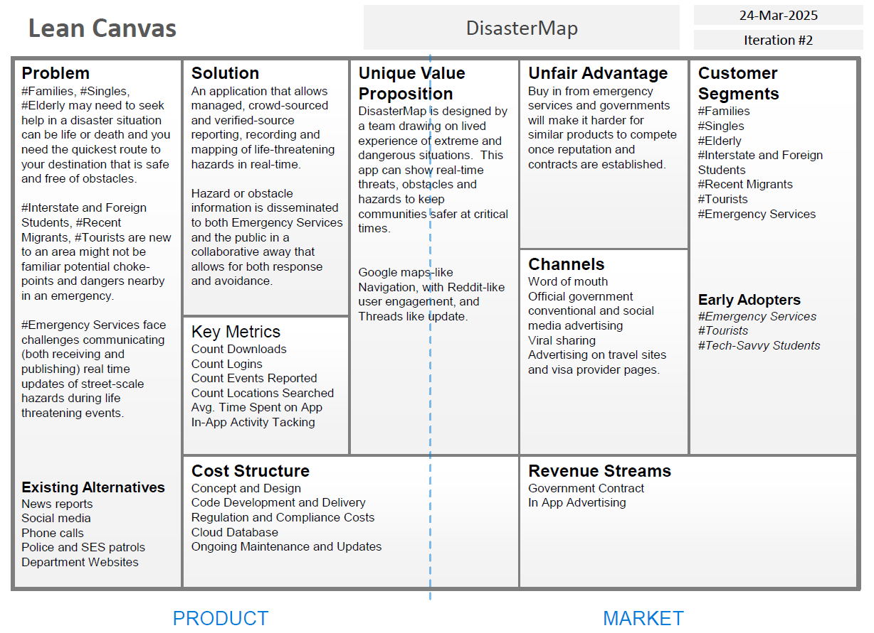

TASK 2 – ENTITY RELATIONSHIP DIAGRAM

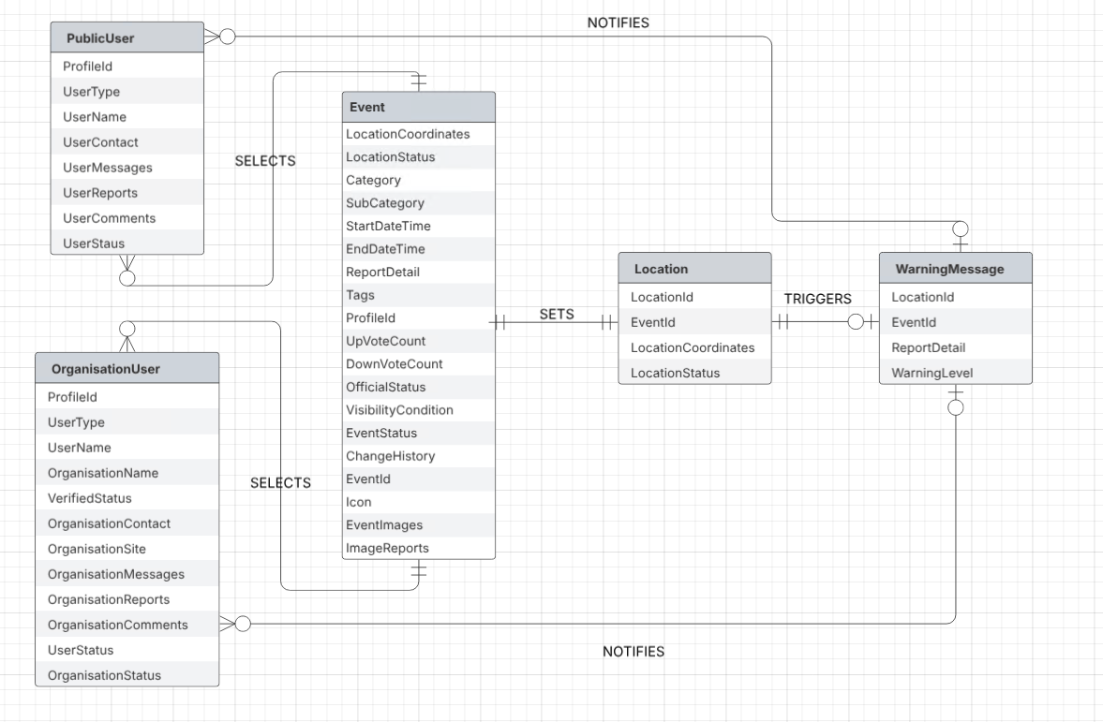

TASK 3 – SCREEN LIST

FirstUseLaunchUI-Search-launchScreen

-firsUse: AskUserType: Login, Report, Search

-firstUse: Report, Search AskForAddress

*Report requires create user

-Login - also prompts for register

SubsequentUsageLaunchUI-Map-launchScreen

-nextUse-PublicUser: RememberLocationDetail

-nextUse-VerifiedOrAdminUser: Login or ManagementUI

ManagementUI

Interface for Admin

Interface for Verified Emergency Services Authorities

Interface for Public Users