|  |
| --- |
| CSEMAD MOBILE APPLICATION DEVELOPMENT  Assessment 1 –  Phase 1 |
| Due 28 MAR 2025  Students: 20219568, x  Authored by: Luke Gardiner, Richard Avery |

TASK 1 – LEAN CANVAS

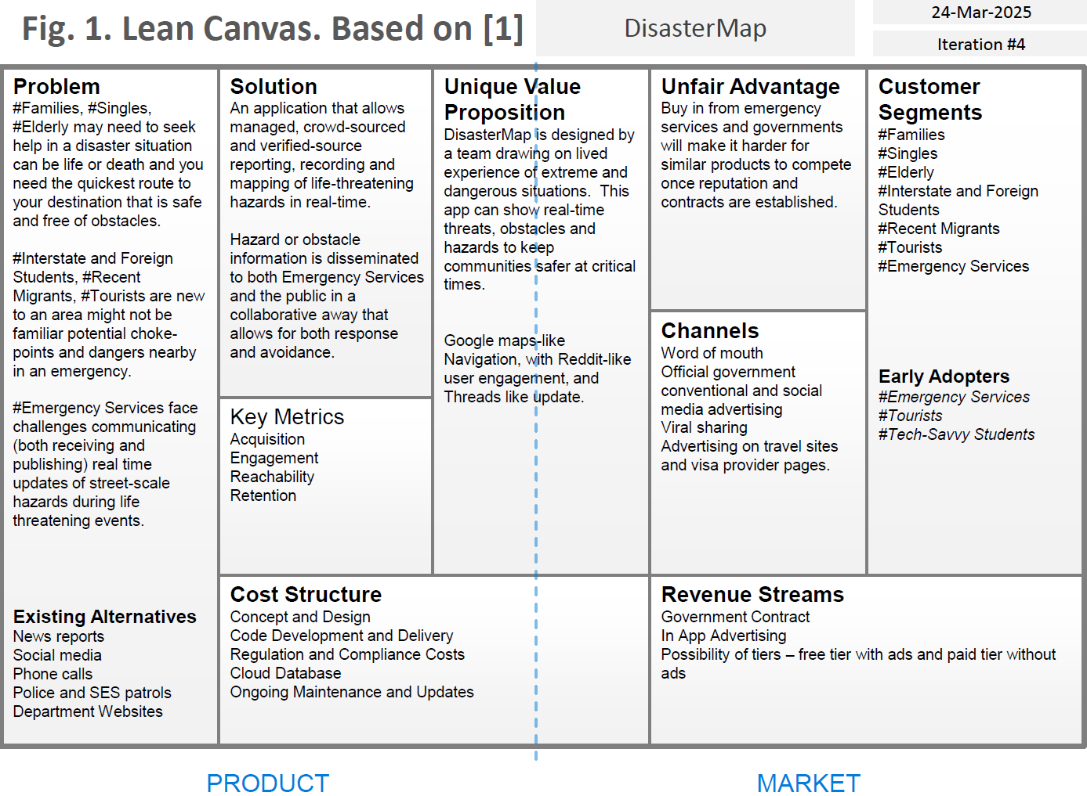

TASK 2 – ENTITY RELATIONSHIP DIAGRAM

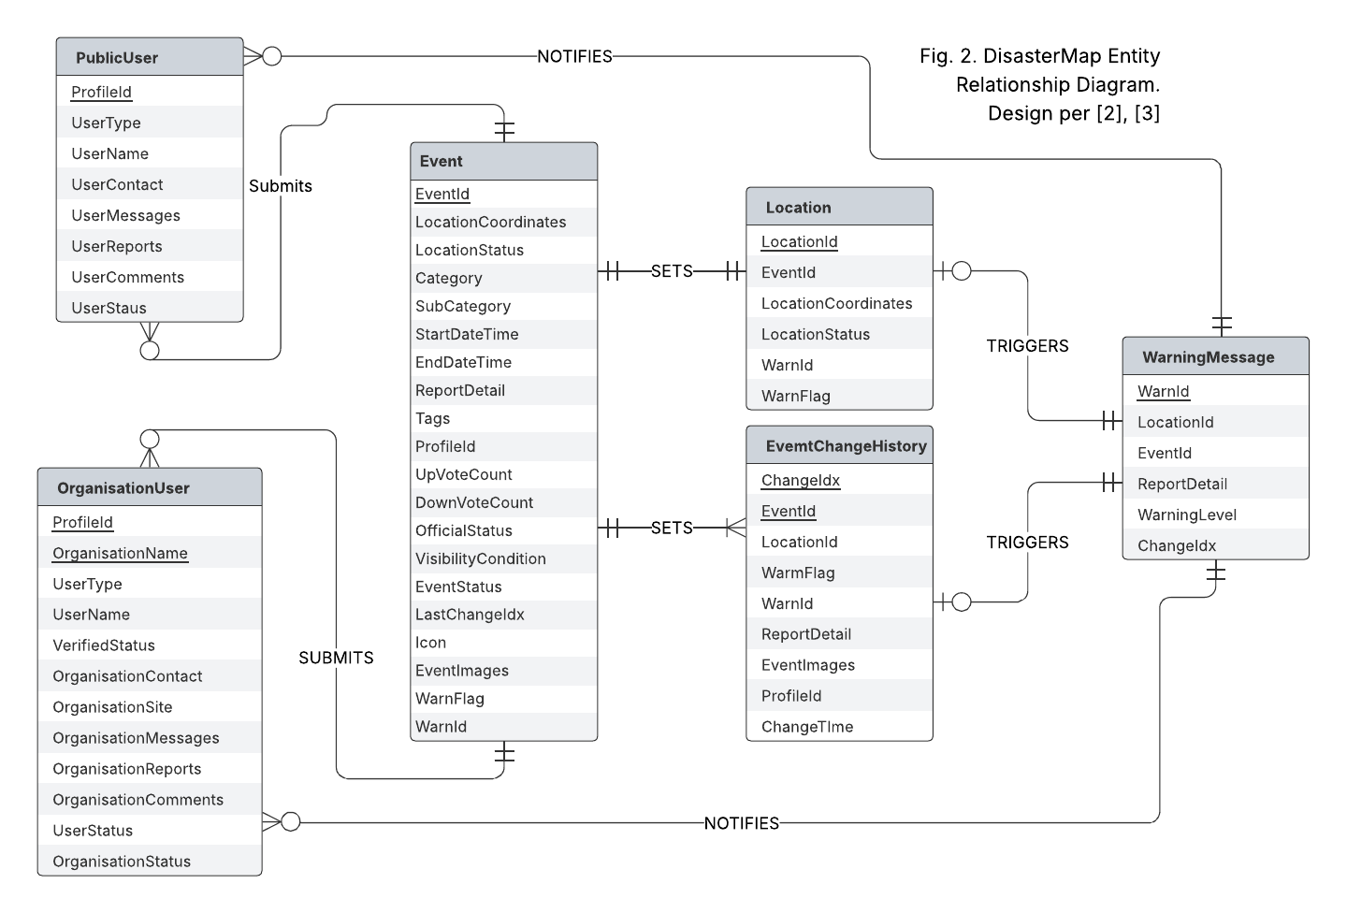

TASK 3 – SCREEN LIST

Launch Screen Load Screen

- Screen displays Application Logo when launching or loading  
  
Landing Screen Event Map (first use)

- User has options to Login, Report, Search

- Will use current location to display local area map if available  
- Otherwise use IP to try to provide nearest map area  
- Subsequent use will forward official / verified account users straight to login if device / IP is remembered

Settings Screen  
- Users can customise settings  
- Users can administer their accounts – profile etc  
- Users can view their activity

Search Screen  
- Users can search for a particular location and check for and disaster or hazard reports in that area  
- Will offer to use current location if location services are available

- Login is optional  
  
Report Event Screen (form)  
- Users can add report an incident or hazard for their area (geo lock?)  
- Users can add a text description  
- Users can add images  
- Other users can upvote or downvote the report depending upon accuracy and currency (the event may be over or obstacle removed)  
- A request change feature if the incident someone is trying to report is pre existing  
- A link feature if two different events or hazards in the same location are linked

- User must create an account or login at the end of report to create the record – this is for safety and contactability if required.

View Event Details / View Report Details Screen  
- When someone clicks on an event from the map or directly form the address or coordinates the can be taken to this screen to view all the activity and reports for this event

- Users could access a summary of the changes in a thread-like way  
- Users can comment or add additional details or images about the event  
- Original reporting user can also make edits via this screen to ‘maintain’ their event

- Login is optional unless the user wants to interact with the report  
  
Login screen  
- Allows user to login or register  
- User can provide email or phone number to register  
- Login link is then sent via email or phone – no password used for speed

Administration + Management UI Screen

- Admin users can use this screen for elevated functions inside the application

- Admin users can directly report (add) official events -  
- Admin users can directly update or close off events (in some circumstances and according to administration rights)  
- Root Administration Users can add or disable other users and have control over official account creation.  
  
Not a screen but also to include push notifications if user is subscribed to event or can receive broadcast notifications from other users they subscribe to

TASK 4 – FLOW DIAGRAM  
  
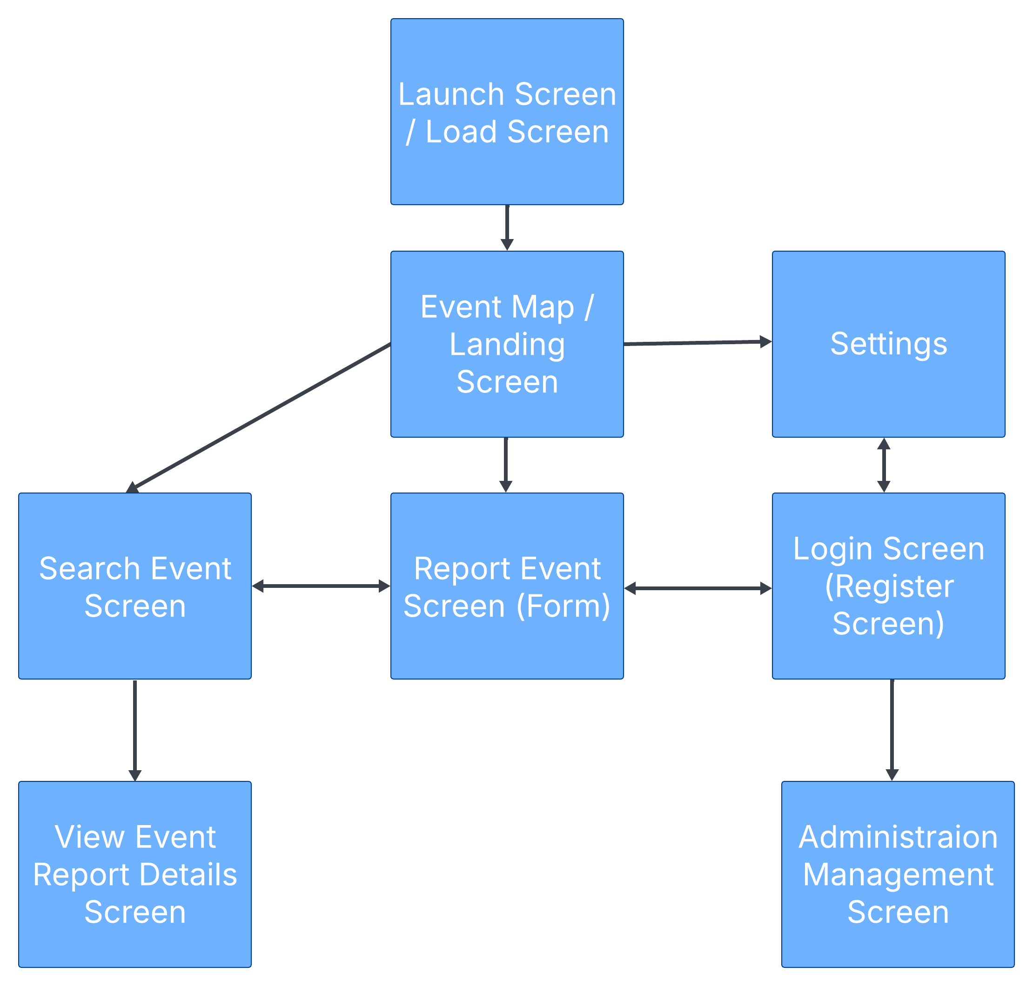

TASK 5 – WIREFRAME/PROTOTYPE  
  
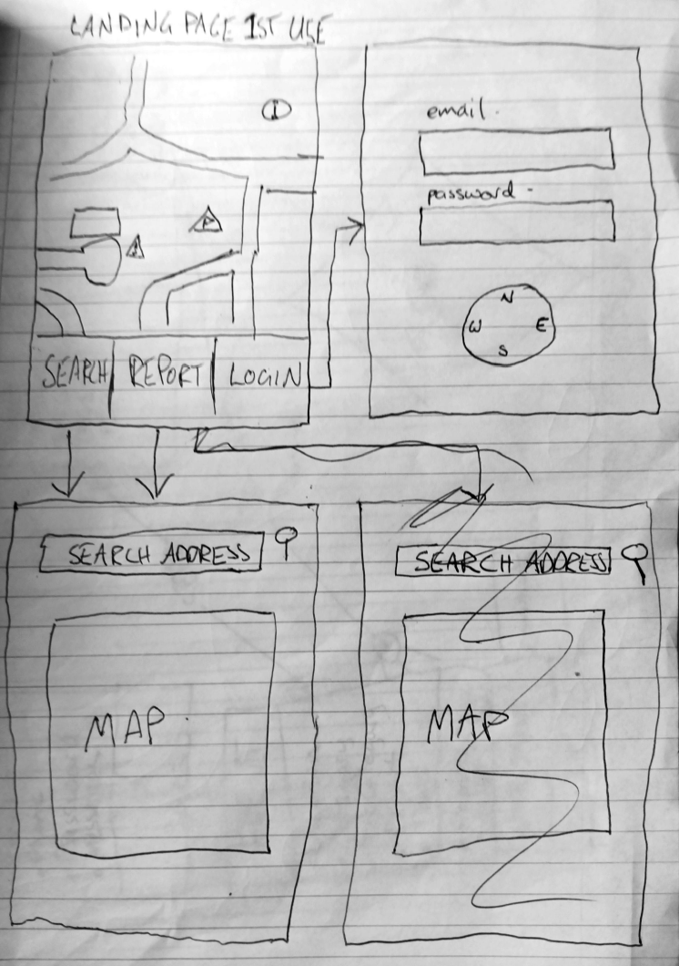

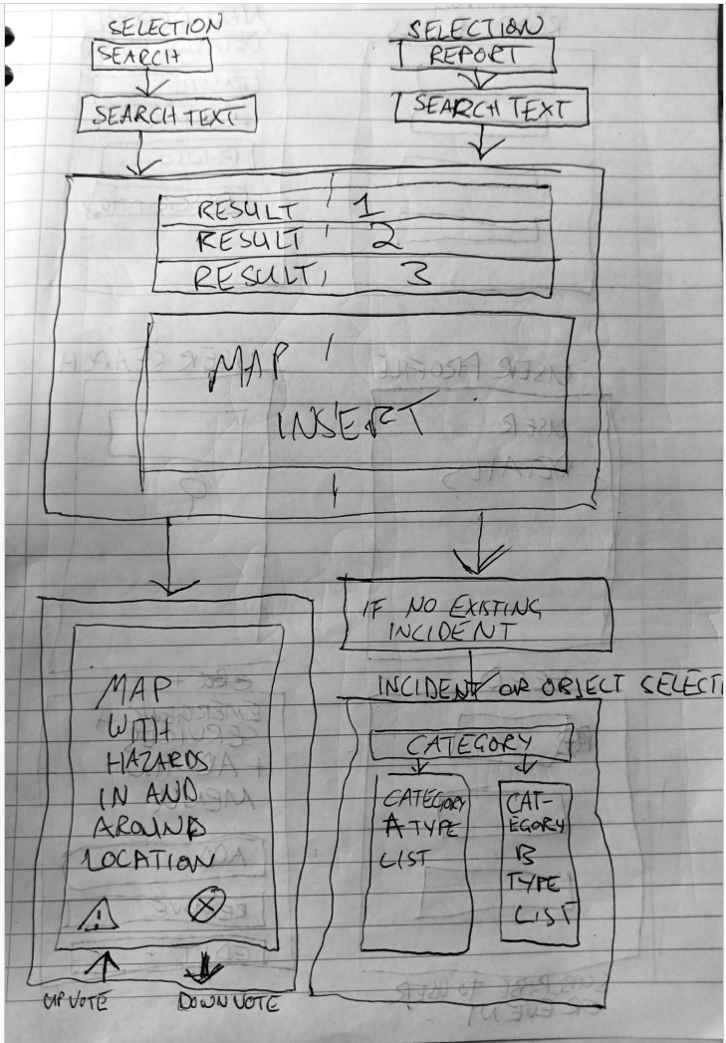

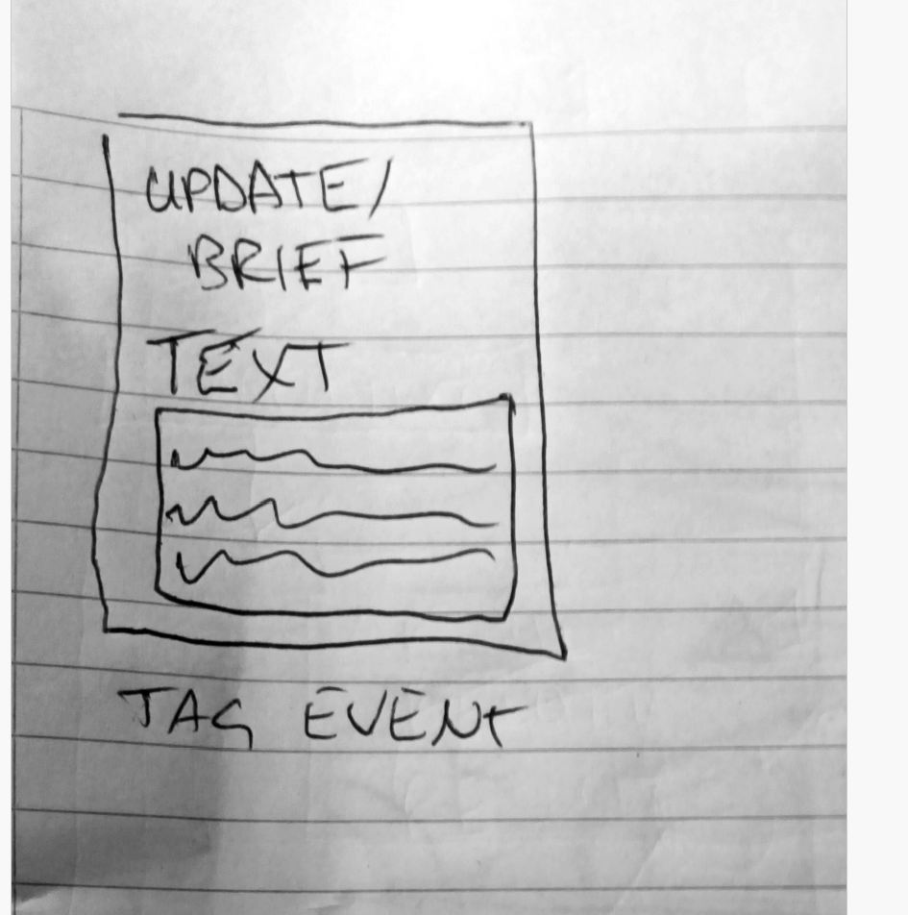

REFERENCE LIST

[1] Lecture Material  
[2] Lecture Material  
[3] Book - Information Modeling and Relational Databases, Third Edition   
Terry Haplin and Tony Morgan