|  |
| --- |
| CSEMAD MOBILE APPLICATION DEVELOPMENT  Assessment 1 –  Phase 1 |
| Due 28 MAR 2025  Students: 20219568, 20224078  Authored by: Luke Gardiner, Richard Avery |

TASK 1 – LEAN CANVAS

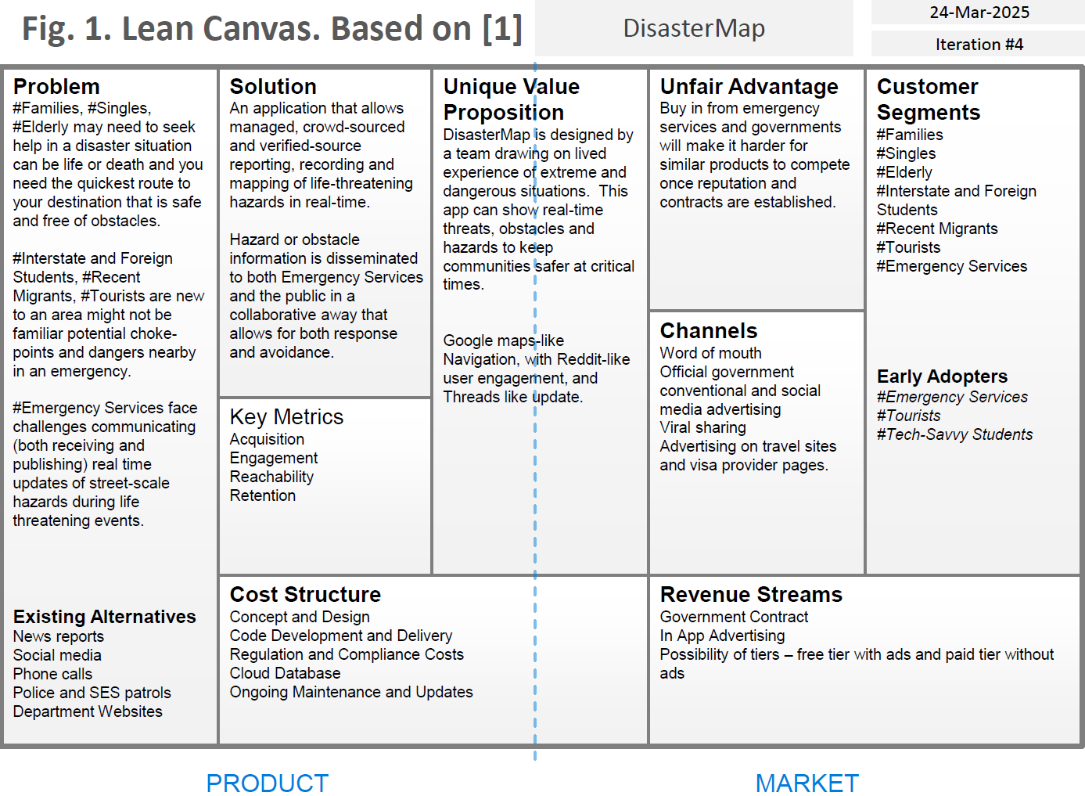

TASK 2 – ENTITY RELATIONSHIP DIAGRAM

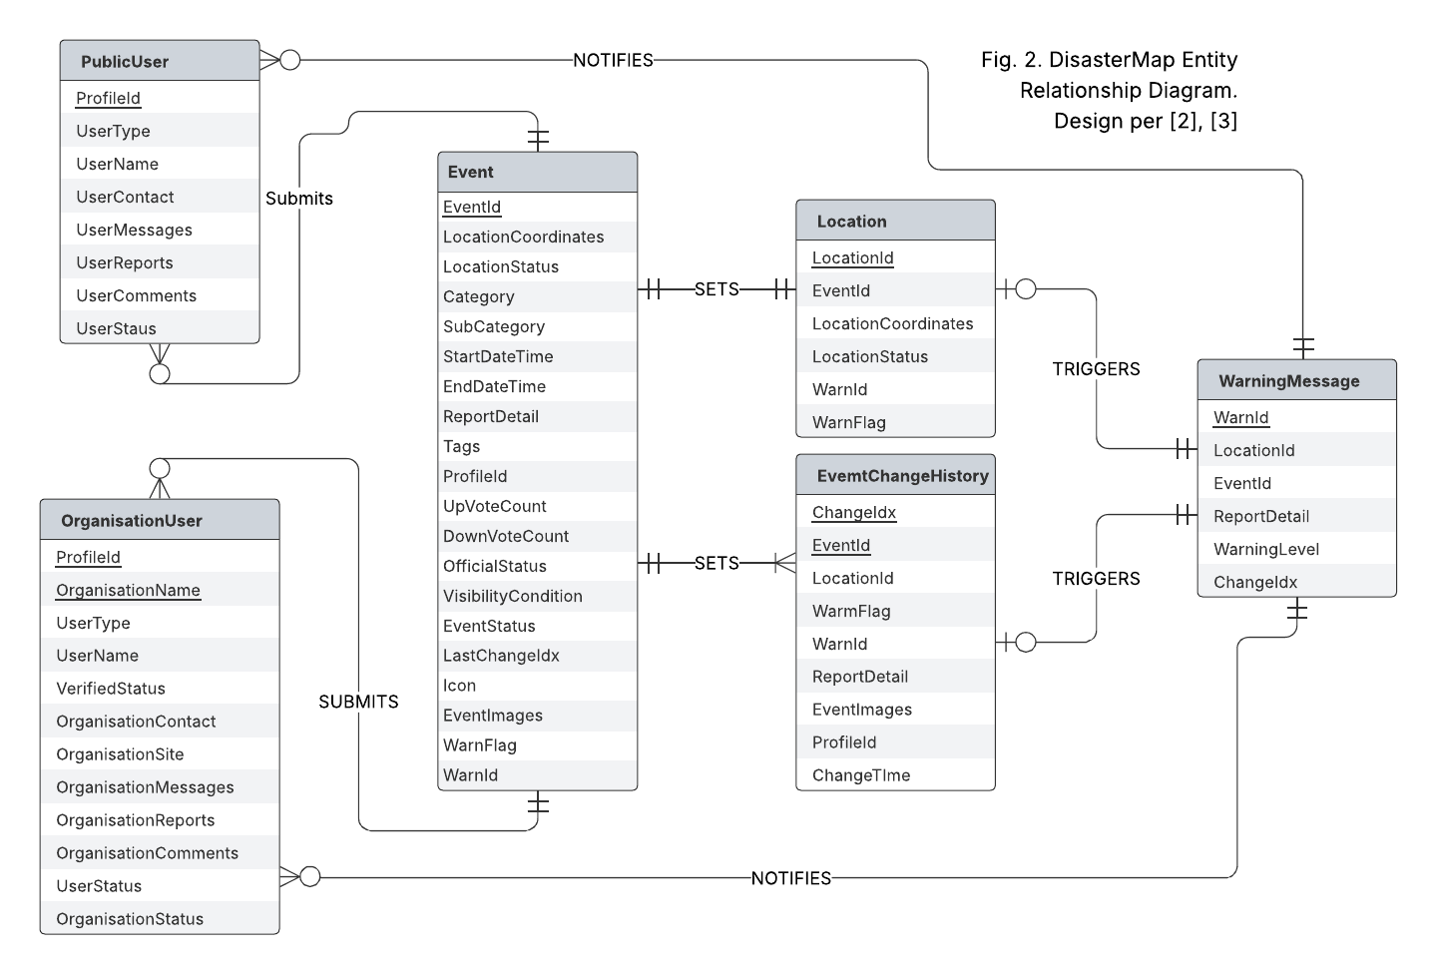

TASK 3 – SCREEN LIST

Set-up Activity:

* The user will be able to:
  + View current hazards using an interactive map
  + Add hazards when they appear
  + Validate/Unvalidate hazards that appear on the map

Loading Screen:

* The user will view a loading screen whilst the app loads.

Main Screen:

* The user can interact with the map. They can view existing hazards on the map with the ability to view or add hazards from here.
* The user can navigate to the settings page for toggling different settings.
* The user can navigate to the search screen to lookup existing hazards.
* The user can login to an account for admin activities.
* The user can navigate to the hazard reporting screen to report a hazard.

Report a Hazard Screen:

* Users can add their own hazard to the map.
* They can add the type, description and any photos they may have taken of the incident for others to be aware of.
* At the end of the process, users will be asked to register their email for authenticity purposes.

Search Activity:

* A user can refine their search by filtering on the type of hazards as well as search for a destination.
* A user can select a hazard to view its details.

Search Hazard Screen:

* When a user searches a hazard, it provides the hazard type, location, time of report, description and any photos the author may have provided.
* The user also has the ability to verify the validity of the hazard report.
* A user can add a comment e.g. “Wow, that fallen tree was huge!”

Settings Screen:

* When selecting the settings button from the home screen, users can configure any settings they would like to change. E.g. distance units, push notification toggle etc.
* User can configure profile information such as icons.

Admin User screen:

* Gives admin users the ability to add, remove or edit official events directly.
* Admin users have the ability to send broadcast messages relating to events through push notifications.

Login Screen:

* Users who obtain an official account, can login to the Admin User screen.
* Users can also register from here.

TASK 5 – WIREFRAME/PROTOTYPE  
  
Note: The colours and shapes chosen in the prototypes are not a reflection of the complete design. Some limitations in Figma. Colours and shapes will be played with during development.

Main Activity

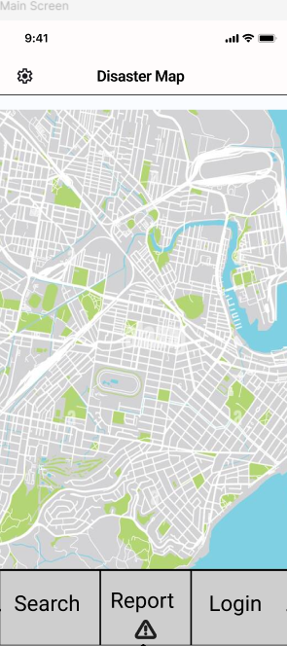

Button to link to settings activity where personalisation and app settings can be configured.

Button to link to login activity where users can login or register an account.

Button to link to hazard search activity where users can filter for particular hazards

An interactive map that starts from your location. The user has the ability to move around and zoom in and out as needed.

Settings Activity

Button to link back to the main activity.

Button to link to report a hazard activity

Button to link to main activity.

Outlines the developers and brief description f the app. Any affiliated government agencies will be listed.

Users can select the button to change things like icons, font etc.

Users can toggle push notifications on/off

Users can toggle between kms/miles for readability.

Users can change language the language to suit their needs.

Report a Hazard Activity

User provides a brief description about the hazard e.g. Tree has fallen across both lanes. No way around it, avoid all together.

User selects the type/category of hazard for example: flood, fallen tree, etc.

Button to link to setting activity

Button to link to main activity

Button to link to report a hazard activity

Once user is satisfied with their report, they can submit. Once submitted, the hazard will appear on the search a hazard and main activity navigational maps.

User can provide any relevant photos they took of the hazard for better context

Search Hazard Activity

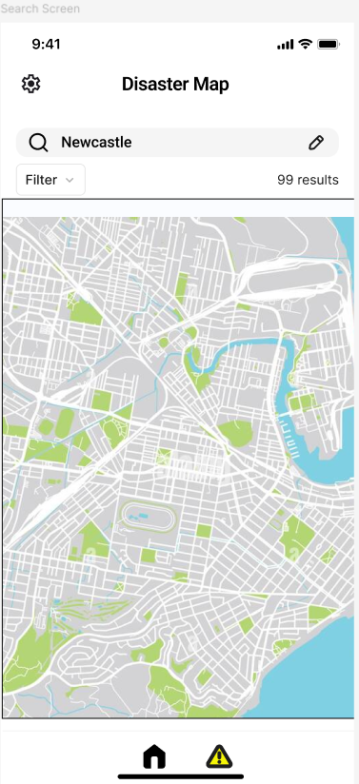

Button to link to the report a hazard activity.

Button to link to main activity.

Navigational map that users can navigate through.

A drop-down filter menu that allows the user to refine their search further by selecting specific types of hazards. This will then filter those hazards on the map.

A search bar where users can search for a particular suburb, town or city.

Button to link to the settings activity.

View Hazard Activity

Button to link to search hazard activity.

Shows the location of the hazard selected. E.g. 123 Abbott St, Melbourne.

Shows the date/time stamp for when the hazard was reported.

Shows the description provided for the hazard recorded.

Button to link to main activity.

Button to link to report a hazard activity.

An upvote/downvote function that can verify the validity of the reported hazards. This allows users to determine when the hazard is still relevant.

Shows the images in a carousel form that the author had submitted. If no images added, it will be left blank.

Login Register Activity

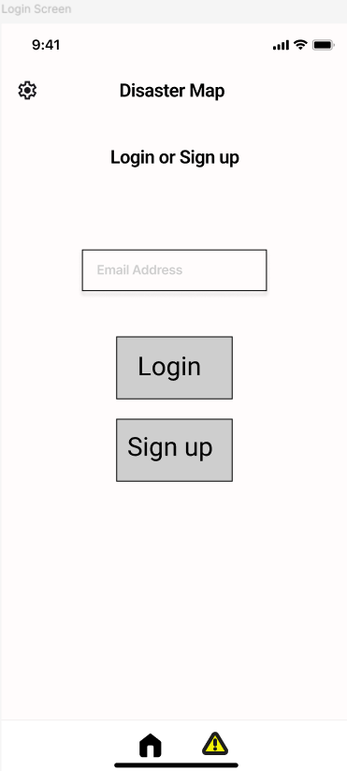

Button to link to report a hazard activity.

Button to link to main activity.

If the user has not previously registered, button to send an email to the users given email address which will provide the authentication to register.

If the user has registered previously, button to link to admin activity.

User enters their email address to login.

Button to link to settings activity.

Admin Activity

A verified user e.g. emergency services have the ability to send broadcast messages to users for official statements.

Button to link to report a hazard activity.

Button to link to main activity.

Button to activate the broadcast message.

Button to link to report a hazard activity.

Button to link to settings activity.

PALLETE & FONT  
  
The application screens will use a Roboto font due to its presentation and utilitarian qualities as outlined by Google [4]. This application will be used by a wide variety of people, including people with accessibility requirements and older people who may not have the best vision in potentially dangerous emergency situations so easy readability and a simple colour scheme are paramount.  
  
The application theme will be chiefly white, grey, and black to support the emphasis on simplicity accessibility and readability. Alerts themselves will align with the from the ISO 3864:2011 [5] for global recognition.  
  
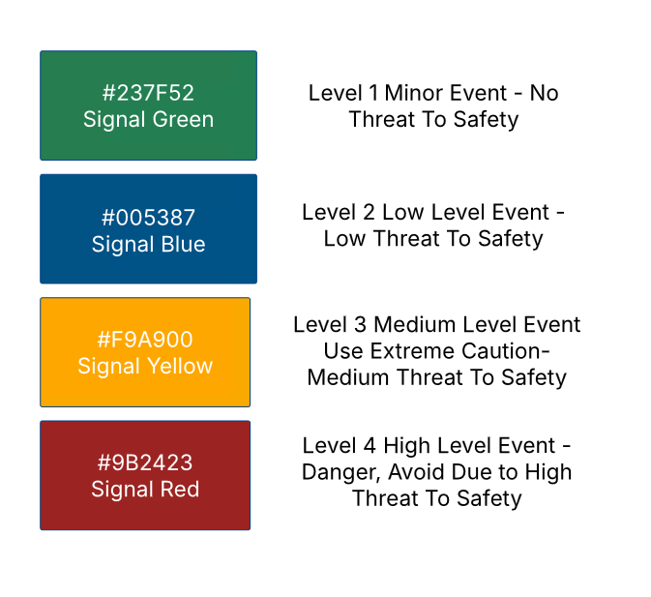

REFERENCE LIST

[1] Lecture Material, CSE3MAD Assignment: Sample Phase 1 Report. pp.2. Available: https://lms.latrobe.edu.au/mod/resource/view.php?id=7779508.  
[2] Lecture Material, CSE3MAD Assignment: Sample Phase 1 Report. pp.3. Available: https://lms.latrobe.edu.au/mod/resource/view.php?id=7779508.  
[3] T. Halpin, T. Morgan, *Information Modeling and Relational Databases Third Edition*. Cambridge, MA, USA: Morgan Kaufman Publishers, 2024.  
[4] From Google Fonts “Roboto.” *fonts.google.com*. https://fonts.google.com/specimen/Roboto/about (accessed 27 March, 2025).  
[5] From Wikipedia, the free encyclopedia “ISO 3864:2011Graphical symbols — Safety colours and safety signs Example safety sign designed according to ISO 3864-1.” *Wikipedia.org*. https://en.wikipedia.org/wiki/ISO_3864 (accessed 25 March, 2025).