## **Basic set up**

* First project structure

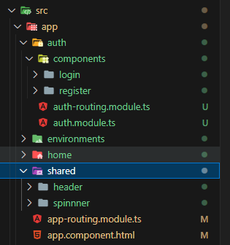

* Output result

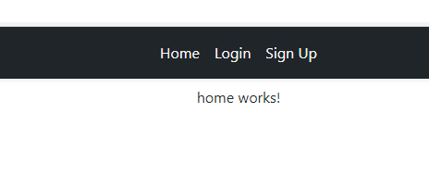

* Install packages

npm install @ngrx/store

npm install @ngrx/store-devtools --save

npm install @ngrx/effects

* You can clone all of this from github

<https://github.com/lukeangular/NGRX_AUTH>

## **Create Models**

* Create models folder

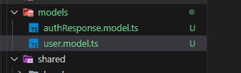

* Auth response model is for mapping data

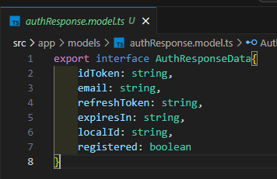

* User model if for formatting data

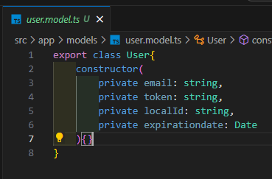

## **Create services**

* Create models folder and generate auth files

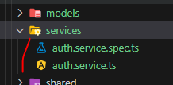

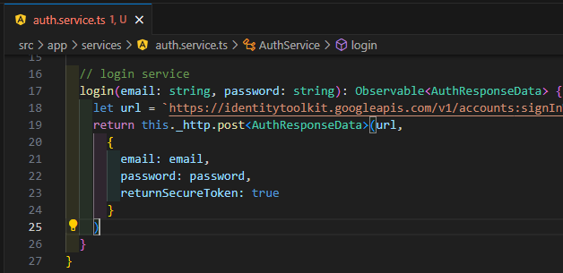

## **Auth state**

* Create auth state and files inside it

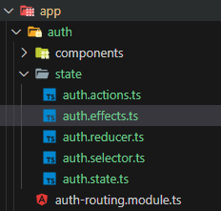

### State

* At first go to state file and create state

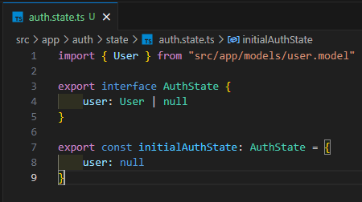

### Action

* Go to action and create actions

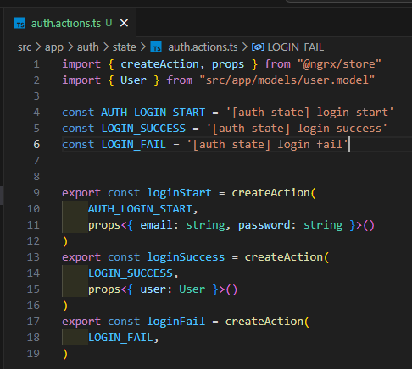

### Reducer

* Open reducer file and write code

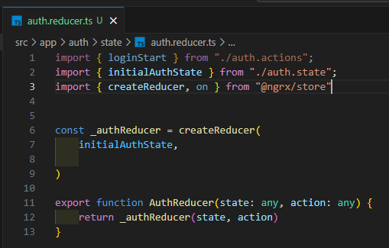

### Effects

* Open effects file and

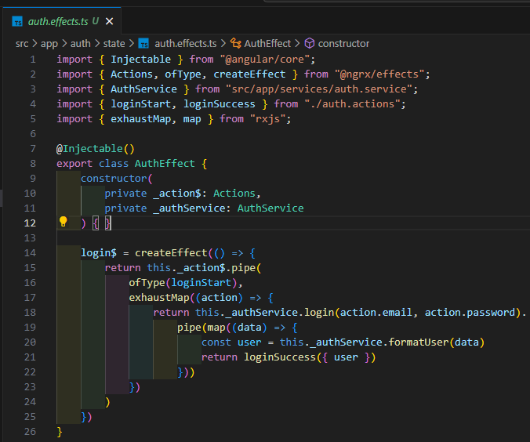

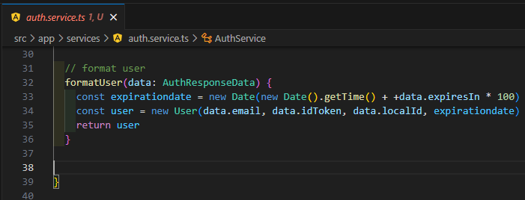

### Selector

* Go to auth selector

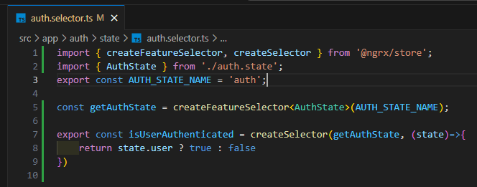

## **App state and register state**

* Auth state should be available among all the components, so we need to make it global

Create app state folder for one global state

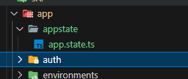

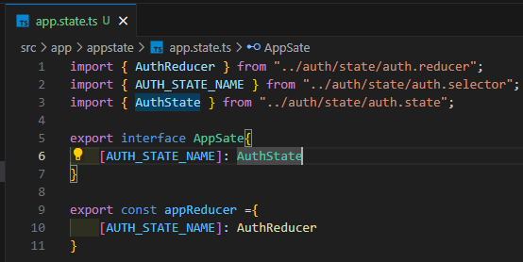

* Now add feature effect of auth, on auth module

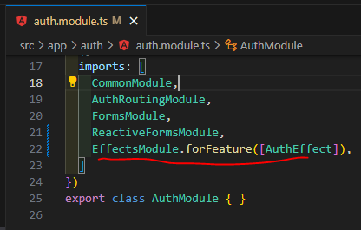

* Go to app module (main module)

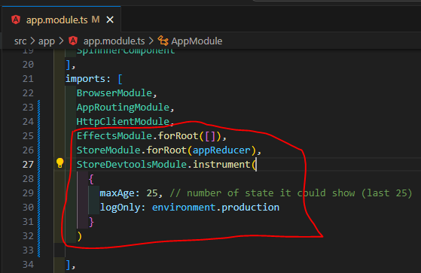

* If use provide valid login and username, we get this

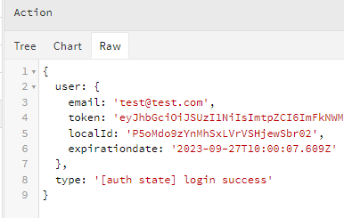

## **Save token in store**

* Go to reducer and update reducer

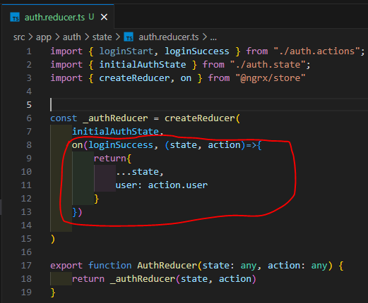

## **Redirect to home page when login**

* For this create redirect effect with dispatch false
* Go to effect file of auth

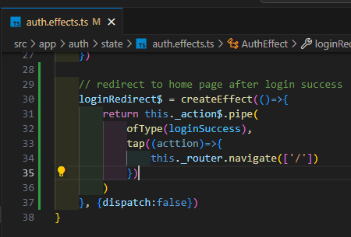

* Now go to header

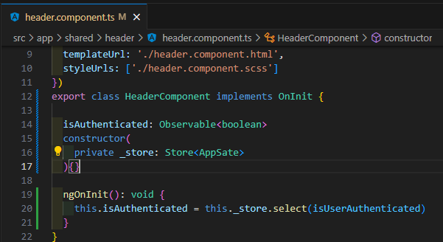

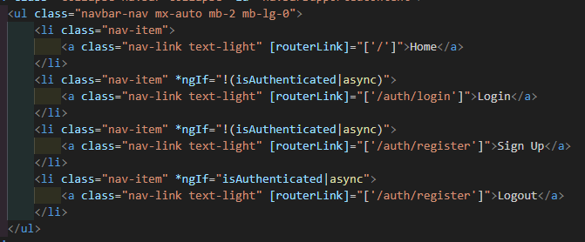

## **Save token in local storage and auto login**

* At first update our action

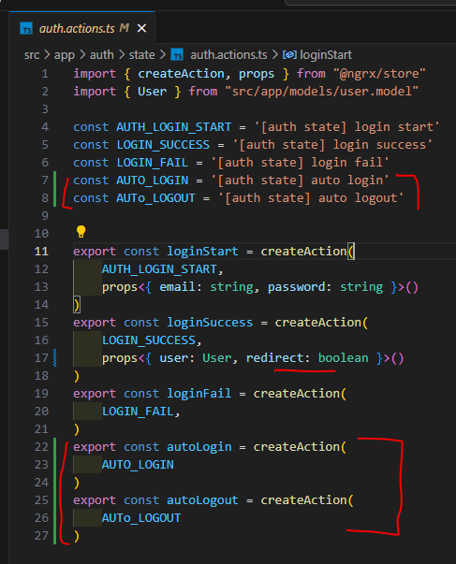

* Go to component and dispatch action on

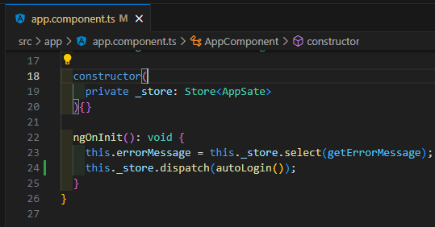

If we see in redux auto login action is firing

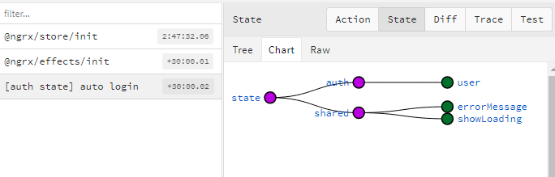

* If we login we are also able to store user data on local storage

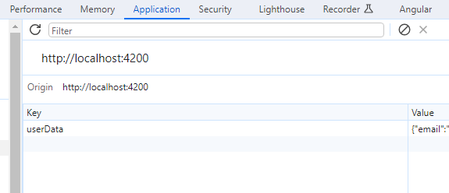

* No go to auth effect

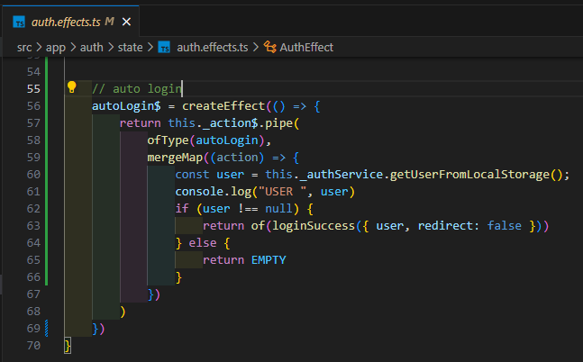

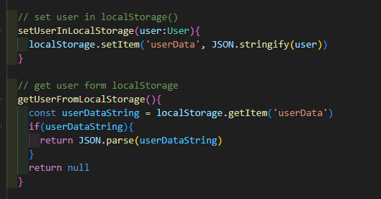

* Now go to auth module

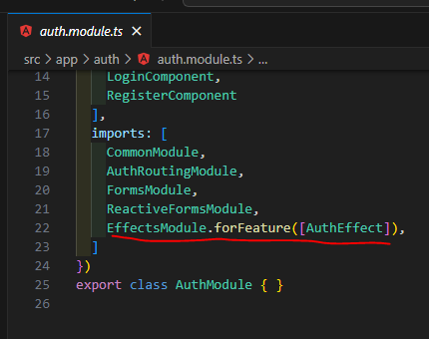

Remove this and put into main module

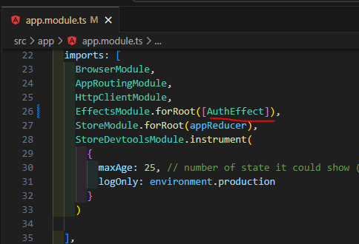

* Now reload page, it should do auto login now

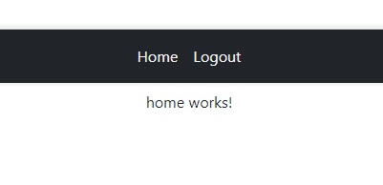

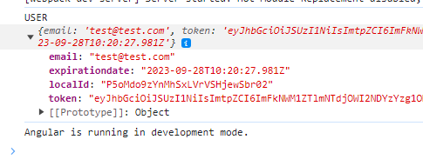

## **When click at logout**

* Go to header

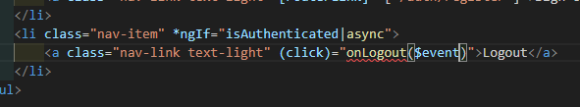

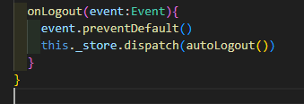

* On reducer (we already wrote this code, so no need to worry)

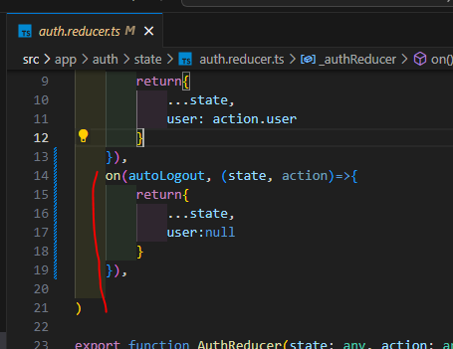

* On effect

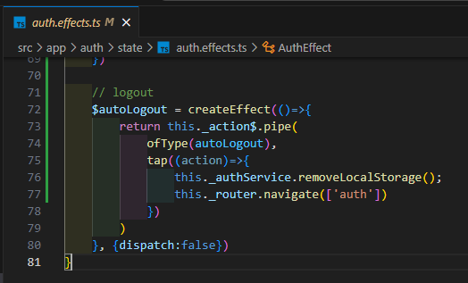

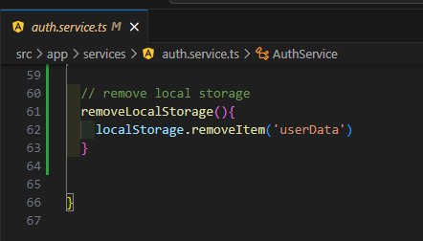

## **What if we get error? (Shared state)**

* To handle to error, we will create sharable state this will be also for the global spinner
* Create state for sharable state

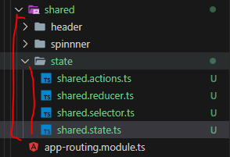

### State

* At first go to state file and create state

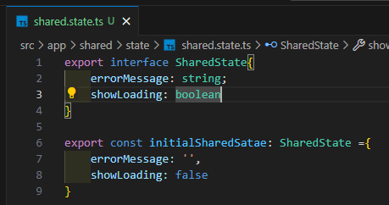

### Action

* Shared actions

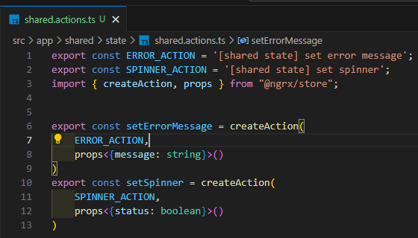

### Reducer

* Open reducer file and

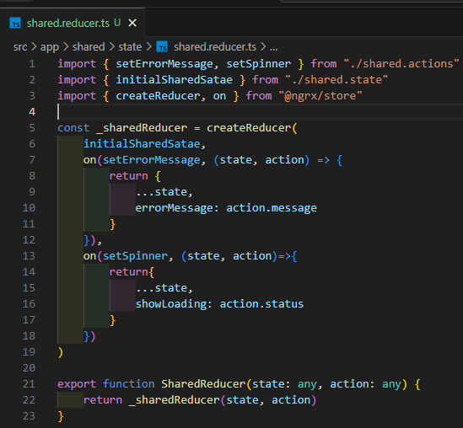

### Selector

* Go to shared selector and

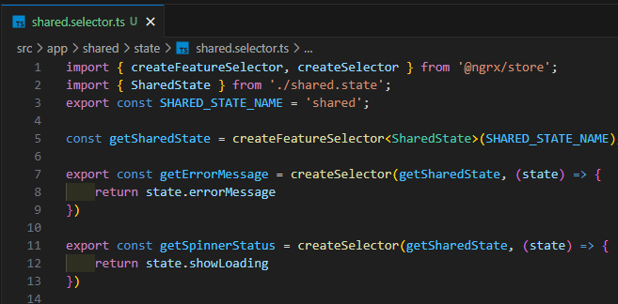

### Effect

* Now go to effect and update effect to handle error

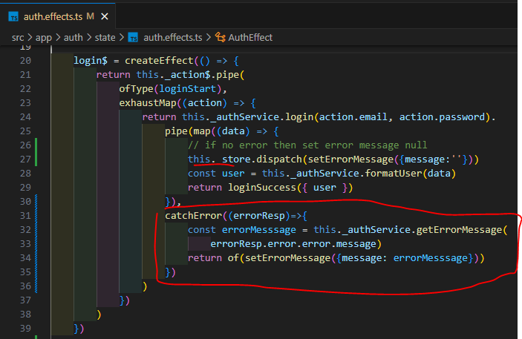

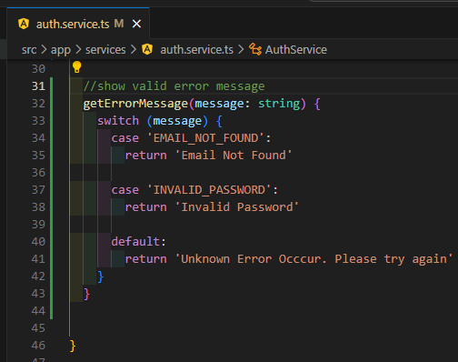

### Add reducer and state to the app sate

* Go app state and

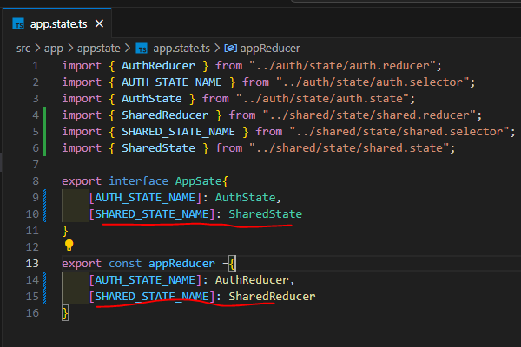

* We want to show error globally so we will add this in app component HTML
* At first go to app component

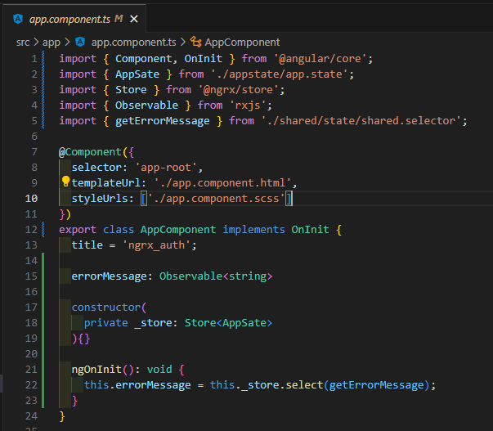

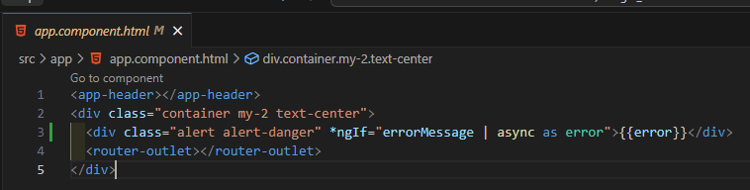

* We can show spinner with too using same logic

## **Register user**

* At create auth form

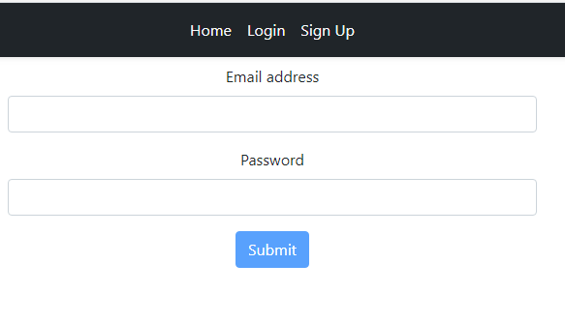

* Then write action code for sign up

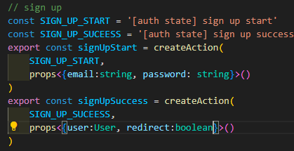

* Go to services

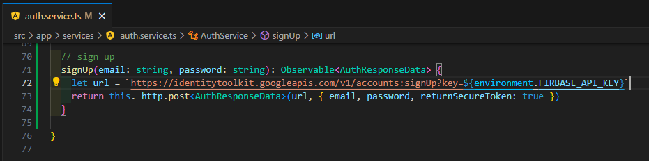

* Go to component

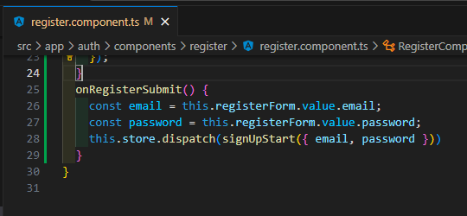

* Go to effect

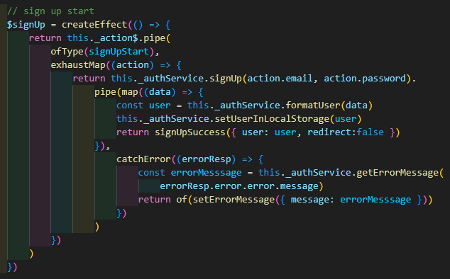

* Update login redirect

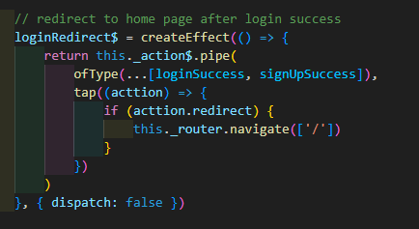

* Go to service and update set error message format function

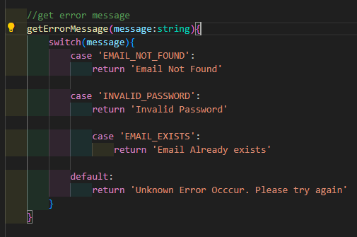

* We have also updated model like this

