An Imagined Geography of Empire: Mining cultural representations of the American colonial state during the St. Louis 1904 World’s Fair

Lucas Avelar, Clemson University

December 2023

#### 1. Introduction

In 1902, serving as the first Civilian Governor of the Philippines after a period of American military control over the islands, William Howard Taft traveled to St. Louis to meet with David Francis, the president of the Louisiana Purchase Exposition. The purpose of the meeting was simple: to make the case for a strong, imposing, unprecedented Philippine exhibit at the St. Louis World’s Fair. “[…] If we have your [the executive board’s] help,” Taft said, “we hope to make the Philippine exhibit the great feature of this exposition.”[1] By the end of Taft’s plea, Francis said that “The people of the United States felt that it was their duty to look after the nine or ten millions of people in the Philippines, and guard their interests, give them education and advance them to civilization.”[2] The executive board’s positive reception of Taft’s ideas made the enterprise of the St. Louis World’s Fair a turning point in the history of Filipino-American relations and the legitimation of the emerging American colonial state.

Taft’s conceptualization of the exhibit found reasoning in two main purposes. First, he was rather interested in proving to the American society that the work he had been doing in the islands was indeed providing fruitful results. In this sense, Taft felt like the importance of bringing back some missionary American teachers along with their Native Filipino students to recreate their schooling model on the fairgrounds could not be overstated. Second, Taft hoped to use the world’s fair as an opportunity to convince the Filipino elites that Americans were allies in “completing pacification and in bringing Filipinos to improve their condition.”[3] Therefore, the problem of how to represent the Filipino culture and identity became a central matter in the fair makers’ agenda.

Two years later, serving as the Secretary of War for Theodore Roosevelt, Taft was trusted with the responsibility to give one final speech to the thousands of people attending the opening ceremony of the world’s fair. He referred to the exposition as “the union of nations in a progress toward higher material and spiritual existence.” More importantly, his speech emphasized that “the government of the Philippine Islands has felt justified in expending a very large sum of money” to make visitors understand the circumstances surrounding the American occupation and control over the Islands. In a comparison to the Louisiana Purchase in 1803, Taft framed the occupation of the Philippines and the formation of the American colonial state as “one great effort of American enterprise and expansion”. He contended that the centennial of the Louisiana Purchase, celebrated at the world’s fair of 1904, marked “the beginning of the great Philippine problem.”[4]

After Taft’s speech, David Francis sent the signal to the White House that would let Theodore Roosevelt know it was time to press the golden telegraph key and provide electrical power to the fairgrounds. “Open, ye gates, spring wide ye portals,” said Francis, while urging visitors to “behold the achievements of your race: learn the lesson here tonight and gather from it inspiration to still greater achievements.”[5] The lesson to be learned within the gates was not only about the achievements of a modernizing world, but even more so about what made America so exceptional in face of other modern nations and imperial powers at the turn of the century. As historian Paul A. Kramer has demonstrated, to make sense of the “great Philippine problem,” U.S. officials and state-builders like Taft and Francis relied on the principle of national exceptionalism.[6] They believed and defended that the United States was indeed not an empire like those of European powers. Rather, the justifying principle for the emergence of the United States as a colonial power was the belief that the American expansive republicanism and “benevolent assimilation” abroad were much different from everything else.

Throughout the nineteenth and twentieth centuries, world’s fairs became the symbolic stages of planned urban utopia in which geopolitical and cultural groups negotiated their economic power, symbolic prestige, and modern collective identities.[7] The fair in St. Louis offered a particular narrative about the progress of civilization and the modernizing world: both discursively and spatially, fair makers imagined a certain geography of the world in which the United States loomed large as an emerging colonial state. But because the American “exception” as an empire could only be displayed among comparable elements, that narrative of civilization and progress was strongly dependent on the participation of particular geopolitical and cultural entities deemed as “uncivilized” and in need of the American “benevolent assimilation:” the Filipinos.

This article looks at local newspapers as intermediaries of fair makers’ ideological messages and visitors’ spatial experiences that produced and promoted their own discursive representations of the geopolitical entities at the fair.[8] It understands the Louisiana Purchase Exposition as a complex metaphor of early-twentieth-century modernity embedded with ritualistic competition, contradictions, and tense power relations. Further, the article pushes for closer scholarly attention to how newspapers engaged with and interpreted the language of empire and American colonialism at the fair. Newspapers relied on the ways in which multiple audiences perceived and engaged with the fair exhibits in order to write their stories and produce complex discursive representations of participating cultures and the modernizing world. By attending to the cultural commentary about the fair through the use of digital methodologies, this article argues that, in response to the power relations and discursive negotiations embedded on the fairgrounds, newspapers contributed to an “imagined geography” of the modernizing world centered around the United States as an emerging (and exceptional) colonial power at the turn of the century.[9] They did so, first, by printing place-names of the United States and the Philippines more often than every other geopolitical entity participating at the fair. Second, by fostering conversations about the Philippine exhibit as a center piece of the exposition and characterizing Filipino people as a nation under American tutelage and guidance towards civilization.

#### 2. World’s Fairs and cultural representations

Historians have often discussed how exclusionary principles of modernity, civilization, and progress underpinned the arrangement of world’s fairs. Robert Rydell’s work was a pioneer in offering a social and cultural perspective on world’s fairs as symbolic universes that not only legitimized the hosting country’s political and scientific authority in the race for modernity, but also provided “a meaning for social experience, placing ‘all collective events in a cohesive unit that includes past, present, and future.(…)’”[10] Those principles enabled fair visitors to experience a digestible version of the modernizing world of the turn of the century, one that relied on the visual separation of cultures in space. As mediators between to the ideological message embedded on the fairgrounds and the citizens of St. Louis, local newspapers reflected on the separation between old and new, tradition and modernity, uncivilized and civilized, generating discursive representations of the participant geopolitical and cultural entities that reinforced an “imagined geography” of the world centered around the United States as an emerging colonial power.

More recent scholarship on the fairs has pushed for a closer attention to how visitors and broader audiences experienced the fair and its ideological message. In 2009, historian James Gilbert wrote about the memory and experience of the fair in St Louis and suggested that scholars of world’s fairs have often described them from the perspective of the organizers and failed to consider common people’s experiences. Gilbert argued that fair goers did not necessarily look at the fairs as symbolic universes of political and cultural legitimation and affirmation of national values.[11] To understand the extent to which particular social groups successfully perceived underpinning narratives of modernity and otherness proved to be a complicated research task that has yet to be fully addressed.

Even though the analysis of newspaper articles cannot account for how visitors perceived the ideological message on the fairgrounds, understanding how participating groups were represented in the press is a valuable step towards a more complex history of world’s fairs. Cultural commentators’ particular positionality enabled them not only as receptors of the fair’s message but, more importantly, as producers of their own representations of the world and – relying on Benedict Anderson’s framework – the “imagined communities” involved in the exposition.[12] Many of the newspaper articles collected for this project incorporated, relied on, and described the spatial experiences of visitors on the grounds for the stories they told. In response to dialectical interactions between discursive communities who negotiated their modern identities at the fair–in this case, fair makers, geopolitical entities, and visitors–, newspapers not only advertised the fair as a profitable event with attractive storytelling features, but they also generated their own imagined geography of the world through discourse.

Some scholars have emphasized that the fairs were meant to win the hearts and minds “as well as the disciplining and training of bodies.”[13] For sociologist Tonny Bennett, the “exhibitionary complex” turned the problem of creating and maintaining a particular social order into a problem of culture. As part of this complex, world’s fairs made visible to the masses the dynamics of power, discipline, and state surveillance. By arranging, regulating, and displaying bodies, they enabled visitors to understand the role of “subjects” and “objects” in the constitution of a new, voluntarily self-regulating citizenry.[14] Anthropologist Burton Benedict, in turn, focused on the rather ritualistic dimension of the fairs, emphasizing the competition (rather than top-bottom imposition) between participating nations and intellectual elites during the events.[15] In a similar direction, historian Mauricio Tenorio-Trillo’s examination of the Mexican representation in the material dimension throughout varied fairs suggested that geopolitical entities, in particular colonized nations, invested in fair exhibits to push for their own interpretation of their modern collective identities. As organized spaces of cultural encounters and power relations, the expositions incentivized negotiation in the narrative dimension over each participant group’s view and experience of modernity.

The fair’s ideological message, its perception by cultural commentators, and its cultural representations are equally relevant to the understanding of the dynamics of power at play (and on display) at the fair. Even though historians have accessed and examined personal letters, diaries, and other sources that shed light on how visitors experienced the exhibits, close reading of those documents often proved insufficient to assess how audiences reflected upon and discursively represented the language of empire and colonialism embedded on the fairgrounds.[16] As this article demonstrates, employing textual analysis methodologies to newspapers accounts about the world’s fair reveals how the exhibits fostered conversations about the American acquisition and control of the Philippine Islands. The extensive cultural commentary about the Philippine exhibit, always in comparative terms to the American culture, generated particular discursive representations of the American colonial state as an not only an example of progress and civilization but also as the center of the modernizing world.

#### 3. The rhetorical construction of the American Empire

As early as the 1890s, American historian Frederick Jackson Turner suggested that any explanation of American history had to come to terms with the notion of the frontier and its implications. “The frontier,” he contended, “is the outer edge of the wave – the meeting point between savagery and civilization.”[17] Despite Turner’s importance for Western Historians that followed and the field of U.S. History in general, his conceptualization of the American national identity as naturally exceptional has been long rejected in twentieth-century historiography. However, as historian Thomas Bender has more recently argued, throughout most of the nineteenth century, the American perspective on the Pacific and East Asia had much to do with the American expansionist ambitions towards the west.[18] When Turner contended that the continental frontier was closed in 1893, American politicians had already been concerned about the next chapter of the history of American proud republican expansion.[19] The rhetoric of empire and U.S. national exceptionalism that grounded the American acquisition and dominance of the Philippines by the turn of the century are key to the understanding of the world’s fair in 1904 as a site of struggle and negotiation between geopolitical entities and their own views of modernity, civilization, and American colonialism.

If the early European rhetoric of empire and land appropriation was largely based on religious justification, by the late nineteenth century, the United States gradually sought legitimization for its imperial actions less on terms of American Christianity and more on economic development and notions of racial hierarchy. Manifest Destiny, in Bender’s words, had become “as much a racial concept as a political one, about the rights (and responsibilities, too, it was believed) of ‘civilized’ nations to rule lesser, uncivilized peoples.”[20] By the 1890s, and based on the racial and political premise of American superiority, the McKinley Administration used the unstable political circumstances in Cuba to get involved in the war against Spain and justify the annexation of Hawaii.[21] Further, defeating Spain in the Spanish-American War in the name of “freedom” and Cuban independence resulted in the United States acquiring sovereignty over the Philippines as well as the territories of Guam and Porto Rico.[22]

During the occupation of Manila by U.S. Troops, local compromises between American diplomats and Filipino insurgents on the ground caused tensions and diverged from what the U.S. State Department had envisioned for American sovereignty over the islands.[23] A competition of state-building strategies between Filipino officials and U.S. commanders followed the Spanish defeat. To add to the complexity of the power dynamics at play, Filipino leaders often relied on the language of “civilization” in seeking international recognition of the Revolution and Emilio Aguinaldo’s self-sufficient government.[24] If Aguinaldo and his diplomatic representatives could convince the United States of the civilized character of the insurgent Filipino government, they thought, the American troops had no reason to stay in control of Manila. But the American lingering presence in the Philippines, in particular, did not come without controversy and domestic opposition.

The American perspective on the Filipinos and their capacity to learn self-government was far from homogeneous, and the “post-war” society blurred the lines of race and civilization in the islands. Anti-imperialist Americans often looked at racial hierarchy to argue against incorporation of allegedly inferior people since it could undermine the meanings of American citizenship.[25] Further, as Kramer has demonstrated, this racial anti-imperialism was heavily informed by the domestic experience of the “Negro problem” and the fear of further “racial corruption” of the United States as a result of the incorporation of more colonial subjects.[26] Public opinion at home was greatly informed by the anti-imperialist ideology and the fear that incorporating territories could undermine the power of white American citizens. As a result of the American military’s reporting on their war experience, it was also common in the public discourse to represent Filipino people and their “barbarous fighting” as savages, non-Christians, and racially inferior.

Those who did not oppose the American occupation of the islands saw it as a benevolent guidance of a non-civilized people towards self-governance. The civilian regime that followed the military dominance sought to distinguish itself from the U.S. army, its war-like practices and treatment of natives. Taft himself made that distinction clear in 1901 during a speech to the Senate by saying that the military regime had found and dealt with “the natives who are in an actual state of war” while the civilian regime had met “the natives who are interested in civil government.”[27] After the six-year-long Philippine-American War, the political configuration and racial narrative employed during the civilian regime was meant, in Kramer’s words, to “persuade its Filipino participants that they were ‘brothers’, not ‘serfs’ [of Americans]. It was also meant to justify the necessity of American tutelage for even the Filipino elites were not ready for the rigors and responsibilities of self-government.”[28]

In the years prior to the world’s fair, the colonial relationship between Americans and Filipinos was characterized by efforts to bridge the civilization gap between both people in midst of an ongoing state of war. For that enterprise, American teachers were sent to the Islands and understood to be their own kind of missionary army. They carried the “white man’s burden” on their shoulders as they took it upon themselves the task of instructing “a people who neither know nor understand the underlying principles of our civilization.”[29] The rhetoric of a “postwar” society based on the notions of “regeneration” and “revitalization” proved to be a challenge for the civilian government in a war-like environment. In fact, as Kramer has argued, the formal declaration of an end to the Philippine-American War did not mean an actual end to war-like circumstances on the islands. Rather, a victorious end to the war was an American narrative strategy that meant, on the one hand, to calm anti-imperialist protest in the metropole. On the other hand, the narrative of a complete war sought to convince the Filipino elites that the insistent American control over the islands was not against their political interests of self-governance and self-determination.[30]

From the politics of Filipino American collaboration emerged a decentralized colonial state. Politically, the civilian government had to find ways to mitigate the power of local Filipino elites by limiting their areas of influence to newly established provinces subordinate to the central government. Racially, the rhetorical division of the Filipino population between a Hispanicized elite and the so-called “non-Christian” tribes contributed to the American strategy of civilizing-missionary state building in the islands. Although religion was a more prominent concept under the Spanish rule, race had already been intrinsic to the rhetoric of empire and the socio-cultural stratification of the Filipino population. By the turn of the century, however, as Donna J. Amoroso has demonstrated, the American colonial rule relied on more secular and pseudo-scientific categories of race to survey, represent, and control the Filipino population.[31] If the civilization rhetoric was a crucial strategy for American dominance over Manila, it also became a crucial component in Filipino self-determination and pro-self-governance discourse.

Pragmatically, the use of the rhetoric of civilization and racial superiority manifested in the Philippine Census. Initiated in 1903 and published in 1904, the Census of the Philippines Islands counted the population of the islands and served, as historian Vincent L. Rafael has argued, as “an apparatus for producing a colonial order coextensive with the representation of its subjects.”[32] In the context of a colonial state that needed to assert its legitimacy both to its colonial subjects and to the international community, the Census not only reinforced the narrative that the war was formally over, but it also served to reinforce the importance of collaboration between the American civilian government and the Filipino elites in the efforts to build a new “imagined community.” With the census and other state bureaucratic tools, such community would be grounded on principles of participatory democracy and, even more so, it would represent and reinforce the racial configuration that separated “wildness and civility”, Hispanicized elites from savage tribes.[33] Filipino elites insisted in a cultural and racial difference between themselves and non-Christian Filipinos. Those tribes like the Moros and the Igorotes were considered to be in their own, long path to civilization while Catholic Filipinos saw themselves as racially superior and capable of self-governance. Leveraging on the political and racial beliefs of the local elites, the American civilian government incorporated their worldview in the new racial and political configuration of the colonial state. “Inclusionary racial formation,” in Kramer’s words, was the only way to achieve successful collaboration with local Filipino leaders and ensure the advance of American “benevolence and tutelage.”[34]

But the success of this newly imagined community and the invented Filipino American colonial state depended not only on the political collaboration with Hispanicized elites, but it also relied heavily on the production of cultural and discursive representations that could legitimize the state in face of anti-imperialist groups in the metropole. Socially and culturally divided by the racial formation of the colonial state, the Filipino population struggled to assertively represent their own modern identity to the international community. By 1903, the problem of cultural representation was such a central matter for the Filipino American civilian government that the planning of the St. Louis World’s Fair divided opinions. They had to decide whether to include Igorrotes, Moros, and other native groups in the exhibit, and if their presence on the fairgrounds could mislead Americans and the broader international community to think of the Filipino people as less civilized. For American elites and fair makers in particular, the question behind this decision was whether emphasizing the cultural differentiation between Hispanicized Filipino elites and non-Christian tribes favored the rhetoric of empire and American exceptionalism to be embedded in the physical layout of the fair.

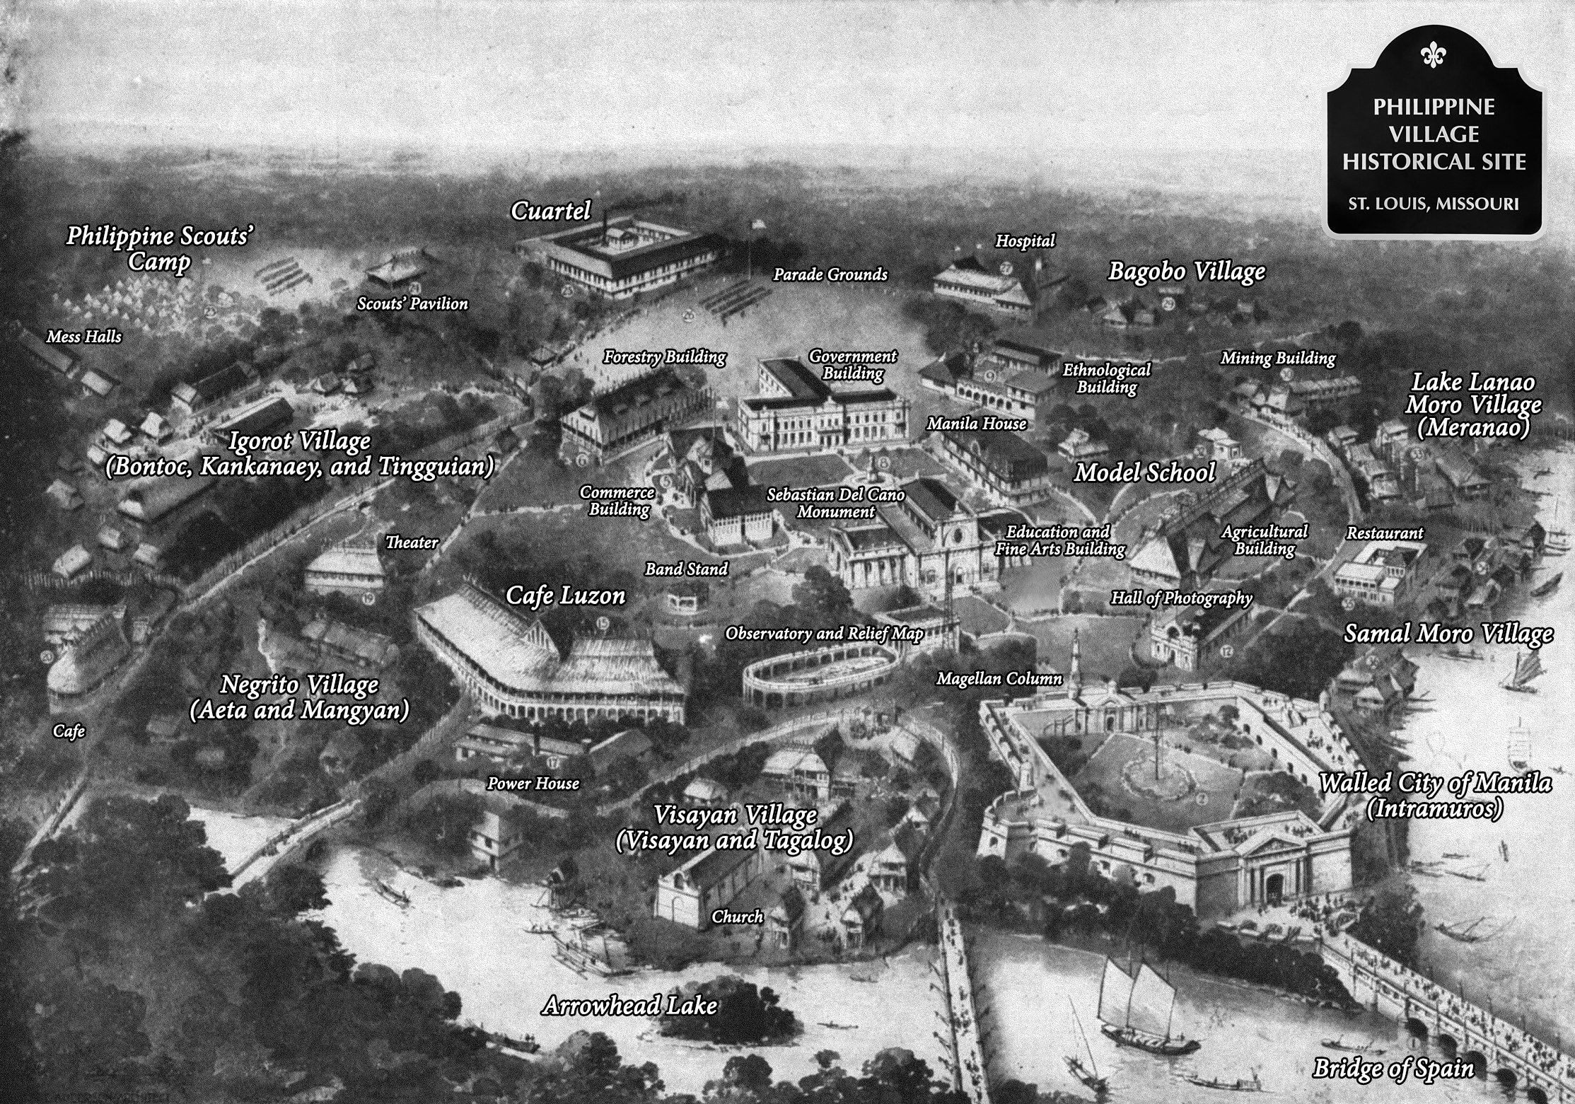

Figure 1: Aerial view of the Philippine Exhibit on the St. Louis World’s Fair grounds. Philippine Village Historical Site, 2023. <https://www.philippinevillagehistoricalsite.com/>

The resulting physical layout of the Philippine exhibit relied on the separation between a Hispanicized, Catholic “plaza” surrounded by tribes officially described as “savage” (the Moros, the Bagobos, the Igorottes, and the Negritos). Separated in space, the presence of these groups on the fairgrounds replicated the model of a civilized center and uncivilized periphery that informed the larger layout of the world’s fair. To reach the Philippine grounds, visitors had to cross the “Bridge of Spain,” a replica of the actual Puente de España that crossed the Pasig River and connected central Manila to surrounding areas. Spanish colonizers had built the original structure in the seventeenth century, and for the following two centuries, it was the only bridge over the Pasig River connecting the “Intramuros”–the central area of Manila surrounded by large walls– to the rest of the city.[35] In 1903, the American civilian government in the islands inaugurated a new bridge crossing the same river, the Santa Cruz Bridge. In Kramer’s words, the bridge carried a specific “symbolic weight,” and its dedication was the seen as a monument to American progress and recognition of the American civilian government and its new racial and political formation.[36] Similarly, on the fairgrounds, the bridge symbolically connected the modernizing world, led by the United States as a leading example of progress and civilization, to the Walled City of Manila and the Filipinos as the recipients of the American benevolence and guidance towards modernity.

But if the Philippine exhibit had a civilized center surrounded by “savage” tribes, the placement of the Visayans in the peripheries echoed the complexity of the American perspective on the Filipinos. In the first decade of the seventeenth century, high-ranking Spanish colonial official Antonio de Morga described the Visayans in his work as “more noble in their actions than the inhabitants of the islands of Luzon and its vicinity.”[37] Throughout the following centuries, the Visayans were Christianized, Hispanicized, and culturally dinstinguished themselves from tribes deemed “uncivilized” like the Moros and the Igorrotes. At the world’s fair in 1904, the otherized cultures at display received much more attention from visitors, and therefore the Christian Visayans and the civilized aspects of the Philippine exhibit were rendered nearly invisible, leading audiences to associate “Filipino” identity with savagery that necessitated American tutelage. The fair makers’ intention, however, was to display the Visayans as the “short-term future of Igorots and Moros, and Igorots and Moros the immediate Visayan past.” In Kramer’s words, even when visitors noticed the civilized Visayans, the layout and propaganda of the Philippine Village narrated the Filipino civilization, when noticed, as “the exclusive result of American influence.”[38]

On August 20, 1904, the St. Louis Post-Dispatch reported on the formal complaint of Teresa Ramirez, a young Visayan girl who had been a student of the model school within the Philippine exhibit grounds. Teresa protested the fact that the fair makers had officially described them as “savages” in the Philippine Guide. The Guide read: “Probably the most effective educational exhibit is the model school conducted by Miss Pilar Zamora, an accomplished graduate of the highest institution in Manila and a practical teacher. Within a trim little nipa and hamboo cottage in the rear of the Manila building 50 little savages, recruited from the various villages, gather each day, and are taught to fashion Engish letters on big blackboards mounted on bamboo poles.” In her complaint, Teresa noted the description, and argued: “But not all [are savages], I think, because, as I have seen that the Visayan people are more polite sometimes than some of the Americans that come around.” She then said that American visitors “asked so many foolish questions. And I’ll say that they are very ignorant people […]. She concluded by stating that “the Filipinos in our village [the Visayan village] are very angry to be called savages and ask me to have you change it. Some are so mad they won’t go to school no more.” Ramirez’ protest is the perfect example of how contradictions in the American perspective on Filipinos ultimately rendered local cultural differences invisible and relied on an invented homogeneous “Filipino” identity that emphasized necessity of American tutelage to guide Filipinos to self-governance and civilization.

#### 4. The U.S. and the Philippines in an “imagined geography” of modernity

Local newspapers echoed the undeniably massive presence of the Philippines as a geopolitical entity at the world’s fair in 1904. Between the first and the last day of the fair, The St Louis Republic, the St. Louis Globe-Democrat, and the St. Louis Post-Dispatch were three of the most important local newspapers reporting about and from the world’s fair. These newspapers were representative of a class of cultural commentators that established narrative hegemony about the fair and other matters in the city of St Louis throughout the latter half of the nineteenth century. In 1945, journalist Charles G. Ross, who had been associated with the Post-Dispatch for most of his professional life, wrote an entire book on the history of the newspaper. By the turn of the century, he argued, the Post-Dispatch had become a “thoroughly national newspaper” with broad interests in issues of national scale.[39] Although overstated in Ross’ biased account, the newspaper’s engagement with national matters was reflected on the thorough report on the world’s fair planning and its political dilemmas, having printed the equivalent of 988 pages about it between June 1901, when the organization of the exposition started, to December 1904, when it closed. Still, The Republic went even further and published the equivalent of 1,012 pages during the same period, while the Globe-Democrat printed an average of five and one-half columns daily about the fair.[40] When writing commentary about the dynamics of the fair, the exhibits, and the fair goers engagement with them, those three newspapers mentioned the Philippines almost just as much as they mentioned the United States.

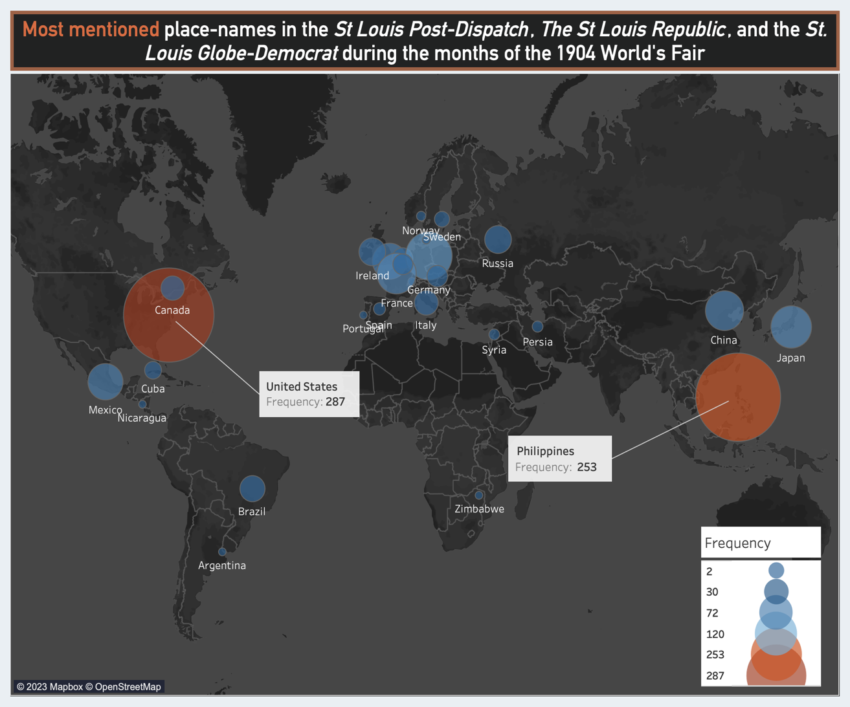

Figure 2: Visualization built by the author in Tableau.

The analysis of how those three newspapers generated a cultural representation of the world in response to the rhetoric of American empire on the fairgrounds suggests that the arrangement of the fair and its embedded ideological message reflected much larger issues of the time. It echoed complex decisions in American foreign policy and issues of colonialism and imperialism towards the Philippines. The map above shows how often each place-name emerged in a data sample of 275 articles of the three St. Louis newspapers randomly collected from a digital database.[41] As Cameron Blevins has argued, newspapers were among the cheapest and most available sources of geographical information by the turn of the century.[42] They contributed to the production and shaping of space in the imagination of late-nineteenth and early-twentieth-century Americans by printing particular locations more often than others. During the seven months in which the world’s fair was open to the public in St. Louis, those prominent local newspapers engaged, if unintentionally, in determining one imagined geography of the modernizing world. Here, the emphasis on one imagined geography is important for the cultural and discursive representation of modernity found in St. Louis newspapers was only one possible representation in the midst of many others.

Because of the metaphoric nature of the world’s fair as a microcosm of modernity, searching for the names of populated places in the newspapers is insufficient to replicate the geography of modernity that resulted from the cultural commentary about the fair. On the fairgrounds, the material culture in display served as metaphors for the represented geopolitical entities, and every mention of nationality, culture, or ethnicity is intrinsically associated with a geographical place in the globe. For this reason, the varied ways in which cultural commentators reflected on and talked about the fair generated discursive representations of the participating geopolitical entities. Said representations are reflected not simply in the place-names printed on the pages, but also in every mention of national and cultural identities and material culture on the grounds that ultimately referred, as a metaphor in itself, to the geopolitical entity represented on the grounds.[43]

As seen in Figure 2, the two most frequent place names were United States and Philippines, with 287 and 253 occurrences respectively. This result in itself significantly reinforces the core argument of this project: that the narrative of modernity embedded on the grounds of the fair in St Louis was greatly dependent on the otherization of the East. It was indeed a comparative view of the world, like it was the case during any other world’s fair: in order to showcase and praise the progress of the civilized West, it had to show its counterpoint. The significance in this case, however, lies on the political and cultural context in which the St. Louis World’s Fair took place.

By the 1890s, with the settlement of the Pacific coast, Turner had recognized that the American “energies of expansion” were to be directed overseas. In fact, he observed “the demands for a vigorous foreign policy, […] and for the extension of American influence to outlying islands and adjoining countries” as symptoms of a continuity between the settlement of the West and a larger imperialistic movement abroad.[44] The American colonial endeavors in the Philippines by the end of the century were the most ubiquitous evidence to the historical continuity that Turner observed. As Bender has pointed out, much similarly to the process of removal of the Native American people or the occupation and acquisition of Mexican territory throughout the 1820s, 1830s, and 1840s, the global extension of American culture was part of a much larger American imperial praxis justified by a common “message of uplift and modernization.”[45] The fair in St. Louis was not the first time that a Philippine exhibit was part of an American fair. But in St. Louis, said message of “modernization”, based on specific notions of race, empire, and civilization, was not only part of the mentality of American fair makers and elite members like Francis and Taft; it was rather the fundamental principle that made possible the conceptualization and construction of an over-sized Philippine exhibit in the St. Louis 1904 World’s Fair.

With a crucial focus on the American benevolent assimilation and guidance of Filipinos towards self-governance and civilization, the fair message indeed relied on principles of American exceptionalism in face of increasing European imperialism.[46] Further, the conditions upon which the American interest in the Pacific increased were specific to the political and cultural circumstances within the United States by the late nineteenth century. Those circumstances did not make the United States empire exceptional; it did, however, make its rhetorical foundation on “uplift and modernization” unprecedented. The resulting cultural representation on the fairgrounds reflected the complex, heterogeneous perspective of American officials towards Filipinos. On the one hand, some American officials insisted that the exhibit should consist of representatives of the Hispanicized elites with whom the American state had the experience of collaborating and negotiating power dynamics with. Others, in turn, believed that the presence of Filipino elites could cause complications. Again, because of the symbolic nature of the world’s fair, their mere presence on the fairgrounds meant international recognition of the Philippines as a legitimate, independent state.[47]

Similarly, the presence of Native tribes from the islands like the Moros, the Negritos, and the Igorrotes, some believed, could harm the image of the Filipinos as too far from the civilizing progress. Whatever the decision was, the Philippine exhibit ought to exist under a careful rhetorical balance between progress and wildness, modernity and otherization, future and past of the human race. As a microcosm of early-twentieth-century modernity, the St. Louis World’s Fair was a catalyst for new representations of the United States and the modernizing world in the discursive dimension. In local newspapers, those representations reflected sometimes seemingly binary notions that were rather part of a complex web of empire, race, and civilization.

#### 5. Between wildness, civilization, and performance: talking about the Filipinos

In order to assess how cultural commentators characterized the geopolitical entities that were part of the geography of modernity they helped imagining, this project relies on another methodology of the digital humanities: word embedding models (WEM). According to historian Ben Schmidt, word embedding models “try to ignore information about individual documents so that you can better understand the relationships between words.” Using WEM, word vector analysis provides significant insight into the semantic relationships between words in a corpus as it reduces “words into a field where they are purely defined by their relations.”[48] In this sense, training a model on the sample of newspaper articles unveil how local newspapers relied on particular notions of empire, race, and civilization – even if unintentionally – to produce discursive representations of the modernizing world. To get a broad sense of what kinds of patterns and topics emerge from the corpus, the best strategy is to cluster the words according to their semantic similarity scores multiple times until something interesting shows up. See below:

set.seed(15)  
centers = 150  
clustering = kmeans(model,centers=centers,iter.max = 200)  
  
sapply(sample(1:centers,4),function(n) {  
 names(clustering$cluster[clustering$cluster==n][1:10])  
})

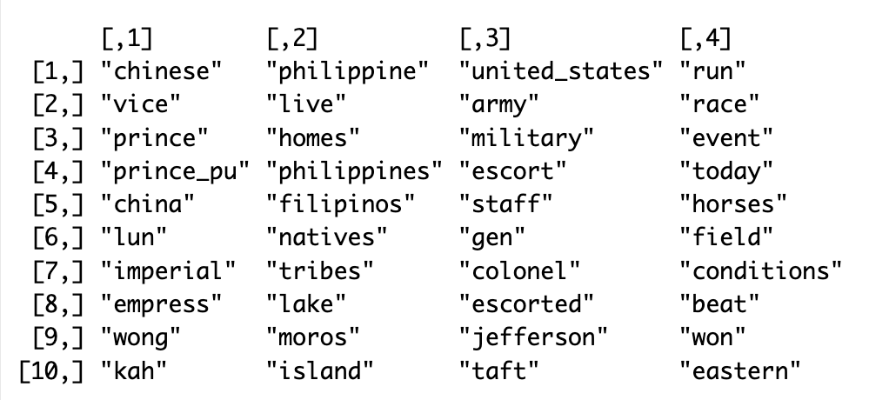

The output above showed up after multiple iterations. It demonstrates that the trained model is suitable for analysis as it is properly clustering words that are semantically similar. Interestingly, “united_states” and “philippine” show up as two separate clusters, with a strong emphasis on military matters. However, topic clustering through vector models can be a matter of trial and error, and not every clustering iteration will be worth exploring. Even though one of the clusters above is explicitly about the Philippines, it does not reveal anything interesting. A few more iterations were needed until the next output worthy of attention showed up.

sapply(sample(1:centers,4),function(n) {  
 names(clustering$cluster[clustering$cluster==n][1:10])  
})

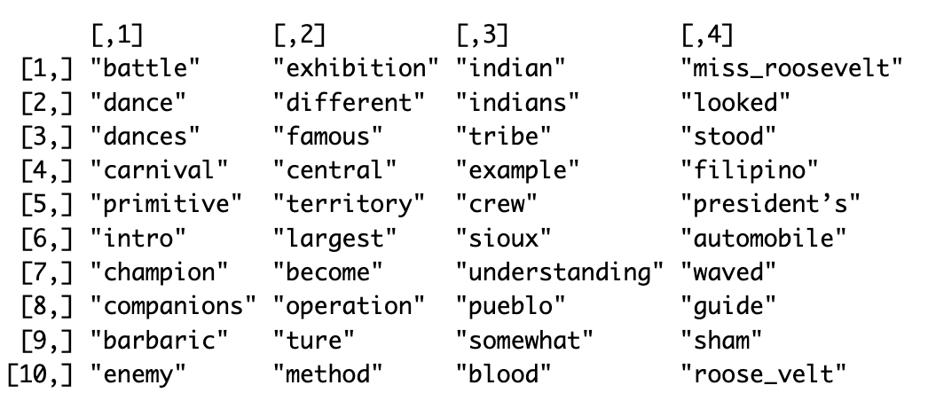

This time, at least three of the four topic clusters have something worth of exploration. The first group of words revolves around issues of performance, and how groups deemed as “primitive” or “barbaric” displayed on the fairgrounds were often talked about along the lines of cultural performativity. In the third group, words like “example” and “understanding” are associated with native exhibits, in particular of Native American groups. It would also be worth exploring the placement of the word “blood” in that group. The fourth cluster, seemingly centered around the visit of the Roosevelts to the fair, still included the word “filipino”. As expected, OCR errors start to populate the results.

sapply(sample(1:centers,4),function(n) {  
 names(clustering$cluster[clustering$cluster==n][1:10])  
})

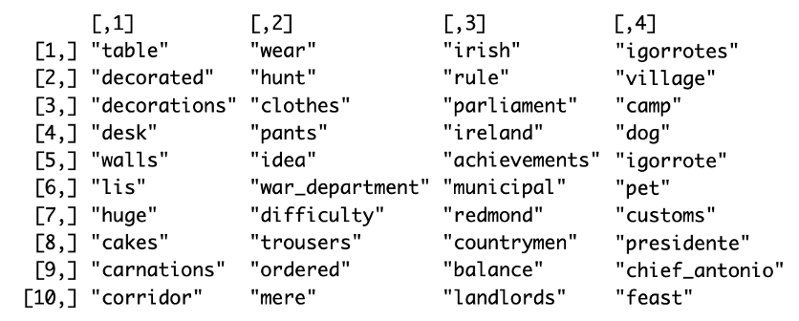

With a few more iterations, the results might present more OCR errors and random associations, but they can also become more specific and more useful. Above, the fourth cluster is specifically about the Igorrotes, and words like “dog”, “feast”, and “chief_antonio” are interesting clues to the themes that newspapers have more commonly focused on when talking about the Igorrote Village at the fair. Meanwhile, the second cluster is relevant as it shows unexpected semantic associations between the Department of War and words like “clothes”, “wear”, and “pants”. Following the hints, the next logical step was to focus on the Department of War and Chief Antonio, one of the tribe chiefs responsible for the Igorrote who practiced the ritual of head hunting. The charts below show the words with the closest similarity score to “chief_antonio” and “war_department” respectively:

df <- model %>% closest_to("chief_antonio", 20) %>% as.data.frame()   
 df %>% ggplot(aes(x = reorder(word, `similarity to "chief_antonio"`), y= `similarity to "chief_antonio"`, labels = )) +   
 geom_bar(stat = "identity") +  
 coord_flip() +  
 labs(y = "semantic similrity score", x = "words")  
 df2 <- model %>% closest_to("war_department", 20) %>% as.data.frame()   
 df2 %>% ggplot(aes(x = reorder(word, `similarity to "war_department"`), y= `similarity to "war_department"`, labels = )) +   
 geom_bar(stat = "identity") +  
 coord_flip() +  
 labs(y = "semantic similrity score", x = "words")

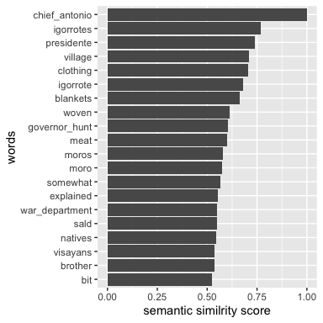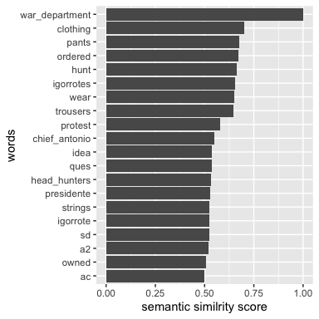

The similarity score indicates how closely associated a set of terms are within the semantic dimension of a corpus. The significant overlap between the two graphs above suggests that Chief Antonio was often brought up when the War Department was involved and vice-versa. The common thread regarding issues of clothing refers to a controversy involving the Department of War and the Igorrotes reported in the newspapers in July 1904. An article published in The St Louis Republic started by posing the question: “Must the savage Igorrotes at the World’s Fair wear civilized, tailor-made, American clothing in preference to the scanty attire as worn in their island home?”. In fact, a week before, the Department of War issued an ultimatum that required Igorrotes to do so, but not without protest and pressure upon Taft to back down from the decision. The St Louis Republic characterized the controversy as “one of the lengthiest and liveliest controversies in connection with authority and government in the new territorial acquisitions that has yet come up for settlement by the United States Government.”[49] While the matter was up for debate, the newspapers reported an increase in attendance to the Igorrote Village and suggested that visitors rushed to see the Igorrotes before clothes were formally imposed.

The centrality of cultural performativity and authenticity was not only important for visitors who were curious about the so-called “brown little brothers” and their distance from civilization, but also a matter of honor for the Igorrotes themselves. The reason that led Taft and the Department of War to issue the clothing order was the unbalanced attention that “uncivilized” tribes were receiving from visitors “at the expense of the civilized tribes of Filipinos at the fair.” For some opiniated citizens of St. Louis, the lack of clothes at the Igorrote Village was seen as an “injustice” towards the “civilized people” of the Philippine Islands because it led visitors “to consider them as being all of one tribe.” Truman Hunt, by then the governor of the Igorrote Bondoc tribe in the Philippine Islands, were willing to cooperate with Taft to reinforce the clothing order, but Chief Antonio of the headhunter tribe said, “his people thought faith had been broken with them”. Further, newspapers inferred that, because of how distinct the Igorrote were from the American culture and civilization, many visitors questioned the legitimacy of embracing Filipinos as American citizens and “brothers” – one of the terms in the list of words semantically associated with Chief Antonio. “Would you ever ha’ believed it! […] that them there war the kind of of folks Uncle Sam was introducin’ us to as our brothers?”, expressed one visitor to the press. Similarly, Reverend William McMurry, a prominent St. Louis citizen, praised the order by the Department of War, contending that “Modern society demands that man and woman be clothed.”[50]

Knowing that some of the most frequent conversations about the Filipino culture in newspapers often compared the Philippine Islands to the United States in term of progress towards civilization and adoption of modern features and customs, it is worth exploring the corpus to understand the words that have a significant score of similarity in relation to the terms “savage” and “progress”. See Figure 3 below.

model %>% closest_to("savage", 20)  
model %>% closest_to("progress", 20)

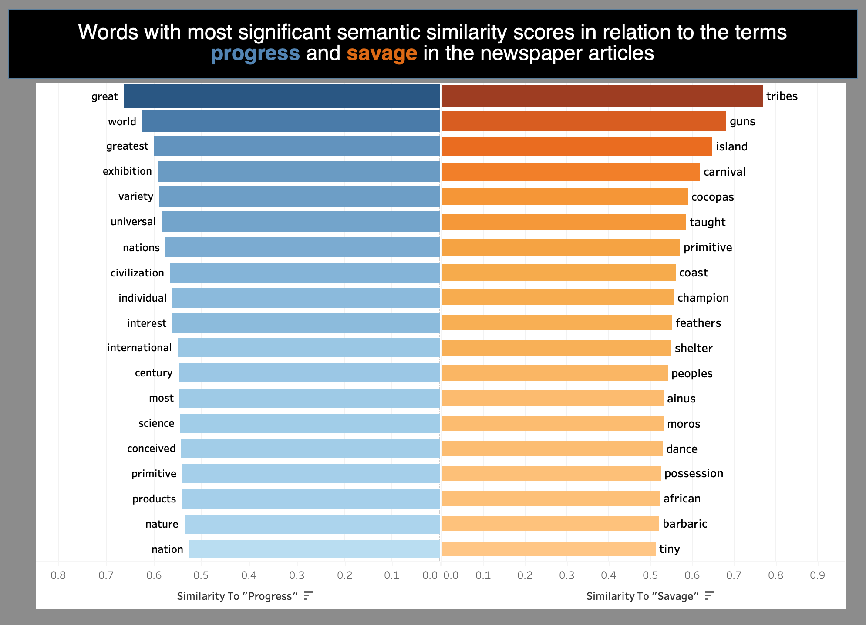

Figure 3: Visualization built by the author in Tableau resulting from the trained word vector model.

In the graph above, a few things can be noted about the “savage” list. First, the word “tribes” is, semantically, the closest word to “savage” in the corpus, and two words that are related to performance show up associated with “savage”: “dance” and “carnival”. Due to the fair’s extensive use of native peoples for exhibits, the term savage wasn’t associated closely with one group but rather with many. Second, a few specific Native groups still show up semantically close to the term “savage” like the Cocopas from North America, the Ainus from Asia, and the Moros from the Philippine Islands. Third, other terms that denote a similar characterization of these groups relevantly show up: “barbaric” and “primitive”. When it comes to the “progress” list, similar trends call the reader’s attention. Most of the the list is composed of fairly broad ideas like “civilization”, “nature”, “science”, “universal”, and “individual”. No specific mentions of particular entities or groups seems as relevant as broader, intangible principles.

Even more interestingly, one term shows up in both lists: “primitive”. As discussed before, the rhetoric of empire and American exceptionalism at the fair was highly dependent on processes of otherization of non-Western cultures. The appearance of the term “primitive” in both lists is an expected link, a signal from the algorithm that, even though those two universes are allegedly separated, as we have seen in the clothing controversy, they overlap in complex ways in the cultural commentary about the fair and the geopolitical entities that negotiated their modern collective identities on the grounds. Using three words from each list, the graphs bellow sought to visualize the vectorized semantic relationships to “progress”, “civilization”, and “science”, on the one hand, and to “savage”, “primitive”, and “barbaric” on the other hand.[51]

#visualize semantic similarity of "savage" and "progress" based on the previous lists  
modernity = closest_to(model,model[[c("progress", "civilization", "science")]], 60)  
vectors_modernity = model[[modernity$word,average=F]]  
plot(vectors_modernity,method="pca")

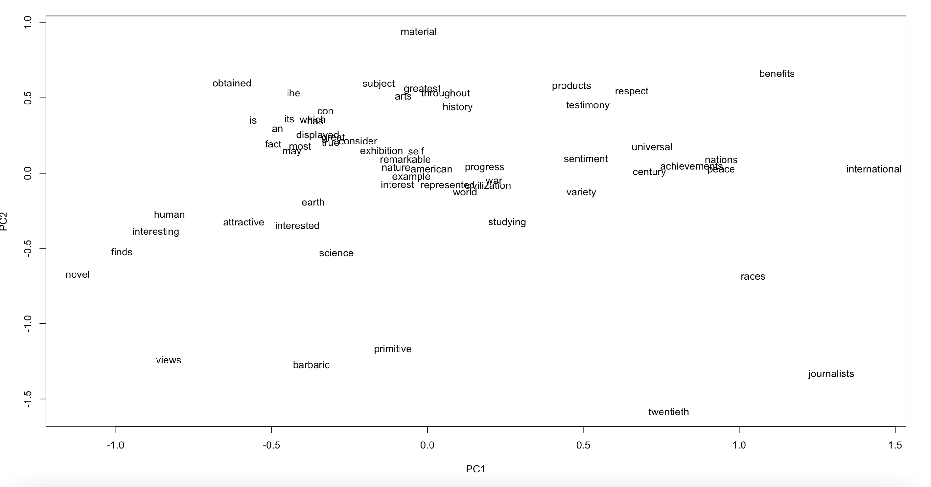

Figure 4: “Modernity” word vectors: the 60 words closest semantically to “progress”, “civilization”, and “science”.

otherness = closest_to(model,model[[c("savage", "primitive", "barbaric")]], 60)  
vectors_otherness = model[[otherness$word,average=F]]  
plot(vectors_otherness,method="pca")

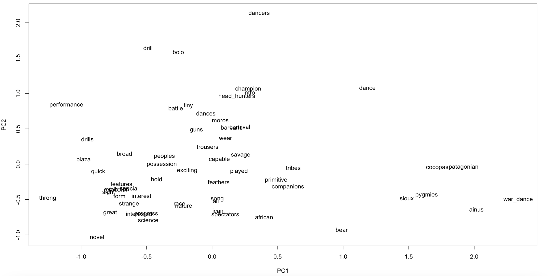

Figure 5: “Otherness” word vectors: the 60 words closest semantically to “savage”, “primitive”, and “barbaric”.

In the first graph, fairly centered in the main cluster of words is the word “american”, surrounded by terms like “remarkable”, “example”, interest”, “progress”, “civilization”, and maybe most notably, “war”. To the left of the main cluster, more spread-out words, including “science”, “interested”, “human”, “attractive”, “finds”, and “novel” bring back to the notion of spectacle and propaganda that is intrinsic to the world’s fair. To the right of the main cluster, a smaller grouping emerges around the words “universal”, “achievements”, “nations”, and “peace”. The central positionality of the words “war” and “peace” in separate but related clusters in the first graph suggests that progress and civilization, semantically, are somehow associated with war and peace. Finally, the most peripheral level of the graph brings together “views”, primitive”, “barbaric”, “races”, “benefit”, and “international”, besides the rather isolated mentions of “twentieth” and “journalists”. Again, the center-periphery model adopted in the spatial narrative of the fairgrounds – and, for that matter, of the Philippine exhibit as well – that positioned “barbaric” groups at the periphery of the civilization explains the shape of the visualization.

The second graph follows a similar trend in organizing the discourses about the fair through the center-periphery model. This time, however, the Moros from the Philippines are central in the main cluster, surrounded by “barbaric”, “carnival”, “dances”, “wear”, “savage”, “capable”, “guns”, and “head_hunters” in reference to the Igorrote tribes. Other native groups are then placed on the far right, as if their characterization proves less significant to the rhetoric of empire in display at the fair than the characterization of Moros and Igorrotes. The Lakotas – here, pejoratively referred to as Sioux – and the Cocopas, from North America, the Pygmies from Africa, and the Ainus from Asia show up in this peripheral group. But more importantly, it is worth noting that every side of the visualization contains at least one term related to performance and spectacle. “dancers”, “performance”, “spectators”, “war_dance”, and “dance”, quite literally, surround the entire graph from the most peripheral level, indicating once again that words like “savage”, “primitive”, and “barbaric” are always associated with cultural performativity.

#plot semantic similarity of "savage" and "progress" terms together  
vector_otherness_modernity2 = model[[c(modernity$word, otherness$word),average=F]] # this is a vector model  
progress_score = vector_otherness_modernity2 %>% cosineSimilarity(model[[c("progress", "civilization", "science")]])  
savagery_score = vector_otherness_modernity2 %>% cosineSimilarity(model[[c("savage", "primitive", "barbaric")]])  
  
plot(progress_score, savagery_score, type='n', xlab="Similarity to 'progress' terminology", ylab="Similarity to 'savagery' terminology")  
abline(a=0,b=1)  
text(progress_score,savagery_score,labels=rownames(vector_otherness_modernity2), cex=.7)

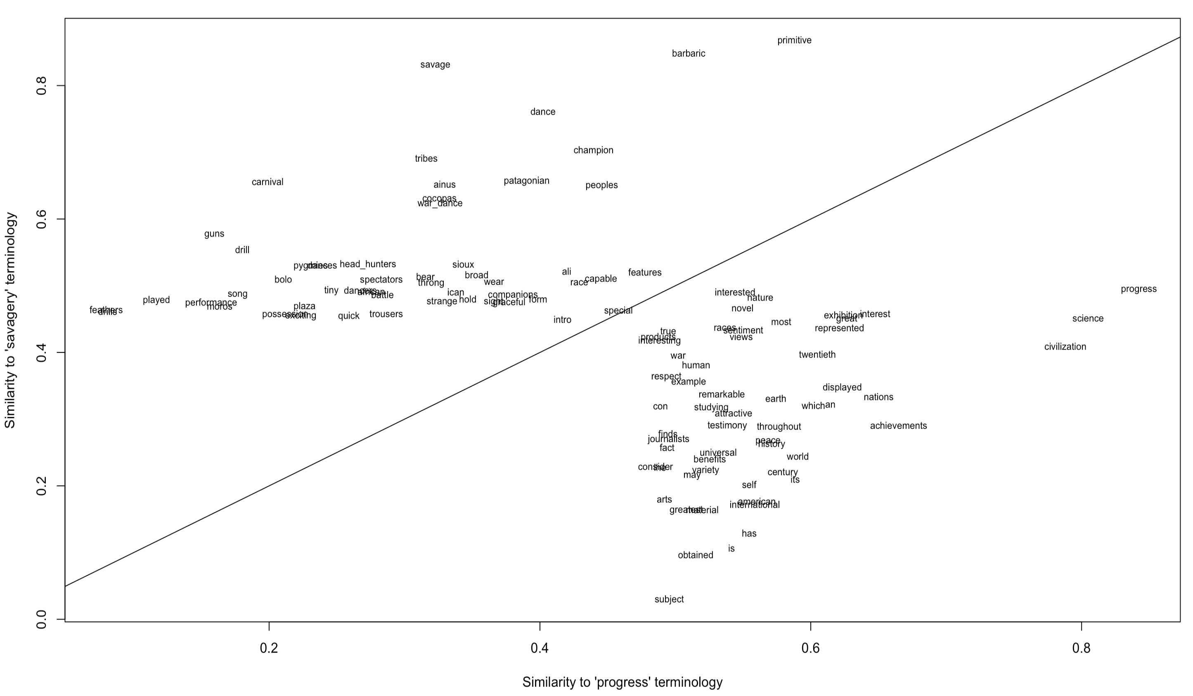

Figure 6: Top 110 words plotted by their similarity to “progress” terminology (x axis) and “savagery” terminology (y axis).

With this in mind, the graph above plots both conceptual universes together. Interestingly enough, spread-out terminology associated with cultural performativity like “carnival”, “guns”, “spectators”, “dancers”, “war_dance”, “battle”, and “carnival” have low similarity score to “progress” terminology but higher similarity score to “savagery” terminology. The words “performance” and “moros” are practically juxtaposed. Through cultural performativity, native groups played the part in the discursive construction of modernity, in which the United States emerges as the example of progress and remarkable achievements – as per the graph showed in Figure 4.

More importantly, note how most terms in the vector representation above are concentrated across two main central axes. Horizontally, terms with varying similarity scores to “progress” seem to have very consistent similarity scores to “savagery”, mostly between .4 and .5. Vertically, the opposite happens: terms with varying scores to “savagery” have very consistent similarity scores to “progress”, mostly between .5 and .6. That is true even for the terms “barbaric” and “primitive” which are centered in relation to the progress score axis, while the terms “progress”, “science”, and “civilization are centered in relation to the”savagery score axis. Notably, the term “moro” has a significantly low progress score while the term “american”, juxtaposed with term “international”, has comparably the same score of similarity to savagery (.2 in both cases). This suggests that the cultural commentary about the fair involving issues of wildness, civilization, and cultural performance occurred more frequently, as this paper has argued, in comparative terms and co-dependently.

#### 6. Conclusion

Despite the frequent co-occurrence of those seemingly binary conceptual universes, the ways in which local newspapers generated representations of the Filipino and the American cultures in a comparative fashion were far from binary. Cultural commentators reflected on the controversies regarding the invention of a homogeneous Filipino identity, and the implications of having so-called savage groups attracting the attention of visitors at the Philippine exhibit. The rendering of Filipino culture as less civilized, on the one hand, benefited the narrative of American benevolent assimilation. On the other hand, by exposing the nuanced distinctions between Hispanicized, Catholic Filipinos and the “primitive” tribes, newspapers represented the Philippines as a nation actively moving towards civilization under the guidance of the United States. The graph below seeks to visualize this complex “civilizing movement” in a vector space:

vector_otherness_modernity = model[[c(modernity$word, otherness$word),average=F]]  
american_filipino_relations = data.frame(word = rownames(vector_otherness_modernity))   
  
american_filipino_vector = model[[c("american", "americans", "america", "united_states")]] - model[[c("philippines", "philippine", "filipino", "moros", "igorrotes", "visayans")]]  
  
progress_savagery_vector = model[[c("progress", "civilization")]] - model [[c("savage", "primitive")]]  
  
american_filipino_relations$american_vs_filipino = cosineSimilarity(vector_otherness_modernity, american_filipino_vector)  
  
american_filipino_relations$progress_vs_savagery = cosineSimilarity(vector_otherness_modernity, progress_savagery_vector)  
  
ggplot(american_filipino_relations, aes(x=american_vs_filipino, y=progress_vs_savagery, label=word)) + geom_text(size=2.5) +  
 scale_y_continuous("<------ less civilized ....... more civilized ------->", limits=c(-.45,.25)) +  
 scale_x_continuous("<------ Filipino representation ....... American representation ------>", limits=c(-.25,.33))

## Warning: Removed 31 rows containing missing values (`geom_text()`).

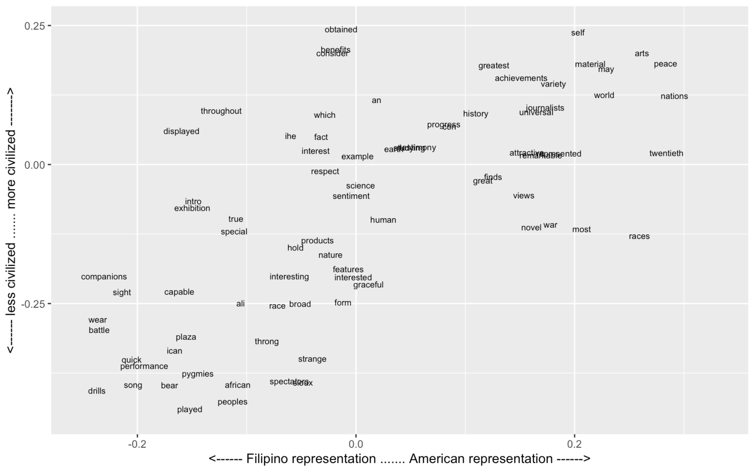

Figure 7: Representations of Filipino and American identities across the “civilization” spectrum.

Although the terms more significantly associated with the Filipino representation in the newspapers are concentrated in the lower-left corner, some terms like “interest”, “example”, and “displayed” show up with a higher “civilization” score. Meanwhile, terms associated with the American representation are more evidently concentrated in the upper-right corner of the graph, suggesting that discursive representations of the American culture were constructed around the United States as a leading example of civilization and modernizing progress. Some of the terms in the upper-right corner like “universal”, “history”, world”, “nations”, and “progress” place the United States in a larger trend of modernization along with other Western nations. Arguably, the only significant terms semantically closer to the American representation with a civilization score lower than zero are “war” and “races”. On the lower spectrum of the civilization score towards the Filipino identity, the word “plaza” – often looked at as the symbol of the imposed civilizing principles by the Spanish colonial rule – is surrounded by terms like “pygmies”, “sioux”, “african”, “performance”, “battle”, and “strange”. The overall, the graph has a clear thread from the bottom-left towards the upper-right corner, as if some words in the middle like “example”, “displayed”, “exhibition”, “interest”, “benefits”, were part of the American discursive strategies to bridge the civilization gap between both cultures and guide the Filipinos towards modernization and uplift.

Far from a simplistic, binary display in which the United States showed as synonym and civilization while the Philippines existed as its antagonistic pole, the narrative embedded on the fairgrounds was much more complex, nuanced, and controversial. Fair makers had to find the precise balance between, on the one hand, otherization of the Filipinos as barbaric, non-Christians, and representatives of a conquered past through modernization, and on the other hand, the assimilation of Filipinos as a people with potential for self-governance, with enough similarities to the American ways that could justify its incorporation. To add on the complexity of representation and discourse, cultural commentators did not simply replicate the fair makers’ narrative of modernity centered around the United States as an emerging colonial empire. Rather, they reflected on the modern collective identities on display and in constant negotiation on the grounds and, informed by their own interests and worldviews, engaged in a complicated process of imagining an empire in space. In the process, as this project has demonstrated, local newspapers still characterized participating geopolitical entities according to the physical separation of culture that organized the fairgrounds, where conceptualizations of what is savage, barbaric, and primitive were necessarily peripheral to the notions of (benevolent) progress and civilization that underpinned the modern identity of the United States as a colonial state.

#### Bibliography

Afable, Patricia O. “Journeys from Bontoc to the Western Fairs, 1904-1915: The ‘Nikimalika’ and Their Interpreters,” 2023.

Allwood, John. *The Great Exhibitions.* London: Studio Vista, 1977.

Anderson, Benedict*. Imagined Communities: Reflections of Origin and Spread of Nationalism*. New York: Verso, 2006.

Arnold, Taylor, and Lauren Tilton. *Humanities Data in R: Exploring Networks, Geospatial Data, Images, and Text*. Quantitative Methods in the Humanities and Social Sciences. Cham: Springer International Publishing, 2015. <https://doi.org/10.1007/978-3-319-20702-5>.

Bender, Thomas. *A Nation among Nations: America’s Place in World History*. 1st ed. New York: Hill and Wang, 2006.

Benedict, Burton et. al. *The Anthropology of World’s Fairs: San Francisco’s Panama-Pacific International Exposition, 1915.* Berkeley: Scholar Press, 1983.

Bennett, Tony. *The Birth of the Museum: History, Theory, Politics*. Culture : Policies and Politics. London ; New York: Routledge, 1995.

Benoit, Kenneth and Akitaka Matsuo. *A Guide to Using spacyr*. 2020. <https://cran.r-project.org/web/packages/spacyr/vignettes/using_spacyr.html>.

Blevins, C. “Space, Nation, and the Triumph of Region: A View of the World from Houston.” *Journal of American History* 101, no. 1 (June 1, 2014): 122–47. <https://doi.org/10.1093/jahist/jau184>.

Blount, James H. *Th American Occupation of the Philippines, 1898-1912.* First published in 1912.New York: Oriole Editions, 1973.

Breitbart, Eric. *A World on Display: Photographs from the St. Louis World’s Fair, 1904.* Albuquerque: University of New Mexico Press, 1997.

Bunnel, W. C. “El Puente de España, 1626-1914,” *Professional Memoirs, Corps of engineers, United States Army, and Engineer Department at Large* 7, no. 35 (September-October, 1915): 615-628.

Clevenger, Martha. *Indescribably Grand: Diaries and Letters from the 1904 World’s Fair.* St. Louis: Missouri Historical Society Press, 1996.

Dobrow, Joe. *Pioneers of Promotion: How Press Agents for Buffalo Bill, P.T. Barnum, and the World’s Columbian Exposition created Modern Marketing*. Norman: University of Oklahoma Press, 2018.

Findling, John and Kimberly Pelle. *Historical Dictionary of World’s Fairs and Expositions, 1851-1988.* Westport: Greenwood Press, 1990.

Gilbert, James. *Perfect Cities: Chicago’s Utopias of 1893*. The University of Chicago Press, 1991.

Gilbert, James. *Whose Fair? Experience, memory, and the history of the great St. Louis Exposition.* Chicago: The University of Chicago Press, 2009.

Go, Julian, and Anne L. Foster, eds. *The American Colonial State in the Philippines: Global Perspectives*. American Encounters/Global Interactions. Durham: Duke University Press, 2003.

Greenhalgh, Paul. *Ephemeral Vitas: The Expositions Universelles, Great Exhibitions and World’s Fairs, 1851-1939.* Manchester: Manchester University Press, 1988.

Grunder, Garel A. and Livezey, William E. *The Philippines and the United States.* Westport: Greenwood Press, Publishers, 1951.

Hart, Jim Allee. *A history of the St Louis Globe-Democrat*. Missouri: University of Missouri Press, 1961.

Hullman, Jessica and Nicholas Diakopoulos, “Visualization Rhetoric: Framing Effects in Narrative Visualization,” *IEEE Transactions on Visualization and Computer Graphics* 17, no. 12 (December 2011): 2231-2240.

Jurafsky, Daniel and James H. Martin. *Speech and Language Processing: An Introduction to Natural Language Processing, Computational Linguistics, and Speech Recognition.* 2nd edition. Upper Saddle River: Prentice Hall, 2008.

Kramer, Paul A. *The Blood of Government: Race, Empire, the United States, & the Philippines*. Chapel Hill, NC: Univ. of North Carolina Press, 2006.

LeFevre, Karen B. *Invention as a Social Act*. Studies in Writing & Rhetoric. Carbondale, Ill.: Southern Illinois University Press, 1987.

Leon, Sharon. “The Peril and Promise of Historians as Data Creators: Perspective, Structure, and the Problem of Representation,” [Bracket] (blog), November 24, 2019. <https://www.6floors.org/bracket/2019/11/24/the-peril-and-promise-of-historians-as-data-creators-perspective-structure-and-the-problem-of-representation/>

Maud Ehrmann, Maud *et. al.* “Named Entity Recognition and Classification on Historical Documents: A Survey,” *ACM Computing Surveys*, Vol 56, no 2. 2023: 1-47.

Moretti, Franco. *Distant Reading*. London; New York: Verso, 2013.

Nussbaumer Knaflic, Cole. *Storytelling with Data: A Data Visualization Guide for Business Professionals*. Hoboken, New Jersey: Wiley, 2015.

Office of The Historian, “The Spanish-American War, 1898”. <https://history.state.gov/milestones/1866-1898/spanish-american-war>.

Office of The Historian, “The Philippine-American War, 1899-1902”. <https://history.state.gov/milestones/1899-1913/war>.

Rafael, Vicente L. *White Love: And Other Events in Filipino History*. American Encounters/Global Interactions. Durham: Duke University Press, 2000.

Rosenberg, Emily S. and Shanon Fitzpatrick (eds.). *Body and Nation: The global realm of U.S. body politics in the twentieth century.* Durham; London: Duke University Press, 2014.

Ross, Charles G. *The story of the St. Louis Post-Dispatch*. St. Louis: Post-Dispatch?, 1949.

Ryan, Yann. *A Short Guide to Historical Newspaper Data, Using R.* 2021. [https://bookdown.org/yann_ryan/r-for-newspaper-data/#](https://bookdown.org/yann_ryan/r-for-newspaper-data/).

Rydell, Robert W. *All the World’s a Fair: Visions of Empire at American International Expositions, 1876 - 1916*. Chicago: Univ. of Chicago Press, 2002.

Rydell, Robert W., John E. Findling, and Kimberly D. Pelle. *Fair America: World’s Fairs in the United States.* Washington, D.C.: Smithsonian Institution Press, 2000.

Schudson, Michael. *Discovering the News: A Social History of American Newspapers*. New York, NY: Basic Books, 1981.

Sinclair, Stéfan and Geoffrey Rockwell. “Text Analysis and Visualization: Making Meaning Count.” In *A New Companion to Digital Humanities*, edited by Susan Schreibman and et. al. John Wiley & Sons, Ltd, 2016.

Tenorio-Trillo, Mauricio. *Mexico at the World’s Fairs: Crafting a Modern Nation.* Berkley: University of California Press, 1996.

The Comprehensive R Archive and Network. “Introduction to tidytext”. 2023. <https://cran.r-project.org/web/packages/tidytext/vignettes/tidytext.html>.

The Comprehensive R Archive Network, “Reading text files with readtext”: <https://cran.r-project.org/web/packages/readtext/vignettes/readtext_vignette.html>.

The Comprehensive R Archive Network, “Using the Tesseract OCR engine in R” (2023). <https://cran.r-project.org/web/packages/tesseract/vignettes/intro.html>.

The Library of Congress, *Chronicling America: Historic American Newspapers.* <https://chroniclingamerica.loc.gov/about/>.

Turner, Frederick Jackson, Richard White, Glenda Riley, Martin Ridge, Donald Worster, Patricia Nelson Limerick, Michael P. Malone, Gerald Thompson, and Elliott West. *Does the Frontier Experience make America Exceptional?* Readings Selected and Introduced by Richard W. Etulain. Boston: Bedford/St. Martin’s, 1999.

Turner, Frederick Jackson. *Rereading Frederick Jackson Turner: “The significance of the frontier in American history”, and other essays*. With commentary by John Mack Faragher. New York: H. Holt and Co., 1994.

Turner, Frederick Jackson. *The Frontier in American History*. Originally published in 1920. Introduction by Andrew S. Trees. The Barnes & Noble Library of Essential Reading, 2009.

Vergara, Benito Manalo. *Displaying Filipinos: Photography and Coloniaslism in Early 20th Century Philippines*. 2. pr. Quezon City: Univ. of the Philippines Press, 1995.

Zelizer, Barbie, ed. *Explorations in Communication and History*. Shaping Inquiry in Culture, Communication and Media Studies. London; New York: Routledge, 2008.

1. World’s Fair Publishing Co., “The Philippine Display to be one of the greatest features of the St. Louis World’s Fair”, *World’s Fair Bulletin*, volume 3, number 07 (1902), 20.
2. *Ibid*, 20.
3. *Ibid*, 21.
4. “Secretary of War Lauds President’s Policy in Philippines,” *St. Louis Post-Dispatch*, April 30, 1904.
5. “Brilliant Opening of World’s Fair,” *St. Louis Post-Dispatch*, April 30, 1904.
6. Paul A. Kramer, “Empires, Exceptions, and Anglo-Saxons” in Julian Go and Anne L. Foster, eds., *The American Colonial State in the Philippines: Global Perspectives* (Durham: Duke University Press, 2003), 75.
7. In 1977, John Allwood wrote a comprehensive history of the World’s Fairs: John Allwood, *The Great Exhibitions* (London: Studio Vista, 1977). Other important scholarly references include Paul Greenhalgh, *Ephemeral Vitas: The Expositions Universelles, Great Exhibitions and World’s Fairs, 1851-1939* (Manchester: Manchester University Press, 1988); and John Findling, Kimberly Pelle, *Historical Dictionary of World’s Fairs and Expositions, 1851-1988* (Westport: Greenwood Press, 1990).
8. Here, the understanding of newspapers and mediators that both influence and are informed by competing values, attitudes, and ideology in the discursive dimension relies on Susan J. Douglas’ work on the invention of the radio. Douglas has looked at the development of the radio through the “cultural contradictions” that have always been part of the media’s portrayal and mediation “between old and new.” Like today’s mass and mainstream media, “by repeating and reinforcing certain values while ignoring or denigrating others,” late-nineteenth and early-twentieth print media also helped “legitimate and perpetuate the established social order.” In the cultural commentary about the world’s fair, newspapers not only mediated between old and new, past and future, tradition and modernity, uncivilized and civilized, but also between the fair makers’ message and the visitors’ experiences. The mediation resulted in new discursive representations of the United States and the world, and as per Benedict Anderson’s framework, contributed to shaping “imagined communities” and their modern geography. *Susan J. Douglas, Inventing American broadcasting, 1899-1922* (Baltimore: Johns Hopkins University Press, 1989), xviii. Benedict Anderson, *Imagined Communities: Reflections on the origin and spread of nationalism* (London: Verso, 1983).
9. This project relies on Cameron Blevins’ terminology and framework to understand how newspapers “print, and thereby privilege, certain places over others.” Blevins relied on Henri Lefebvre’s notion of space as a social construct and Edward Said’s idea of imaginative geographies.” He also took into consideration Benedict Anderson’s work on imagined communities. See: Cameron Blevins, “Space, Nation, and the Triumph of Region: A View of the World from Houston,” *Journal of American History* (June 2014): 122-147. Henri Lefebvre, *The Production of Space,* trans. Donald Nicholson-Smith (Cambridge, Mass., 1991); Edward W. Said, *Orientalism* (New York, 1979); Benedict Anderson, *Imagined Communities*.
10. Peter L. Berger and Thomas Luckmann, *The Social Construction of Reality: A Treatise in the Sociology of Knowledge* (New York: Anchor Books, 1967), 92-108 Apud Robert Rydell, *All the World’s a Fair: Visions of Empire at American International Expositions, 1876-1916* (Chicago: The University of Chicago Press, 1984), 2. Despite John Allwood’s earlier contribution to the field, Robert Rydell’s cultural analysis and approach to the fairs has had a deeper impact in argument-driven interpretations of the fairs. In conversation with sociologists like Berger and Luckmann, Rydell argued that the fairs were more than entertainment events and held deeper ideological meanings.
11. James Gilbert, *Whose Fair? Experience, memory, and the history of the great St. Louis Exposition* (Chicago: The University of Chicago Press, 2009), 5.
12. Benedict Anderson, *Imagined Communities*.
13. Tony Bennett, *The Birth of the Museum: History, Theory, Politics* (Abington: Routledge, 1995), 62.
14. Tony Bennett, *The Birth of the Museum*, 63.
15. Burton Benedict, *The Anthropology of World’s Fairs: San Francisco’s Panama Pacific International Exposition of 1915* (Berkley: Scholar Press, 1983), 7.
16. Martha Clevenger edited an important account on the St Louis World’s Fair of 1904 and relied on visitors’ experiences as early as 1996. This interpretation was part of a broader historiographical shift in the last decades of the twentieth century towards individuals, groups, and classes that had been left out of mainstream historical narratives. Martha Clevenger, *Indescribably Grand: Diaries and Letters from the 1904 World’s Fair* (St Louis: Missouri Historical Society, 1996).
17. Frederick Jackson Turner, *The Frontier in American History. Originally published in 1920*. Introduction by Andrew S. Trees (The Barnes & Noble Library of Essential Reading, 2009), 2.
18. Thomas Bender, *A Nation Among Nations: America’s Place in World History* (New York: Hill and Wang, 2006), 220.
19. Thomas Bender, *A Nation Among Nations*, 220-222.
20. Thomas Bender, *A Nation Among Nations*, 209.
21. Office of The Historian, “The Spanish-American War, 1898”. <https://history.state.gov/milestones/1866-1898/spanish-american-war>.
22. Office of The Historian, “The Philippine-American War, 1899-1902”. <https://history.state.gov/milestones/1899-1913/war>.
23. Paul A. Kramer, *The Blood of The Government: Race, Empire, the United States, and the Philippines* (Chapel Hill: The University of North Carolina Press, 2006), 96-97.
24. Paul A. Kramer, *The Blood of The Government*, 100-101.
25. Thomas Bender, *A Nation Among Nations*, 222.
26. Paul A. Kramer, *The Blood of The Government*, 117.
27. Paul A. Kramer, *The Blood of The Government,* 194.
28. Paul A. Kramer, *The Blood of The Government*, 161.
29. Adeline Knapp, “A Notable Educational Experiment,” in Gleason, Log of the Thomas,” Apud Paul A. Kramer, *The Blood of The Government,* 169.
30. Paul A. Kramer, *The Blood of The Government*, 171. As Julian Go contended in his Introduction to the book *The American Colonial State in the Philippines*, historians must come to terms with the distinct aspect of the United States imperialism in the Philippines. The acquisition of the islands and political dominance over its people by the United States was not simply a manifestation of American imperialism, but rather of colonialism. In Go’s words, colonialism was “a distinct form of imperialism that involves the explicit and often legally codified establishment of direct political domination over a foreign territory and peoples.” By now taking part in the colonial rule of territory overseas, American officials had to create a new state apparatus – both practical and symbolic – with a certain political and racial configuration that somehow incorporated local elites without undermining the power of the central government. Julian Go and Anne L. Foster, eds., *The American Colonial State in the Philippines: Global Perspectives* (Durham: Duke University Press, 2003), 5.
31. Donna J. Amoroso, “Inheriting the ‘Moro Problem’: Muslim Authority and Colonial Rule in British Malaya and the Philippines” In Julian Go and Anne L. Foster, eds., *The American Colonial State in the Philippines: Global Perspectives*, 125.
32. Vicente L. Rafael, *White Love and Other Events in Filipino History* (Durham: Duke University Press, 2000), 24.
33. Vicente L. Rafael, *White Love and Other Events in Filipino History*, 35; Benedict Anderson, *Imagined Communities*.
34. Paul A. Kramer, *The Blood of Government*, 226.
35. W. C. Bunnel, “El Puente de España, 1626-1914,” *Professional Memoirs, Corps of engineers, United States Army, and Engineer Department at Large* 7, no. 35 (September-October, 1915), 616.
36. Paul A. Kramer, *The Blood of Government*, 159.
37. Antonio de Morga, *Succesos de las Islas Filipinas* (1609) In Antonio de Moga, *The History of the Philippine Islands*, Translation by Emma Helen Blair and James Alexander Robertson (Project Gutenberg eBook, 2004). Available at: <https://www.gutenberg.org/cache/epub/7001/pg7001.html>
38. Paul A. Kramer, *The Blood of Government*, 269-271.
39. Charles G. Ross, *The story of the St. Louis Post-Dispatch* (St. Louis: Post-Dispatch?, 1949), 7.
40. Jim Allee Hart, *A history of the St Louis Globe-Democrat* (Missouri: University of Missouri Press, 1961), 184-185.
41. The articles were collected from the online database Newspapers.com and stored across 461 JPG files that were then OCR’ed using the R package tesseract and processed as plain text data in RStudio. Even though Chronicling America is the standard open-source digital database of historical American newspapers, the search engine provided in Newspapers.com made this project feasible in a timely manner. Moreover, unlike Chronicling America, Newspapers.com included digitized pages from the St. Louis Globe-Democrat, a newspaper that historians of the St. Louis World’s Fair have constantly relied on as primary source. The collection was done through both random and proportional sampling, which means that the textual data is proportionally distributed across the three newspapers and the seven months of the fair using a fix interval, yet the articles chosen to populate each date were randomly picked from the “word’s fair” term query results. With a raw count of 196,336 words, the analysis is significant as a sample of potentially broader patterns to be encountered in future work.
42. Cameron Blevins, “Space, Nation, and the Triumph of Region,” 128.
43. Of course, this approach comes with complications. This project understands human interventions to the data and the algorithmic process as an essential step in digitally driven historical inquiry. See the project’s [Data Biography and Ethics Statement](https://github.com/lukeave/TextAnalysis_StLouisFair) for more on ethical concerns and methodological decisions in the process of data exploration and curatorship for text analysis.
44. Frederick Jackson Turner, “The Problem of the West” in *The Frontier in American History*, Introduction by Andrew s. Trees, 143.
45. Thomas Bender, *A Nation Among Nations*, 206.
46. Paul A. Kramer has argued that the exposition planners’ dedication in including and centering the Philippine exhibit in the fair was not “about the U.S. national exceptionalism but its opposite.” In his understanding, the fair simply followed a model offered by previous expositions and the display of European colonies as a way to “dramatize before metropolitan audiences the benefits of distant colonial wars and governments.” Still, even though it was an established practice, this project makes the argument that the ideology of American exceptionalism and the narrative of benevolent assimilation of the Philippines as a distinctive treat of the American colonial state particularly informed the St. Louis World’s Fair. Paul A. Kramer, *The Blood of Government*, 238-239.
47. Paul A. Kramer, *The Blood of Government*, 246-247.
48. Ben Schmidt, “Vector Space Models for the Digital Humanities”, October 25, 2015. <https://bookworm.benschmidt.org/posts/2015-10-25-Word-Embeddings.html>.
49. “Shall the Igorrote Don The Clothing Worn in Civilized Countries?”, *The St Louis Republic*, July 03, 1904.
50. *Ibid*.
51. It is important to note that, like Schmidt has warned us, word embedding transformations are not sufficiently suitable to represent multidimensional relationships – which, for clear reasons, are always preferable when trying to replicate real-world relations. Since vector models represented in often two dimensions (x and y), many expected similarities (like, “dance” and “dances”) do not show up close to each other. When this happens, it only means that the algorithm found a particular dimensionality of the relationship between both terms that is not so evident for us. Further, because of the barrier of OCR errors at the current stage of this project, some tokens that show up in the graph are rather irrelevant and empty of meaning. Still, many of the relationships that are plotted are worth noting and exploring for they shed light on how local newspapers thought of, wrote about, and represented the rhetoric of modernity and American empire at the fair. Ben Schmidt, “Vector Space Models for the Digital Humanities”, 2015.