C:\Users\newpcuser\AppData\Local\Microsoft\Windows\INetCache\Content.Word\Cognitive_cymk.png

*July 2025*

**SMA PROMO REFRESH 2025**

**HCP DISCUSSION GUIDE**

1. **INTRODUCTION** *(3 mins)*

Thank you for agreeing to take part in this interview, which will last approximately 60 minutes.  During this discussion, I'd like to obtain your thoughts and feedback on Spinal Muscular Atrophy (SMA).

Review Logistics with Respondent:

* Independent marketing research firm – no vested interest in responses, therefore, be frank
* Information discussed will be kept strictly confidential
* Members of the research team listening (when appropriate)
* No right or wrong answers – opinions from their own perspectives based on individual experiences
* Recording of interview for analysis purposes

Different people sometimes respond in different ways to the same medicine, and some side effects may not be discovered until many people have used a medicine over a period of time.  For this reason, we are now required to pass on to our client, who is a pharmaceutical company, details of any side effects/product complaints related to their own products that are mentioned during the course of market research.

Although what you say will, of course, be treated in confidence, should you mention during the discussion a side effect when you, or someone you know, became ill after taking one of our client’s medicines, or a problem you have had with one of our client’s medicines, we will need to report this so that they can learn more about the safety of their medicines.  Everything else you say during the course of the interview will continue to remain confidential, and you will still have the option to remain anonymous if you wish.

Are you happy to proceed with the interview on this basis? ***(If no, end the interview here)***

Throughout this discussion, please focus on your general patient population and not on any specific patients. As we are talking today, please avoid discussing any particular patient experience with any medication. We are interested in your overall experiences and opinions, rather than specific experiences.

**US ADVERSE EVENT DISCLAIMER**

We are required to pass on to our client details of adverse events and product technical complaints that are mentioned during the course of market research. Although what you say will, of course, be treated in confidence, should you raise during the discussion an adverse event or product technical complaint in an individual or group of individuals, we will need to report this.

In such a situation you will be asked whether or not you are willing to waive the confidentiality given to you under the Market Research Codes of Conduct specifically in relation to that adverse event or product technical complaint. Everything else you say during the course of our discussion will continue to remain confidential, and you will still have the option to remain anonymous if you so wish. Are you happy to participate in the interview on this basis?

*[YES/NO; IF NO, THANK AND END INTERVIEW]*

1. **BACKGROUND** *(10 mins)*

*SECTION GOAL: Obtain HCP background, patient load, practice information and initial SMA warm up.*

1. Would you please briefly introduce yourself and tell us about your practice?
   1. Confirm specialty, years in practice, and practice setting (Academic or Community?)
   2. Estimated number of SMA patients that are currently under your care?
      1. How many are currently untreated? Why are they untreated?
      2. *PROBE on patient ages*
2. What is your primary role and responsibilities in managing the health of patients with SMA?
3. What factors are most important to you when deciding which SMA treatment to prescribe?
4. At a high level, tell me about your typical approach to treating SMA. What do you recommend to patients? How well do you feel that treatment works?
   1. Do you have a preferred SMA treatment? Why? What do you recommend to your patients? *PROBE on Evrysdi, Spinraza, Zolgensma general perceptions*
   2. What are your current patients prescribed for the treatment of their SMA? *IF EVRYSDI, PROBE on proportion of tablet vs. liquid users*
      1. *IF ZOLGENSMA USER:* How are these patients generally doing on Zolgensma?
         1. How often do they end up adding on another treatment like Evrysdi or Spinraza, and why? Which one do they typically add on?
      2. When a patient is considering switching from their current treatment, do you typically have a discussion with them about it? What topics do you usually cover during that conversation?
5. Are you aware of any products in development for the treatment of SMA?
   1. *Allow for unaided recall, then PROBE on High-Dose Spinraza, Expanded Indication of Zolgensma, Anti-myostatin combination therapy. DISPLAY PRODUCT DESCRIPTIONS (STIMULI A) AND ALLOW TIME FOR BRIEF REVIEW. ASK FOLLOWING QUESTIONS FOR EACH PRODUCT:* 
      1. What is your overall impression of this product?
      2. What do you feel are the key benefits of this product? Are there any drawbacks or concerns?
      3. Who do you feel are the best candidates for this product?
      4. Have your patients expressed interest in any of these? If so, which one(s) and why?
6. **CATEGORY RANKING**  *(6 mins)*

*SECTION GOAL: Gauge the importance of broad treatment categories before reviewing specific messages to uncover what respondents value most when choosing an SMA treatment.*

*DISPLAY STIMULUS D.* Please take a moment to review each of the 5 themes displayed.

*DISPLAY WORKBOOK*

|  |  |
| --- | --- |
| 1 | **Consistent, daily treatment effect:** Works daily, has a consistent effect from dose to dose, sustains increases in SMN protein levels |
| 2 | **Long-term results and safety:** 5 years of results and safety from long-term treatment |
| 3 | **MOA:** Systemic treatment that goes beyond the CNS, addresses a driver of SMA severity by increasing SMN protein production |
| 4 | **Broad Indication:** Approval and results in a broad range of ages, types, and abilities |
| 5 | **Leading Treatment in SMA:** Chosen by more people with SMA than any other treatment |

1. What are your initial reactions and thoughts, both positive and negative?
2. Which of these themes do you consider most important when deciding which SMA treatment to prescribe?
3. Do you associate any of these themes with a specific SMA treatment? *IF YES:* Which treatment(s) and why? *PROBE on Evrysdi, Spinraza / High-Dose, Zolgensma / IT Zolgensma, Anti-myostatin*
4. **DETAILED REVIEW OF MESSAGING** *(25 mins)*

*SECTION GOAL: Aided and comprehensive review of statements in detail. Opportunity to optimize the statements to best communicate the main idea and improve comprehension and maximize interest.*

I am going to show you some Evrysdi specific statements that I would like your opinions and feedback on. Each statement includes a bolded headline, along with a subhead underneath.

*SAMPLE DISPLAY CARD IS BELOW. RESPONDENT WILL SEE THE CARD BELOW AND BE ASKED QUESTION 1-8 FOR EACH CATEGORY. CATEGORY-SPECIFIC PROBES (QUESTIONS 12-18) WILL BE ASKED ACCORDINGLY.*

*MODERATOR NOTE: IF THE RESPONDENT BEGINS TO “MIX AND MATCH” HEADLINES AND SUBHEADS, PLEASE REMIND THEM THAT, FOR THE PURPOSES OF THE INITIAL QUESTIONS, THE HEADLINES AND SUBHEADS SHOULD BE CONSIDERED AS FIXED PAIRS AND NOT SEPARATED.*

*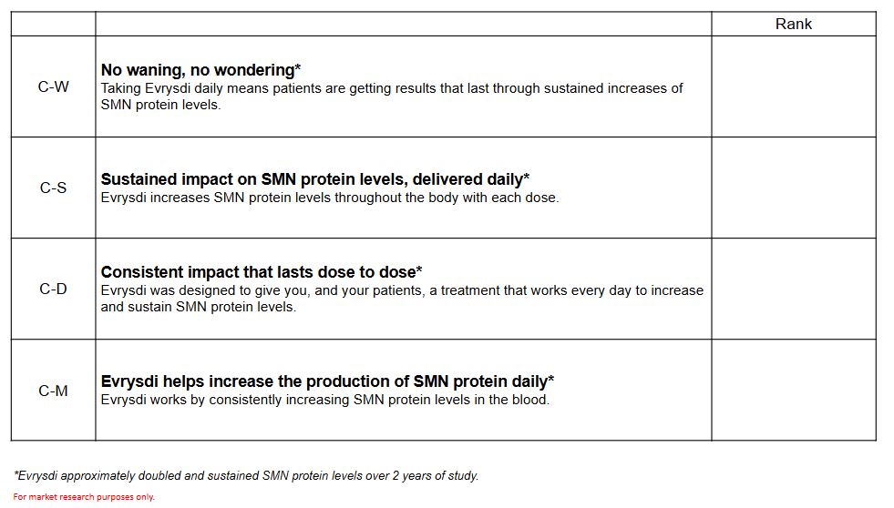*

1. Please take a moment to read the statements in this group. I would like you to read this section in its entirety before we discuss it in more detail.
   1. What is your overall reaction to these statements?
   2. Is any of this information surprising or new to you?
2. Please rank order these statements from your MOST preferred statement to your LEAST preferred statement.
   1. Why did you rank them in this order?
   2. What is it about this that makes it your MOST preferred?
   3. What is it about this that makes it your LEAST preferred?

*REVIEW EACH STATEMENT INDIVIDUALLY. REPEAT QUESTIONS 3-10 FOR EACH STATEMENT BEFORE MOVING ON.*

1. What words and phrases caught your attention in this statement? Why? *MODERATOR NOTE: HIGHLIGHT WORDS AND PHRASES IN WORKBOOK*
   1. What about the language or phrasing enhances or detracts from the statement?
   2. Is there anything you find unclear about this statement?
2. How motivating is this statement? Why?
3. How differentiating is this statement? Which treatments does this differentiate Evrysdi from?
4. Is this statement believable? Why or why not?
5. What are your thoughts on the headline of this message? The subhead?
6. How effectively do the headline and subhead work together?
   1. Does the subhead help clarify anything that was unclear in the headline?
7. How much additional value does the subhead bring to the overall message?
8. What patient type would this statement support?
   1. PROBE: How do you think this message would resonate with those not currently on treatment? Spinraza users? Evrysdi users?
9. What, if anything, could be changed or modified to improve this statement as a whole?
   1. *PROBE to understand whether swapping out any headlines or subheads would affect how they ranked the messages.*

*MODERATOR NOTE: QUESTIONS 10 AND 11 SHOULD BE CONSIDERED IN THE CONTEXT OF THE OVERALL MESSAGES WITHIN EACH CATEGORY.*

1. What is your main takeaway from these messages overall? How does this impression compare to other SMA treatments, both those currently available and those in development? *ALLOW SPONTANEOUS DISCUSSION AND IF NOT MENTIONED, THEN PROBE ON SPECIFIC TREATMENTS (Spinraza / High Dose Spinraza, Zolgensma / IT Zolgensma, Anti-myostatin) .*

*CATEGORY SPECIFIC PROBES TO BE ASKED WHEN CATEGORY IS BEING EVALUATED.*

**CATEGORY C: CONSISTENT, DAILY TREATMENT EFFECT** [EVERYDAY CONTROL] *(STIMULUS E)*

1. Let’s take a closer look at Message C-D. How believable do you think this statement is?
   1. How, if at all, does this message differentiate Evrysdi from Spinraza? Evrysdi from Zolgensma?

**CATEGORY S: LONG-TERM EFFICACY AND SAFETY** [EVRYSDI AS EXPECTED] *(STIMULUS G)*

1. These messages use the phrases, “manageable tolerability”, “established safety”, and “well-characterized safety”. Which of these do you find most compelling, and why?
2. Some of these messages, like S-O, S-C, and S-N, only talk about Evrysdi’s long-term efficacy, while others (S-E) mention both efficacy and safety. Do you find it more compelling when a message focuses solely on efficacy, or do you prefer when both are included?
3. *DISPLAY STIMULI Q*. Here are two alternative headline options for Message S-O. Including the original, which of the three do you prefer and why?

**CATEGORY M: MOA** [PROTECTION EVERYWHERE] *(STIMULUS I)*

1. In Message M-R, the phrase, “calls for systemic treatment” is mentioned. Another option would be “requires systemic treatment.” Which of these variations do you prefer? Why?
2. Message M-O starts with the phrase, “Consistent care.” Another option would be “therapeutic effect”. Which variation do you prefer? Why?

**CATEGORY B: BROAD INDICATION** [FOR EVERYONE] *(STIMULUS K)*

1. How do you feel about the word “reliable” in Message B-R?
   1. In your mind, what qualities make a treatment “a reliable choice”?
   2. Do you feel Evrysdi reflects those qualities?
2. Looking at Message B-P, does having a more inclusive clinical trial make any difference in your decision to prescribe an SMA treatment? If so, how much of an influence does it have?

**CATEGORY L: LEADING TREATMENT IN SMA** [LEADING EVERYWAY] *(STIMULUS M)*

1. Message L-B uses the phrase, “foundational treatment.” In your own words, what does this phrase mean to you?
   1. Would you use this phrase to describe Evrysdi? Why or why not?
   2. Does reading this phrase change how you feel about Evrysdi?
2. *DISPLAY STIMULUS O* Message L-R reads “Evrysdi is the most chosen treatment for SMA”. Imagine that this headline was replaced with “Evrysdi is the #1 prescribed treatment for SMA” (Message L-S). Do you think this statement feels more impactful overall? If yes,what makes it feel that way—and how much of a difference does it make to you?
3. **OVERALL MESSAGE PREFERENCE** *(15 min)*

*SECTION GOAL: Evaluate overall message preference, regardless of bucket, and identify which messages are most critical to enhance current brand story. Uncover nuances between category rankings and message preferences to assess whether messages should be further refined while still remaining essential to include.*

*DISPLAY SUMMARY SLIDE OF ALL MESSAGES, STIMULUS P*

Now that we’ve explored all the messages in detail, let’s step back and take a broader look.

1. Looking at all of these messages, please select the five statements you prefer most overall. **Do not worry about how they’re grouped**—your selections can come from the same column or from all different ones.
   1. Can you walk me through your thought process for choosing those messages?
2. Looking at your top five messages, which two do you feel are most important to communicate about Evrysdi? Why?
   1. *How big of a gap do you feel there is between the importance of these two messages and the other three you selected?*
   2. *Do you feel that these two messages complement one another, or do they seem disconnected when considered together?*
3. Did any of these messages change your perception of Evrysdi? Which message(s) and how?
   1. Did any messages change the way you feel about Evrysdi in comparison to other treatments, either currently available or entering the market? *IF YES:* Which message(s) and why? *PROBE on Spinraza / High Dose Spinraza, Zolgensma / IT Zolgensma, Anti-myostain*
   2. Is there anything missing from these messages that you would include to better differentiate this treatment from others?
4. Which messages do you believe best differentiate Evrysdi from:
   1. Other currently available SMA treatments? Which message(s) and why? *PROBE on Spinraza, Zolgensma*
   2. Other SMA products in development? Which message(s) and why? *PROBE on High-Dose Spinraza, IT Zolgensma, Anti-myostatin*

*IF CLEAR DISCREPANCY BETWEEN THEME AND MESSAGE PREFERENCE, REMOVE WHITE BOX COVERING THEME TITLES/DESCRIPTIONS AND ASK QUESTION 5.*

1. I have uncovered the message themes along the top of this slide. Was your selection of most important messages different from what you expected, based on which themes you initially considered most important?
   1. *If message under theme is not selected but importance of theme was high:* How can the message(s) be improved to better reflect the importance of the theme? Is there anything missing that you would like to see included?
   2. *If message under theme is selected but importance of theme was low:* What made this message stand out to you as important to communicate—even though its theme wasn’t something that was initially considered a priority?
   3. Are there any additional messages you believe should be communicated, even if they weren’t under the themes you found most important?
2. **THANK AND CONCLUDE**  *(1min)*

*SECTION GOAL: Wrap up and ask any outstanding questions.*

1. Any last comments?
2. Thank and conclude