# **Haemophilus and HACEK Group Organisms (Fastidious GramNegative Rods)**

**Haemophilus Species:**

* Small, pleomorphic Gram-negative rods (coccobacilli)
* **oxidase positive** (most) and **catalase positive**
* **fastidious**
* Will grow on **Chocolate agar** (which supplies both X and V). -
* Satellism around colonies that provide V e.g., a streak of *Staphylococcus aureus*

**Key factors**

* **X factor = haemin (hemin/protoporphyrin IX)** → needed for cytochromes/heme.
* **V factor = NAD**  → redox cofactor; *not* available from intact RBCs on plain blood agar (NADases destroy it).

**Media & conditions**

* **Chocolate agar (heated blood)** releases **X & V**, usually with an enrichment (e.g., IsoVitaleX) → standard for pathogenic *Haemophilus*.
* **Incubation:** 35–37 °C, **5–10% CO₂**, 24–48 h; some species slower.
* **Satellitism test:** on sheep/blood agar, streak **S. aureus**; *H. influenzae* forms tiny colonies satelliting within the β‑haemolysis zone where **V factor** is liberated.

**Disc (factor) test on confluent lawn**

* Place **X**, **V**, **XV** discs on a heavy suspension spread on Mueller–Hinton or TSA with 5% blood:
  + **Growth only around XV** → **requires both X & V** → *H. influenzae* (and *H. haemolyticus*).
  + **Growth around V (±XV), not X** → **requires V only** → *H. parainfluenzae*, *H. parahaemolyticus*.
  + **Growth around X (±XV), not V** → **requires X only** → *H. ducreyi*.
  + **No disc dependence** (growth everywhere) → consider **Aggregatibacter aphrophilus** (reclassified; formerly *H. aphrophilus/paraphrophilus*; **neither X nor V** required).

**Porphyrin (δ‑ALA) test**

* Detects ability to **synthesise heme** from δ‑ALA (fluorescent porphyrins).
  + **Negative (no fluorescence)** → **X factor required** → typical for *H. influenzae*.
  + **Positive** → **no X factor required** → e.g., *H. parainfluenzae, H parahaemolyticus*

**Species pointers for exams**

* *H. influenzae*: **X+V**; non‑haemolytic (on horse blood); porphyrin **neg**.
* *H. haemolyticus*: **X+V**; **β‑haemolytic** on horse blood; porphyrin **neg**.
* *H. parainfluenzae*: **V only**; porphyrin **pos**.
* *H. parahaemolyticus*: **V only**; **β‑haemolytic**; porphyrin **pos**.
* *H. ducreyi*: **X only**; very fastidious; 33–35 °C, high humidity, 5% CO₂; porphyrin **neg**.
* **Aggregatibacter aphrophilus**: **neither X nor V** (note reclassification).

**Common pitfalls**

* Using **plain blood agar** → poor/absent growth for *H. influenzae* (V factor destroyed).
* Reading discs too early/late—incubate in **CO₂** and check at 24 h (and again at 48 h if scant).
* Misidentifying *H. haemolyticus* as *H. influenzae*—use **haemolysis on horse blood**, MALDI‑TOF, and clinical context.

**Factor Requirements by Species:**

Requires V Hemolysis on Horse/

Species Requires X (Hemin)?

(NAD)? Rabbit Blood?

|  |  |  |  |
| --- | --- | --- | --- |
| *H. influenzae* | Yes | Yes | No (non-hemolytic) |
| *H. haemolyticus* | Yes | Yes | **Yes** (β-hemolytic) |
| *H. parainfluenzae* | No | Yes | No |
| *H. parahaemolyticus* | No | Yes | **Yes** (β-hemolytic) |
| *H. ducreyi* | Yes | No | No (requires special media, hard to grow) |
| *Aggregatibacter aphrophilus* (formerly *H. aphrophilus*) | Variable (can grow without X and V) | No (doesn’t need V) | No |

* The beta-hemolysis is observed on rabbit or horse blood agar (not on sheep blood; sheep blood agar doesn’t show Haemophilus hemolysis well due to sheep RBC resistance).
* *H. influenzae* is the most clinically significant: causes respiratory tract infections, meningitis (type

b), etc. It requires both X and V. It can be serotyped by capsule polysaccharide (a, b, c... f or nontypeable if no capsule). The **quellung test or latex agglutination** can detect type b capsule in CSF.

* *H. parainfluenzae* is normal flora of throat, requires only V factor (hence “para” = alongside; it can grow on blood agar around Staph which supplies V, since X is not needed).
* *H. haemolyticus* is basically like H. influenzae but hemolytic; historically not distinguished much clinically.
* *H. ducreyi* causes chancroid (an STI ulcer). It requires X factor and special conditions (very fastidious, GC agar + 1% hemoglobin + 5% CO₂, and 33°C). It’s identified by Gram stain from ulcer (school of fish arrangement) more often than culture in normal labs.

**Haemophilus Identification:** -

* **Quad Plate Test:** Labs use agar quadrants containing: I – X only, II – V only, III – X+V (chocolate), IV – horse blood (X+V + can show hemolysis). Inoculate all and see growth:
* **Porphyrin Test (ALA test):** An alternative to factor disks to check X dependence. Tests if the organism can synthesize hemin from δ-aminolevulinic acid. **Porphyrin test positive** (red fluorescence under UV or color change) means the organism does NOT require X factor (it produces porphyrins itself). So *H. parainfluenzae* is porphyrin positive; *H. influenzae* is porphyrin negative (needs X). This is a convenient single-test to check for X requirement.

**Other HACEK Group:**

* **A:**
* Aggregatibacter aphrophilus
  + Does not require X or V
  + Uniquely ferments glucose.
* **Aggregatibacter actinomycetemcomitans** –
  + a small Gram-negative rod
  + Non motile
  + causes endocarditis often after dental manipulation; also found in actinomycosis mixed infections.
  + **star-shaped colonies** after 48 hours (**“crossed cigars”** in colony center). I
  + It requires CO₂,
  + does not require X or V (will grow on blood agar but slowly).
  + Ox+, Cat+,Ind-,Ure-
* **C: Cardiobacterium hominis**
  + a pleomorphic Gram-negative rod often
  + forming **rosette arrangements** on Gram stain.
  + indole positive (notable: among HACEK, **Cardiobacterium is indole pos**).
  + It can pit the agar occasionally.
  + Ox+Cat-Ind+Ure-
* **E: Eikenella corrodens** –
  + slender Gram-negative rod
  + often from human bite wounds (clenched-fist injury) and also causes endocarditis in IV drug users (esp. lick the needle).
  + **does not ferment carbohydrates** (asaccharolytic).
  + **pits or corrodes the agar surface** and has a **bleach-like odor** due to hypochlorite production.
  + Ox+Cat-Ind-Urea-
  + It is also **indole negative** and **lysine decarboxylase positive**. -
* **K: Kingella**
  + short Gram-negative rods/coccobacilli; can be misseen as Gram-positive because they sometimes retain crystal violet.
  + *Kingella kingae* is increasingly recognized for pediatric septic arthritis/osteomyelitis and endocarditis.
  + *K. kingae* is β-hemolytic on blood agar (tiny beta hemolysis)
  + It can ferment glucose. Non-motile but may twitch.
  + *Kingella denitrificans* can mimic gonococcus in Gram stain but is catalase negative and reduces nitrate (thus the species name).
  + Ox+Cat-Ind-Ure-

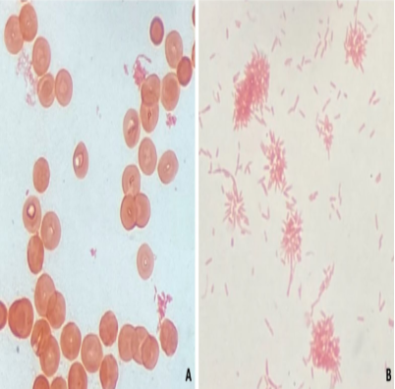

The rosette forms of Cardiobacterium hominis Gram negative rods

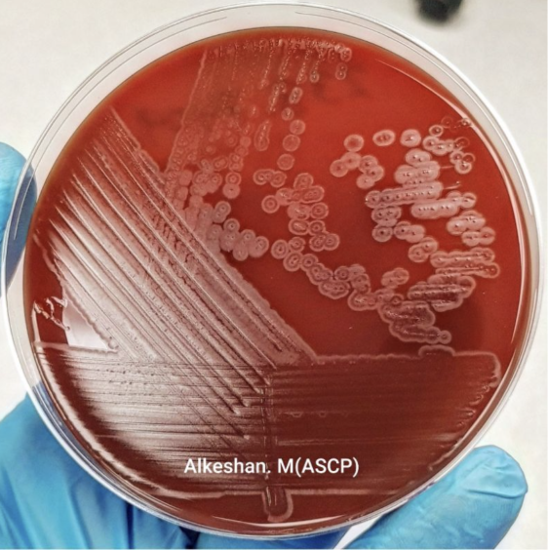

Eikenella corrodans pitting the agar

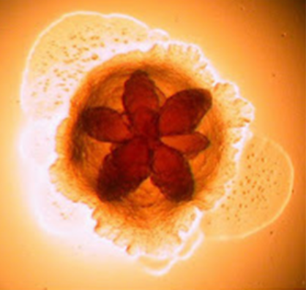

Aggregatibacter actinomycetesmcomitans