Coaches Assistant
User Guide: setting up and running a game for each sport
Screenshots are from the Android app on a Pixel 10 emulator, using sample players and a sample game against "Hawks".

1. What the app does
Coaches Assistant helps a coach run a team on match day. You keep a roster, track a live game (clock, score, substitutions, infractions and MVP votes), and export the game afterwards. It works across 17 team sports, and every sport keeps its own roster and game history.
The app works offline and keeps everything on the phone. The Training tab can generate drills with an AI provider, but only if you add that provider's API key in Settings.

2. Choose your sport
When you open the app for the first time it asks you to choose a sport. Sports are grouped into Court, Field, and Ice & Water. Tap the sport you coach. You can change it later from Settings (Switch sport).
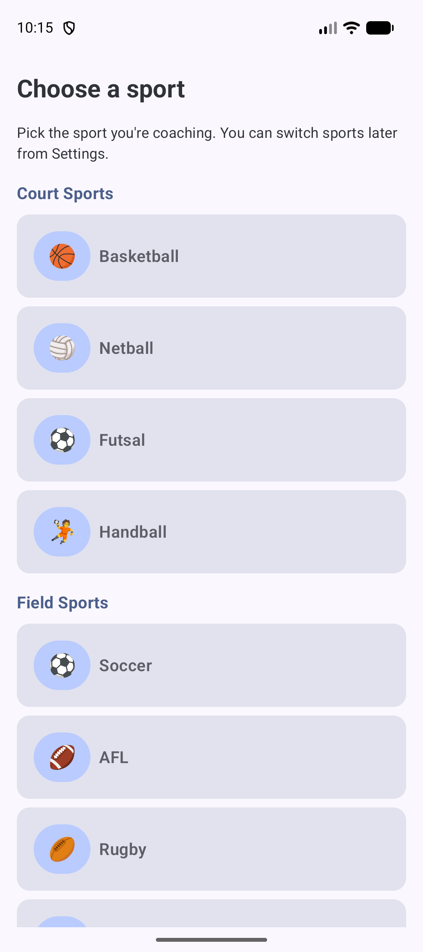
Figure 1. The sport picker. Court Sports and Field Sports are shown; scroll for Ice & Water.
- Court: Basketball, Netball, Futsal, Handball
- Field: Soccer, AFL, Rugby (Union or League), Touch Football, Flag Football, Gaelic Football, Field Hockey, Lacrosse, Ultimate Frisbee, Cricket
- Ice & Water: Ice Hockey, Water Polo
Rugby asks you which code you are coaching, Union or League, because the two have different scoring and positions.

3. Set up your roster
Open the Roster tab. Add each player with a name, an optional jersey number and an optional position. The position buttons change with your sport (see section 6). Each player appears in the list as #jersey name and position.
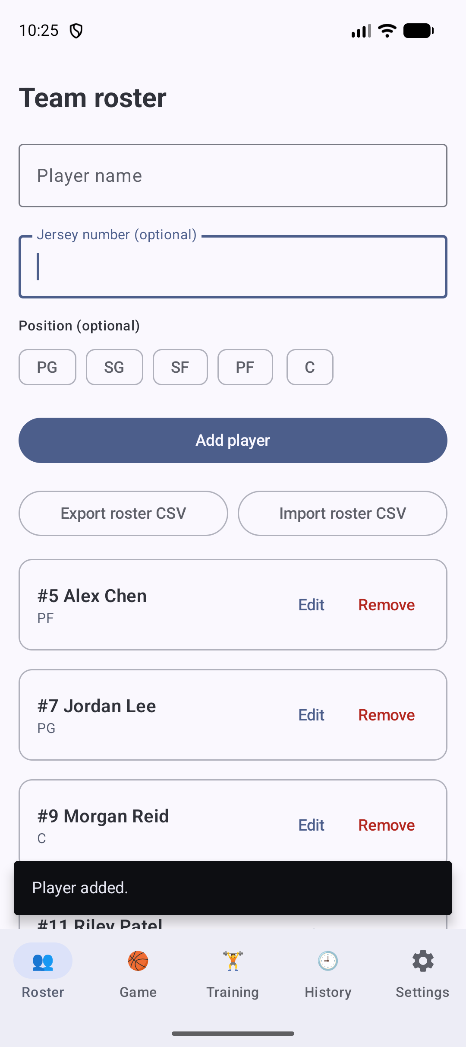
Figure 2. The Team roster screen with players added. Edit or Remove each player from their card.
- Edit or remove: use the Edit and Remove buttons on a player's card.
- CSV: Export roster CSV saves the roster to a file. Import roster CSV loads one in. The file holds name and jersey number.

4. Create and select a game
Open the Game tab. Under Create a game, fill in:
- Game title: for example Round 3.
- Opponent: the other team's name. It appears in the game list and in the event log.
- Periods: 2 halves, 3 periods or 4 quarters. Each sport's default is preselected.
- Period duration (minutes): the length of each period. Each sport's default is filled in.
Tap Create game. The new game is listed under Games and is marked Selected. Export or Delete a game from its card.
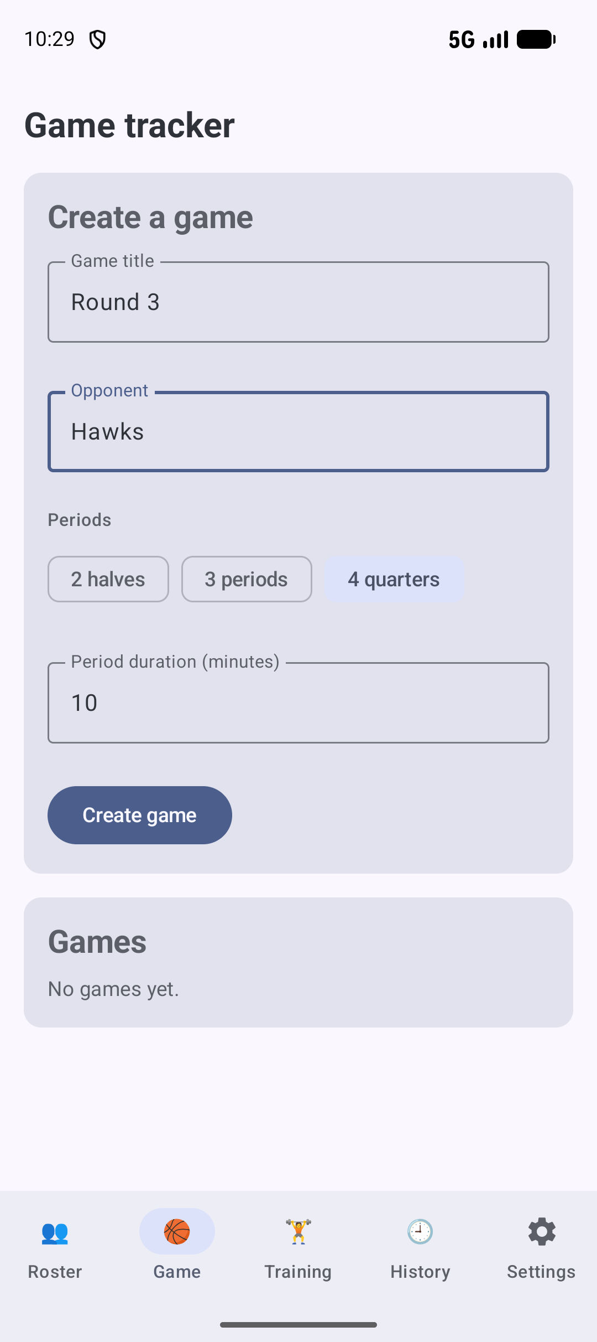
Figure 3. The Create a game form, with an opponent name entered.
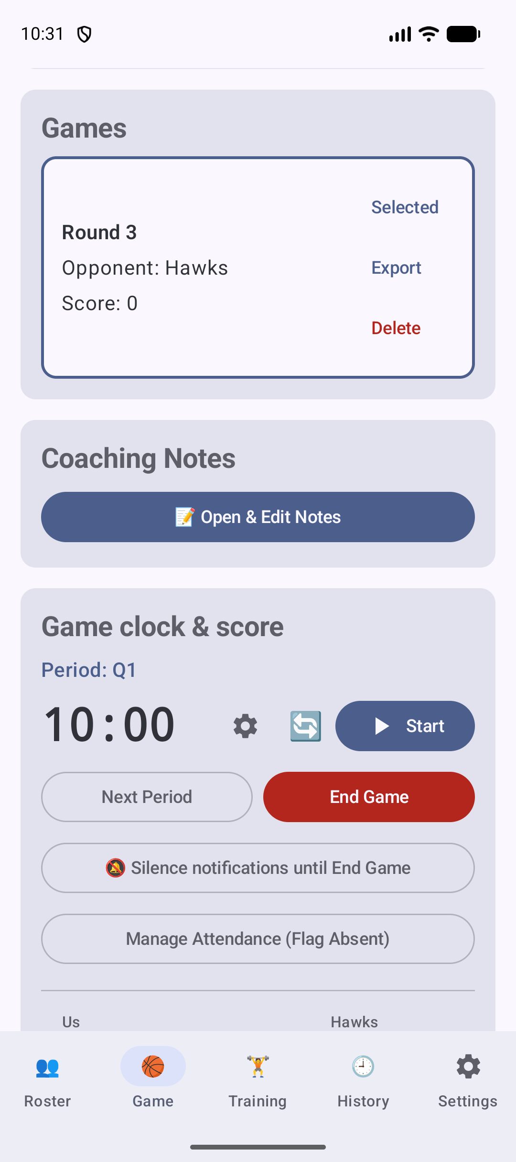
Figure 4. Game clock and score. The clock shows the period (Q1), Start, Next Period and End Game. Under it are the Us and Hawks score rows.

5. Running the game
Scroll down the Game tab to the Game clock & score panel. It holds the controls you use during play:
- Clock: Start and stop the period clock. The gear icon adjusts the time manually. The reset button sets the clock back. The clock stops by itself when a period ends.
- Period: Next Period moves to the following period. End Game finishes the game and sets its result.
- Game Day mode: Silence notifications until End Game turns on the app's Game Day mode for this game (Android 10 and later).
- Attendance: Manage Attendance (Flag Absent) marks players who are not at the game, so they are left out of the lineup.
- Scores: Use the sport's scoring buttons for each side. The app logs every score, and you can undo it from the message that appears.
- Substitutions: Choose the players coming on and off. A banner suggests a swap when a player on court has played well beyond an even share of the game. You can accept it (Sub now), dismiss it (Later), or turn the suggestions off in Settings.
- Infractions and MVP: Each player has a counter for the sport's infraction (see section 6 for each sport's name). MVP votes are recorded the same way.
The game stats cards show each player's ON COURT or BENCH status and time. The Settings tab controls the clock options, including keeping the screen on and clock notifications.

6. Sport by sport
Each sport has its own on-court size, minimum number of players to start, squad positions, default periods, scoring buttons and infraction name. The defaults below come from the app's sport settings. You can change the minimum for a competition in Settings.

Basketball
Category: Court
Setting | What the app uses
On court | 5
Minimum to start | 5 (FIBA)
Positions | PG, SG, SF, PF, C
Default periods | 4 quarters, 10 minutes each
Scoring buttons | +1, +2, +3
Infraction | Foul

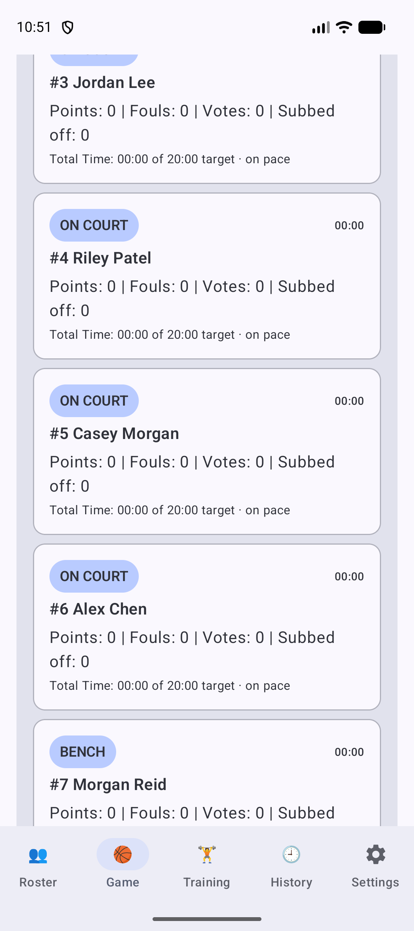
Basketball: the Game tab with the players on court. Scroll to see the scoring and infraction controls for each player.

Netball
Category: Court
Setting | What the app uses
On court | 7
Minimum to start | 5
Positions | GS, GA, WA, C, WD, GD, GK
Default periods | 4 quarters, 15 minutes each
Scoring buttons | Goal (1)
Infraction | Penalty

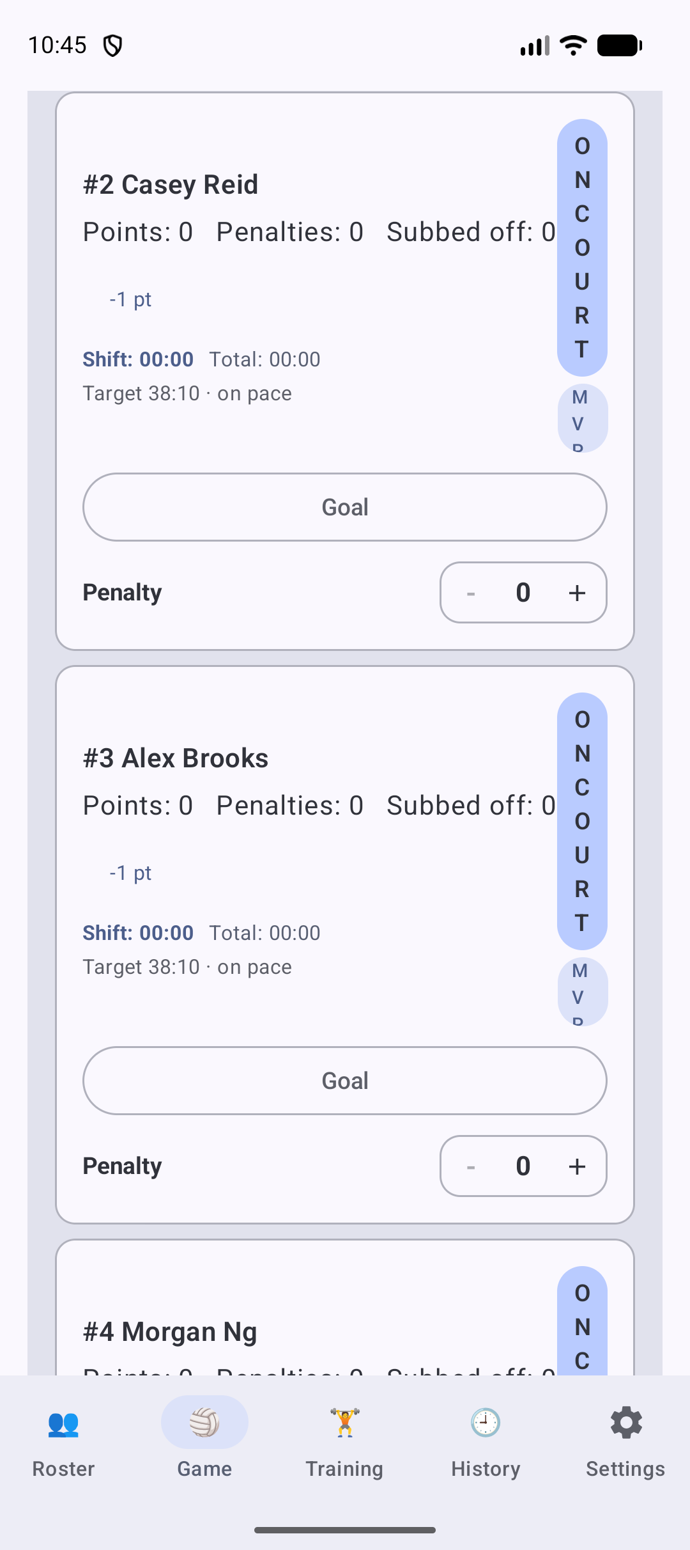
Netball: the Game tab with the players on court. Scroll to see the scoring and infraction controls for each player.

Futsal
Category: Court
Setting | What the app uses
On court | 5
Minimum to start | 3 (some competitions require 4)
Positions | GK, FIX, ALA, PIVO
Default periods | 2 halves, 20 minutes each
Scoring buttons | Goal (1)
Infraction | Foul
Keeper | GK plays the whole game; left out of substitution suggestions

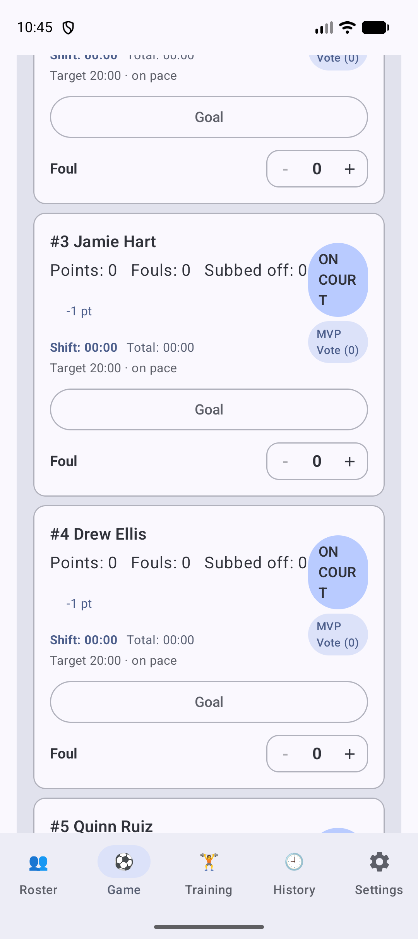
Futsal: the Game tab with the players on court. Scroll to see the scoring and infraction controls for each player.

Handball
Category: Court
Setting | What the app uses
On court | 7
Minimum to start | 5 (IHF)
Positions | GK, Left Wing, Left Back, Centre Back, Right Back, Right Wing, Pivot
Default periods | 2 halves, 30 minutes each
Scoring buttons | Goal (1)
Infraction | Foul
Keeper | GK plays the whole game

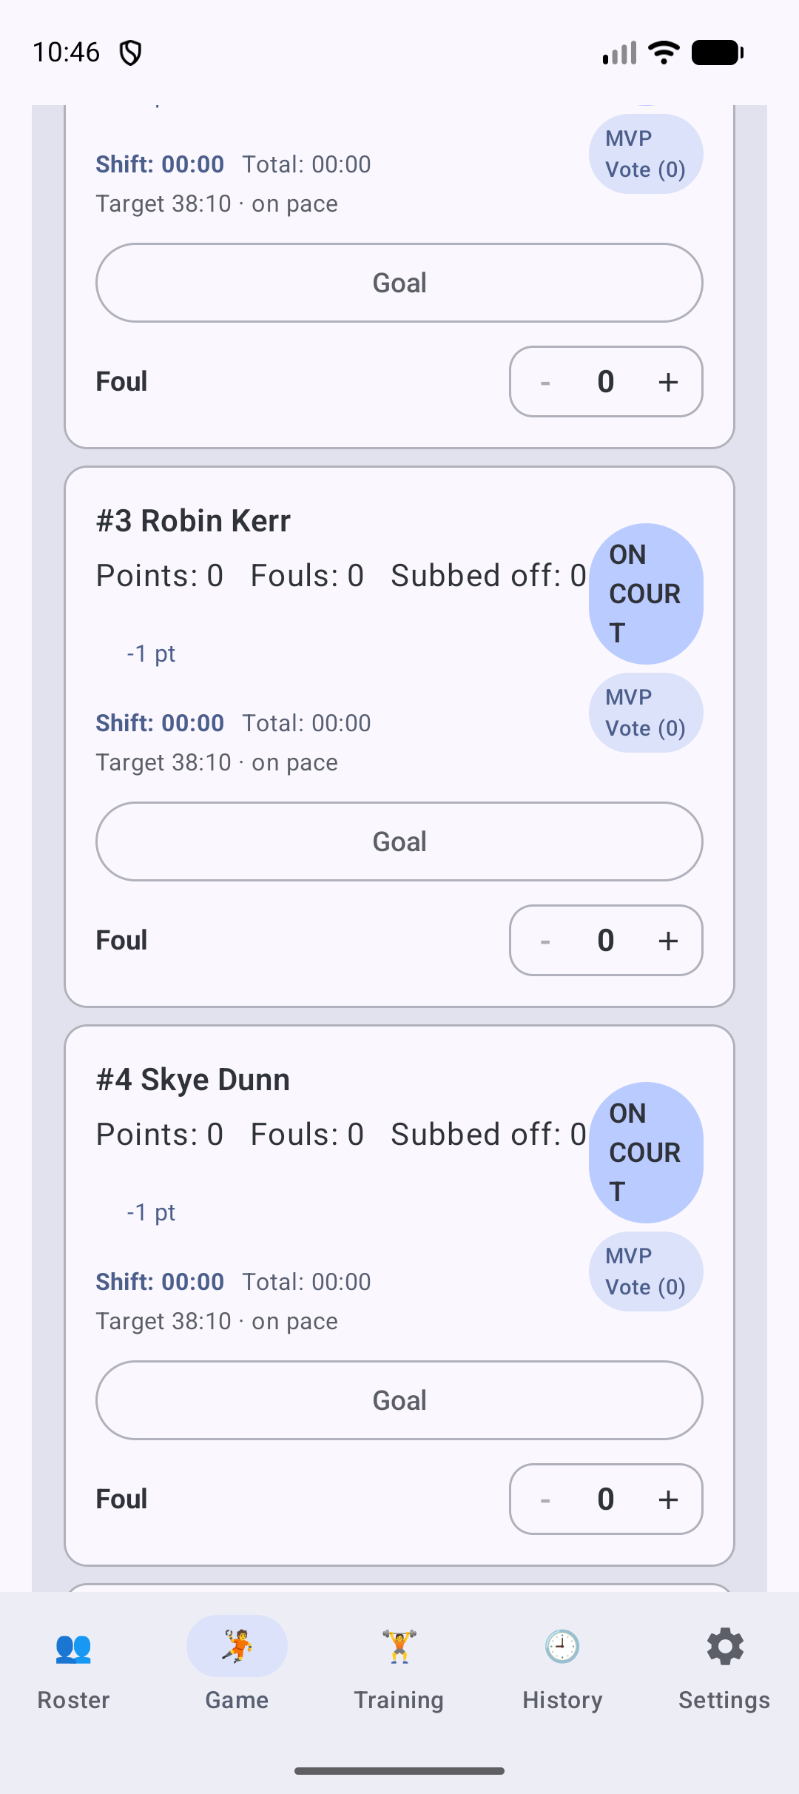
Handball: the Game tab with the players on court. Scroll to see the scoring and infraction controls for each player.

Soccer
Category: Field
Setting | What the app uses
On court | 11
Minimum to start | 7 (IFAB Law 3)
Positions | GK, DEF, MID, FWD
Default periods | 2 halves, 45 minutes each
Scoring buttons | Goal (1)
Infraction | Card
Keeper | GK plays the whole game

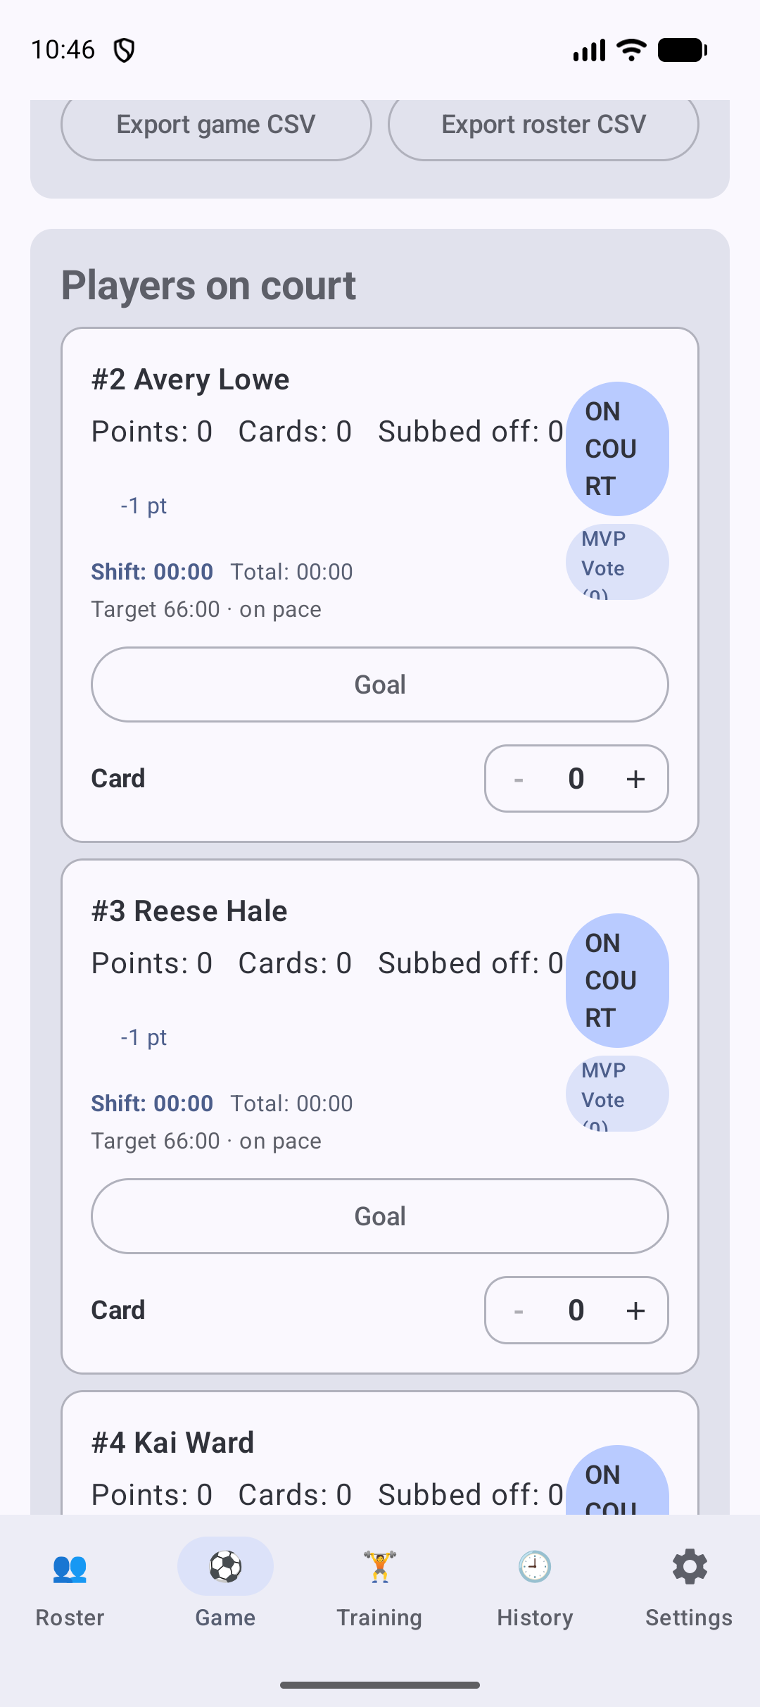
Soccer: the Game tab with the players on court. Scroll to see the scoring and infraction controls for each player.

AFL
Category: Field
Setting | What the app uses
On court | 18
Minimum to start | 14 (AFL Queensland community competitions)
Positions | Full Forward, Half Forward, Midfield, Half Back, Full Back, Ruck, Interchange
Default periods | 4 quarters, 20 minutes each
Scoring buttons | Goal (6), Behind (1)
Infraction | Free Kick

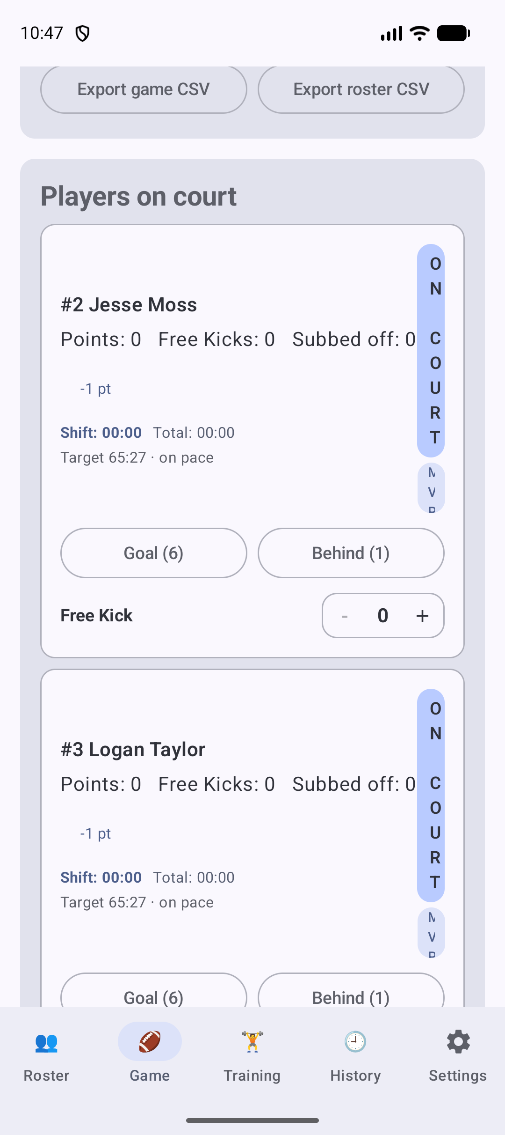
AFL: the Game tab with the players on court. Scroll to see the scoring and infraction controls for each player.

Rugby Union
Category: Field
Setting | What the app uses
On court | 15
Minimum to start | 12
Positions | Prop, Hooker, Lock, Flanker, No.8, Scrum-half, Fly-half, Centre, Wing, Fullback
Default periods | 2 halves, 40 minutes each
Scoring buttons | Try (5), Conversion (2), Penalty (3), Drop goal (3)
Infraction | Penalty

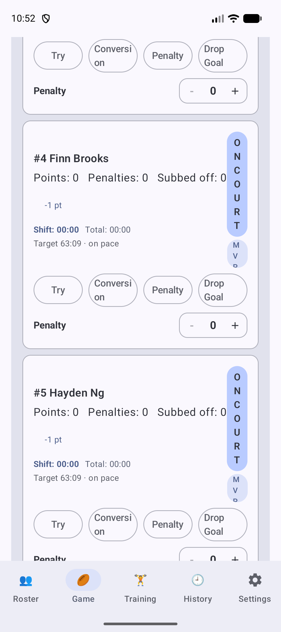
Rugby Union: the Game tab with the players on court. Scroll to see the scoring and infraction controls for each player.

Rugby League
Category: Field
Setting | What the app uses
On court | 13
Minimum to start | 9
Positions | Prop, Hooker, Second Row, Lock, Halfback, Five-Eighth, Centre, Wing, Fullback
Default periods | 2 halves, 40 minutes each
Scoring buttons | Try (4), Conversion (2), Penalty (2), Field goal (1)
Infraction | Penalty

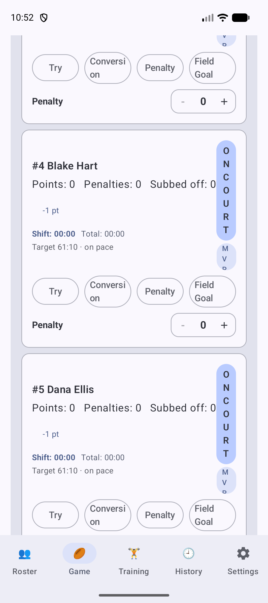
Rugby League: the Game tab with the players on court. Scroll to see the scoring and infraction controls for each player.

Touch Football
Category: Field
Setting | What the app uses
On court | 6
Minimum to start | 4 (FIT rules)
Positions | Link, Middle, Wing
Default periods | 2 halves, 20 minutes each
Scoring buttons | Touchdown (1)
Infraction | Penalty

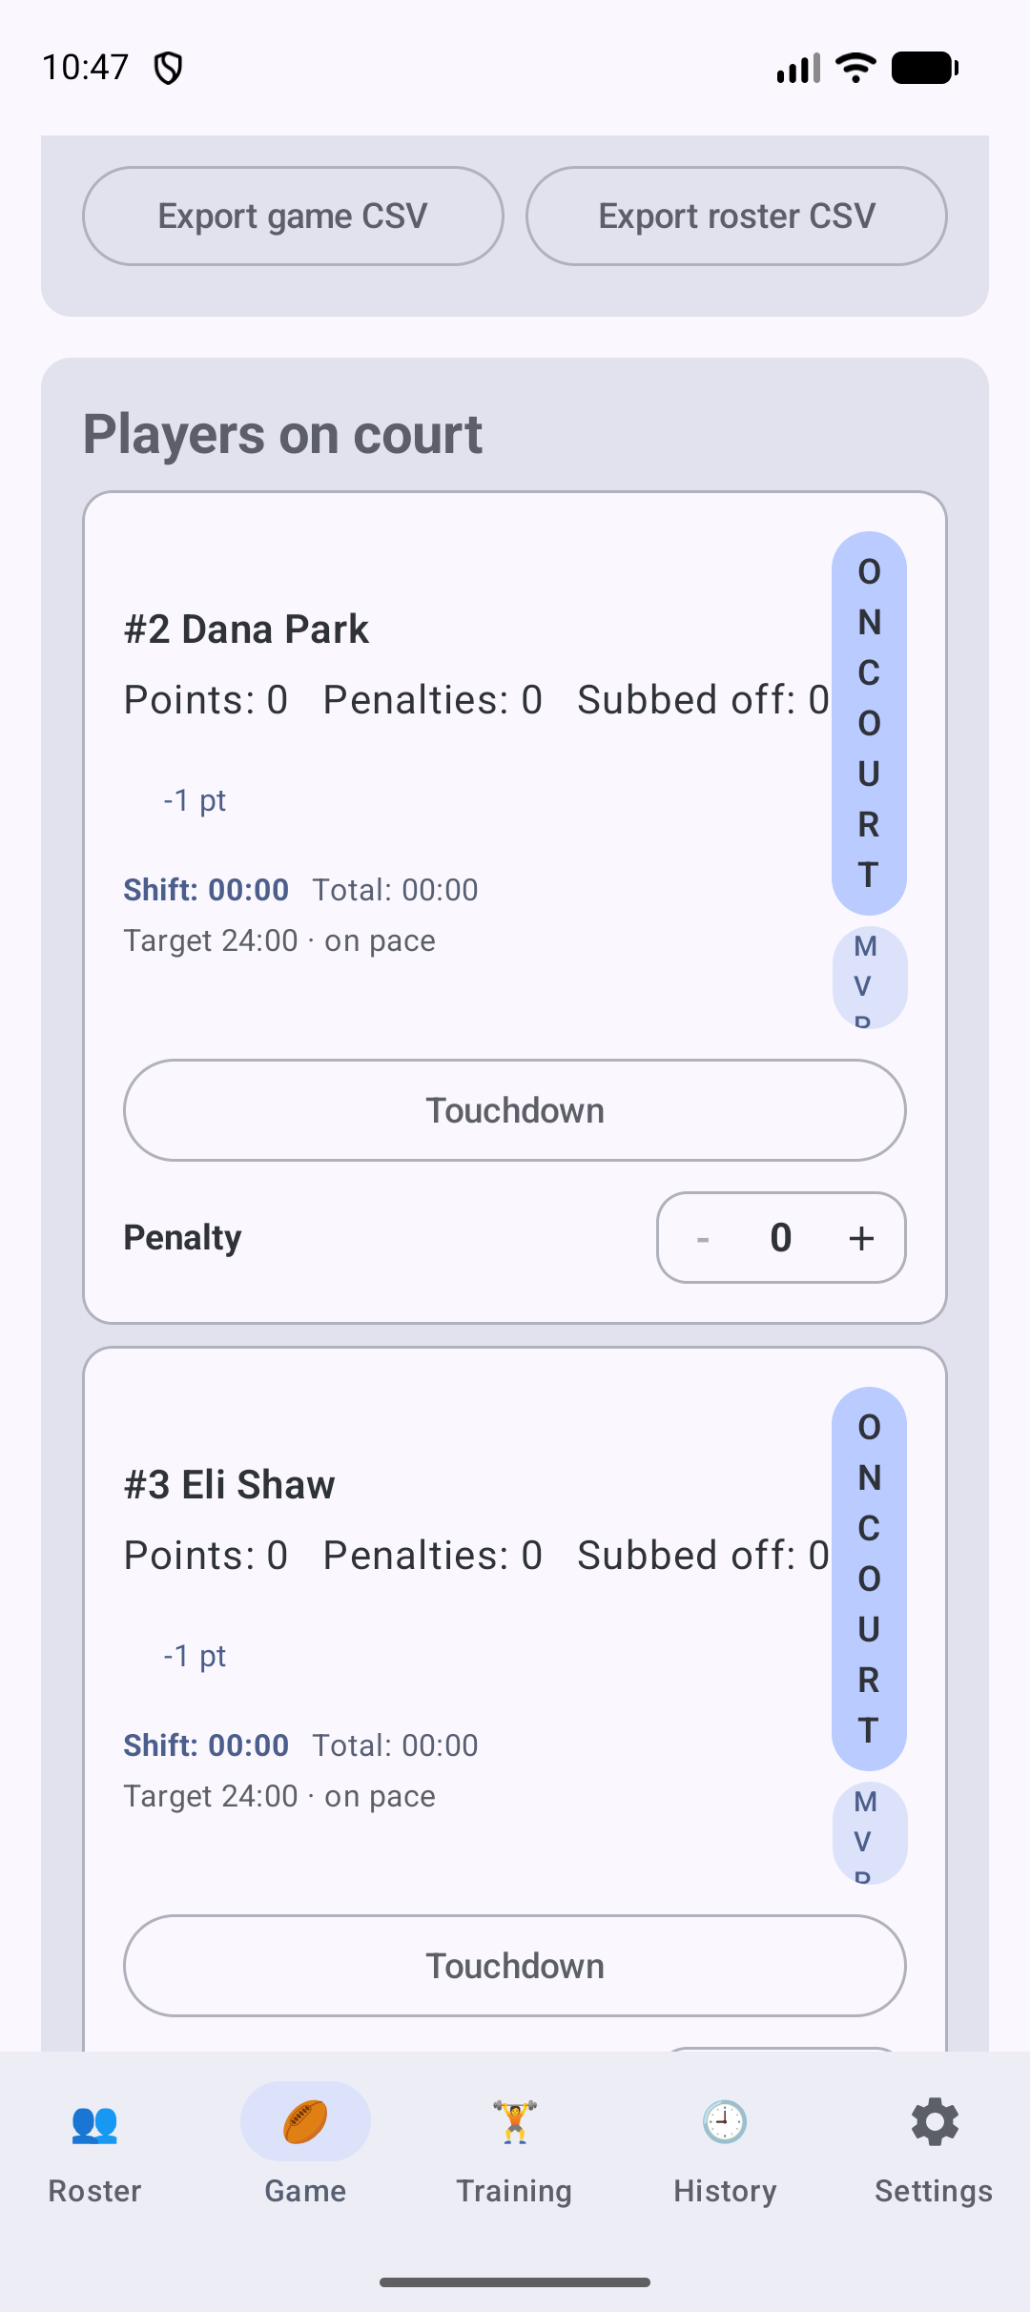
Touch Football: the Game tab with the players on court. Scroll to see the scoring and infraction controls for each player.

Flag Football
Category: Field
Setting | What the app uses
On court | 5
Minimum to start | 4 (IFAF flag rules)
Positions | QB, WR, RB, DB, Rusher
Default periods | 2 halves, 20 minutes each
Scoring buttons | Touchdown (6), 1-point extra (1), 2-point extra (2), Safety (2)
Infraction | Penalty

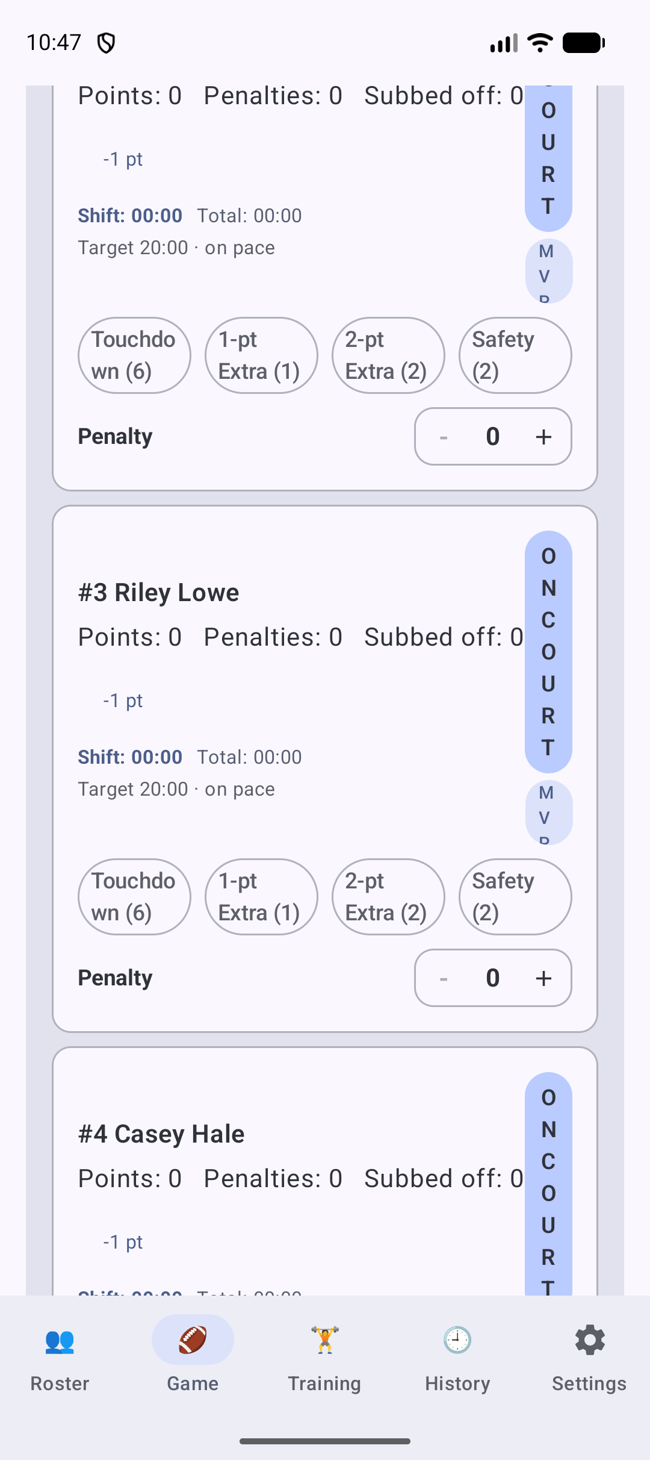
Flag Football: the Game tab with the players on court. Scroll to see the scoring and infraction controls for each player.

Gaelic Football
Category: Field
Setting | What the app uses
On court | 15
Minimum to start | 13 (GAA Official Guide)
Positions | GK, Full Back, Half Back, Midfield, Half Forward, Full Forward
Default periods | 2 halves, 30 minutes each
Scoring buttons | Goal (3), Point (1)
Infraction | Foul
Keeper | GK plays the whole game

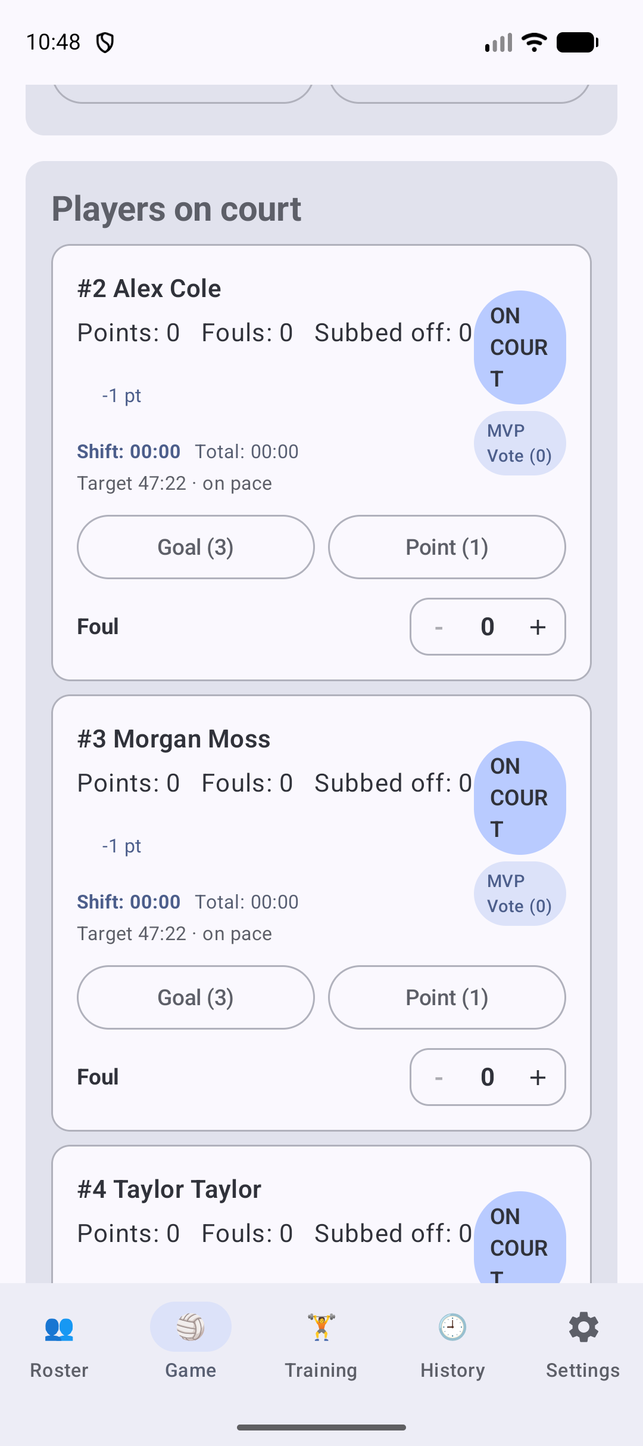
Gaelic Football: the Game tab with the players on court. Scroll to see the scoring and infraction controls for each player.

Field Hockey
Category: Field
Setting | What the app uses
On court | 11
Minimum to start | 7 (common competition minimum)
Positions | GK, DEF, MID, FWD
Default periods | 4 quarters, 15 minutes each
Scoring buttons | Goal (1)
Infraction | Card
Keeper | GK plays the whole game

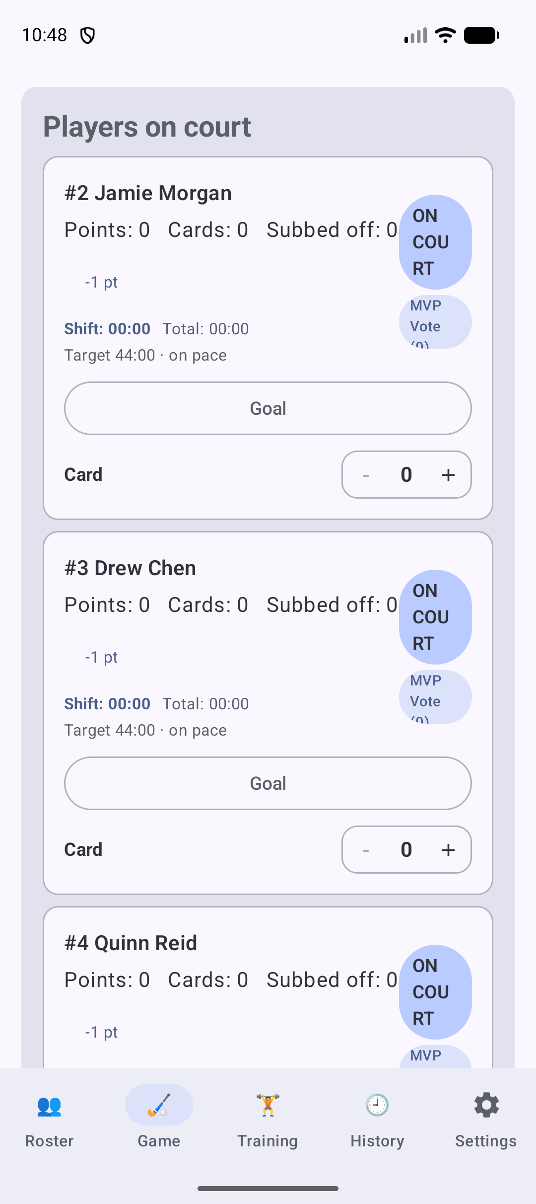
Field Hockey: the Game tab with the players on court. Scroll to see the scoring and infraction controls for each player.

Lacrosse
Category: Field
Setting | What the app uses
On court | 10
Minimum to start | 8 (competition rules)
Positions | GK, Defense, Midfield, Attack
Default periods | 4 quarters, 15 minutes each
Scoring buttons | Goal (1)
Infraction | Penalty
Keeper | GK plays the whole game

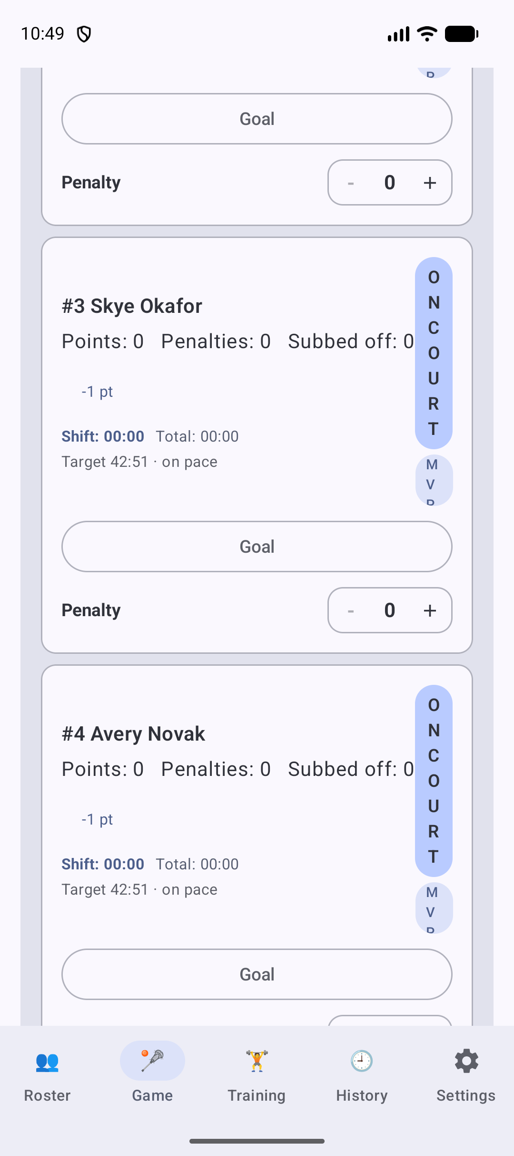
Lacrosse: the Game tab with the players on court. Scroll to see the scoring and infraction controls for each player.

Ultimate Frisbee
Category: Field
Setting | What the app uses
On court | 7
Minimum to start | 5 (WFDF)
Positions | Handler, Cutter, Deep
Default periods | 2 halves, 20 minutes each
Scoring buttons | Point (1)
Infraction | Foul

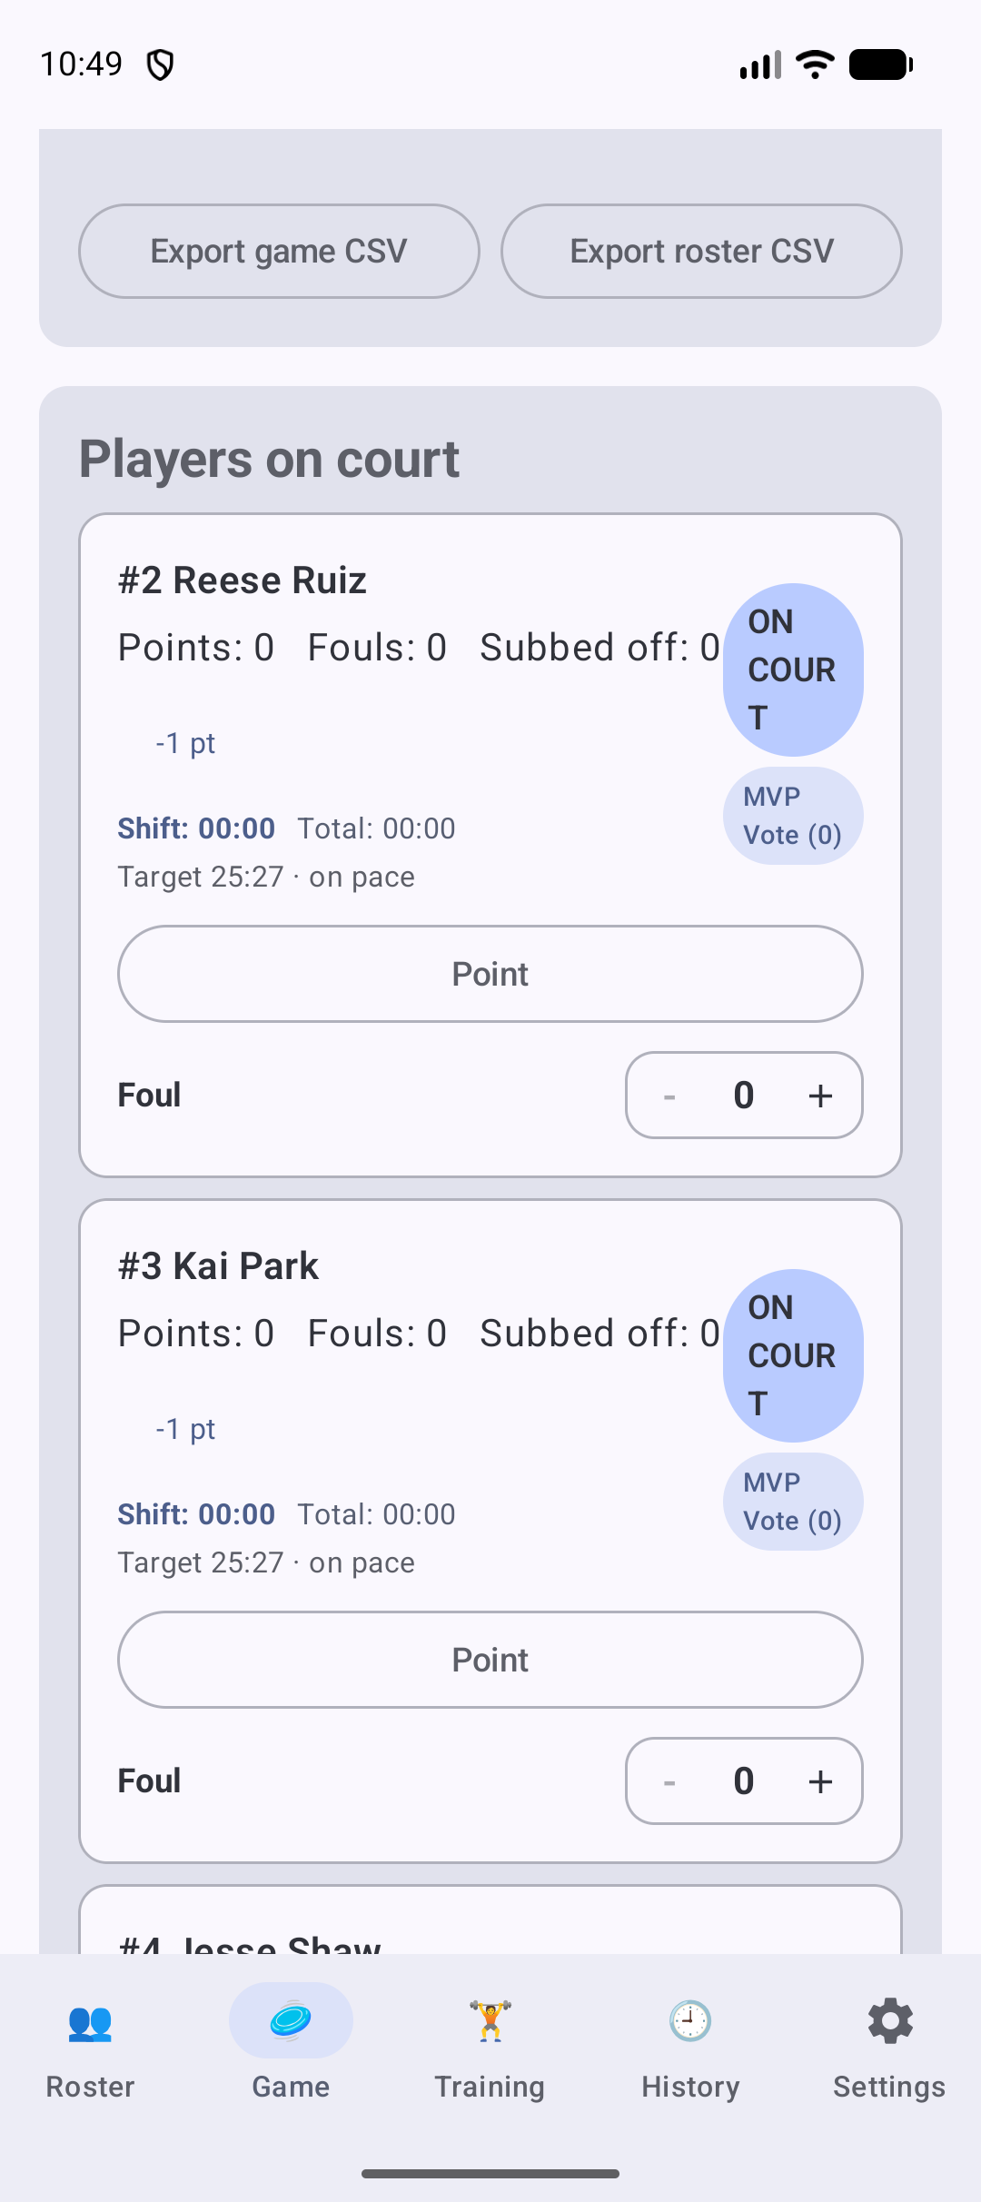
Ultimate Frisbee: the Game tab with the players on court. Scroll to see the scoring and infraction controls for each player.

Cricket
Category: Field
Setting | What the app uses
Format | Scorecard per player, not a live game. No periods, clock, lineups, substitutions or scoring buttons.
Players | 11 per side (minimum 11)
Recorded | Batting, bowling and fielding for each player, plus a field plan per game

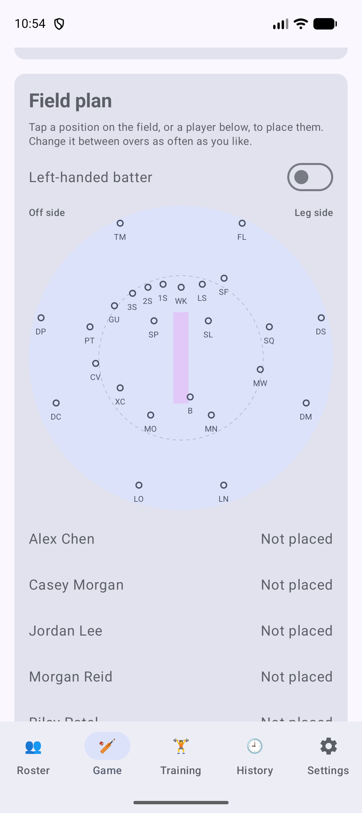
Cricket: the field plan for a game. Each player is placed on the field diagram, and the scorecard is entered per player.

Ice Hockey
Category: Ice & Water
Setting | What the app uses
On court | 6
Minimum to start | 5 (IIHF: a goalkeeper and four skaters)
Positions | G, LD, RD, LW, C, RW
Default periods | 3 periods, 20 minutes each
Scoring buttons | Goal (1)
Infraction | Penalty
Keeper | G plays the whole game

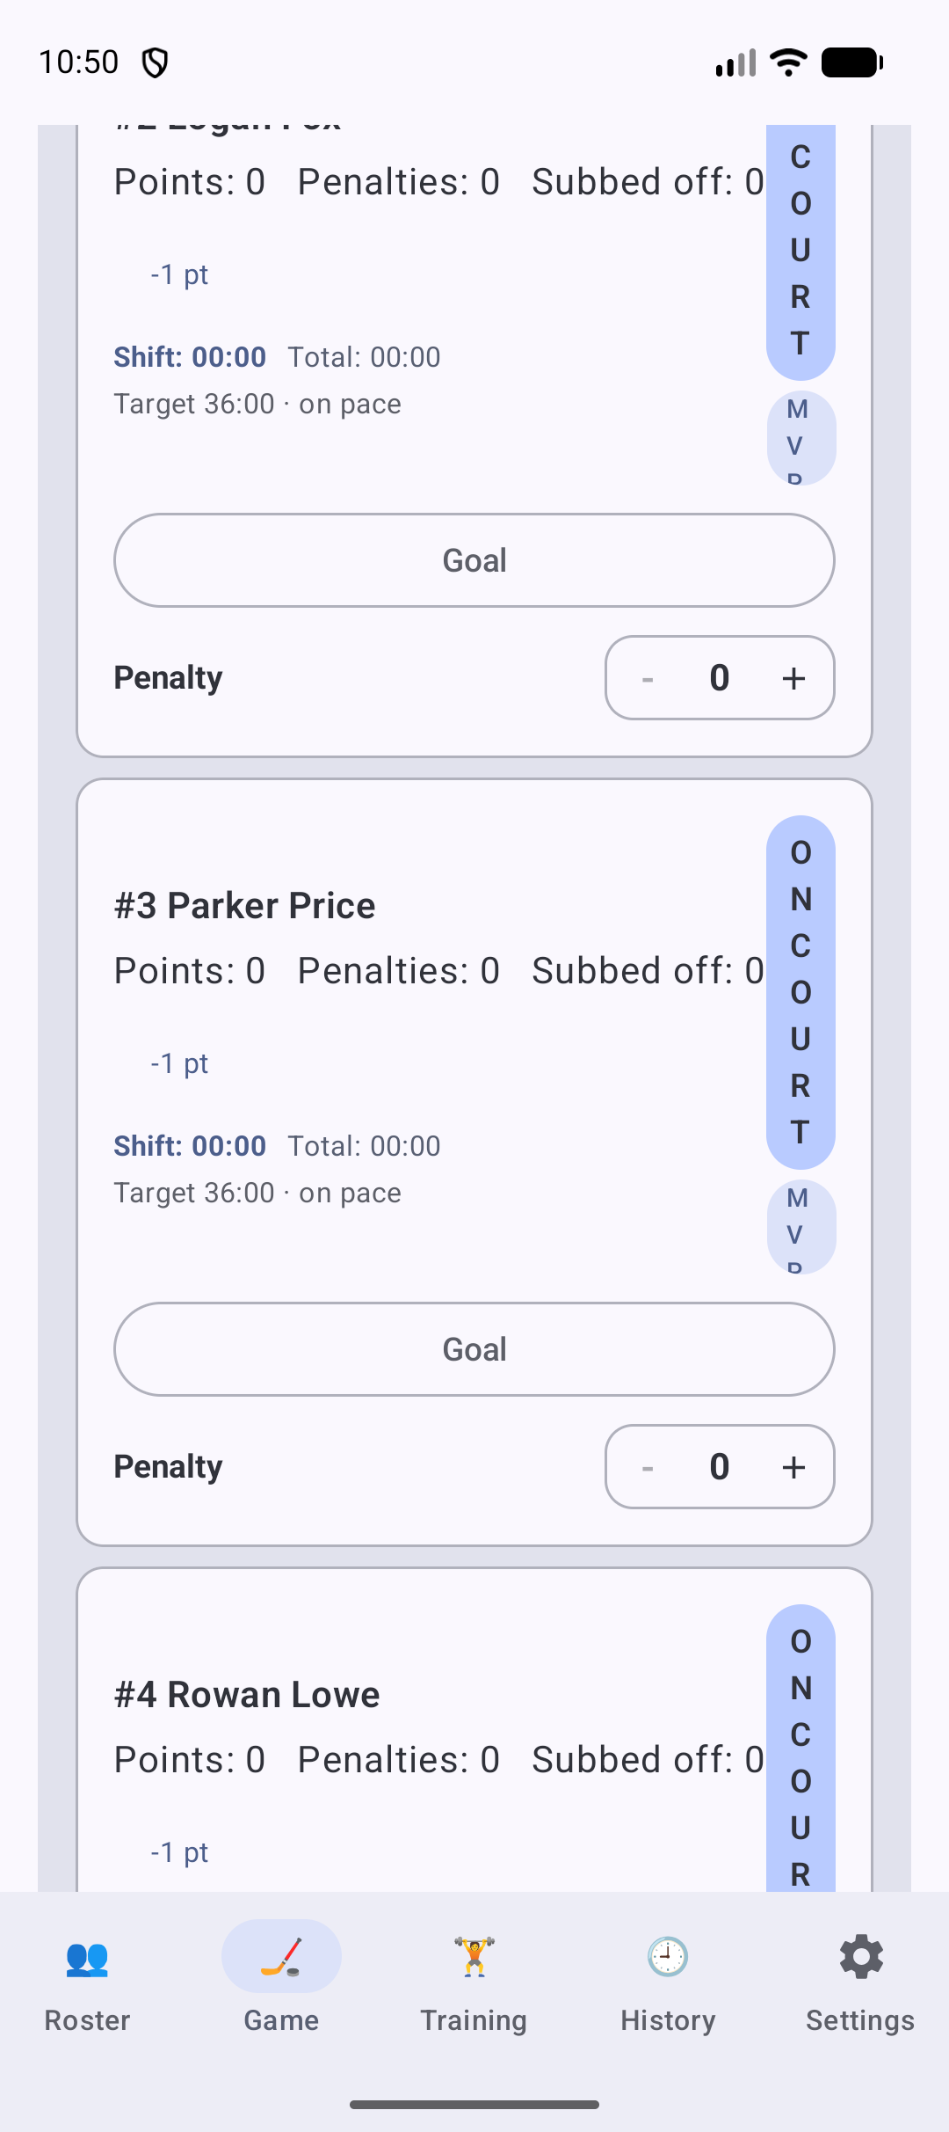
Ice Hockey: the Game tab with the players on court. Scroll to see the scoring and infraction controls for each player.

Water Polo
Category: Ice & Water
Setting | What the app uses
On court | 7
Minimum to start | 7 (World Aquatics)
Positions | GK, Driver, Hole Set, Wing, Point
Default periods | 4 periods, 8 minutes each
Scoring buttons | Goal (1)
Infraction | Exclusion
Keeper | GK plays the whole game

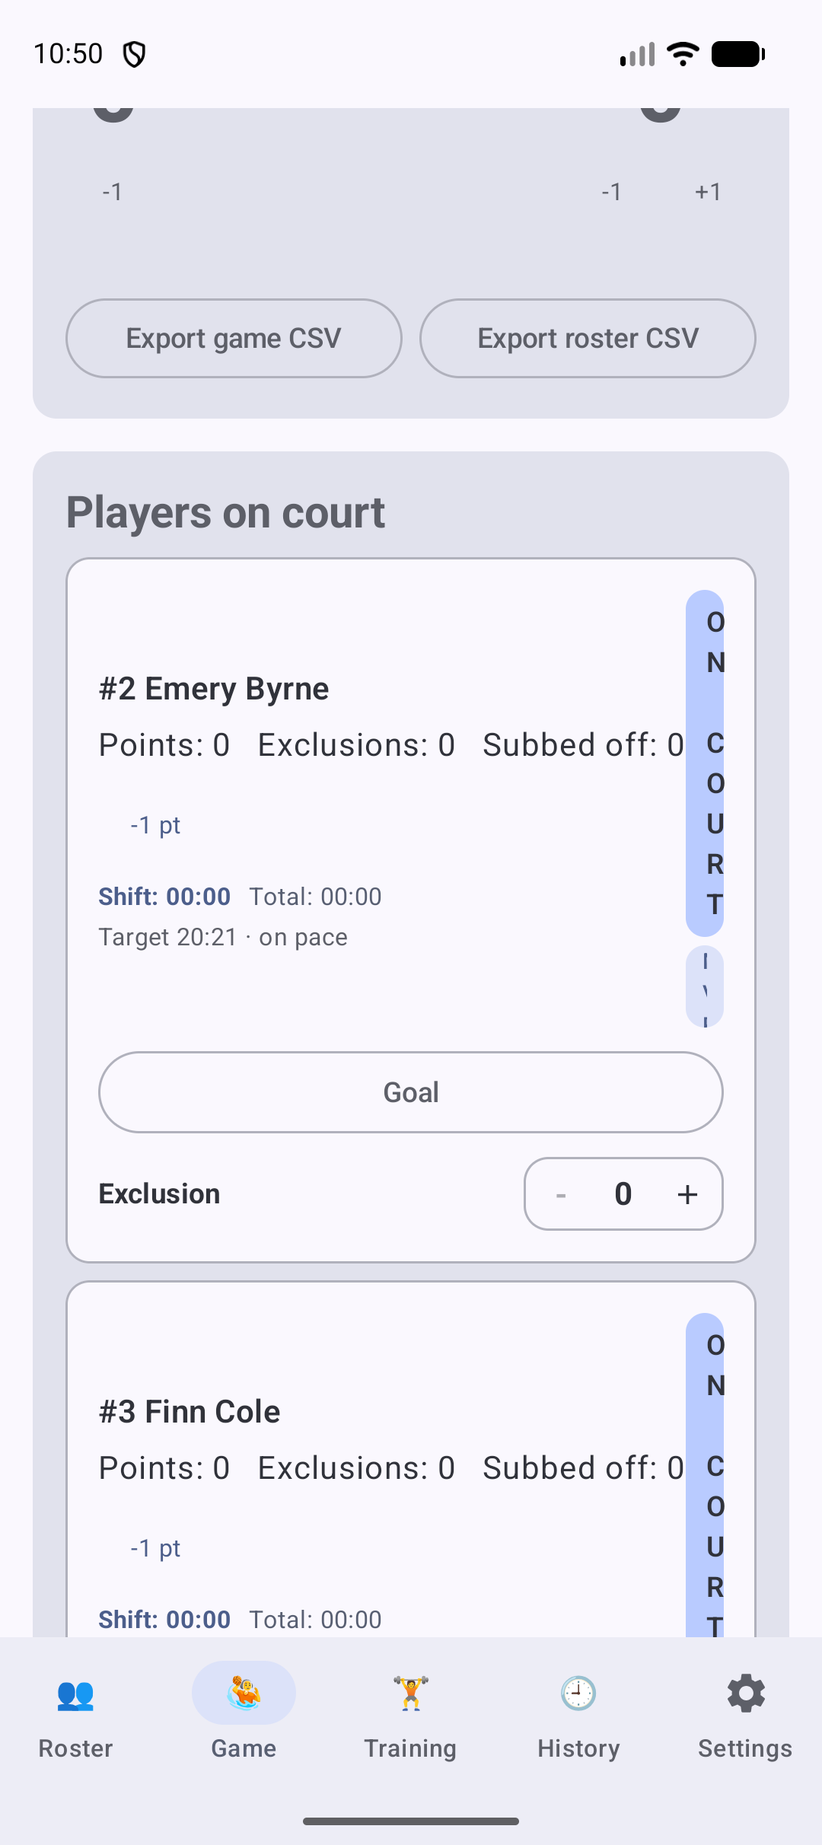
Water Polo: the Game tab with the players on court. Scroll to see the scoring and infraction controls for each player.

7. Other tabs
- History: lists finished games, newest first, with win, loss or tie, final score and date. It also shows a season summary for the sport: games played, points, minutes and MVP votes for each player. Export or delete a game from here.
- Training: generates age-group drills with an AI provider (Gemini, Claude, ChatGPT or a custom endpoint). Add that provider's API key in Settings first. Each drill has a Report button.
- Settings: switch sport, change the language, set the minimum number of players to field a team, substitution suggestions and notifications, the AI provider and key, and back up or restore all data. Delete options only affect the current sport, unless you choose to delete everything.

8. Good to know
- Each sport keeps its own roster and games. Switching sport does not delete any data.
- A backup from Settings includes every sport's players and games, but not API keys.
- Finishing a game (End Game) removes it from the active list on the Game tab. It stays in History.
- Position labels are for information only. The app does not enforce each sport's positional rules.

