

Wish List Application

USER GUIDE

CHILDREN’S HOME NETWORK

Table of Contents

1.0 Application User Guide 3

1.1 User Functionalities 3

1.1.1 Creating a Wish List 4

1.2 Administrator Functionalities 6

1.2.1 Creating a Wish List 7

1.2.2 Creating a User Account 9

1.2.3 Managing a Wish List 10

1.2.3.1 Filter for a Wish List 11

1.2.3.2 Sort Wish Lists 11

1.2.3.3 Export Wish Lists to Excel 12

1.2.3.4 View a Wish List 12

1.2.3.5 Enter Donor Information 13

1.2.3.6 Update if Gift Received 14

1.2.3.7 Remove a Wish List 15

1.2.4 Managing a User Account 15

1.2.4.1 Update User Account Password 16

1.2.4.2 Remove User Account 17

1.2.5 Managing Wish List Alert 18

2.0 Salesforce User Guide 19

2.1 Running a Report 19

2.2 Export a Report 20

2.3 Creating a Report 22

2.4 Editing a Report 26

2.5 Creating a Wish List 28

2.6 Editing a Wish List 30

3.0 Technical User Guide 33

3.1 Where the Application is Hosted 33

3.2 Different Technologies Used 33

# Application User Guide

## User Functionalities

This is the outlined uses of a regular user of the application.

1. Navigate to http://chwl.herokuapp.com/

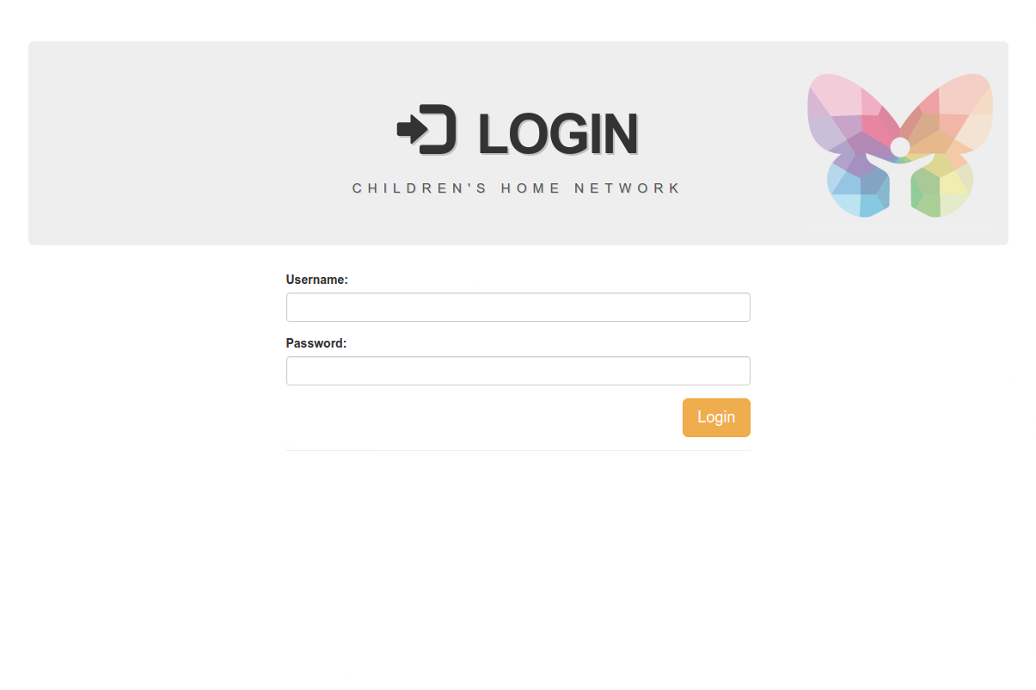

1. Log in as a regular user. You will be directed to the user home page.

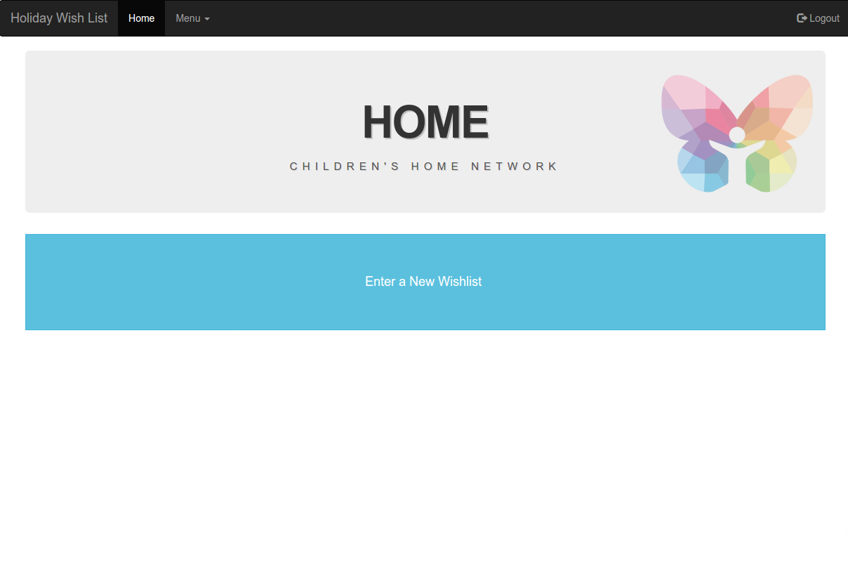

### Creating a Wish List

1. Navigate to the user home page.



1. Click on the blue button “Enter a New Wishlist.”
2. You will be directed to the “Holiday Wish List” page to create a wish list.

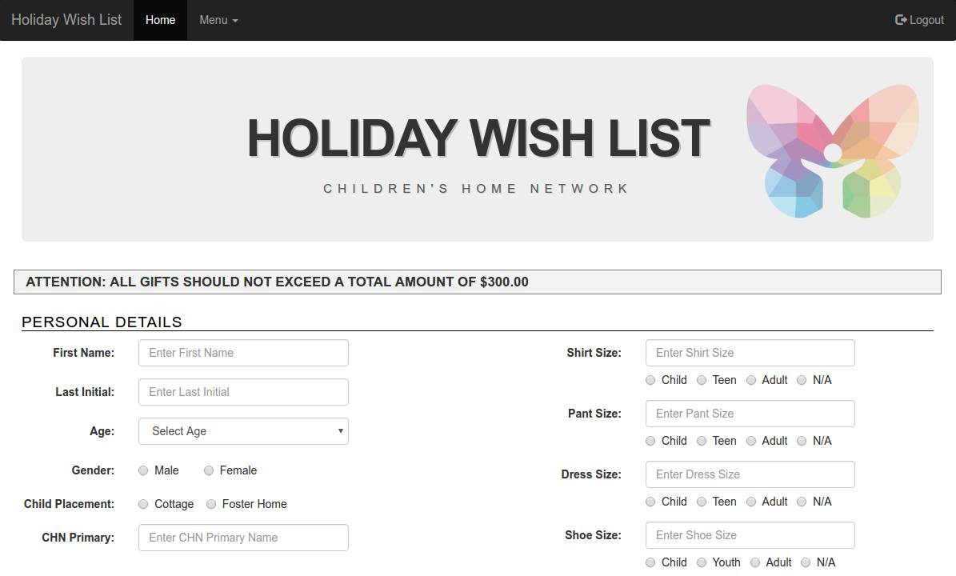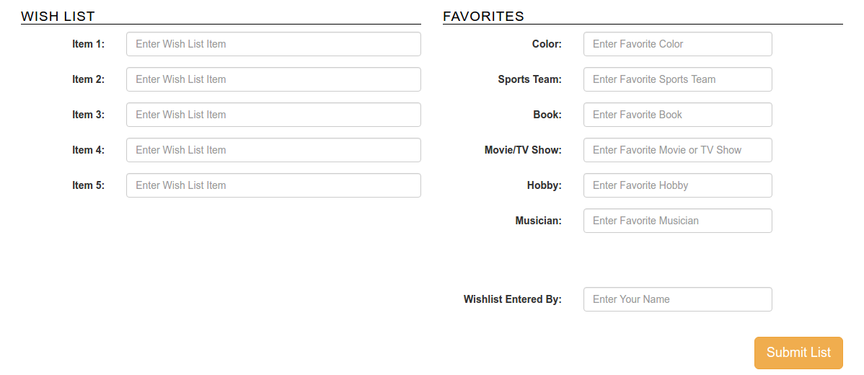

1. You will be navigated to the “Holiday Wish List” page to create a wish list. Enter all details and remember to read the “ATTENTION” message at the top of the page, as the contents may change from time to time.
   1. First Name: Enter the first name of the child. This is a required field.
   2. Last Initial: Enter the last initial of the child. This is a required field and you can only enter one character.
   3. Age: Select an age in the dropdown. This is a required field.
   4. Gender: Choose the gender of the child. This is a required field.
   5. Child Placement: Choose where the child is currently placed. This is a required field.
      1. If “Cottage” is chosen, enter the name of the cottage.
      2. If “Foster Home” is chosen, enter the name of the foster family.
   6. CHN Primary: Enter the name of the assigned Children’s Home Network primary. This is a required field.
   7. Shirt Size: Enter the shirt size and then choose what age gap of clothing size they fall into. If these fields do not apply, please enter “NA” and choose the “NA” radio button.
   8. Pant Size: Enter the pant size and then choose what age gap of clothing size they fall into. If these fields do not apply, please enter “NA” and choose the “NA” radio button.
   9. Dress Size: Enter the dress size and then choose what age gap of clothing size they fall into. If these fields do not apply, please enter “NA” and choose the “NA” radio button.
   10. Shoe Size: Enter the shoe size and then choose what age gap of shoe size they fall into. If these fields do not apply, please enter “NA” and choose the “NA” radio button.
   11. Item 1: Enter the child’s first wish list item. This is a required field.
   12. Item 2: Enter the child’s second wish list item. If there is no item to enter, leave blank.
   13. Item 3: Enter the child’s third wish list item. If there is no item to enter, leave blank.
   14. Item 4: Enter the child’s fourth wish list item. If there is no item to enter, leave blank.
   15. Item 5: Enter the child’s fifth wish list item. If there is no item to enter, leave blank.
   16. Color: Enter the child’s favorite color. This is a required field.
   17. Sports Team: Enter the child’s favorite sports team. If there is no favorite sports team, leave blank.
   18. Book: Enter the child’s favorite book. This is a required field.
   19. Movie/TV Show: Enter the child’s favorite movie and/or TV show. This is a required field.
   20. Hobby: Enter the child’s favorite hobby. This is a required field.
   21. Musician: Enter the child’s favorite musician or type of music. This is a required field.
   22. Wish list Entered By: As the individual who is submitting this list – enter your name. This is a required field.
2. After all the fields are completed, click on “Submit List” at the bottom of the page. After submission, the only people that can edit the wish list are the administrators of the application.

## Administrator Functionalities

This is the outlined uses of an admin user of the application.

1. Navigate to http://chwl.herokuapp.com/



1. Log in as an administrative user. You will be directed to the administrator home page.

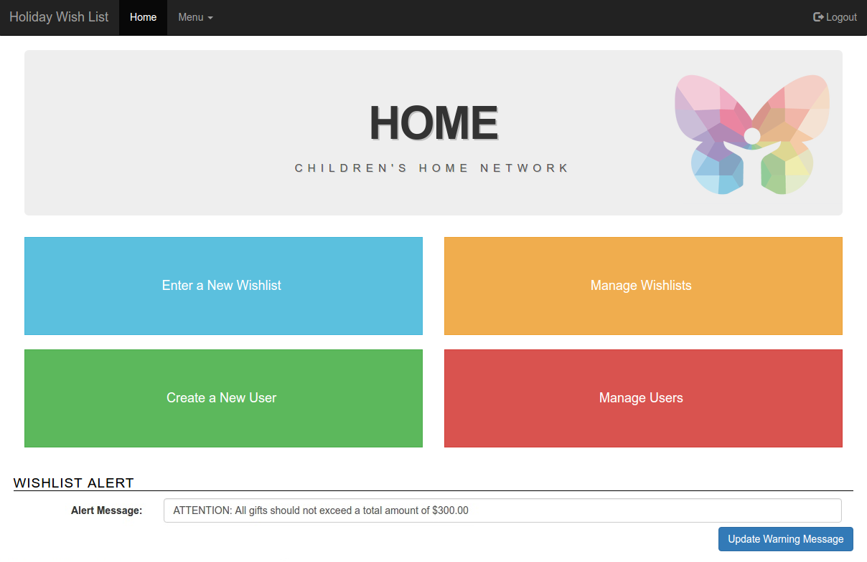

### Creating a Wish List

1. Navigate to the administrator home page.



1. Click on the blue button “Enter a New Wishlist.”
2. You will be directed to the “Holiday Wish List” page to create a wish list.



1. Enter all details and remember to read the “ATTENTION” message at the top of the page, as the contents may change from time to time.
   1. First Name: Enter the first name of the child. This is a required field.
   2. Last Initial: Enter the last initial of the child. This is a required field and you can only enter one character.
   3. Age: Select an age in the dropdown. This is a required field.
   4. Gender: Choose the gender of the child. This is a required field.
   5. Child Placement: Choose where the child is currently placed. This is a required field.
      1. If “Cottage” is chosen, enter the name of the cottage.
      2. If “Foster Home” is chosen, enter the name of the foster family.
   6. CHN Primary: Enter the name of the assigned Children’s Home Network primary. This is a required field.
   7. Shirt Size: Enter the shirt size and then choose what age gap of clothing size they fall into. If these fields do not apply, please enter “NA” and choose the “NA” radio button.
   8. Pant Size: Enter the pant size and then choose what age gap of clothing size they fall into. If these fields do not apply, please enter “NA” and choose the “NA” radio button.
   9. Dress Size: Enter the dress size and then choose what age gap of clothing size they fall into. If these fields do not apply, please enter “NA” and choose the “NA” radio button.
   10. Shoe Size: Enter the shoe size and then choose what age gap of shoe size they fall into. If these fields do not apply, please enter “NA” and choose the “NA” radio button.
   11. Item 1: Enter the child’s first wish list item. This is a required field.
   12. Item 2: Enter the child’s second wish list item. If there is no item to enter, leave blank.
   13. Item 3: Enter the child’s third wish list item. If there is no item to enter, leave blank.
   14. Item 4: Enter the child’s fourth wish list item. If there is no item to enter, leave blank.
   15. Item 5: Enter the child’s fifth wish list item. If there is no item to enter, leave blank.
   16. Color: Enter the child’s favorite color. This is a required field.
   17. Sports Team: Enter the child’s favorite sports team. If there is no favorite sports team, leave blank.
   18. Book: Enter the child’s favorite book. This is a required field.
   19. Movie/TV Show: Enter the child’s favorite movie and/or TV show. This is a required field.
   20. Hobby: Enter the child’s favorite hobby. This is a required field.
   21. Musician: Enter the child’s favorite musician or type of music. This is a required field.
   22. Wish list Entered By: As the individual who is submitting this list – enter your name. This is a required field.
2. After all the fields are completed, click on “Submit List” at the bottom of the page. After submission, the only people that can edit the wish list are the administrators of the application.

### Creating a User Account

1. Navigate to the administrator home page.



1. Click on the green button “Create a New User.”
2. You will be directed to the “Create New User” page.

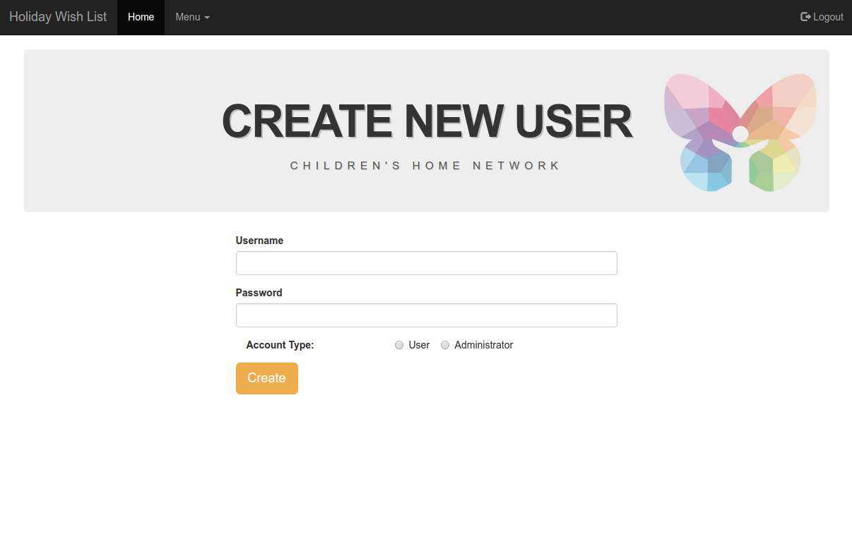

1. Enter the new user account details.
   1. Username: The desired user account name. This is case sensitive.
   2. Password: The desired password for the account. This is case sensitive.
   3. Account Type: This is to determine if they are a regular user or an administrator. This is defaulted to a regular user.
2. Click on “Create” to create the user account.

### Managing a Wish List

1. Navigate to the administrator home page.



1. Click on the orange button “Manage Wishlists.”
2. You will be directed to the “Manage Wishlists” page.

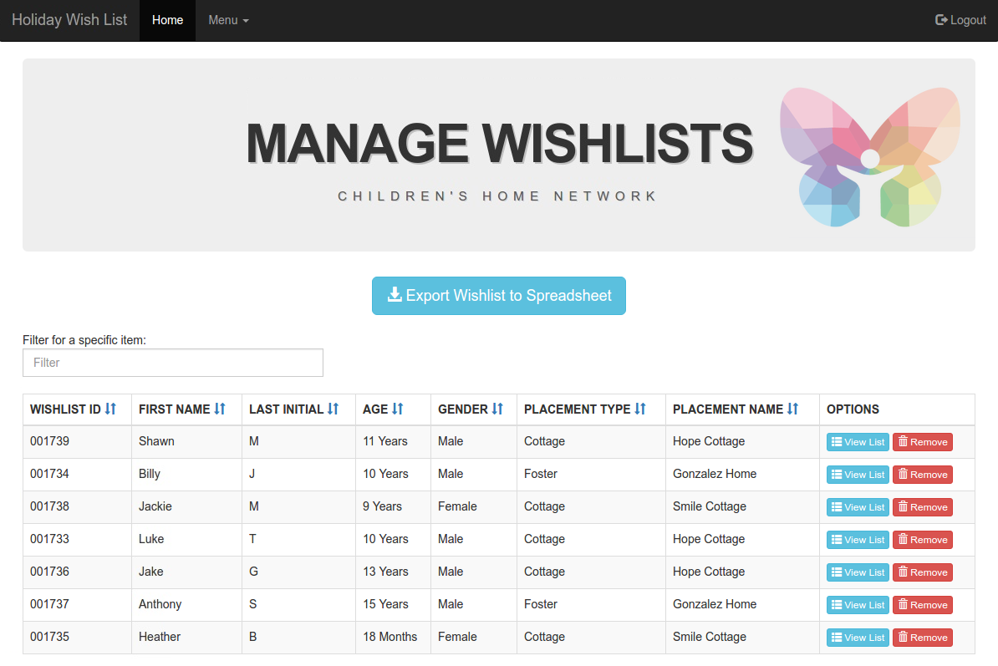

##### Filter for a Wish List

* 1. Enter text in the below outlined field to filter for specific wish lists.

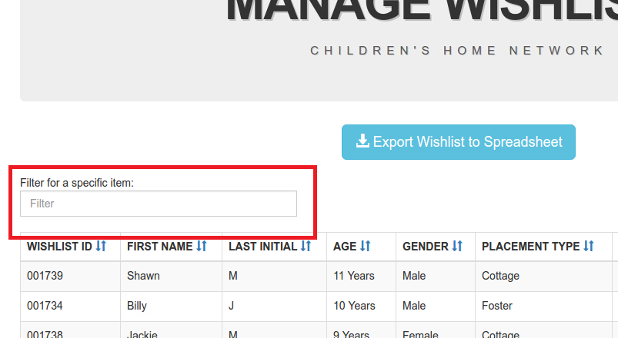

##### Sort Wish Lists

* 1. Click on any of the below outlined arrows to sort the wish lists by those fields.

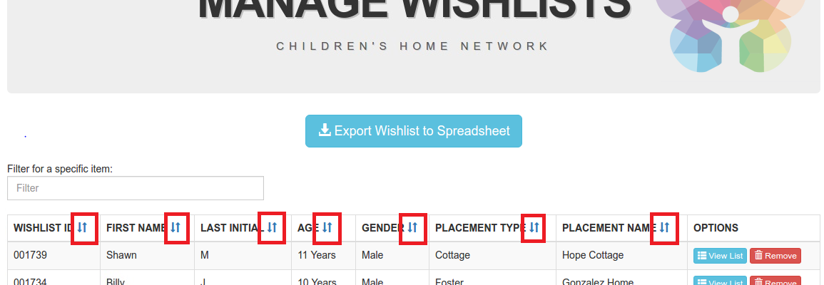

##### Export Wish Lists to Excel

1. Click on the button named “Export Wishlist to Spreadsheet” to export the wish lists to an excel spreadsheet.

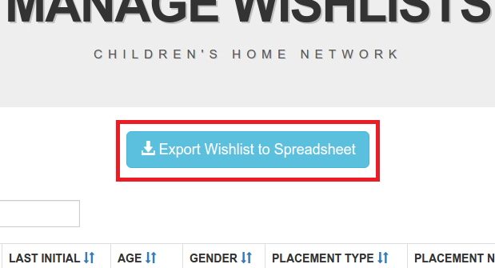

##### View a Wish List

1. Click on “View List” button next to the desired wish list that you are trying to observe.

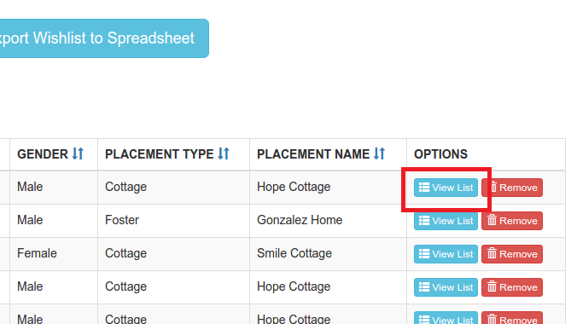

##### Enter Donor Information

1. Click on “View List” button next to the desired wish list that you are trying to add a Donor to.



1. After clicking, a pop up will display. In the “Donor Name” field, enter the Donor name.

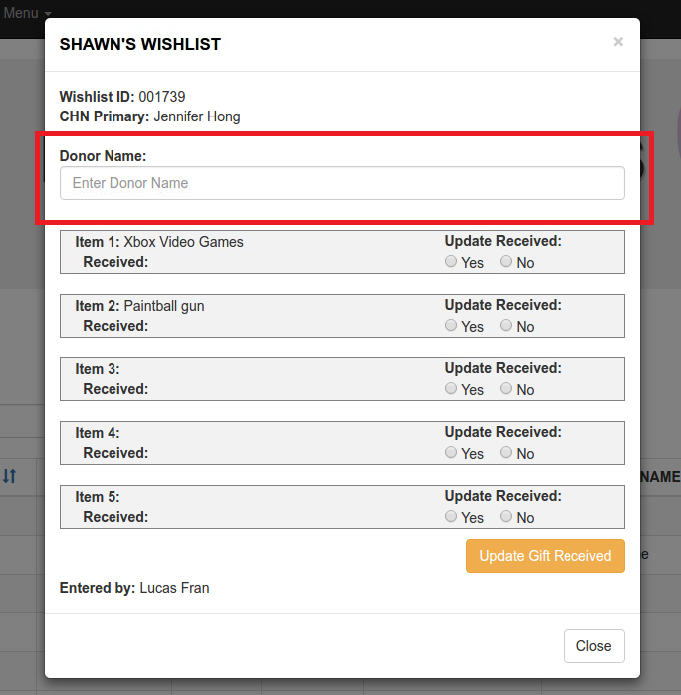

1. Click on “Update Gift Received” to save your changes.

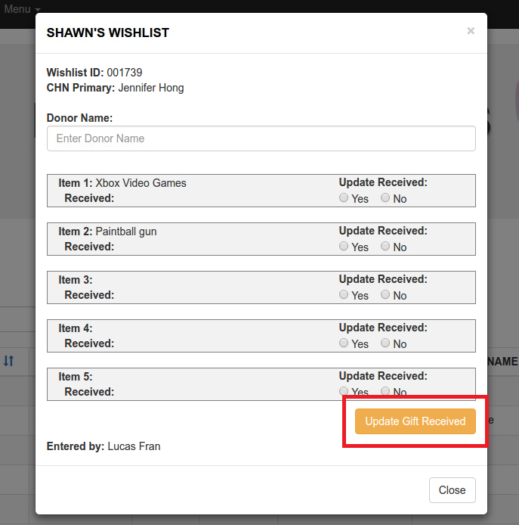

##### Update if Gift Received

1. Click on “View List” button next to the desired wish list that you are trying to add a Donor to.



1. After clicking, a pop up will display. Next to each item is an “Update Received” field. Choose one of the Yes/No options.

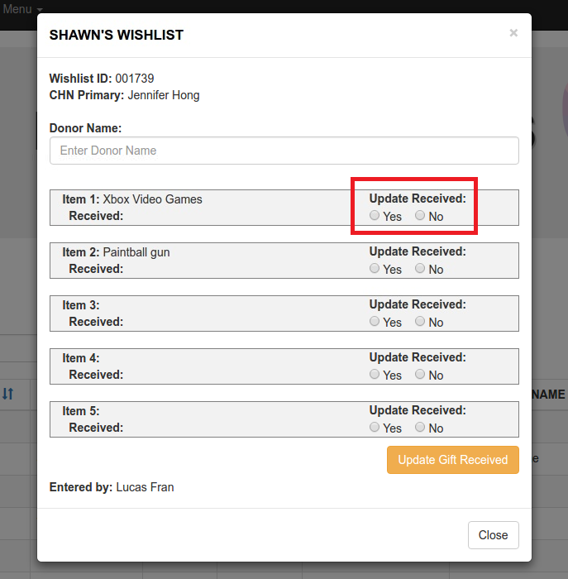

1. Click on “Update Gift Received” to save your changes.



##### Remove a Wish List

1. Click on “Remove” button next to the desired wish list that you would like to delete.

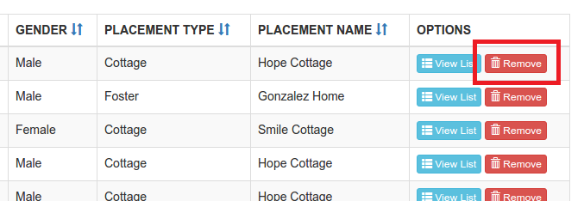

### Managing a User Account

1. Navigate to the administrator home page.



1. Click on the red button “Manage Users.”
2. You will be directed to the “Manage Users” page.

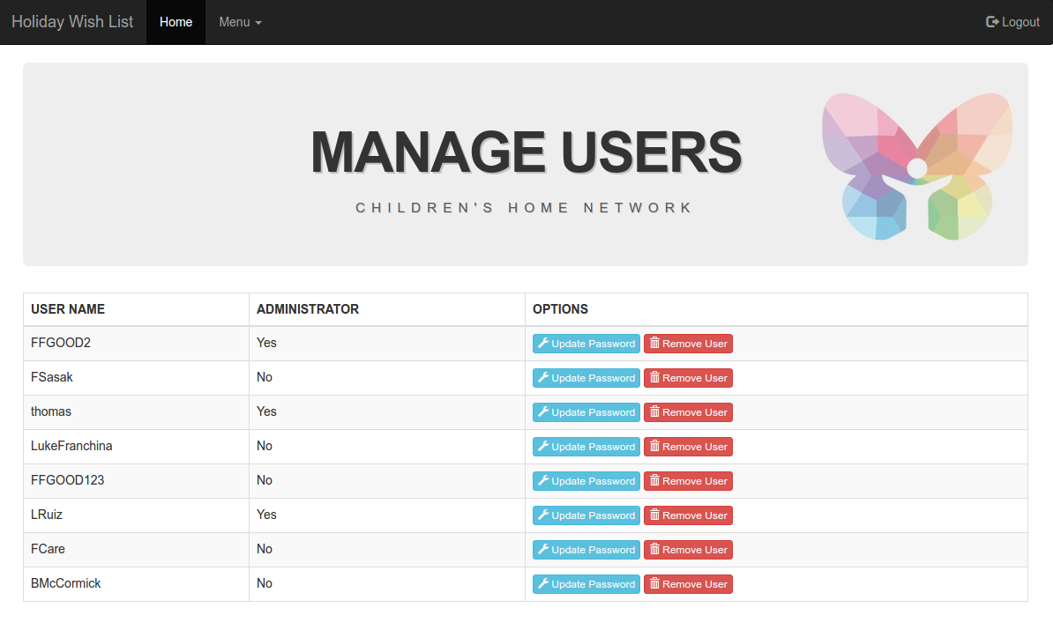

##### Update User Account Password

1. Click on “Update Password” button next to the desired user account that you wish to change the password to.

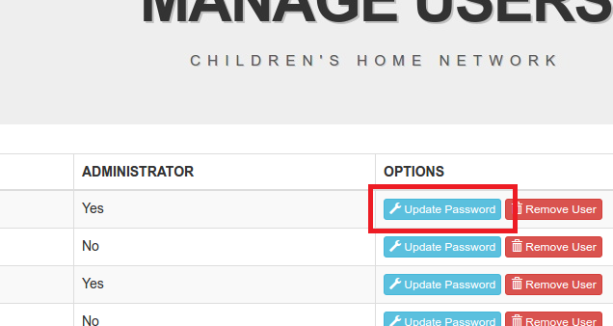

1. After clicking, a pop up will display with a field labeled “Change Password.” Enter the new password.

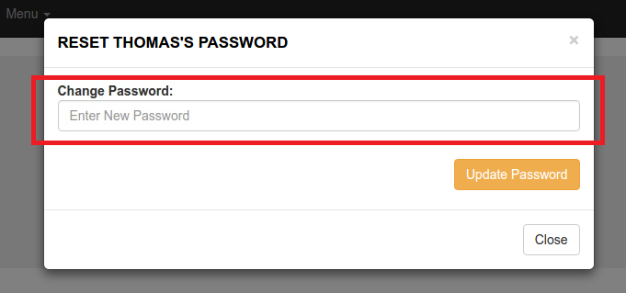

1. Click on “Update Password” to save your changes.

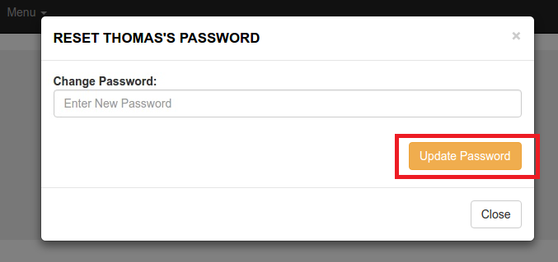

##### Remove User Account

1. Click on “Remove User” button next to the desired user account that you would like to delete.

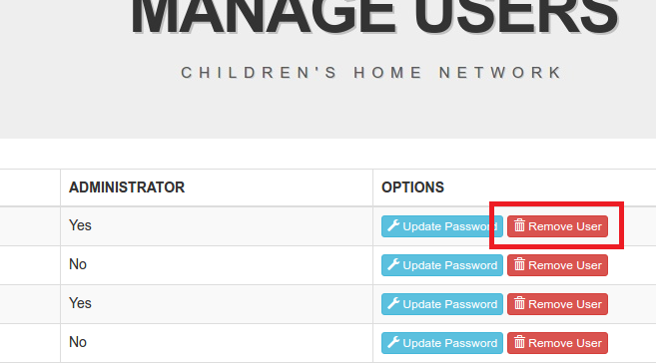

### Managing Wish List Alert

1. Navigate to the administrator home page.



1. Update the “Alert Message” text to your desire.

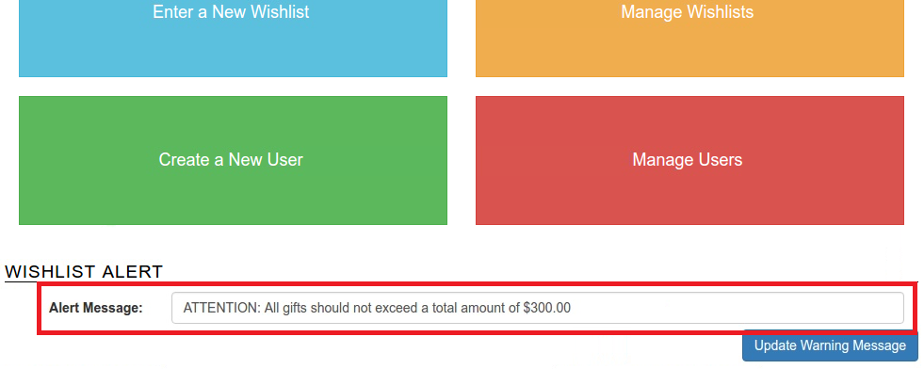

1. Click on “Update Warning Message” to save your changes.

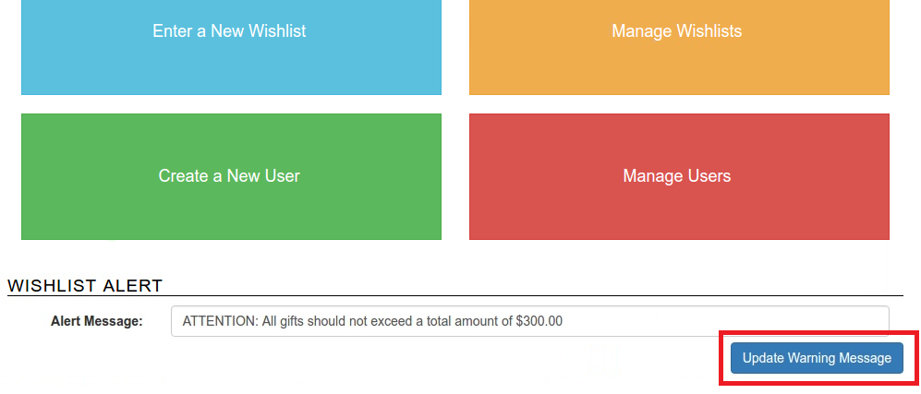

# Salesforce User Guide

### Running a Report

1. After you log into Salesforce, navigate to the reports tab.

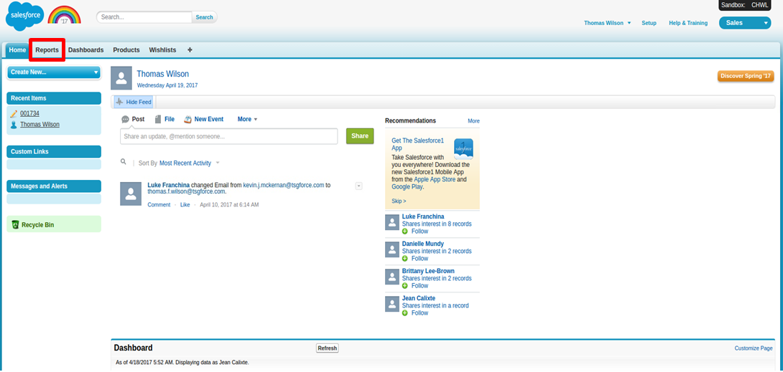

1. Click on any listed report to view it.

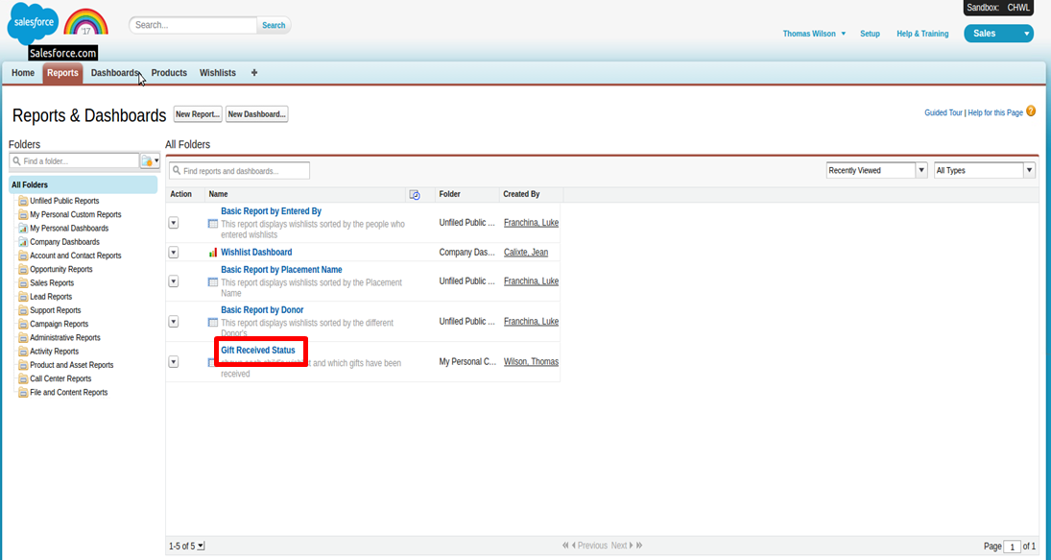

1. When you are in the report of your choice, click on “Run Report” to run a report.

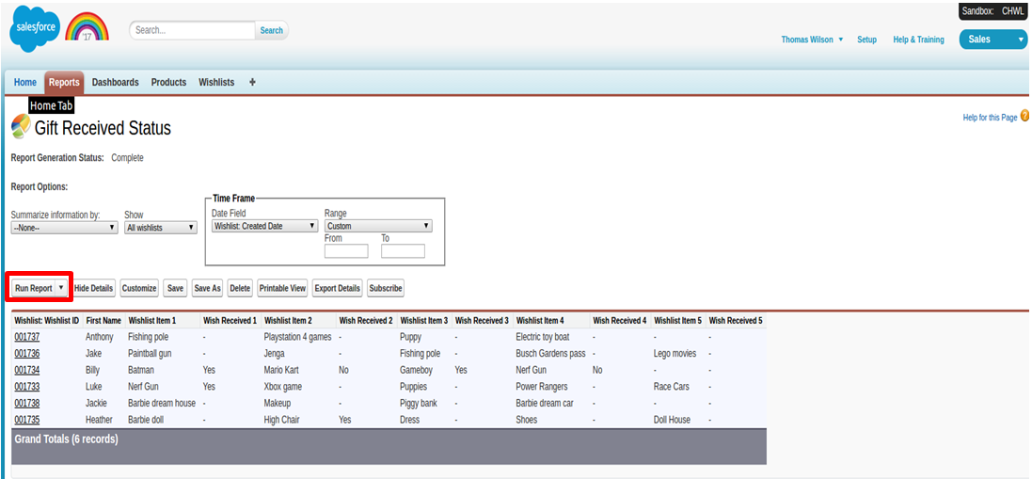

### Export a Report

1. After you log into Salesforce, navigate to the reports tab.



1. Click on any listed report to view it.



1. When you are in the report of your choice, click on “Export Details” to export a report to excel.

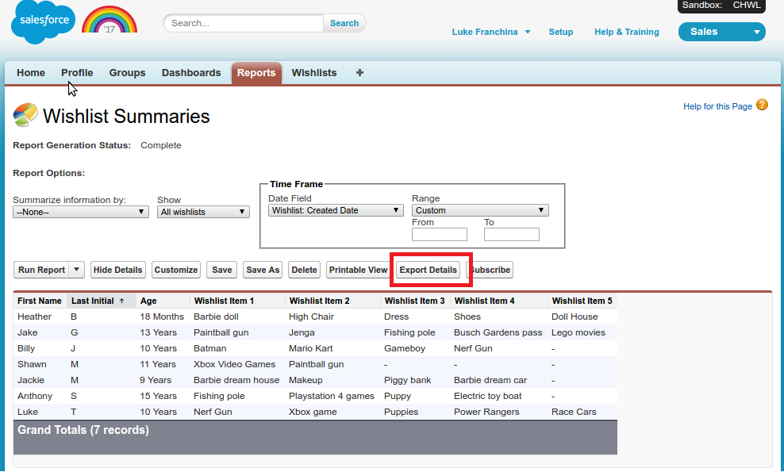

1. Click on “Export” to export the list to an excel sheet.

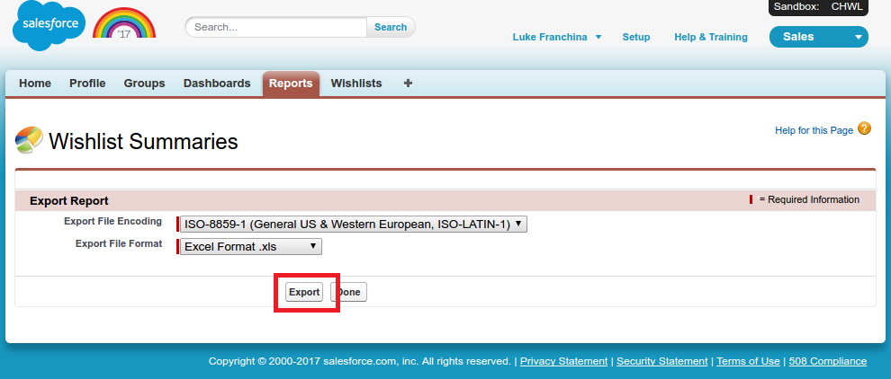

### Creating a Report

1. After you log into Salesforce, navigate to the reports tab.



1. Click on “New Report” at the top of the “Reports & Dashboards” page.

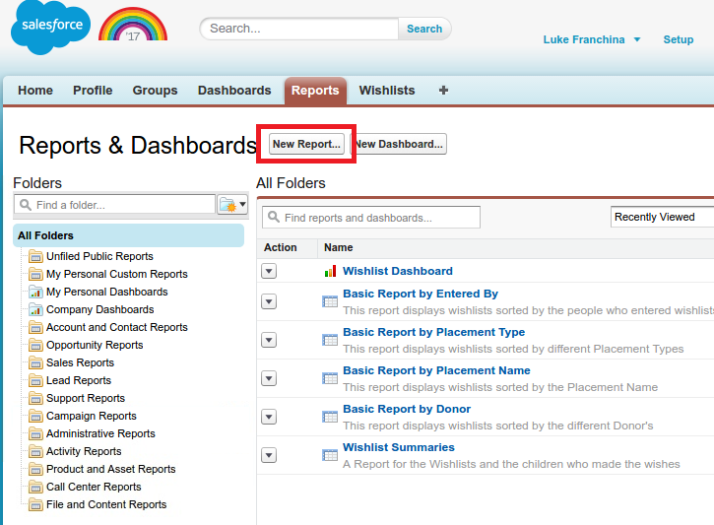

1. Under “Other Reports” Select “Wishlists”

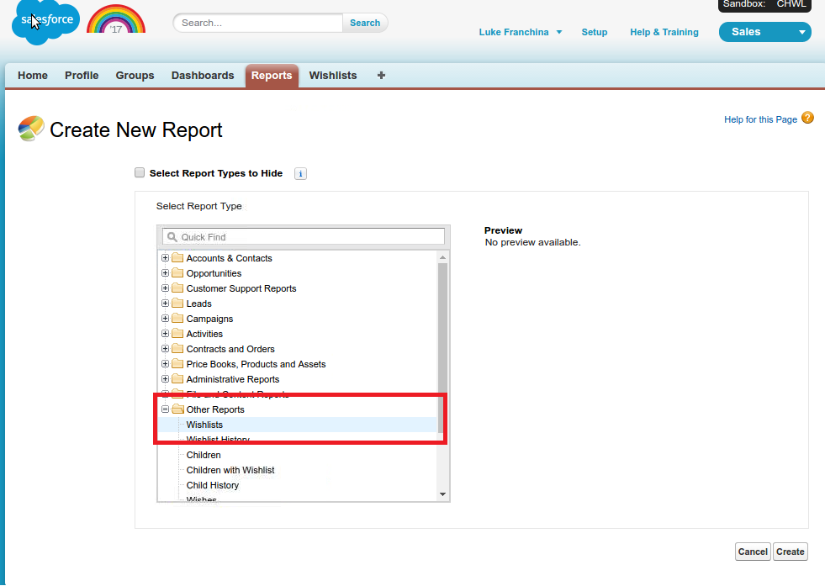

1. Then select the “Create” button.

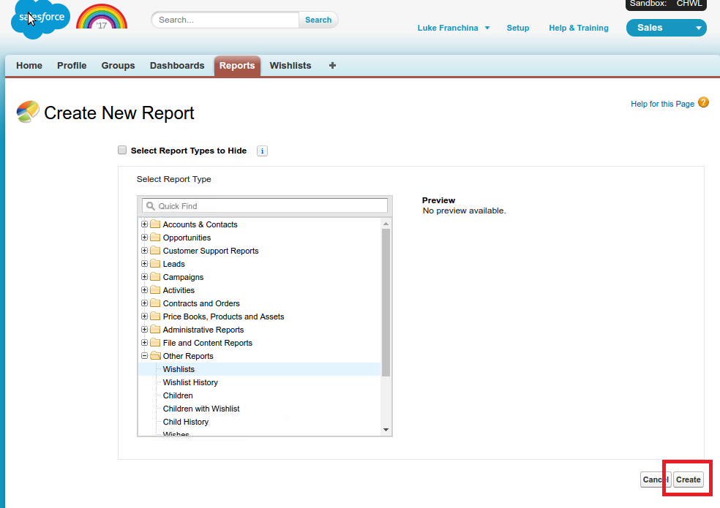

1. Drag and drop the fields that you would like to be included in the report.

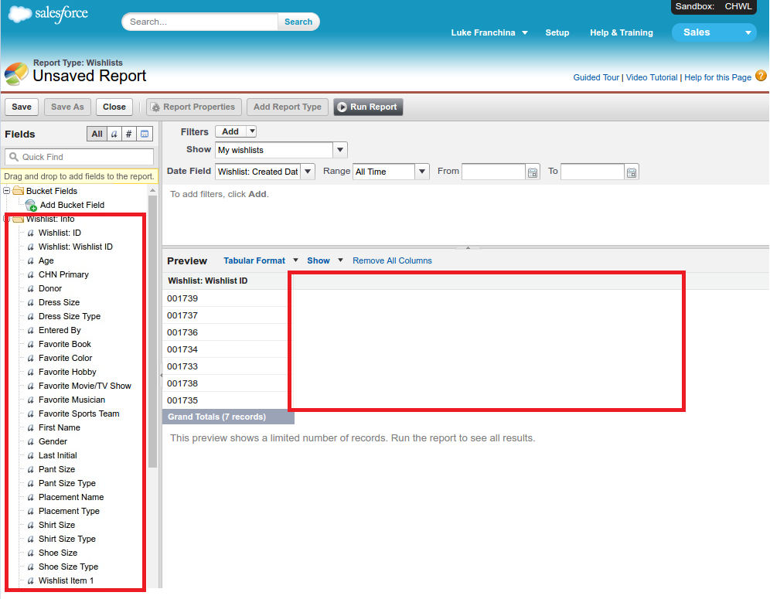

1. Click on the “Save” button at the top of the page.

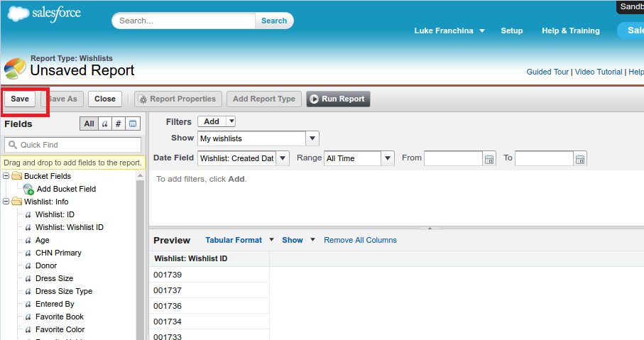

1. Name the report what you would like it to be named and include any description of what it is. Then click “Save.”

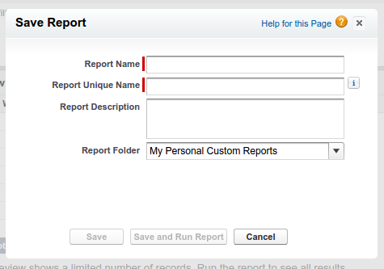

### Editing a Report

1. After you log into Salesforce, navigate to the reports tab.



1. Click on any listed report to view it.



1. When you are in the report of your choice, click on “Customize” to edit the fields.

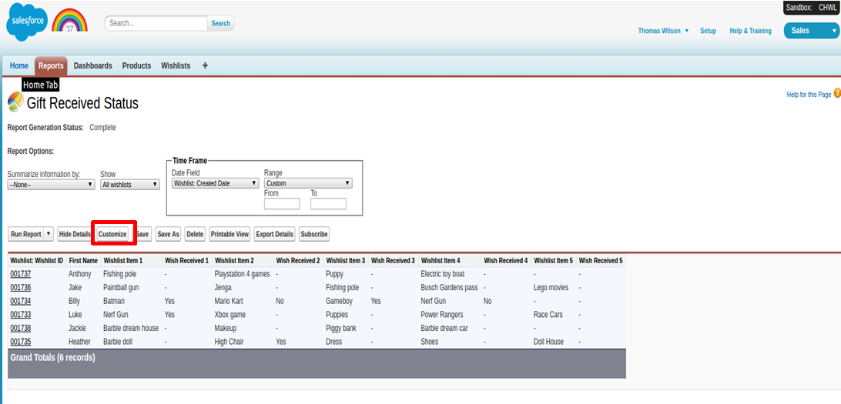

1. Drag and drop the fields to wish you add to the report, remove from the report, or rearrange the order of the items in the report.

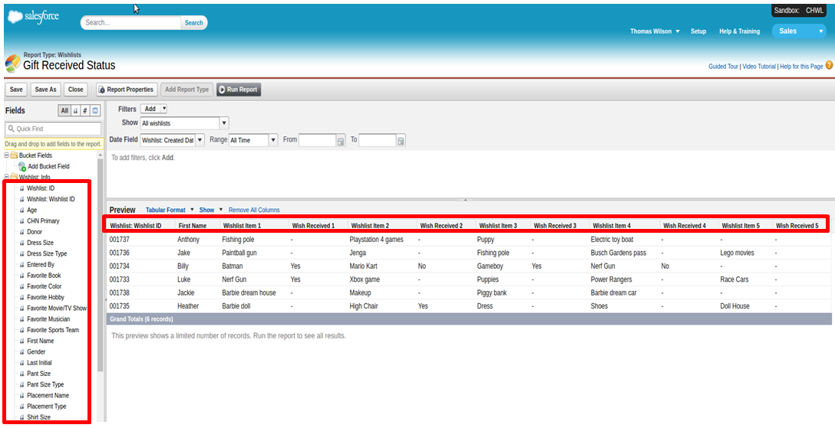

1. Click “Save” to save your changes.

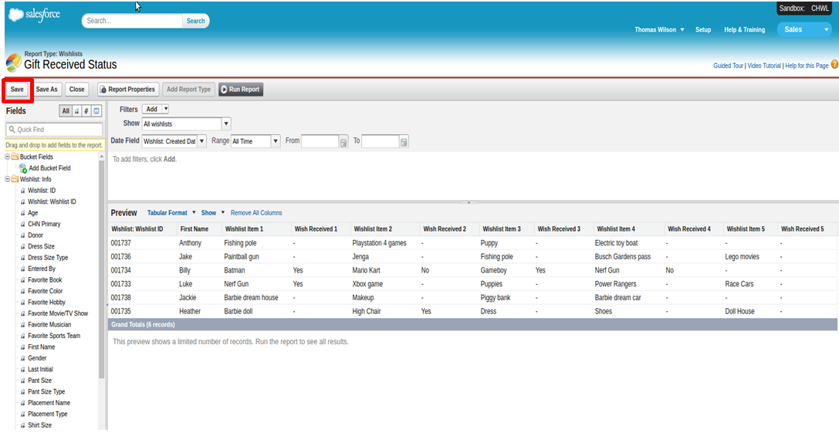

### Creating a Wish List

1. Navigate to the “Wishlist” tab.

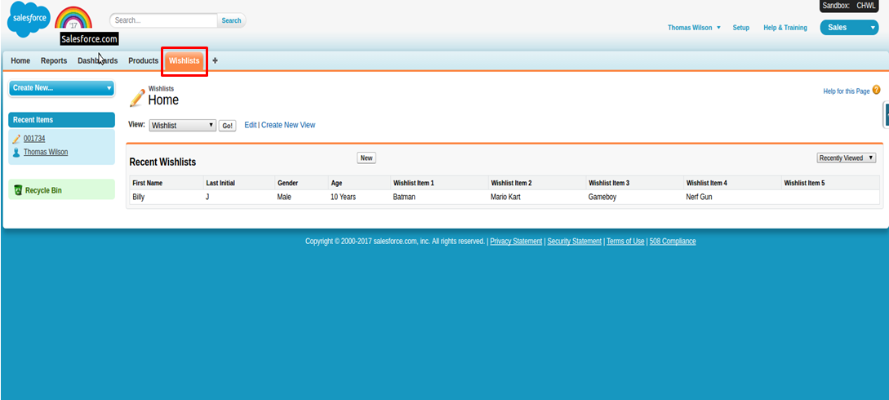

1. When on the Wishlist page, click on “New” to enter a new wish list.

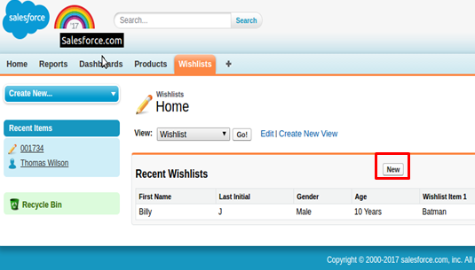

1. It will then bring you to the next page where you will be able to enter the wish list fields.

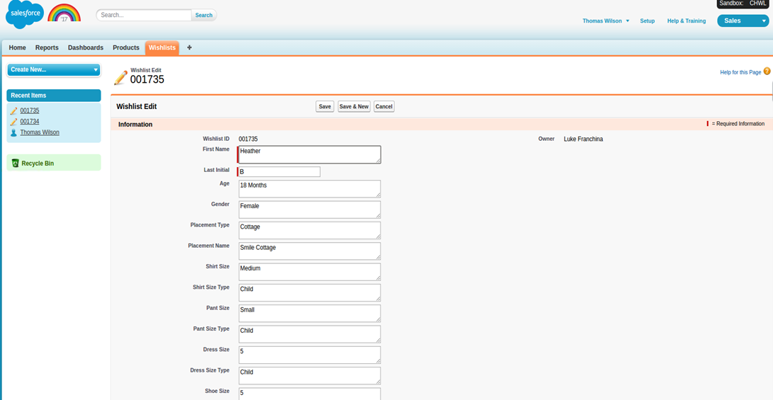

1. When finished, click on the “Save” button to create the new wish list.

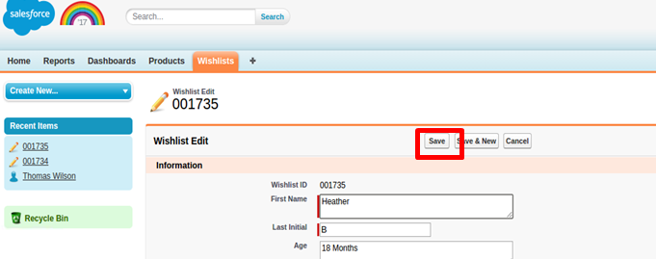

### Editing a Wish List

1. Navigate to the “Wishlist” tab.



1. When on the Wishlist page, make sure you choose the “View” option that you would like to see.

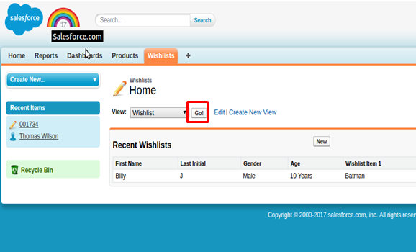

1. It will then bring you to the next page where you will be able to click on the “Edit” button next to the wish list you desire to change.

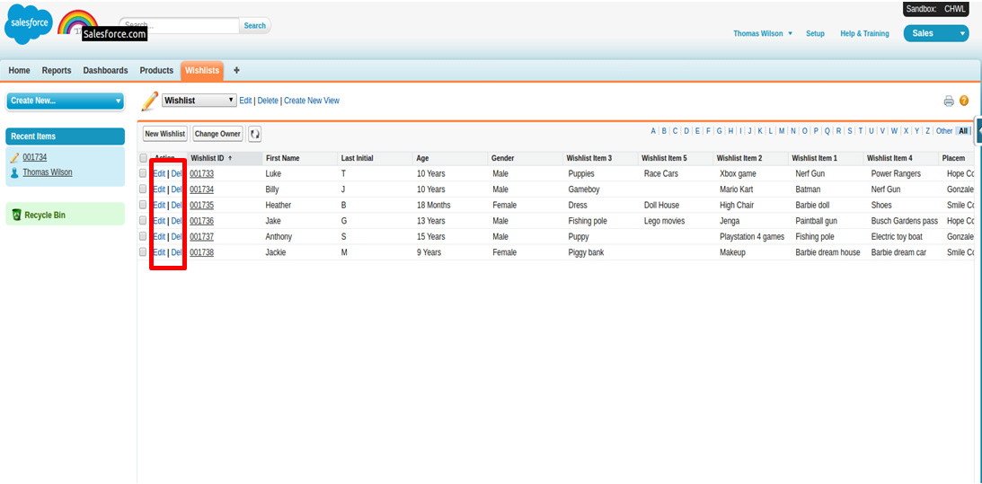

1. On the next page, make the necessary changes to the wish list.



1. When finished with your changes, click on the “Save” button to save the changes.



# Technical User Guide

### Where the Application is Hosted

The application is hosted on Heroku, which is described as a cloud Platform-as-a-Service which supports several programming languages that is used as a web application deployment model.

Heroku allows us to host the code on a platform which the Children’s Home Network will not have to manage. Everything to do with updating technology comes from Heroku themselves, so there is virtually no maintenance needed.

### Different Technologies Used

* PostgreSQL – The open sourced relational database that is being used and that is hosted on Heroku. It is not controlled by any corporation or other private entity and the source code is available free of charge.
* Sequelize – This is a promise-based ORM (Object-relational mapping) for Node.js and io.js. It supports the dialects PostgreSQL, MySQL, MariaDB, SQLite and MSSQL and features solid transaction support, relations, read replication and more.
* NodeJS – Node.js is a platform that allows JavaScript to be used outside the Web Browsers, for creating web and network applications. It uses an event-driven, non-blocking I/O model that makes it lightweight and efficient, perfect for data-intensive real-time applications that run across distributed devices.
* Express – Express is a minimal and flexible Node.js web application framework that provides a robust set of features to develop web and mobile applications.
* AngularJS – AngularJS is a structural framework for dynamic web apps. It lets you use HTML as your template language and lets you extend HTML's syntax to express your application's components clearly and succinctly. AngularJS's data binding and dependency injection eliminate much of the code you would otherwise have to write.