

[www.childrenshome.org](http://www.childrenshome.org/default.aspx)

[**Mission**](https://confluence.uk.jpmorgan.com/confluence/display/FORCEFORGOOD/2016+-+The+Children%27s+Home+Network#id-2016-TheChildren'sHomeNetwork-Mission)**-** [**Organization Overview**](https://confluence.uk.jpmorgan.com/confluence/display/FORCEFORGOOD/2016+-+The+Children%27s+Home+Network#id-2016-TheChildren'sHomeNetwork-OrganizationOverview)**-** [**Team Members**](https://confluence.uk.jpmorgan.com/confluence/display/FORCEFORGOOD/2016+-+The+Children%27s+Home+Network#id-2016-TheChildren'sHomeNetwork-TeamMembers)[**Overall Project Status**](https://confluence.uk.jpmorgan.com/confluence/display/FORCEFORGOOD/2016+-+The+Children%27s+Home+Network#id-2016-TheChildren'sHomeNetwork-OverallProjectStatus)**-** [**Milestones**](https://confluence.uk.jpmorgan.com/confluence/display/FORCEFORGOOD/2016+-+The+Children%27s+Home+Network#id-2016-TheChildren'sHomeNetwork-Milestones)**-** [**Project Vision**](https://confluence.uk.jpmorgan.com/confluence/display/FORCEFORGOOD/2016+-+The+Children%27s+Home+Network#id-2016-TheChildren'sHomeNetwork-ProjectVision)**-** [**Social Impact**](https://confluence.uk.jpmorgan.com/confluence/display/FORCEFORGOOD/2016+-+The+Children%27s+Home+Network#id-2016-TheChildren'sHomeNetwork-SocialImpact)**-** [**Project Approach**](https://confluence.uk.jpmorgan.com/confluence/display/FORCEFORGOOD/2016+-+The+Children%27s+Home+Network#id-2016-TheChildren'sHomeNetwork-ProjectApproach)**-** [**Meeting Agendas**](https://confluence.uk.jpmorgan.com/confluence/pages/viewpage.action?pageId=566034312)

|  |  |
| --- | --- |
| **Mission** | The Children's Home strengthens communities through programs that support, serve and protect children and their families. |
| **Organization Overview** | The Children's Home Network is a child- and family-centered organization that is positioned to care for struggling families and children seeking the comfort of a loving family. With roots that can be traced back to 1892, we have been a beacon in the community—providing a safe haven for children who have suffered abuse, neglect or abandonment. The tradition of love sparked by our founders continues to be our driving force to protect, heal and care for Tampa Bay's children and families.  We believe children deserve the opportunity to have a happy childhood.  We believe families deserve a chance to be successful.  These values are the essence of our mission to create a community where children and families feel loved, nurtured, and safe. Children need love.  Families need security.  That's why we are charged with being the source of strength and opportunity for children and families.  Through our nationally recognized residential therapeutic program to our Family Support and Resource Centers, we have impacted the lives of many who rely on support and care during times of uncertainty. In 2016, we cared for more than 25,000 children in the community. The Children's Home Network is a local 501 (C)(3) not-for-profit organization serving the Central Florida region. |

|  |  |  |  |  |  |  |  |  |  |
| --- | --- | --- | --- | --- | --- | --- | --- | --- | --- |
| https://confluence.uk.jpmorgan.com/confluence/download/thumbnails/508986429/MaryLou_Stanley.PNG?version=1&modificationDate=1493064805000&api=v2 | Peter Cruikshank | https://confluence.uk.jpmorgan.com/confluence/download/thumbnails/508986429/missing-mcsanl.gov_.png?version=1&modificationDate=1469031205000&api=v2 | https://confluence.uk.jpmorgan.com/confluence/download/attachments/508986429/Luke%20Franchina.PNG?version=1&modificationDate=1493039554000&api=v2 | https://confluence.uk.jpmorgan.com/confluence/download/attachments/508986429/Brittany_Brown.PNG?version=1&modificationDate=1493039778000&api=v2 | Danielle Mundy | https://confluence.uk.jpmorgan.com/confluence/download/thumbnails/508986429/Sharon_Wong.jpg?version=1&modificationDate=1493071517000&api=v2 | https://confluence.uk.jpmorgan.com/confluence/download/thumbnails/508986429/missing-mcsanl.gov_.png?version=1&modificationDate=1469031205000&api=v2 | https://confluence.uk.jpmorgan.com/confluence/download/thumbnails/508986429/missing-mcsanl.gov_.png?version=1&modificationDate=1469031205000&api=v2 | https://confluence.uk.jpmorgan.com/confluence/download/thumbnails/508986429/missing-mcsanl.gov_.png?version=1&modificationDate=1469031205000&api=v2 |
| **[MaryLou Stanley](https://phone.jpmchase.net/phone/phonebook.htm" \l "type=profile&standardID=N003208)**  *Client Lead* | [**Peter Cruikshank**](https://phone.jpmchase.net/phone/phonebook.htm#type=profile&standardID=U233326)  *Project Lead* | [**Rajmohan Naidu**](https://phone.jpmchase.net/phone/phonebook.htm#type=profile&standardID=R157369)  *Technical Lead* | [**Luke Franchina**](https://phone.jpmchase.net/phone/phonebook.htm#type=profile&standardID=I665011)  *Core Team Lead* | [**Brittany Brown**](https://phone.jpmchase.net/phone/phonebook.htm#type=profile&standardID=I659420)  *Core Team* | [**Danielle Mundy**](https://phone.jpmchase.net/phone/phonebook.htm#type=profile&standardID=D557063)  *Core Team* | [**Sharon Wong**](https://phone.jpmchase.net/phone/phonebook.htm#type=profile&standardID=V679871)  *Core Team* | [**Tom Wilson**](https://phone.jpmchase.net/phone/phonebook.htm#type=profile&standardID=V653931)  *Core Team* | [***Roman Sloan***](https://phone.jpmchase.net/phone/phonebook.htm#type=profile&standardID=F603103)  *Core Team* | [**Matt Miller**](https://phone.jpmchase.net/phone/phonebook.htm#type=profile&standardID=R580059)  *Core Team* |



|  |  |
| --- | --- |
| **Overall Project Status** |  |
| **Milestones** | |
| **Project Launch** | |
| Internal Team Kick-off Meeting Held | COMPLETE |
| Client Kick-off Meeting Held | COMPLETE |
| Requirements Sign off | COMPLETE |
| Technical Design Complete | COMPLETE |
| Tech Direction Sign Off | COMPLETE |
| **Project in Flight** | |
| Backlog Created | COMPLETE |
| Sprint Plan Created | COMPLETE |
| Stories Assigned | COMPLETE |
| Components Demoed | COMPLETE |
| MVP Complete/ Demoed | COMPLETE |
| MVP Feedback Collected from Client | COMPLETE |
| **Project Completion** | |
| Final Product Completed | IN PROCESS |
| Tech Transferred to Client Environment | INCOMPLETE |
| Project Closed Out | INCOMPLETE |

|  |  |
| --- | --- |
| **Project Type** | Database/CRM Migration/Implementation - A system that allows for management of relationships between parties and turns it into insightful information, for example contact management, reporting, etc. |
| **Project Vision** | Continuation of The Children's Home project would give the staff and coordinators the ability to add additional enhancements that would benefit the collection and distribution of the children's wish list.  The additional enhancements will provide the organization the ability to better manage the lists from the children and the caseworkers, help with the distribution of the lists and the collection of the gifts from the donors that support the organization during the holiday season.  Currently the Wish List web application provides a way to collect data in a standard format that is easy to read. It can also be exported to a spreadsheet so that the program coordinator can work with it. The contents of the application's database cannot be edited once created, only viewed and deleted. The vision for this project is to extend the querying capabilities of the web application and to allow for data manipulation within the application itself, rather than having to store changes in a spreadsheet to be manipulated. Each field should be able to be queried by.  Each 'wishlist' needs to be tracked. Workflow reporting would be extremely beneficial for this. As it moves through the workflow (undistributed, distributed and received) different fields would need to be populated. For undistributed, the wishlist application fields that currently exist are probably sufficient. For distributed wishes, which donor or group it was distributed to and potentially contact information for the donor/group should be recorded. For received wishes, it may also be helpful to note which specific items on the wishlist were received. |
| **Social Impact** | Having the ability to automate and manage the wish lists would free up the staff to focus more on the children and their wishes and work with the donor's to provide them with a better list that is more suitable for their organization.  For example, JPMorgan cannot participate in collecting gift cards, etc. since we are a financial institute however other organizations may only want to provide gift cards.   Having the ability to query the lists will help the coordinator to better manage and distribute the lists to the donors accordingly.  Today the process is very cumbersome and time consuming with a manual collection of wish lists being hand written by the children, on-site counsellors and case workers in the field.  The future enhancements would give the organization the ability to leverage filtering/querying of the data, administrative functions, importing/exporting features, and reporting capabilities.  Refer to the attachment (The Children's Home Current Process & Future Enhancements for the Wish List Collection) for supporting details on the existing process and the desired future enhancements. |
| **Project Approach** | * ***Technical Direction-****The team has met with our Technical Lead to review the database design in relationship to the user interface.  The database design has been reviewed with the Non-Profit partner.* * ***Planned steps****-The team has met with the Non-Profit partner to review and prioritize the requirements currently listed in the backlog.  Though a series of 2 week sprints the team is accepting requirements from the backlog, accepting technical tasks, and completing the stories/requirements based on the team's "Definition of Done".* * ***Technology Selection and implementation-****Heroku and Salesforce will be used.*   **Backlog**  Currently in progress:   * N/A   Completed (Minimal Valuable/Viable Product for 2016-2017 ends with requirement #9):   1. Update the logo/branding 2. Remove the website/store fields on the wishlist 3. Allow for the list to show what the kids have or have not received, including salesforce for reporting 4. Export excel spreadsheet at the gift level, instead of the child level 5. Assign a wishlist to a specific corporation or donor 6. Allow for the admin to change/update passwords of user accounts 7. Add reminder on wishlist page to not exceed a certain amount of money (Admin functionality to change the $ amount) 8. Add “Entered by” field on the wishlist – required field 9. Allow for the lists to be edited/updated after already being submitted 10. Ability to expand the use of this to more holidays/events 11. Inventory of gifts brought in throughout the year: item, color, size, gender, value, donation date, donor name, program checkout     1. Gifts     2. Healthcare     3. Clothing     4. School supplies     5. Admin ability to add/remove cottages |

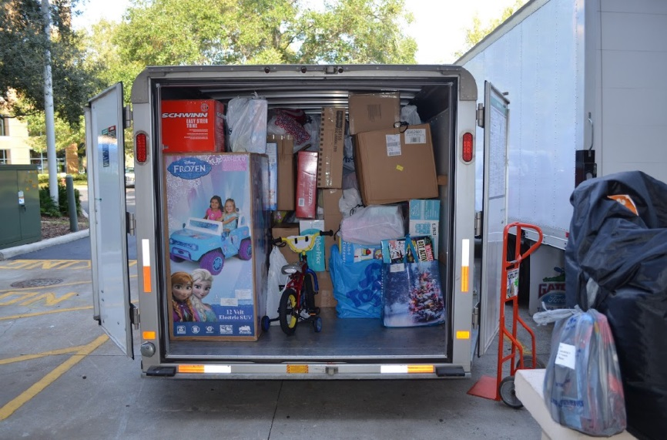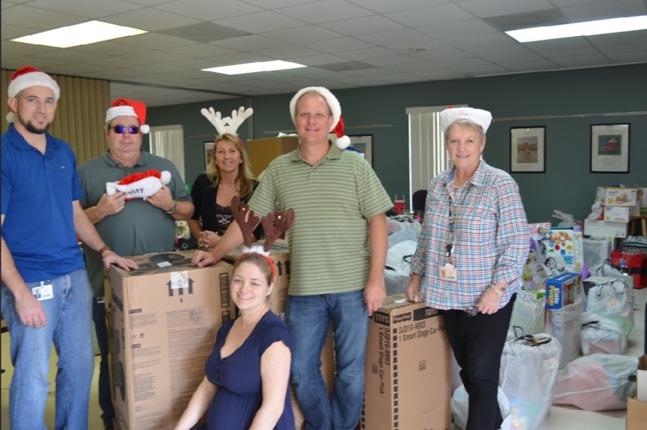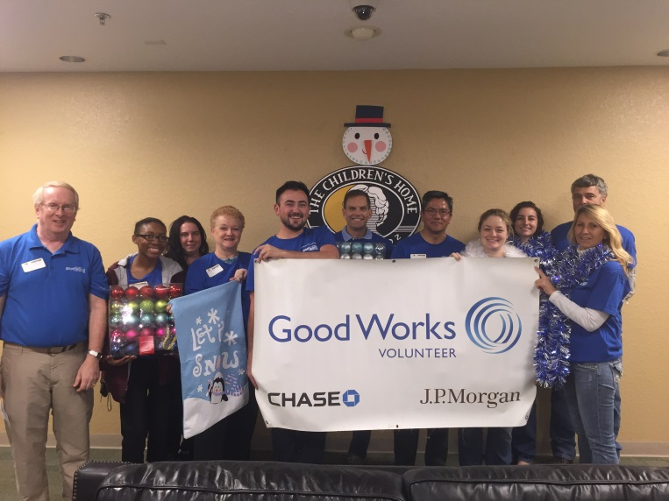

**Solution/Key Functionality**

* *This application is a great benefit to the children's home network because it will allow them to easily enter wishlists to help each child receive their Holiday wishes.*
* *SalesForce helps to pull clear and concise reports - which can help increase funding and donations!*

*.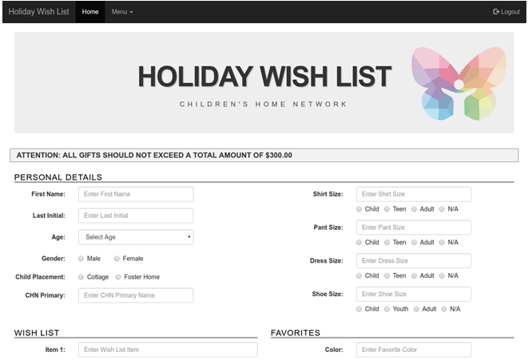*

**Highlights**

* Quotes from Team Members:

Peter Cruikshank,

“The Children’s Home Network FFG team really pulled together and formed a force that delivered more than what the non-profit requested.

The team followed an Agile approach but were not bound to strict agile ceremonies or practices. They adapted their approach to deliver client prioritized

Holiday Wish List functionality in short product increments. I really enjoyed working with the team and the Children’s Home Network.”

* Quotes from the NGO:

*Lauren Ruiz*,

“The Children’s Home has partnered with JP Morgan Chase for years in helping make the holiday wishes come true.

The old process created a great deal of manual work and difficulty for both of our organizations as well as other corporations who were donors.

JP Morgan Chase took the initiative to help alleviate some of the manual work and frustration with this process by utilizing the Force for Good program to turn a problem into an opportunity.

This has greatly benefited The Children’s Home to make our staff happier with an easier way to organize and process requests. It makes our donors happy because they are getting clear, concise information.

Ultimately, it makes the children we serve have a joy-filled holiday season.  It is a win, win, win for everyone. Thank you for sharing and caring to make a difference!"

* *Our Project Team was located in the Highland Oaks and Fountain Square offices.*
* *We worked throughout the project using in-person, telepresence & Skype meetings.*