
An Informative Title: An Optional Subtitle

First Author, Another Author
First Affiliation
and
Someone Else
Second Affiliation

Use as many key words as possible in your abstract. Limit its length to 960 characters. For an empirical study, use 100 to 120 words to describe the problem, participants, method, findings, and conclusions. For a theoretical or review article, use 75 to 100 words to state the article’s topic, thesis, scope, sources, and conclusions. Define all abbreviations and unique terms. Spell out names of tests and technologies. Use paraphrases, not quotations.

Keywords: Human-robot interaction, recognition, sensors, emotion
Introduction
This article is a description of how to create a document of the appropriate style for a submission to the Journal of Human-Robot Interaction (JHRI). The journal is an interdisciplinary journal, so it is useful to note that different disciplines use the term “style” differently. This article should help you understand both usages, and create a document that can be easily read and understood by readers from a wide variety of disciplines.
The first use of the term “style” refers to typesetting and layout. This Word document shows how to format your article. The second use of the term “style” refers to standard heading, tables, figures, references, and citation formats. The Journal of Human-Robot Interaction uses the standards from the American Psychological Association for these style settings although the editors are not going to be strict about the style if your paper is technical.

Equations

Here is an example of an equation.

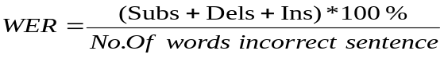

where Subs – No. of wrong words substituted in the recognized text.
Dels – No. of correct words deleted in the recognized text
Ins – No. of new words inserted in the recognized text

Primary Heading or Numbered Section uses “Primary Head style”
Here is the paragraph after a main heading, with the paragraph not indented. The font of the heading is Times New Roman 12pt, and the font of the main text is Times 10. (If you do not have Times New Roman, then use Helvetica.) This paragraph should use “initial body text” style.
The next paragraph uses “body text” style with the paragraph indented. You would sometimes break this section into subsections and subsections into subsubsections. Also, you can use paragraph headings instead of subsubheadings.
Example of a Subsection using “Secondary Head” style
This is the beginning of the subsection. Note that it uses “initial body text” as the style, which means the paragraph is not indented.
Second Example Subsection
Note that the main words are capitalized in the subsection head.
Subsubsection Name –Uses Tertiary Style
The subsubsection is followed by “initial body text” style. Subsequent paragraphs have “body text” style (with indented paragraphs).

Paragraph heading. Use Initial Body Text style and italicize heading. Only the first word is capitalized. There is a period after the heading. Then you follow the heading with your text. This style is often used when you have one or two paragraphs for each type of content, such as variable descriptions.
You would continue with regular body text style.

Numbering of Sections and Subsections
The format of the journal allows either numbered or unnumbered sections. The examples in this template are, of course, unnumbered. If you chose to number sections, only sections, subsections, and subsubsections are numbered; paragraphs and subparagraphs are not numbered. Sections are numbered as “1. Section Title”; subsections are numbered as “1.1 Subsection Title”; and subsubsections are numbered as “1.1.1 Subsubsection Name”.

Figures
When you create a figure using Word, it is advisable to insert a text box, and place your figure and figure caption inside the text box. Doing so helps prevent your figure from “wandering.” When using Word, another strategy for placement is to place the figure on the bottom or top of the same page (as in Figure 1). In doing so, you avoid splitting paragraphs awkwardly.
Please be sure that readers can see the labels on your figures, and that both the Y and X axes are labeled. Avoid using fancy graphics such as three-dimensional columns that do not add new information.
One way to show differences across conditions in a graph is to use letters to label which means are significantly different with the others. If you test many means, be sure to adjust for the number of significance tests using (a) planned contrasts, (b) students’ t tests or Tukey tests, or (c) Bonferroni adjustments of your p values.

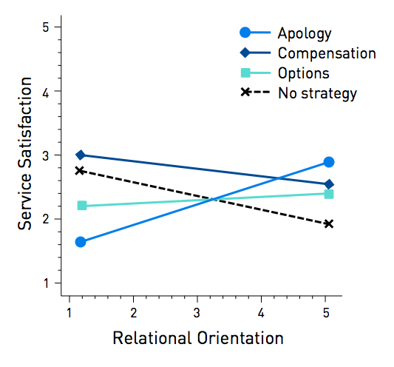
Figure 1. The relationship between participants' relational orientations and their satisfaction with a robot's service.

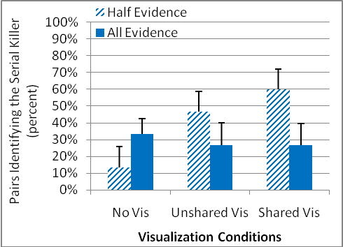
Figure 2. Percent of pairs solving the serial killer task by condition.

Figure 3 shows another example of a figure. Here, the author has used a diagram to convey information about his method. The diagram is pasted inside the textbox, and the caption is inserted inside the textbox as well.
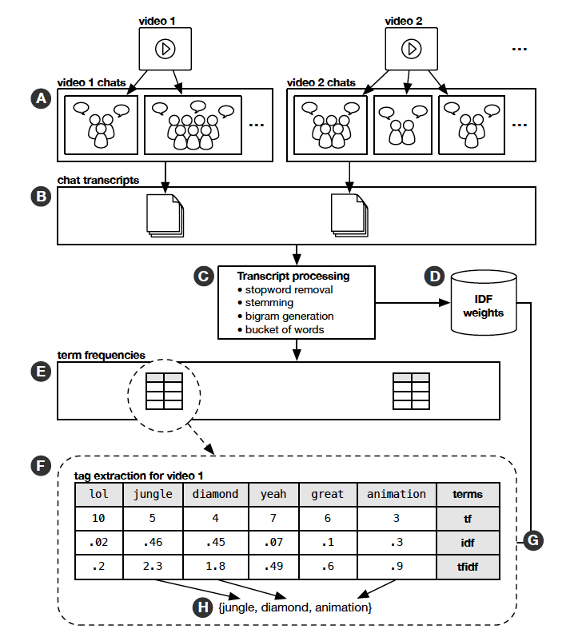
Figure 3. Tag extraction process. A. Groups of views chat while watching a video. B. Chat transcripts collected. C. Transcripts processed into a collection of stemmed terms. D. IDF weights computed. E. Term frequency tables computed for each video. F. Tag extraction process computes tF-IDF weights. Example shows terms spoken during video 1. G. IDF weights are global across all videos. H. Tag extraction for terms with the highest TF-IDF weights.

Tables
Please give adequate information not just for current readers but also for subsequent meta-analyses that may use your results. To be useful, you should present means and standard errors (if you have done analyses of variance or regressions) or standard deviations.
See Tables 1 and 2 for examples of acceptable tables.

Table 1. This is an example of a table heading (style = Table Head) showing means and standard errors (in parentheses). The title should tell the reader what the numbers mean.

Variable 1 | Variable 2 |  | Variable 3
Variable 1 | Low | High | Small | Big
News | 47.1 (3.0) | 14.1 (.1) | 26.9 (4.0) | 13.8 (2.0)
Politics | 34.7 (2.0) | 28.6 (.1) | 26.4 (4.0) | 25.9 (2.6)

Note that in Table 2 we have used Times 8 for numeric information so that all the information can be included within boundaries of the table. Initial body text follows a figure or table, just as it does a heading. In the table (Table 2), the font and placement of columns has been altered to fit a great deal of data into one table. Note how p values are referenced. Another way to provide p values is to use letters to show where there are differences across conditions.

Table 2. The impact of a robot’s recovery strategy on service and robot evaluations, showing mean [standard error] in each of four conditions.

Dependent measure | No Strategy | Apology | Compensation |  | Options
Service Evaluation
Good or bad service | 2.35 [.13] | 2.70^{t} [.12] | 2.72*[.13] | 2.56 [.13]
Service satisfaction | 2.16 [.11] | 2.46^{t} [.11] | 2.68***[.10] | 2.36 [.11]
Willigness to return | 2.66 [.14] | 3.06* [.14] | 2.99 ^{t} [.13] | 3.12**[.13]
Robot Evaluation
Politeness | 3.24 [.07] | 3.97***[.08] | 3.62***[.07] | 3.69***[.07]
Competence | 2.99[.08] | 3.27* [.08] | 3.16[.08] | 3.20[.08]
Trust robot | 2.84[.12] | 3.01[.13] | 2.85[.12] | 2.79[.12]
Like robot | 3.40[.11] | 3.72*[.11] | 3.31[.10] | 3.36[.11]
Feel close to robot | 2.79[.12] | 3.16* [.13] | 2.81[.12] | 2.85[.12]

Note. The numbers show the least squared means and the standard error in brackets. Robot evaluation ratings shown are post-scenario, and the analyses control for pre-scenario ratings. Significance tests compare each strategy with the No strategy comparison condition.
^{t}p < .10, *p < .05, ** p < .01, *** p < .001

Statistics
Here are some examples of how to cite various statistical tests in your paper. Typically you would also point readers to a table or figure, or insert the means and standard error values into your text.
ANOVA results are cited using the F test (e.g., F (1, 38) = 4.94, p = .04). F and p are italicized. Give the exact p value to two decimal places except when greater better than p < .01. Try to avoid more than two decimal places, as readers are not very interested in exact values; comparisons are more important. The F value is followed by the degrees of freedom in the numerator and denominator. Here is how one author of a mobile phone study (Author, 2010) reported an interaction effect:
The data were analyzed in a 2 (Age: young vs. old) x 2 (Device: Phone A vs. B) mixed measures analysis of variance (ANOVA). We found an interaction of Age X Phone (F [1, 38] = 26.18, p < .0001). The contrast showed older people using Phone B took considerably longer to complete the task, F (1, 38) = 69.16, p = .02. (p. 6).
Correlations using product moment tests are reported using r (e.g., r (200) = .19). The number in parenthesis following the r value represents the degrees of freedom (df), or N – 1. Including the degrees of freedom provides the reader with a sense of statistical significance, in that correlations are highly sensitive to the number of data points. For instance, with 200 scores on both variables, .19 will be a significant correlation whereas with only 30 people, it will not be statistically significant.
T tests (e.g., t [20] = 100.2, p < .01) are reported giving the degrees of freedom in the denominator. (The numerator df is always 1, as is true of correlations.)
Notice how brackets are placed inside parentheses to reduce confusion.

Citations
There are many rules for citing references using the APA format, but you should satisfy most of them by following the template. See
http://www.nova.edu/library/dils/lessons/apa/print.htm.
This section provides a few examples to emphasize some of the most fundamental rules.
Citing two papers with multiple authors, but the same first author (Parasuraman, Sheridan, & Wickens, 2000; Parasuraman & Riley, 1997). A collection (Balch & Parker, 2002). A journal paper (Parasuraman & Riley, 1997) A paper in a conference proceedings (Olsen, Wood, & Turner, 2004). A paper with more than three authors (Bradshaw et al., 2002). Some papers appear in electronic-only proceedings or journals. For those journals, no page number or publisher address is included. If this is the case, please include the Digital Object Identifier (DOI) (see http://www.doi.org/).
DOI's must be included for all references that have them. A hyperlink must be included and active to each DOI reference. You can look up the DOI for a published paper by going to {\tt http://www.crossref.org/guestquery/} and entering bibilographic information. This form will return the DOI in as a link to a webpage. Include this webpage as the last element of your reference as illustrated in the References below.

Quotations
For long quotations, please intent the quote as follows:
Four score and seven years ago our fathers brought forth on this continent a new nation, conceived in liberty, and dedicated to the proposition that all men are created equal.
Use “initial body text” to follow a quote. In some cases, for example where you are quoting participants in an ethnographic or qualitative study, you may want to set quoted material apart using italics as in the following example:
We tried to collaborate, but it was just impossible. (Researcher #4)

Acknowledgements
You should acknowledge anyone who reviewed and helped you with your work here. Also acknowledge all sources of funding. This is also the place to declare any conflicts of interest. Note that the acknowledgements section is never numbered.

References
Balch, T., & Parker, L. E. (Eds.). (2002). Robot teams: From diversity to polymorphism. Natick, MA: A. K. Peters Ltd.
Bradshaw, J. M., Sierhuis, M., Acquisti, A., Feltovich, P., Hoffman, R., Jeffers, R., et al. (2002). Agent autonomy. In H. Hexmoor, R. Falcone, & C. Castelfranchi (Eds.), Adjustable autonomy and human-agent teamwork in practice: An interim report onspace applications. Norwell, MA: Kluwer Academic. http://dx.doi.org/10.1080%2F0954009021000068763
Olsen, D. R., Wood, S. B., & Turner, J. (2004). Metrics for human driving of multiple robots. In Proceedings of the 2004 IEEE International Conference on Robotics and Automation (Vol. 3, pp. 2315–2320). NY: IEEE.
Parasuraman, R., & Riley, V. (1997). Humans and automation: Use, misuse, disuse, abuse. Human Factors, 39, 230-253. http://dx.doi.org/10.1518%2F001872097778543886
Parasuraman, R., Sheridan, T. B., & Wickens, C. D. (2000, May). A model for types and levels of human interaction with automation. IEEE Transactions on Systems, Man and Cybernetics – Part A: Systems and Humans, 30, 286-297. http://dx.doi.org/10.1109%2F3468.844354
Authors’ names and contact information: I. M. Author, Affiliation, Institution, Main Town, Country. Email: author@gmail.com; I.M. Author2, Afiliation, Institution, Town, Country. Email:

