

DMN Modeler Report
DT on BKM implicit parameters

Published: 7/30/2018
By: Edson Tirelli
Table of Contents
Page 1 3
Decision Requirement Diagram 3
Elements 3

Page 1

Decision Requirement Diagram
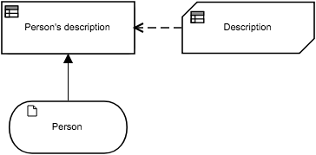

Elements
Person's description (Decision)
Output Data Type
Type | Text

Decision Logic (Invocation)
Person's description
Text
 | Description
 | Person.Gender  Text |  | Person.Gender
 | Person.Name  Text |  | Person.Name
 | Person.Children  Number |  | Person.Children

Description (Business Knowledge Model)
Output Data Type
Type | Text

Decision Logic (Decision Table)
Description
Text
 | U | Person.Gender |  | Person.Name | Person.Children | Description | Description
 |  | Text  "Male", "Female" |  | Text | Number | Text
 | 1 | "Male" |  | - | - | Person.Name + " is a dad of " + string(Person.Children) + " children."
 | 2 | "Female" |  | - | - | Person.Name + " is a mother of " + string(Person.Children) + " children."

Person (Input Data)
Input Data Type
Type | tPerson

tPerson
Name | Text
Gender | Text  "Male", "Female"
Children | Number

